Math Blogging Retrospectus 2012

A look back at some of the math blogging that inspired us in 2012

Introduction
We are truly living in the golden age of math curriculum. Never has it been easier to find great stuff and collaborate with great people online. In particular, this past year saw a sort of boomlet in math blogging. You can find literally hundreds of like-minded, creative and supportive math teachers online in just about any time zone.
However, with this boomlet comes a marked increase in the difficulty in following it all. Whereas just a few years ago it was easy to toss a few links into your Google reader and you had all there was to digest math-wise, now there’s an avalanche of math teachers blogging through their practice. While the act of blogging is certainly therapeutic and beneficial for them, being the selfish person I am, I want to know how to improve my own practice through the efforts of others.
What is this thing?
As 2012 drew to a close, I put out a simple request: send me the math blog posts that touched, inspired or helped you in the past calendar year. I wanted to catch up on all the great stuff I had missed throughout the year, now that I had a couple weeks off for Winter break. With each passing post that was submitted, I was honored by these teachers’ willingness to put themselves out there, successes and failures. This document is merely a compilation of those posts. Instead of following link after link, it’s a single artifact capturing some of the most fascinating blog posts by teachers in the trenches. I lightly edited for format and the occasional spelling mishap, but the posts are basically in their original form. It’s an admittedly unscientific crack at finding just some of the good stuff that happened online in 2012 before it slips through the cracks. It may also serve as an outward facing document to demonstrate to non-online math teachers how much great stuff there is out there. Whether you use this document or not, I hope that you find the posts that these authors poured their blood, sweat, and tears into as inspiring as I did.
If you are a “contributing” author and would like your blog post removed from this compendium for any reason, please let me know and I’ll remove it and re-upload.
How to use this thing
Obviously, this is not the medium in which the original blog posts existed or were intended for. To fully appreciate many of the posts, you need to follow hyper-links, watch videos, and participate in the comment section. So it has some limitations. Still, all the posts have the hyperlinks still in them, including links to the videos. The pictures still live here. So even with those limitations, I’d recommend a few potential uses:
- Toss it into Evernote or whatever cool reading app you have for your mobile device.
- Use your school’s paper and ink to print it out yourself and read it on the train. Go back and look at the videos and stuff when you’re safely at home and youtube isn’t being firewalled.
- Spend some time in silent sustained reading for your next professional development (or, perhaps, in lieu of district-led professional development).
- Bypass all the cut-and-pasted text and go right to the hyperlinks and read each post in its original glory.
- Download the Word version, pare it down to just your favorites, then print it out and give it as presents or something, mix-tape style.
The posts are organized into three categories: Stories, Commentary, and Tasks, but since many combined multiple of these elements, rather than a typical listed table to contents, a Venn Diagram TOC is probably more appropriate.
Geoff
Venn Diagram of Contents

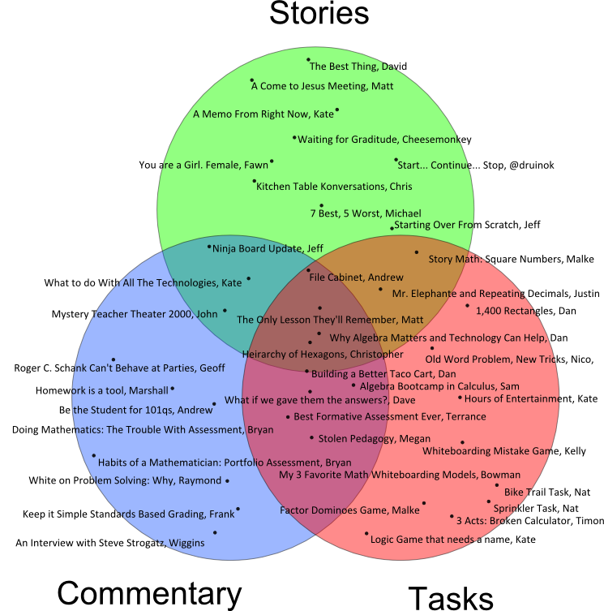


List of Contents
Stories
- Starting Over From Scratch, Jeff … 6
- A Memo From Right Now, Kate … 7
- Start… Continue… Stop, @druinok … 8
- You are a Girl. Female, Fawn … 9
- A Come to Jesus Meeting, Matt … 10
- Kitchen Table Konversations, Chris … 13
- The Best Thing, David … 16
- Mr. Elephante and Repeating Decimals, Justin … 16
- File Cabinet, Andrew … 17
- 7 Best, 5 Worst, Michael … 20
- Ninja Board Update, Jeff … 25
- Waiting for Gratitude, Cheesemonkey … 28
Commentary
- Mystery Teacher Theater 2000, John … 30
- White on Problem Solving: Why, Raymond … 30
- Why Algebra Matters and Technology Can Help, Dan … 32
- Be the Student for 101qs, Andrew … 39
- What to do With All The Technologies, Kate … 42
- Doing Mathematics: The Trouble With Assessment, Bryan … 43
- Habits of a Mathematician: Portfolio Assessment, Bryan … 43
- Keep it Simple Standards Based Grading, Frank … 45
- Roger C Schank Can’t Behave at Parties, Geoff … 48
- Homework is a tool, Marshall … 52
- What if we gave them the answers?, Dave … 54
- Stolen Pedagogy, Megan … 55
- My 3 Favorite Math Whiteboarding Models, Bowman … 57
- An Interview with Steve Strogatz, Wiggins … 59
Tasks
- Whiteboarding Mistake Game, Kelly … 64
- Algebra Bootcamp in Calculus, Sam … 73
- Logic Game that needs a name, Kate … 76
- Sprinkler Task, Nat … 80
- Factor Dominoes Game, Malke … 83
- 3 Acts: Broken Calculator, Timon … 87
- Bike Trail Task, Nat … 89
- Building a Better Taco Cart, Dan … 92
- 1,400 Rectangles, Dan … 97
- Hierarchy of Hexagons, Christopher … 99
- Teaching an Old World Problem New Tricks, Nico … 103
- Best Formative Assessment Ever, Terrance … 108
- Story Math: Square Numbers, Malke … 109
- Hours of Entertainment, Kate … 112
- The Only Lesson They’ll Remember, Matt … 113

Stories

Starting Over from Scratch
Jeff 9/22
Because I’m teaching the same classes as last year, I’ve been fired up all summer because I feel like I’ll be able to knock it out of the park. After two weeks of school-wide culture building, we finally began content this week. Regardless of whether I’ve taught the class before, I’ve never taught these classes – these kids. I have to start over. From scratch. Here’s some stuff I learned/remembered.
- It is a rough transition from passive to active learning – but it’s such a fun and important journey. I love the looks on learners’ faces after I walk away to another group. There’s this puzzled look that says “Wait…he didn’t answer our question. He only asked more questions. We have more thinking to do.” (At least that’s what I’d like to believe they’re thinking).
- Learners are used to being told what to do, step by step. This is made very clear the first time we determine our next steps. After being given a problem scenario, we determine what we know about the problem, what we need to know to solve it, and what our next steps will be. After the teeth-pulling required for Knows and Need-to-Knows this first time, we finally develop a solid list of next steps. The learners have created them, I have the learners repeat them, we have them listed on the board…but the first question I get after we begin working is “What are we supposed to be doing?” Their task is not laid before them, worksheet style with a list of things to do. Our next steps are aimed at tackling Need-to-Knows in whatever way best suits the learner. This is hard to wrap their minds around.
- Some habits – like hiding mistakes – are hard to break. As part of our cooperative environment, we have group contracts for each unit to help the groups work together. On this first contract, I included five problem-solving norms (mostly stolen from Malcom Swan) to get them started, but gave them the option to only use them if all members agreed. What I got was this:
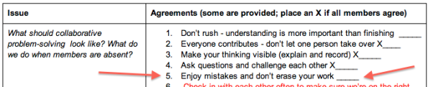
Apparently rushing and erasing mistakes are important to kids.
Only about half the groups agreed to the norm for enjoying mistakes and not erasing work. I told them that’s fine…we’ll work on it.
- Adding the word “yet” to many learners’ comments makes a big difference. “We can’t figure this out”…yet. “Our group isn’t getting along”…yet. This leads us to determine our next move – how can we overcome this problem?
- Never carry a pencil. The beginning of the year is the most crucial time for this. By high school, kids have become very good (and stubborn) at getting you to do the work for them. Not carrying a pencil helps, but I have to remind myself not to carry a mental pencil either – to create a culture of questions rather than a culture of answers.
- At the end of the day, debrief. It took me until this year to figure this out, which is embarrassing. It’s as simple as holding three minutes sacred at the end of class (I build it into the agenda) to ask “what did we learn today?” or “what did you think of the day?” It gives learners the first opportunity to reflect on their learning, and I’ve already gotten some great insights from them.
- Kids are more willing to believe “the internet” than a strong argument from peers. Sad face. This came about as we talked about measures of central tendency and particularly the mode. A problem was posed in which a data set had one of every number, but two 0’s and two 26’s. The question came up in every class – what is the mode? So I turned it back on them. What do you think? Let’s decide as a class. (Full disclosure: I don’t really know if the set should be considered bi-modal or if it has no mode…nor do I really care. The discussion that came from the question is more important to me than the answer). In one class, they came to consensus that the set had no mode, in another class they agreed to keep thinking about it…but in the third class, the following discussion occurred:

Learner 1: Since the mode is the most frequently occurring number, and there is a tie, then there is no most frequently occurring number. So there’s no mode.
Me: There’s an argument…anyone want to take the other side?
Learner 2: Well I looked it up and it said that both numbers were the mode – it’s bi-modal.
Me: What is “it”?
Learner 2: The internet.
Me: OK, so the “internet” said that this particular data set is bi-modal?
Learner 2: No, but it said that if there are two modes, then it’s bi-modal.
After a bit more discussion, we tried to come to consensus. The class agreed that the internet was right, and the learner’s solid argument was not.
So here’s another thing we’ll have to work on. And man am I fired up for this year – just not for the reasons I thought before the year started.

***

A Memo from Right Now
Kate 10/23
Did you maybe at one time feel that this job would be easy? That you would sort of have it figured out and it would just make itself happen? And then you could just bask in the adoration of students? I think I admit that I sort of did, at one time. I have also thought that everything would be easier if I got my body in shape, or everything would be easier once I made new friends in a new country. Routines get established and you learn what has to be done. But the work doesn't go away. The need to assess where the kid is at and ask the next question is a relentless, recurring task. The need to wrestle the bicycle into the lift and get it outside and sit on it and pedal for an hour or so doesn't ever go away. The need to reciprocate invitations and tell people what you appreciate about them will never be sated.
I like to do things well and be done with them and brush my hands on my pants and move on. But some things will never be done. I forget that, and I get in a feverish little funk. I get aggravated by the maintenance requirements of living my life.
I know better. I know to pause in moments and notice the riot of things happening right now. I know not to drag kids over the finish line but to look at their face with curiosity and tenderness and ask what they think and shut up and look and listen. I know to notice my legs working while they pedal and notice the sun warming my shoulders and take a big cool humid lungful of springtime air. I know that thinking up something to do on Saturday and picking up a phone is a critical strike against loneliness. I know all these things are gifts that make every single day okay to just be in.
***

Start.... Continue.... Stop....
@druinok 7/6
Today was the day that all AP teachers fret about... the day that the College Board releases the AP scores to the teachers. Technically they started yesterday with the Eastern time zone, but my day was today and they arrived right on schedule. Of course, I spent a huge chunk of time today pouring over the scores, analyzing their relationship to student grade, trying to figure out what I could do to be a better teacher next year. Yes, I totally know that part of the responsibility falls on the student, but that's not something I control - I can control what *I* do as the teacher, so that's what I'm going to focus on for now. :)
That reminded me of a tweet that @tbanks1906 sent out last week: What is 1 thing you plan to START doing in your class, CONTINUE doing and STOP doing this year?
Start...
I actually have two things that I plan to start doing this year. The first one is about notebooks. I've already posted about the Interactive Notebook in Algebra 2 and I am really looking forward to hearing @mgolding's talk on it at Twitter Math Camp in just a few weeks. If you're not sure about notebooks, I encourage you to go read these posts:
Interactive Notebooks by @molding
The $1 Textbook by @ultrarawr
The other thing I would like to tinker with is the idea of Whiteboarding. Kelly O'Shea posted an amazing post about it yesterday. Go read about it here:
Whiteboarding Mistake Game: A Guide by @kellyoshea
Continue...
Again, two things that I definitely plan to continue are Standards Based Grading and Active Learning. Much has been written, both on this blog and others about the benefits of SBG, so I won't rehash them here. At some point, I do need to recap how this year went with SBG in AP Stat, but needless to say, I will definitely be continuing it. As for Active Learning, I am still very concerned with the idea that many classrooms are where students go to watch teachers work. I will continue to develop strategies to make my classroom active.
Stop...
This is definitely the hardest one of these to answer, but I'm going to *try* to stop letting paper accumulate. This actually takes several different "faces". Papers to be graded, papers to be passed back, papers to be filed, papers to be recycled, papers to be shredded, papers, papers, papers! I have paper files of quiz/test masters and answer keys from 12-14 years ago sitting in my closet. Why do I have them? Because I can't let them go. I need to let them go. I have a copy of them electronically and I could always make an answer key again, but honestly my quizzes and tests are way better now and I wouldn't use those in their current form anyway, so I need to let them go.
Thanks to @tbanks1906 for a great prompt! I'm curious... what would YOU start, stop, and continue in your life/classroom?
***

You are a girl. Female.
Fawn 4/9
Nicolai and I had another nice conversation this evening when I drove him back to his dorm. The sun was a giant orange ball sinking near the horizon of Pacific Coast Highway. We talked about girls. I talked about my mistakes, lots of them. I told him the same thing I said at the dinner table two weeks ago when my sister and her two kids visited, "Don't marry someone you love. Marry someone who loves you." My sister disagreed.
**********
I settle in to make the one-hour drive back home — Pandora is set to Elton John Radio. I get a whole mix of great nostalgic songs from Journey, The Beatles, Stevie Nicks, CCR, and EJ himself.
A sense of gratefulness envelops me.
I see the waves still slapping against the sandy beaches under the now dark sky. The ocean does not sleep. The dark waters flood me with memories of our escape: our days floating out somewhere in the South China Sea, our boat bobs up and down without a captain because there is no fuel for it to move anyway, all 13 of us on board already know tomorrow was never promised to any of us. But I'm only 11 years old, and I really don't want to die.
We all see it because it's the only thing we've been looking for — our glimmer of hope. It is a single dot in the canvas of blue sky and blue water. The dot gets bigger. The men wave their dingy white shirts, hollering out for help but only hearing their own voices bounce off each other. My own mouth is dry, I try to yell for help too but no words come out, I've been without water for a long time. The bigger dot is now elongated. Then it begins to look very much like part of a ship's mast. An eternity goes by when the dot has finally morphed into a ship. No one speaks of it being a possible pirate ship —
I'm grateful to the Thai crew of this ship — this large fishing vessel — to feed us and give us water. I still can taste the sweetness of the giant steamed squids from that night. How do you thank people who save your life?
**********
If you put my three kids into three separate rooms and ask each this question, What does your mom want for you? they should all give you the same answer, To be kind and to be happy. It's a mantra I've been repeating since they were little. Nicolai, on his own, ended his 8th grade valedictorian speech with a familiar quote from Mark Twain: Kindness is the language which the deaf can hear and the blind can see.
I know "be kind and be happy" is vague — like lazy parenting — but life is vague. I want them to define their own happiness. But I don't want kindness to be a choice for them, I just want them to bekind.
All 13 of us were rescued by the fishermen who reached out with immeasurable kindness. Then this great country welcomed our family with open arms. This is the only America I know — the America that made it all possible for me and my family to go to school, earn a college degree, work, raise a family. How do you thank a country for all this? There has never been a single moment when I hear or sing the American national anthem and not tear up.
**********
I'm now about half way home. But I don't want to rush the drive. It's a perfect night, the highway is sparse, I turn up the volume — Stevie Nicks is singing "Landslide."
I'm overwhelmed by all the kindness that comes in small packages too.
I'm in 6th grade. Carla, tall with brown short curly hair, sits next to me in class. There is a form that we all have to fill out. I write down my first and last name. Then I am stuck because I don't understand what the form is asking me. I glance over at other kids' papers and see that they're already halfway through the form. Carla smiles at me because she always does. She notices that I'm not writing. I'm embarrassed that I don't know enough English to fill out this form. She leans over and puts a check in the "female" box for me. She says quietly, You are a girl. Female. And she points to Tony across from us, He is a boy. Male. She smiles again. Carla doesn't know that I still think of her today.
I'm pulling out of the school's parking lot. It's the start of winter break and also my three-month maternity leave. I'm really pregnant with my first baby. I see Brian, my 7th grade student, running fast toward my car, he's out of breath. I turn off the engine and step out of the car. Brian pulls out a blue stuffed animal from under his jacket. He says between breaths, I'm glad you're still here, Mrs. Nguyen. Here, I want your baby to have my stuffed animal that I got when I was a baby. I want to tell Brian that I can't accept this precious blue floppy eared stuffed puppy from his childhood. But I can't get myself to say anything. His kindness breaks my heart.
***

A Come to Jesus Meeting
Matt 9/22

It’s a phrase that my mom used when I was young. “We’re gonna have a Come to Jesus meeting when you get home about your grades in English.”
A balding preacher springs to my mind–white knuckles gripping the podium–leaning toward the congregation and flecking the front row with frothy vengeance, screaming, “Turn from thy wicked ways!”

That’s certainly how I felt on Thursday with my iPad class.

On Wednesday, I got an email from one of the P.E. teachers describing her discontent with my students using their iPads to take pictures, play games, and dick around during P.E. class.
She probably didn’t say “dick around”. That’s an embellishment.
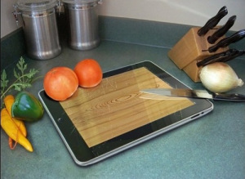
This email–copied to my administrators, of course–gave voice to a sentiment that other teachers were probably feeling; I don’t know what to do with these things. Can I confiscate them? Can I discipline the students for taking them out?

I sent an email apologizing for the students and assuring that I would deal with it. I sent an email with the iPad policies to the whole staff, then cracked my knuckles and waited for the iPad class to stumble unwittingly into 3rd period.
As they entered, I shook everyone’s hand (as I do every day) and said, “Good morning! Please put your iPad in the cart and have a seat.”
Then I came to my podium.
“Can I cut vegetables on it? Or just fruits? Is a tomato a fruit?”

“Teachers have been complaining about this class. [dramatic pause] They say that you are taking your iPads out in other classes, taking pictures, playing games, and letting other students use them. [dramatic eye contact with the offenders] You all know what the expectations are; you signed a contract and so did your parents. You know what to do, and you’re making me look bad. So today, we’re going to practice how to have a class without the iPad, so you know how your other classes should look. Clearly, you need some practice.”
Then I put on a smile and we went through the period. I thought they got the point.
The next day, I caught two different students playing games in my class. I directed them to put their iPads in the cart, and their responses were:
“What? I’m done already.”
and “Why?”
To the second student, I fixed him with my best teacher stare and asked in a low tone, “Is that a serious question?”

He wisely didn’t respond.
I quite enjoy Halloween. I love to put on a costume and be somebody different for a short while. It’s not because I don’t like my usual self, but it’s just so fun to be somebody new for a little bit.
That’s why I’m comfortable being a hardass in short installments. I like when everyone in my class is happy, but teachers will tell you that a teacher who is only happy will result in a class that is only unruly.

For those two students, I began taking deep breaths about 10 minutes before the period ended, preparing myself to instill the fear of the Lord in them.
“Boys and Girls, it’s time to please…oh! Is that a knife?”
When the class ended, I motioned for those two to wait, and the RSP teacher to also stick around. I brought them over to my desk and showed them a copy of the student/parent contract.
“This is the contract that you and your parent signed. This bullet point says I will use the iPad for academic purposes during school hours in accordance with the rules set forth by MVUSD. You both were well aware of the rules–especially after our conversation yesterday– but you chose to break them anyway. In this contract, the penalty is removal from this program and this class. We will have a meeting this weekend to see if you should be removed. I’ll let you know what we decide on Tuesday. You’re dismissed.”

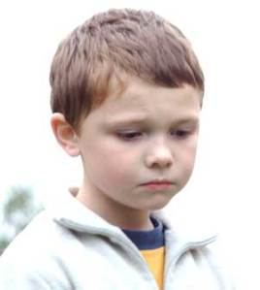
Two wide-eyed and trembling teens trudged out the door. Once it closed, I turned to the RSP teacher and asked, “Too much?”
“This is worse than when Nemo died and I had to flush him.”
Her eyes were also wide. “No! That was awesome!”
Then I called their parents and gave them the same discussion. I predict two very remorseful students in my 3rd period on Tuesday.
Furthermore–and this is the part that my wife doesn’t get–I’m buying myself an easier year by sacrificing these two little lambs on the altar. Because middle-school students gossip like two old church ladies at bridge club.
You can guarantee that every other student in the class will be terrified to use a game in class, which is exactly what I wanted. That’s why I was comfortable wearing the Red-Faced Preacher mask for a few minutes.
So that I can be Happy Math Teacher for the rest of the year.

***

Kitchen Table Konversations
Chris 11/12
There are things my daughters say that make me feel proud to be their dad. From my 7-year-old:
“I have a lot of stuff. For my birthday party, can I ask each of my friends for a toonie instead of a present? I’m going to give the money to the SPCA.”
“Dad, that new song by The Sheepdogs sounds a lot like The Black Keys, don’t you think?”¹
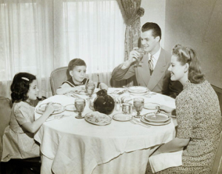
There are also things my daughters say that make me feel proud to be their mathteacherdad.
One day this week, we were talking math at the dinner table.
Being in Grade 2, Gwyneth is not yet learning about multiplication at school. However, her best friend knows about “timesing,” so she is curious and motivated. We’ve been discussing multiplication in terms of groups of. Don’t worry, we’ll have conversations about arrays later. Dropping in, mid-conversation:
Me: What do you notice?
Gwyneth: Two groups of three is the same as three groups of two.
At this point, I could have said, “That’s right. Changing the order doesn’t change the answer.” I didn’t. Being a math teacher and her dad, I also could have said, “That’s because multiplication is commutative, Sweetie.” I didn’t.
Me: What about three times five and five times three?
Gwyneth: Three groups of five is … fifteen.
Me: How do you know?
Gwyneth: Well, two groups of five is ten and one more group makes fifteen.
Me: Okay, so what about five times three?
What she said next, after a brief pause, blew me away.
Gwyneth: Nine and six make fifteen.
Me: How did you get that?
Gwyneth: I took one away from six to make ten and …
Me: No, I get that. I mean where did the nine and the six come from?
Gwyneth: Well, three groups of three is nine and two groups of three is six.
I was asking my daughter questions to have her explore the commutative property and she drops the distributive property into our conversation! Any English teachers still reading this blog after my last post may question my use of an exclamation mark. Math teachers will not. Gwyneth understands, conceptually, that 5 × 3 = (3 × 3) + (2 × 3).
I asked her to draw this for me. She drew five groups of three dots.
Gwyneth: Three, six, nine, twelve, fifteen.
Me: Wait! What about the nine and the six?
Gwyneth: I said those. Three, SIX, NINE.
Me: Yeah, I heard you. But, before, you ADDED the six and the nine.
Gwyneth: Dad, I’ve got LOTS of strategies.
I was so proud to hear her say this that I didn’t even mind the eye-rolling.
In his book The Joy of x, Steven Strogatz writes about the counterintutiveness of the commutative law.
Whereas it is intuitive to Gwyneth that adding five to three should be the same as adding three to five, it is not intuitive to her that having three groups of five should be the same as having five groups of three.
Why is 5 + 5 + 5 …
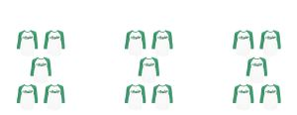
… obviously the same as 3 + 3 + 3 + 3 + 3?
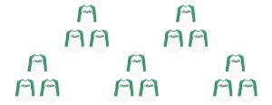
Strogatz makes the point that if we visualize 3 × 5 as a rectangular array with 3 rows and 5 columns …
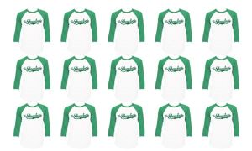
and turn this picture on its side giving us 5 rows and 3 columns, or 5 × 3, …
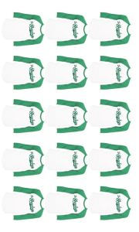
then 3 × 5 must equal 5 × 3. The commutative law becomes more intuitive.
Strogatz, a frequent guest on Radiolab, goes on to give examples of real-world situations in which people forget, or refuse to accept, the commutative law.
Once again, I have taken a page out of Christopher Danielson’s playbook with this post.
¹ I just learned that The Sheepdogs’ album was produced by The Black Keys’ Patrick Carney. Impressive kid, eh?
***

The Best Thing
David 10/24
I'm overwhelmed. I'm tired. I have pockets of excellence in a sea of mediocrity. My wife deserves more than I'm giving. My two-year-old is challenging everything I ever thought I knew about parenting--we have put child locks on the freaking upper cupboards, for crying out loud. My other boys need more of me. Four of my five periods are spent teaching a class we are inventing as we go. I'm convinced that everything revolves around the scientific method or some variation of it. Questions still are way more satisfying than statements. My planning is always weaker than the adjustments I make in the middle of the period. A good problem is more engaging than engagement strategies, but I don't know enough good problems. Expo markers dry out way too fast. Some of my students have bigger problems than I'll ever encounter and somehow I have to make what we do matter.
And yet, my students keep showing up, my boys still greet me with "I love you, Daddy" and my wife still loves me.
And tomorrow, I get to be better.
***

Day 28: Mr. Elephante and Repeating Decimals
Justin 10/18
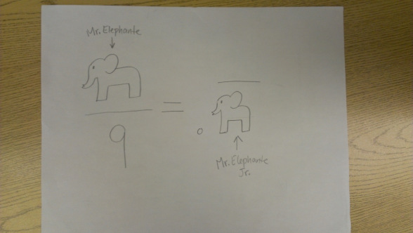
The photo above needs no verbal embellishment from me. Hooray for seventh graders!
Instead, I’ll share with you the story and idea that I shared with my class. Two years ago, I was teaching seventh grade for the first time, and consequently really teaching things about repeating decimals for the first time. I had an epiphany in the shower one morning: once you accept that .9 is equal to 1, you can figure out how to write other repeating decimals as fractions by comparing them to it. For example, these two infinite decimals

.373737…
.999999…
compare as 37 compares to 99, since for every chunk of 37 above, there’s a corresponding chunk worth 99 below. That means .37 is equal to 37/99. Neat! Other ones, like .273 can be found through a little adjustment via fraction addition or subtraction (37/99 – 1/10). I find these methods more charming and intuitive that the classic algebraic explication of turning repeating decimals into fractions, although this method also has its place. Perhaps one is often partial to the insights one hews out for oneself.

But really, folks—hurray for Mr. Elephante and Mr. Elephante Jr.!
***

File Cabinet
Andrew 4/30
By far, File Cabinet has got to be my favorite 3 Act lesson to date!
I am proud of my newfound passion for 3 Act lessons and the final product for my File Cabinet lesson. However, I am even more proud of:
- My students for their interest, critical thinking, and assistance with Post-Its and filming
- My family, friends, and colleagues who took an interest in the project/lesson
- Fawn Nguyen for using the lesson, providing feedback, and sharing her dynamic results, classroom and students with us
- Dan Meyer for calling me 'Crazy Bananas.' I deserve it. I own it proudly!
Here's the story:
In previous years, a Mr. Stadel Geometry class sounded something like this during the surface area unit, "If we covered this object in wrapping paper, we'd need to figure out the total surface area of the solid so we know how much paper to use. Let's use this formula. Blah, blah, blah!"
Cue the sigh, the yawn, the head tilting back, and eyes closing. The class would use a bland formula to trudge through a static textbook question so that they could arrive at some theoretical answer that meant absolutely nothing to everyone, including me at times.
Not this year... Dan Meyer's 3 Act lesson format is here to breathe life into applied math. I was staring at this file cabinet at the back of my room, saw a stack of Post-Its on my desk and thought, how many Post-Its would it take to cover this rectangular son-of-a-prism... and so it began.
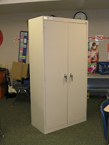
Forget wrapping paper, Post-its FTW!
I filmed File Cabinet - Act 1 (http://vimeo.com/40917688) last Monday, posted it to101qs.com and every day I chipped away at sticking Post-Its for about 40-60 minutes after school. Yes, it was a lot of work, but totally worth it! This math lesson/project instantly became a huge conversation piece in my classroom. Students came in completely intrigued by what was going on in the back of my room. They stared at it. They did weird finger, arm, and eyeball measurements. They walked around it numerous times before I finally said, "Make an estimate. It's free! Write it on the board." My whiteboard at the front of the class had about 30 kids' names on it with their estimates. It was so invigorating to hear them discuss or argue their estimate. One student made an estimate within 1 Post-It of the actual result.
Going beyond estimates, students wanted to help and the only thing I felt comfortable having them do was write numbers on the Post-Its and tape down Post-Its that were sticking out. My students were a HUGE HELP! Thanks guys! Knowing I will post my math videos online, I will not include my students in my videos for what I think are obvious reasons.
The math lesson went extremely well. My students calculated the theoretical answer for homework after we watched Act 1, made estimates, and discussed the necessary information in order to answer the question, "How many Post-Its will cover the file cabinet?" The next day we discussed the different ways my students calculated. NONE of them used any formula from the textbook. I love it! Students either:
- Found the total amount of Post-Its on each face and found the total sum or
- Found the sum of the areas of each face and divided it by 9 square inches.
I was impressed by their ingenuity, resourcefulness, and independent thinking process. Bottom line: I didn't help. I didn't force-feed them a formula that means nothing to them. Instead, I allowed them to derive the answer. Little voice in my head says, "Derive the answer or formula on your own!" We also discussed potential problems with the theoretical answer as they walked around the cabinet. Check out Act 3 to get a 'handle' on the potential problem. Here's a hint:
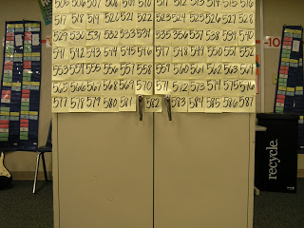
Get a handle on the potential problem.
I asked my new online math teacher friend Fawn Nguyen if she had done surface area with her Geometry kiddos and I was glad to share File Cabinet - Act 1 with her. Check out Fawn Nguyen's blog here for an exciting read about how her kids responded, their inquisitiveness, ingenuity, and the depth in which Fawn took the lesson. One of my favorite parts was seeing the kids come up to her board and measuring the video display in order to make estimates. They also estimated my height while they were at it... classic! I was flattered and happy that the lesson sparked such a great interest with her and her students. They were so kind to send me a 'thank you' picture. I love it! I shared the story with my class.
Another new online math teacher friend Nathan Kraft simply said, "I'm using this."
I'm glad! I hope you do too! and send me some feedback.
I also sent out the video link to family and friends and got a healthy amount of intriguing responses. My brother, who has great insight regarding the furniture business, was able to eyeball two-thirds of the file cabinet dimensions and had a blast calculating the number of Post-Its. It was fun to go back and forth with him about this. When asking friends what their first question was after watching Act 1, one family friend shared a perspective I wouldn't have thought of in a milion years. Her husband underwent chemotherapy years back and they used Post-Its to count down the days left. They had a pack of Post-Its in the car and counted down each of the 33 days of radiation treatment. This was an extremely touching email as I learned a life-impacting fact, all because of a math video about Post-Its.
As I was busy sticking Post-Its on the cabinet all week, staging the next camera angle, stop motion setup, or editing the video, I was honored to see Dan Meyer's blog post of his weekly Five Favorites - 101Questions [4/28/12]. Yes, Dan is correct that I'm 'Crazy bananas.' I am proud of that title and fully embrace it. I also got this tweet from him:

I don't think I'll be using a Post-It for awhile... and every time I use a Post-It I will think of this math lesson. Enjoy File Cabinet - Act 3.
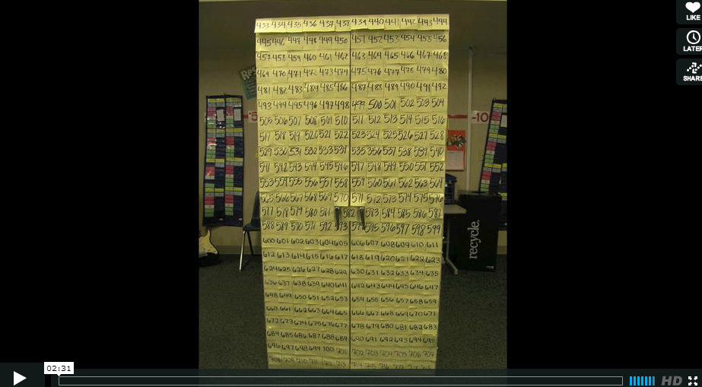
File Cabinet - Act 3 from Mr.Stadel on Vimeo (http://vimeo.com/41227350)
If you'd like the information for Act 2, email me or post a comment. I'm working on making Act 2 files more accessible or downloadable. Until then, drop me a line!
Best,
1131
***

7 Best, 5 Worst
Michael 12/3
It's time for a quarterly review. Here's the good and the awful from this year's teaching.
7 Best
1. Paul Salomon's Introduction to Proving Stuff about Exponents - The idea is to use function notation to prove things about exponents without being distracted by the repeated-multiplication model that we (rightly) inculcate our kids with in the early years. Maybe the best thing about this problem is that it really does force everybody in the room to use proof. There's no mushiness, no intuition to fall back on, just cold reason. The second best thing might be getting student work that looks like this:
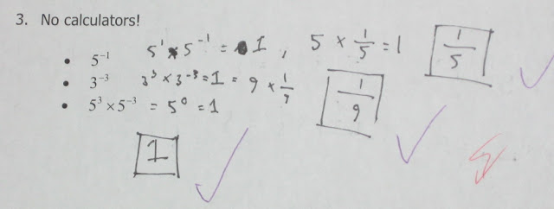

2. Exponents for Functions - And all it took was a little bit of nudging to get kids to understand why the hell f^-1 should refer to the inverse of f. It was beautiful. Then we drew the analogy farther, figuring out what a rational "power" of composition would have to mean.

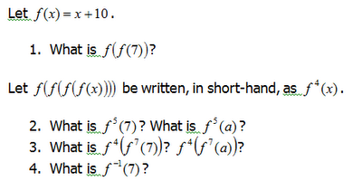

3. Encryption and Inverse Functions - Not huge, but it gave me a language for talking about invertibility. Plus, it was a ton of fun. ("Can you give us, like, enough time to actually figure the code out?")


4. Swap and Solve with Equations - My kids were struggling with equations. They could handle anything that you could undo the steps on, but that thing don't work if you've got variables on both side of an equation. I wanted to share with them the "you've got equal weights on a balanced scale" thing, but I couldn't make it snappy.
This was a blast. I gave everyone an index card with a number on it, and they had to write an equation that had that number as its solution. Then, they gave their equation to a pal and asked them to solve it.
Why did this work? Because if you want to stump your friend you need to write a hard equation. And once some jerk reveals what makes x + 30 - 20 + 4 - 7 + 1 = 10 a pretty easy problem ("Oh, come on Mr. P, you gave it away!") you have to up your game. To use fancy man language, there was a load of intellectual need in that room.
5. 100m Dash/Stratos Space Jump - We used the 100m dash to talk about linear regression, and the Space Jump to break it. Both of these problems fundamentally worked as contexts for using the line of best fit to make predictions.
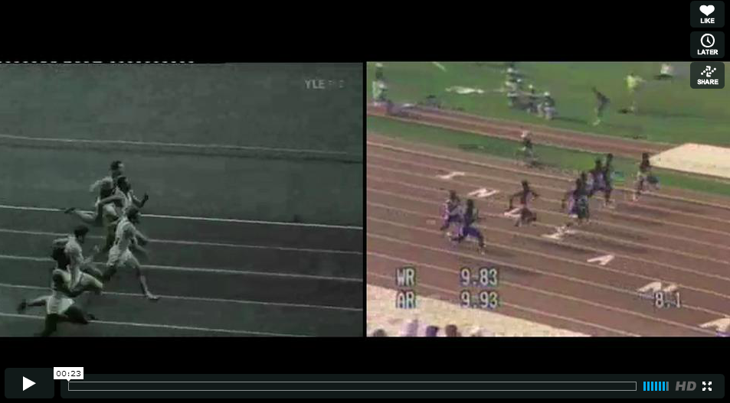
(Two Races video: http://vimeo.com/49421370)
6. Height v. Shoe Size - I love making graphs on the white board. This was a particularly fun way to introduce two-variable data to my Algebra students. They put the post-its at their height and shoe size. Hey, look, there's a trend there. And we can talk about outliers too. The next day I took this picture and abstracted everything but the datapoints, leaving a scatterplot. (Explicitly imitating this guy.)
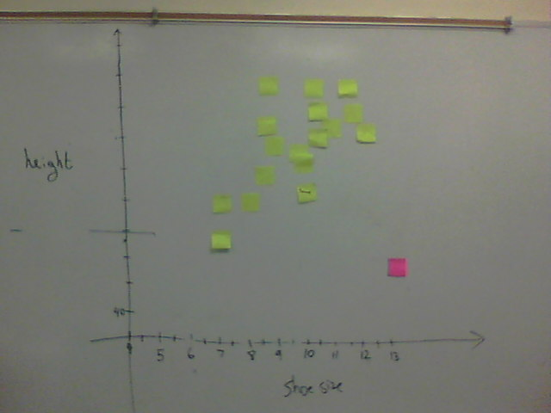

7. Constructing Number Tricks - This was pretty similar to my swap and solve activity with equations, and it worked in a similar way. Kids like coming up with their own things.
5 Worst
1. Guess-Check-Generalize - This was a boatload of frustration for me. Guess-Check was an easy sell for me; I'm still looking for buyers on Generalize. I tried lots of problems, drawn from CME and Park Math, and they did hook kids in, but every time that I brought in any abstractions I lost the crowd. My one minor success was with this pretty on-the-nose worksheet. Next time I teach this I'm going to try that sort of on-the-nose stuff earlier, and I might also wait until all my kids are extremely comfortable solving equations to attempt teaching this strategy.
2. Life Expectancy - I blogged about this guy already, but it bears repeating: this was a huge disaster lesson for me.
3. Graphs of Inverse Functions - No idea how to teach this. I'm, like, 1 for 6 in attempts to teach this thing, and I'm pretty sure that the one win was a fluke. Maybe the issue is that I just find it really cool that the graphs of a function and its inverse reflect across y = x, and I expect kids to find it as cool as I do. That very well might be the problem, since I tend to teach this by asking kids to graph and bunch of functions and their inverses and keep an eye out for something cool.
Or maybe the issue is that they're not comfortable with technology and graphing interesting functions is cumbersome? Whatever it is, I don't know how to make what really should be a cool idea pop for students.
4. Defining New Symbols - So promising! I love the problems, some of my kids love the problems, and it seems like a great way to practice evaluating expressions while also ramping-up the sophistication for the stronger kids.
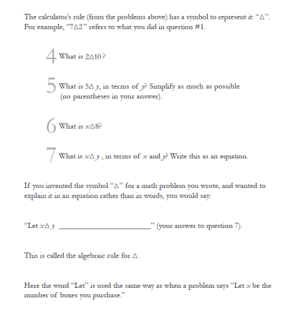
It was way too hard for the kids just getting used to variables and expressions, and my attempts at explaining this stuff were just met with blank stares. (We lost a day to me trying, like, three different ways of explaining this to a eerily quiet room.) I love this idea, but I'm not yet sure how to make it work.
5. Percentage/Fractions - Don't know how to teach 'em, especially quickly, especially to Algebra students who have never quite gotten them and need to know them for more advanced topics. I tried a bunch of stuff, and it all kind of failed. The one thing that I'm feeling better about is division by a fraction, which I'm pretty sure that I know how to teach now.* The issue is everything else.
* Next year you can be sure that I'm going to draw out the distinction between two different division models very early. Is 10/2 = 5 because 10 split up into 2 even groups would have 5 members each, or because there are 5 groups of 2 in 10? Only one of these models really works well for 10/0.5.
Bonus: Solving Equations, in General - I don't know how long it takes most teachers to get kids up to speed on solving linear equations, but holy cow it took me a while. We've got to speed things up, I think.
Soapbox
I wouldn't mind seeing your "X Best and Y Worst" post. I think that would be fun.
***

Ninja Board Update: Week 1
Jeff 9/22
Previously, I talked about this silly idea I had to implement an achievement system themed around ninjas for some reason. The original intention was to see whether or not it would have an effect on student motivation in my class, particularly in the academic respect.
While there have only been three days of school so far and it's waaaaay too early to tell whether or not this will be the case (just as ESPN.com is jumping the gun on projecting my Spartans to go to the Rose Bowl), I made an important realization: the Ninja Board is perhaps going to be far more useful as a tool for developing classroom culture (which, of course, would affect student motivation in turn). This is because I can use it to define and recognize those "awesome moments" in class and capture them for posterity.
Some things went according to plan on the first day. I said absolutely nothing about the Ninja Board. I didn't even point it out. I was secretly planning to award the first ninja point to the first student who asked about the Ninja Board. I figured someone was going to at some point.
The entire first block passed without anyone asking about it.
I was genuinely surprised at first; then I began to think that perhaps nobody would ask about it unless there was more to pique their curiosity than just a blank wall.
I looked for other opportunities to award ninja points to a few students. During my second block class -- which also ended up passing by without anyone noticing the Ninja Board -- one of my students asked me if I wanted to see the folder she was using for my class. I said I would love to, so she reached into her binder and pulled this out:
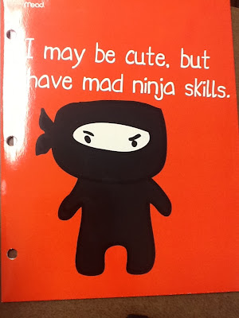
COOLEST FOLDER EVER.
So I decided to award her a ninja point for being the "first to bring in a ninja item."
I have a particular way of awarding ninja points. When a student does something worthy of a ninja point, I say nothing. I don't announce, "CONGRATULATIONS! YOU WIN A NINJA POINT!" (Doing so would be very un-ninja-like; ninjas don't announce to their victims, "GREETINGS! I AM ABOUT TO ASSASSINATE YOU WITH THIS KATANA! YOU'D BEST ATTEMPT TO FLEE!")
Instead, I jot a note to myself on my iPad: I write down the student's name, how many points they earned, and the reason they earned the points. During my planning time, I make a sign for each student that earned ninja points:


Before I leave school for the day, I tape all the signs to the wall. The students don't find out that they earned ninja points until the next day when they come back and see their names posted.
So after the first day, I picked out three students who earned a ninja point. (And the cool thing is that since I tell the students absolutely nothing about the Ninja Board, I can come up with all kinds of reasons to award ninja points.)
The next day, another block period passed without any questions about the Ninja Board. Finally, however, one student approached me during second block with the question:
"Hey Mr. B, what's the Ninja Board?"
I smiled. I smiled partly because I was happy someone had finally asked me that question after nearly two days of waiting. I smiled partly because she was going to get a ninja point for asking that question. Mostly, though, I smiled because I knew what my answer was going to be:
"That is an excellent question."
And I said nothing else. I think I giggled involuntarily.
A few more students earned ninja points on the second day, and more names were added. On Friday, I have several more inquiries about the Ninja Board, and each time I replied with a non-answer. Slowly but surely, interest in the Ninja Board started picking up.
Even though I'm being incredibly stubborn with my refusal to explain the Ninja Board to my students, I do want them to know what they're earning ninja points for. So, in addition to their names, I also post a list of "unlocked ninja achievements." Here's the complete list from the first week of school:
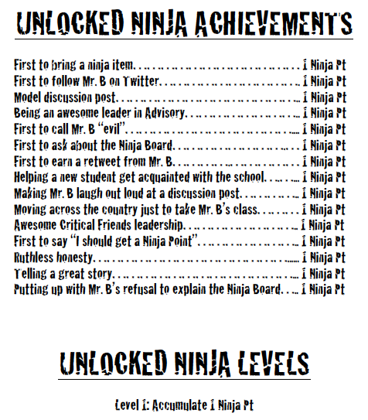
In all honesty, only about one or two of these "achievements" were pre-planned. The rest are being made up as I go. When I notice my students doing something really awesome, like demonstrating leadership or kindness, that kind of thing deserves ninja points. If I have one of those little student/teacher "moments" where we're building or supporting good rapport, I give ninja points for those, too. To keep my students on their toes (and partly to include those students who are traditionally the "invisible" ones), I also award ninja points for other random things.
It seems to add a certain whimsy to our classroom culture that I particularly enjoy. I'm curious to see how the Ninja Board will continue to play out in week two.
Incidentally, there's much more about the Ninja Board that I haven't revealed yet on this blog -- but that can wait for another time.
***

Waiting for Gratitude: a reflection on pink slip day (or, Beware the Ides of March)
@CheesemonkeySF 3/15
I got my pink slip early this year, and I'm finding that waiting for gratitude is a bit like waiting for Godot. But my dharma practice teaches me that waiting is just another word for trying to find a doctor's note that will excuse me from this human experience of groundlessness.
So as long as I keep waking up early anyway, I've been getting my butt out of bed and onto the couch to do writing practice on how this particular episode of groundlessness really feels -- trying to capture on the page what I am experiencing as I keep running out of runway.
Wile E. Coyote is my patron saint of groundlessness. I keep an enameled pendant depicting him hanging over my desk. He is nose-down, hanging by his left foot, having chased the Road Runner over the cliff yet again.
Like me, he really ought to know better, but he is a slow study. Like me, each time it happens, he looks out at the camera and blinks twice, before he crashes to the canyon bottom.
The hardest part of today was the fact that my students remained so bloody happy to see me and to spend time with me. My Algebra students wanted to wrestle with factoring nonmonic quadratic trinomials, while my English students wanted to brainstorm on their "Product of the Future" ideas for our science fiction unit. Being eighth-graders, most of their ideas for outstanding products of the future revolved around bathroom components, clothing/shoe/makeup accessories, or variations on teleporting devices.
My only product idea was for a Recess-Extender -- one that would stop time and allow me to take a nap during recess after I bolt my yogurt.
The best part of today was doing math with students -- finding patterns as we factored nonmonic quadratic trinomials, and saying "nonmonic quadratic trinomials." They love the words of mathematics, as much as the language of algebra. Anything they can use to stun their parents at the dinner table is a good day's work.
At the end of class in English (as we were cleaning up from the product of the future brainstorming), two of my 8th-graders who are in Geometry asked me about a problem they were struggling with. For about three minutes, I lost myself in the Pythagorean Theorem and in wondering how -- or whether -- we could prove that the area of the black region of a hexagon was equal to the white region of the hexagon.
This led to a quick discussion about equality, equivalence, and proof. And that made me feel sad as I remembered that I had just been laid off.
***

Commentary

Mystery Teacher Theatre 2000
John 6/18
Welcome to our first episode. Recently, in the halls of School University, some teachers attempted some selfdirected professional development, encouraged by their principal and given hope by Sal Khan, a man described as "Bill Gate's favorite teacher" (from a TED endorsement), "very popular," "extremely popular," "an educational revolutionary," and being like "like a nerdy, South Asian-American Seinfeld." (I'm not making any of those up. The last is from Wired.)
Here's what happened.
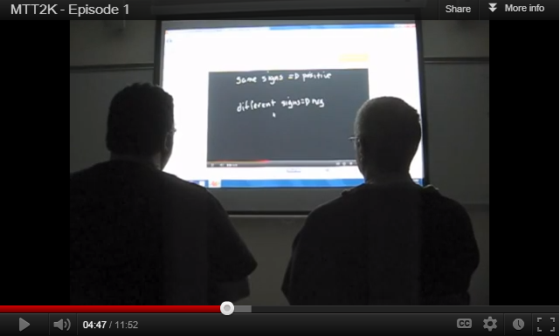
(http://youtu.be/hC0MV843_Ng)
So, obviously, as comedy improv actors we're a couple of math teachers.
We're very interested in your comments. What do you think of this video? Of the teaching? What did we miss in our commentary?
Dave was the instigator here, but is too smart to put it up at Deltascape.
***

White Paper on Problem Solving: The Why
Michael 8/22
I'm putting together a short series of posts on problem-solving to get myself ready for the new year. In particular, there are a bunch of changes that I want to make in my classroom and I want to make sure those are properly justified and motivated.
But first, look at this cat:
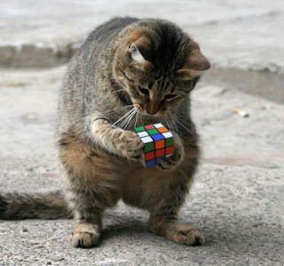
Such beautiful creatures. But they'll burn you if you're not careful. Anyway,
What do I mean by “problem solving”?
For me it means that students are regularly asked to make progress on questions that they have never been told how to answer. This isn’t an air-tight definition, but it will do for now.
Why?
There are a lot of supposed benefits of a problem-solving approach to learning math. Here are a few that come to mind:
- It’s truer to the work that mathematicians do
- It’s more fun for students
- It develops habits of mind that are transferable
I think I agree with the first two ideas, and I’m skeptical of the third, but that's all sort of beside the point. My core responsibility in the classroom is to teach these kids a bunch of skills and concepts in a way that compares favorably to the way they’re learning them next door. If the most effective way to teach is lecturing and drilling, I will teach that way, even if it’s boring and unlike the way that mathematicians work.
The good news is that fun, truth and effective learning coincide in this case. I think.
I want my students to solve difficult problems in class because I believe it’s the most effective way for them to learn and remember the content. Here are my pedagogical assumptions:
- Difficult tasks help organize knowledge: When a person is faced with a difficult task, they search their memory for a way to accomplish the task. They think about the tools that they have and how well they fit the task at hand. This search reinforces a person’s understanding of their tools and how they are used. In math, the tools are the sorts of things we want kids to know: procedures, skills, concepts and habits of mind.
- Organization takes the form of connections between topics: It's a pretty solid result that novices organize knowledge by topic, and experts organize them by their underlying structure. A difficult problem doesn’t cue students into the tools that they’ll need to use, and so anything might be relevant. As students attempt difficult problems they need to start organizing what they know into more useful clusters than “first semester” or “lines stuff.” Instead, when presented with an equation they’ll start thinking about what tools they have for solving equations. When presented with a challenging proof they’ll need to think about other problems that they’ve proven in the past and decide which ones are relevant for the current puzzle.
- Students will fail often: Some studies have shown thatknowledge sticks better after a person has taken a difficult test and failed. This makes a certain amount of sense – the brain is most attentive when we know we’re missing something. The right answers come in a problem-solving class, but they will always follow failure.
- Different approaches invite justification: It’s helpful for learning to have different approaches to discuss. Multiple approaches create the need for explanation, and explanation and justification also help students organize and remember their mathematical knowledge. When solving a good problem, students will almost never have just one approach. The teacher can skillfully select multiple approaches to bring to the fore.
- The mind remembers stories very well: "If you want to make something memorable, you first have to make it meaningful." But how do you make it meaningful? Stories that connect with the rest of the things that you know can do this. As Dan Meyer has put it, good math stories come in three acts. First comes the hook, where the problem is posed. Then comes the development, where students struggle with the math and run into trouble. Then comes the resolution, which we might talk about as a whole group, or students might discover on their own. The daily story telling comes easily: “Today we tried to do this, and we ran into trouble. Then we discovered X, and then we were able to solve the problem. But what about Y? See you guys tomorrow.”

These are the things that I think are true. Where possible, I’ve pointed to evidence supporting my assumptions. But they’re empirical assumptions, and I’d feel better if I had more evidence supporting them. Where did I go wrong? Lemme know in the comments.
Coming up in this series I'll point to things that I was doing wrong last year and how I think that I can fix them.
***

Panel Remarks: Why Algebra Matters And How Technology Can Help
Dan 2/9
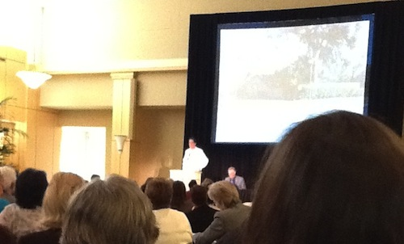
2012 Feb 21. They uploaded video of the event. My remarks begin at 30:26 in this video.

I was a panelist at Middle Grades Math: Why Algebra Matters and How Technology Can Help, a conference at Stanford co-sponsored by Policy Analysis for California Education, NewSchools Venture Fund and Silicon Valley Education Fund. (I know. Awkward, right.)
The following are my introductory remarks and responses to two questions.
Introductory Remarks

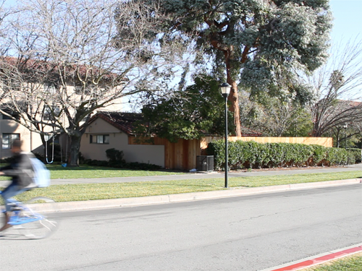
I could ask you how tall do you think that lamppost is. Just give a guess. I could ask you for a guess you know is too low. Too high. A wrong answer, if you will.
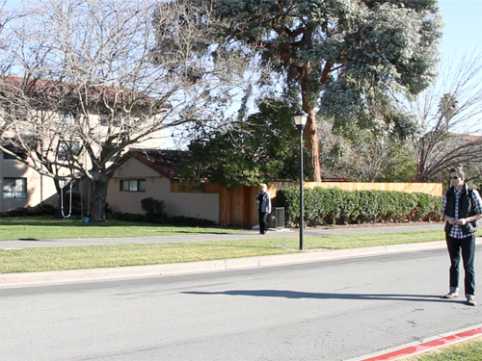
I could then ask you what triangles do you see on this image now. How many? What types? Where are they?
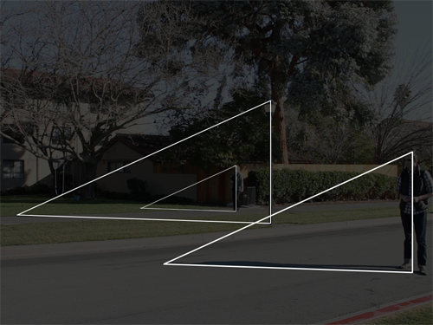
And once you point out certain triangles that you see, I could ask you, "Do you notice anything special about those triangles? Are they just arbitrary, random triangles drawn here or there?"
"No, there's something special about them," you tell me. "They're mathematically similar-looking."
And I could ask you, "How do you know that? Could you help me prove that?" And we know that if you have two angles that are the same in two different triangles, they are mathematically similar. "What two angles in each of those triangles are the same? Can you help me with that?"
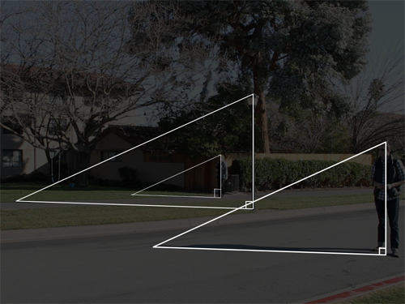
And you might point out to me that all of these angles are the same. In fact they're all ninety degrees. Because, you tell me, we're all standing perpendicular to the ground. Even the lamppost is.
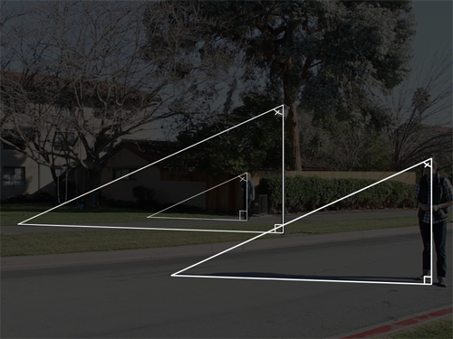
You could point out that these angles are the same.
"Why?"
"Because the sun's rays all strike us at the same angle because we're all in more or less in the same spot."
So we have these similar triangles. And I could ask you, "What parts of these triangles are easier to measure than others?"
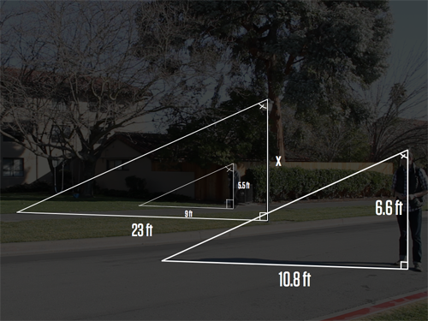
And we could have that conversation. You might point out that our heights are all known, except the lamppost's. And our shadows are all fairly easily measured. And at this point, you could solve for that unknown height.
We've just gone from the concrete —
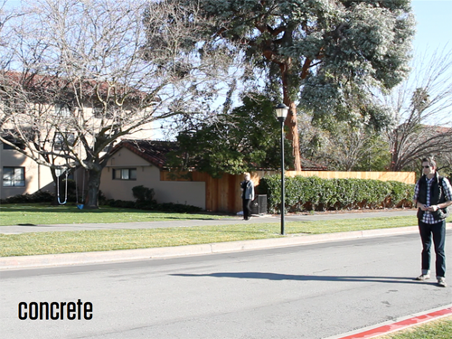
— to the very, very abstract.
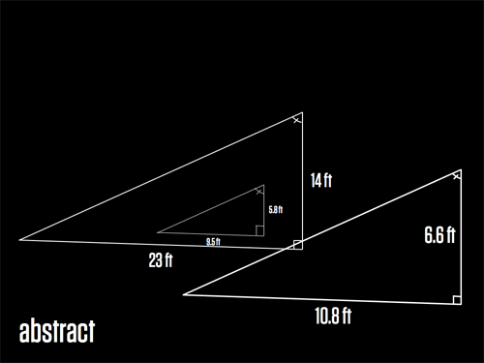
— you and me — in this process called mathematical abstraction where we formalize the informal. It's a process that is invaluable to our students, something that mathematicians do all the time. It's engaging to students and it's accessible to students at every level.
If I could think of one way to restrict access to math to the already-haves and close it off from the have-nots, I could do no better than to rush as quickly as possible to the highest level of abstraction as possible on this scene. And that's, of course, how we see this problem in even highly regarded textbooks.
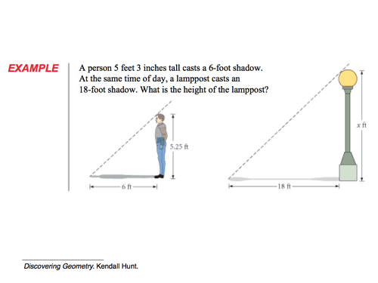
Like right here. I can't ask you, "What triangles do you see?" Those triangles have already been abstracted.
I can't ask you, "What information is easiest to gather here?" It's already there.
The problem, as I perceive it, is print. The process that we went through, stepping that out gradually, required ten extra slides in a slidedeck. That cost me a few bits and bytes on a hard drive. It's nothing. But ten extra printed pages in a textbook. That's very expensive.
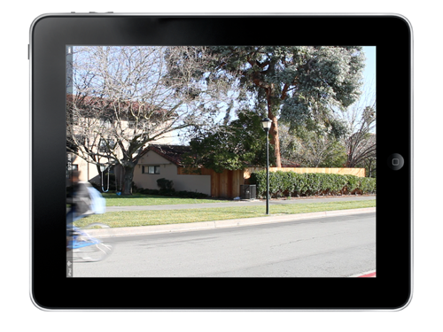
So I'm here today very optimistic about digital curricula and its ability to open that process of abstraction up to all of our students.
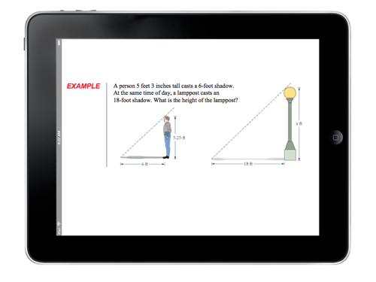
That's not to say this process couldn't go horribly, horribly wrong.
So I just want to point out here, to close it up and turn it over to you guys, that print is a medium. Same as digital photos. Same as a teacher's voice. Same as a YouTube video. Same as a podcast. These are all different media. And as we know, the medium is the message. The medium defines and constrains and sometimes distorts the message. The math that can be conveyed in a YouTube video is not the same math that can be conveyed in a digital photo or a podcast or a print textbook.
We're so enthusiastic here in the Silicon Valley and in this group about technology that disrupts and scales but I think it's really important to point out here the fundamental misapprehension of this whole process of technology that we have is that there is one monolithic "mathematics" and we are all just innovating around "mathematics." But those innovations distort what mathematics is. That's the ball that I urge us all to keep our eye on today. I'm really excited to be here and tease apart those issues with you and take some questions. Thank you.
How will the Common Core Standards paired with the computer assisted adaptive assessments that are envisioned by the Smarter Balanced Consortia change or disrupt middle grades mathematics?
Yeah, I like the Smarter Balanced assessment items, particularly their printed items. And that's kind of controversial to say, I guess, at a tech conference. But the stuff you can assess online is just different. Someone I admire says, "the computer is not the natural medium for mathematics." Not yet. There's no natural language processing. You can't easily grade automatically and adapt to a written argument the student makes about some figures he says are similar, for instance. So that's stuff that I would feel sad to lose in our hurry to get to computer adaptive testing.
What kind of support are teachers and schools going to need to transition to Common Core, to make the changes in middle school math? Should the state be providing some support? Should county offices or foundations be providing that support?
Most of the PD that I underwent as a teacher stayed very close to content. It was one or two degrees from how you teach content and, now that we have these practices in the Common Core, that opens up an entirely new PD challenge. The most effective PD I've facilitated — and I've facilitated some very ineffective PD, I'll admit that — the effective stuff has always included a large component where we do the practices. Because I think if you've taught for thirty years under a particular style of teaching, it has to distort what your perception is of math and how it should be taught. It's unavoidable, to be steeped in that for so long. So to realign yourself, I imagine, is a very difficult thing. So PD that involves problem solving, involves reasoning, argumentation, that'll be essential going forward.
Also:
- Key Curriculum Press asks, "Where were the women?"
- Jason Buell follows the money.
Photo by Jason Buell
***

Be the 'student' at 101qs.com
Andrew 5/11
*Disclaimer: I’m not a professional cinematographer! I haven't taken any film lessons! I consider myself a novice with film editing. However, I'm passionate. I want to improve my craft with film almost as much as improving my craft of teaching!
Dan Meyer was kind enough to invite me to the beta testing of 101qs.com after seeing my Fake Money - Act 1.
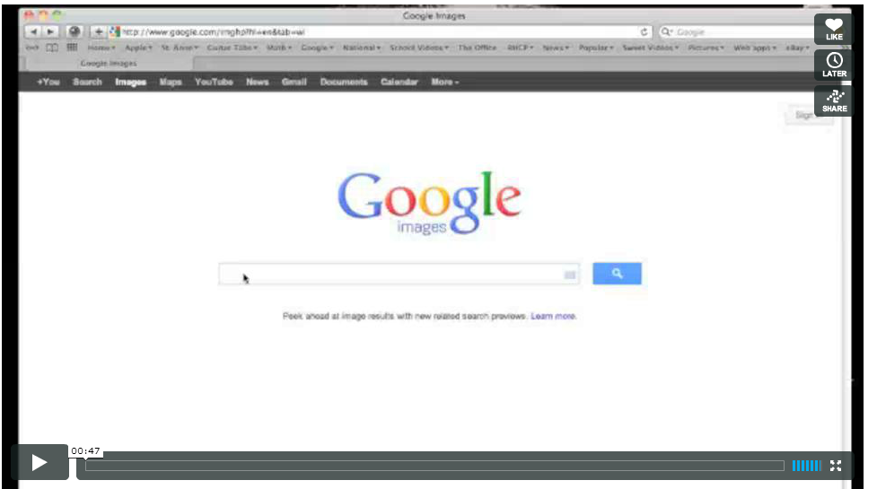
http://vimeo.com/38285683
I was both flattered an honored that he dug my exponential growth video and wanted to include me in the beta testing before his site went live. One of the best pieces of advice Dan gave me was, "Buy yourself a tripod for Christmas, Andrew." His feedback from Sand Vase - Act 1. I totally agreed with him and didn't wait for Santa. A tripod makes the experience much easier on the viewer. Plus, no matter how perplexing you might think your tire rolling down a hill is, you run the risk of losing your audience from a shaky camera or poor camera work. (Hits forehead with palm, D'oh)
Look, I've read many blogs and comments that challenge Dan's objective with 101qs, the perplexity rating, the lack of comments/feedback, the initial question versus the discussion, and on and on. My objective here is not to rehash any of that. Hands down! It's a solid site and beneficial to us teachers! Embrace its ingenuity! My goal is to offer some observations and advice that might contribute to making the viewing experience even better for you and your students. Here's how:
- Have measurable acts.
- Be the 'student' during both the staging and viewing portions.
- Have fun!

Make sure it's measurable:
I've thrown some pics up on 101qs.com, but they were flops because it's not measurable or epic. I can discuss it with my class, but that's it. If we can't measure it, we're done. Maybe we can create a small scale project, but that could detract from the amazement of the initial media. John Golden's Largest Land Vehicle in the World pic is epic. But how do you measure it? I don't have a giant earth mutating blade in my backyard. Do you? However, one of my all-time favs is Nathan Kraft's Tuba Echo. There are definitely some measurable parts here. Plus, it's really simple!

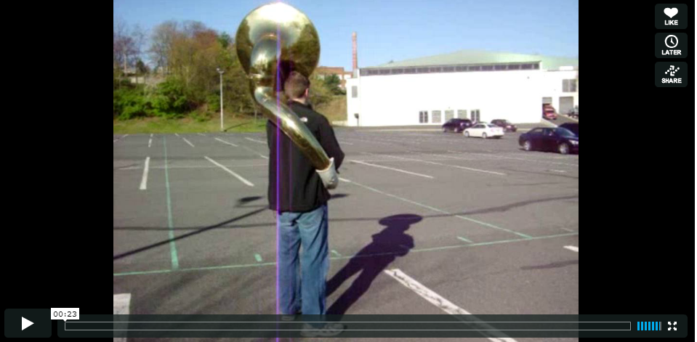
http://vimeo.com/40377128

Be the 'student':
Before pressing record or taking a plethora of pictures. Before sitting down to create, to plan, or to stage your first act, stop and think as a 'student'. Be every student you have! Be the die-hard learner. Be the mediocre student who goes with the majority. Be the smart-aleck kid who loves any opening for a joke or wise comment. Get some candles, some incense, channel them all... okay you get the point! Let the 'student' critique, trash, beat up, and make fun of your mere idea! Take the rose-colored glasses off.
This doesn't count for off-the-cusp pictures you can take with a digital camera while experiencing some majestical moment on vacation. However, be the 'student' before uploading said pictures. Would this really be something a student would be interested in, be perplexed by, have a question about, wonder about? Be honest. Your student doesn't necessarily think like you. Amazement and perplexity are two different things.
*My goal is to allow my classes to experience 101qs.com next week and see what they think. Seeing other teachers do this inspired me.
Staging:
Face it, we have a demographic. When staging your videos or pictures, keep students in mind; your students, my students, someone else's students. Sit in their desk, put their glasses on, be your demographic. Sorry John Hanks, is your Dirt really going to interest your students? Maybe yours. It wouldn't perplex mine. What might be perplexing for you or the general majority of the users of 101qs.com is not necessarily perplexing for yourstudent. So how do you effectively stage an act? I'm going to use Chris Hunter's Big Box o' Krispies. It's my new favorite.
I think the intended question was 'how many?' Hence all the skips. Longtime users are for the most part...done with 'how many?' But c'mon, they're Rice Krispies! SNAP! CRACKLE! POP! Think outside the box here (I can't pass up a good pun!) I'm going for another audio clip here, "How loud would the Snap Crackle Pop be if they were poured into a barrel of milk?" Can you imagine that? If I had a box that big, here's how I'd stage it:
Use a tripod, put a small bowl on a table, pour some Krispies in, and then pour in some milk. Record the audio up close. Cut to a picture of a barrel, a few or many gallons of milk, and the huge box of Rice Krispies. Cut. Act 1!
Think about the sequel? If it's not loud enough, how much cereal should we add? How quickly? What type of milk will yield the loudest response? How much longer will the barrel snap crackle pop compared to the bowl? What's the perfect ratio of milk to cereal for the highest decibel? Maybe invest in a decibel meter? You can still cover your volume question and more... I love it! So what about the 101qs.com viewing experience?
Viewing:
When viewing the uploads on 101qs.com, think like a 'student'. Sometimes the expected questions are staring you in the face. I've commented to Dan that some users are abusing their power with the 'Skip' button, but I respect their autonomy. I can't force or coerce a student into what I think is perplexing so I'm not going to bash a 101qs.com user. However, I would encourage that user or student to still offer some feedback. Why is this boring? Why did you press 'skip'? I don't care if I'm on the top ten (no, that's not loser talk). I don't. I care that I hit my intended mark. I care that I get constructive feedback from a flop and improve upon it. I care that my students are perplexed. Lastly, I believe I can offer feedback to those on 101qs.com if I pretend to be that smart-aleck kid in your class. Perplexity in math is a natural component of classroom management. If you can't engage me, the smart-aleck, I'm cracking jokes and off-task. Here's how I'd make Abbie's Oatmeal slightly more student friendly. There's too much text. Students don't want to read much or dig through text after they've become accustomed to you showing them epic pictures. Crop this picture. Zoom in on what you want the student to question. I almost skipped this, but offered Abbie some feedback because this picture has great potential.
Have fun:
If you're not having fun, your students aren't having fun. It was fun to put Post-Its on a huge File Cabinet. The students had fun making estimates. They had fun writing the numbers on the Post-Its. They had fun doing the math to figure out the actual number. They wanted to know how many Post-Its to write numbers on. I said, "You tell me." They didn't blink. They took ownership of both the writing of numbers and the math. Keep these fun moments in mind when you are channeling the student. If it's fun for them, it'll be fun for you while you plan, stage, record, and edit your media.
Have fun,
222
***

What to Do with All the Technologies
Kate 3/29
Among people who know me professionally I have a bit of a reputation as a technology person. It might be because when people walk by my room, there's usually laptops and calculators all over the place. Or it might be because I put it all over my CV because people like that sort of thing. Or it might be my third robotic arm. Who knows.
But when people talk to me about the technology I have to constantly Reframe the Issue and explain how I'm not all pro any technology for its own sake. You don't go, "Oh here's this cool technology let me shoehorn it into my classroom." Instead you go, "I think I have thought of the best way to teach this, and it would be impossible in an analog world, but I know enough about the technologies to realize this idea." You don't go to a twenty-minute inservice about xyz.com and go "I'm going to make an xyz.com lesson." You use xyz.com for your own purposes, or you suspect its utility and put it in your back pocket, until your awesome instruction idea needs xyz.com in order to exist. Your lesson is the fuel and xyz.com is the oxygen.
So here is a lesson that would not exist without dynamic geometry software and classroom polling. It does not matter what sort of dynamic geometry software. I've done it with Sketchpad and I've done it with Nspire and next year I'll probably do it with Geogebra (damn, that sentence makes me sound disreputablllllle.) But I don't think you could get the same effect without the technology. Maybe you could give them diagrams on paper and rulers and protractors, but there's no way to make those not static, even if there's a lot of them.
We are discovering additional properties of special kinds of parallelograms. So everyone starts with a sketch of a parallelogram (that you give them, or in our case, that we constructed the day before.) And the children are in groups. Each group gets a different set of questions to explore. Writing these exploration-y questions is a bit of a dark art. You don't want to send them on a chase of the wild-goose variety but you don't want to set them down too much of a pre-defined path either.

Example: Group 1. Start with your sketch of a parallelogram. Construct both diagonals. Drag points around until the diagonals are perpendicular to each other. You will have to decide what to measure so you can be sure. What is the name of the special kind of parallelogram you get as a result of perpendicular diagonals? Now you need to find at least two NEW properties of this shape. They must be NEW properties that are NOT properties of any old parallelogram. You will have to measure some stuff. If you can't find two new properties, keep staring at it until you get a good idea. Write them down. Verify them with measurements. See if your group members agree. Drag vertices to make a different parallelogram where the diagonals are still perpendicular. Are your new properties still true? Challenge: It is possible to construct a quadrilateral with perpendicular diagonals that is NOT a parallelogram. Open a new page and construct such a shape. What other properties does it have?

They get ten or so minutes to play around. It is helpful to give them some verbal marginally-hysterical (at least in my case, they always feel slightly deranged) instructions like "It is not a square! Nobody has squares! The correct answer to any question is not "square!"" and you also need to run around like a crazy person and make sure everyone knows how to grab points and drag them around (you might as well admit that screaming about rhombuses to a roomful of 15 year olds makes you a little bit of a crazy person.) Because you KNOW there are at least three maybe four kids who try one thing for half a second and it doesn't work and then they will sit there and stare at their desk for twenty minutes unless you interrupt that little party.
Once they have had ample time to explore, and the faster workers are getting bogged down in the challenge questions you put at the end, you ask them to respond. I have queried each group verbally in front of the class, one by one, and that doesn't work so hot. Usually in a class of 30+ hardly anybody likes to talk in front of everybody. Better... send them a link to a Google Form where they can type an answer to each question. Or come up with your own response system that your existing tech will support. This year I used TI Navigator polls. They are annoying because the TI's don't have a qwerty keyboard. (Lesson number 9,125,698 learned the hard way.)
Once all the groups have had a chance to report by whatever method, then you write down your notes of properties of rhombuses and rectangles. And then you give them a bunch of problems to find missing measurements in rhombuses and rectangles. They can reason it out now. You don't have to show them example problems first. It feels like kind of a magic trick.
THAT's what the technology is for.
***

Doing Mathematics: The Trouble With Assessment
Bryan 3/9
The closer my pedagogy gets to supporting students in "doing mathematics," the more difficult it becomes to decide what assessment and grades should look like. The shift to doing mathematics means that you aren't looking for students to replicate processes and demonstrate their acquisition of new "knowledge." Instead, you are looking for their development in thinking mathematically - in reasoning and sense making. This is particularly difficult in the
K-12 public education system where, in many ways, we are forced to do our best in supporting students in "doing mathematics" through a variety of predetermined concepts to be explored.
It seems to make sense to me that in order to assess mathematical thinking, you would have to 1. determine the habits that comprise mathematical thinking, 2. have some sort of feedback system to assist students in developing those habits, and 3. figure out some way of measuring student progress in each.
At the moment, I have been toying with the idea of having students contribute to a semester/year long portfolio. The portfolio would be based around the habits of a mathematician, with a divider/section for each one. As we progress through the year, students would complete reflections on works of their choice and file them in the appropriate section. At the end of the semester/year, each student would evaluate their portfolio and present or reflect on their growth.
A few questions:
1. Am I even on the right track here?
2. How would this portfolio system correlate to a grade?
3. Does this system support students and give them enough feedback on how they can develop/improve/progress?
P.S. I just had another thought…what does a "unit test" implicitly tell students about what is valued/looked for in class?
***

HABITS OF A MATHEMATICIAN: Portfolio Assessment
Bryan 5/7
I've written about this "Habits of a Mathematician" Portfolio system before, but I have done some work on it and wanted to post on my updated version. I really want the Habits of a Mathematician to be the centerpiece of ALL that we do in class next year. In my opinion, they really get at what it means to be "doing mathematics" and are useful in helping reinvest in students a sense of agency and authority that is sometimes lost in the mathematics classroom. Of course, some content "knowledge" (I write that with some hesitation) will be an outgrowth of our work on problem-based units, but I'm leaning (heavily) towards not testing or hoping for "mastery" of any of that (the content knowledge piece is a bigger philosophical argument, which you can read about in a previous post).

The Portfolio System
At the beginning of the year, each student will purchase a 3-ring binder with 12 dividers. Each divider will represent one of the 11 "Habits" and the last section will be for "Unit Packets" (all of the other work). Students will have requirements weekly, at the end of each unit, and at every third of the semester. Here is what I am thinking for each:
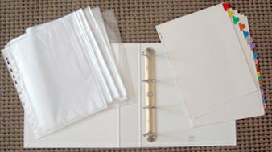

Weekly
At the end of each week, students will select one piece of work that they feel best demonstrates one of the "Habits of a Mathematician." They will fill out this reflection sheet (see below) and will submit it to me. I will provide short feedback on the sheet and hand it back to them. After reviewing the feedback, the student will submit that work to the appropriate section in their portfolio.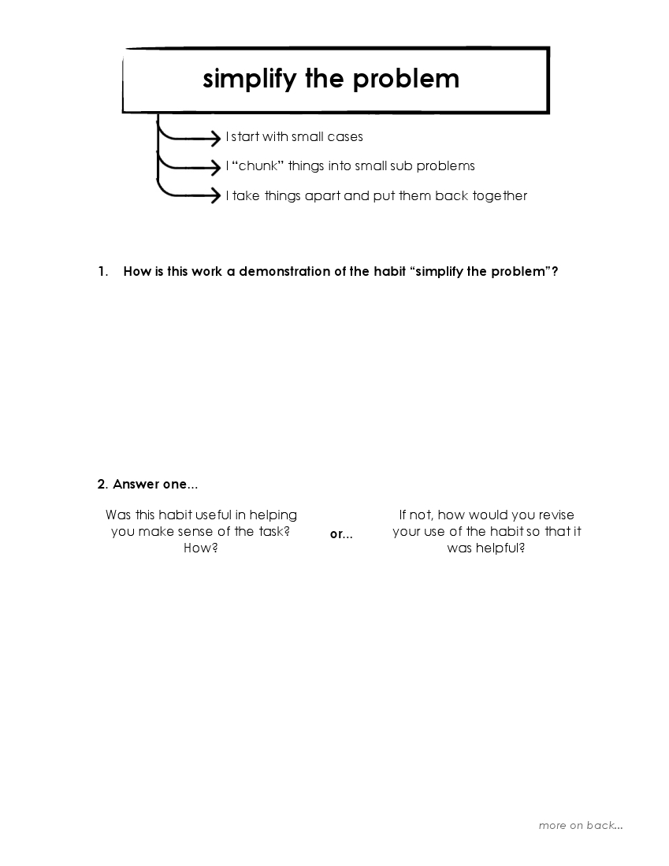



End of Unit
At the end of each unit, students will put together all of their work from that unit (excluding the work that has been submitted as "habit" exemplars). They will complete a unit checklist and write a cover letter for their packet that summarizes the mathematical themes for that unit.

Three Times a Semester
Each student will have a "critical friend;" someone who they work closely with in evaluating their work and their progress. At each 1/3 mark in the semester, students will have their portfolio reviewed by their critical friend, by their parent, by me, and by themselves. With all of this in mind, students evaluate where they are at with the "habits" and set specific goals about how they want to progress.

Grading
I would love for this to be a grade-less system. My students tell me "the world is not ready for that yet." I can't see how it could be done any other way. My thoughts at this point are that grades would only be given at the end of each semester. Student grades would be decided on by the individual student based on feedback from their critical friend, their parent, and me. Mostly, I imagine their grade to be a representation of their progress toward their specific goals set for themselves.
I'm beginning to like this system a lot. What we assess in our classes says a lot to students about what is valued and I think this system more clearly shows students that math is about "doing" and not about "knowing." I worry a little bit about parent concerns but I'm not sure that should stop us from pushing the boundaries and redefining grading. The system is still evolving and I would love any feedback or suggestions you have.
***

Keep It Simple Standards-Based Grading
Frank 8/23
Keep It Simple Standards-Based Grading (K.I.S.SBG.)
This post will probably raise the ire of SBG purists. If you are considering switching to SBG, I say go for it. Even if it means you keep it simple the first year, as you and your students figure it all out for the first time. Here’s my K.I.S.SBG. story…
Last spring, I taught a section of conceptual chemistry. Brand new subject for me. To make my life easier, I initially told the students that I would be using the same points-based grading system as their teacher from the fall semester.
And then I sat down to grade their first quiz.
How many points was each question worth? Should some questions be worth more than others? How many points in total? How should I give partial credit? And how is any of this providing helpful feedback to students?
All those questions made it clear: I couldn’t go back to a points-system. It just didn’t make sense to me anymore. So I decided to go SBG, but with a few caveats to keep everyone sane. This is how it ended up looking:
A set of ~5 standards per unit. WHY: This seems to get at the right scope–not too granular, not too broad. Of course, some units had a few more standards, others a few less. Keep it simple.
Each standard was graded binary YES/NO. WHY: Prevents point-grubbing from students. No need to deal with questions like, “Why did she get a 3 on that standard while I only got 2?” Either the student met the standard or they didn’t. Keep it simple.
Standards that are YES cannot go back down. WHY: Prevents students from perceiving this new grading system as unfair. This can save you many headaches, frantic emails from students, and phone calls from parents. Keep it simple.
Term grade = 50 + 50*(#YES/#TOTAL). WHY: No need to worry about conjunctive grading systems, decaying averages, or tiered standards. Kids can quickly and easily calculate their grade. Keep it simple.
No student-initiated reassessments. WHY: This actually wasn’t my rule, but I was lucky if these students showed up to class in the first place. No one came to extra help or during a free period to reassess. So I just put the most missed standards on subsequent quizzes. It worked out fine and I didn’t have kids hounding me for reassessments when the term ended. Keep it simple.
I didn’t write the standards on each quiz, but put them on a separate scoring sheet (see below). As I looked over the quiz, I marked “✔” or “X” for each standard.
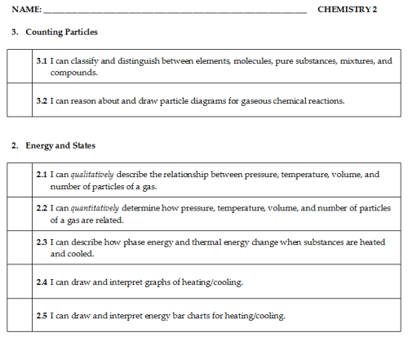
When I finished marking all the quizzes, I used the score sheets to transfer the grades into ActiveGrade.
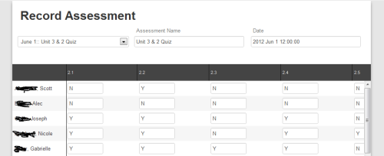
After all the scores were entered, I printed a current grade report for each student. I stapled together the quiz, the score sheet, and the grade report so each student would know where they stood when I returned the quizzes. That way, if the score sheet showed that student “went down” in a standard they previously had correct, they were reassured by the grade report that the YES grade from a previous quiz remained on record. No worrying about logging into ActiveGrade after school or during class. Keep it simple for the student.
At the end of each term was one final quiz to show understanding any unattained standards.
One final bit of advice: If you still want to grade HW, binder organization, class participation, etc, go right ahead. The best part of SBG, in my opinion, is that it gives multiple chances to be successful, gives better feedback about what students can/cannot do, and forces the teacher to spiral the curriculum to enable reassessment. I don’t want you to forgo all those SBG benefits because you still feel uneasy about giving up grading HW completion. Baby steps, baby steps.
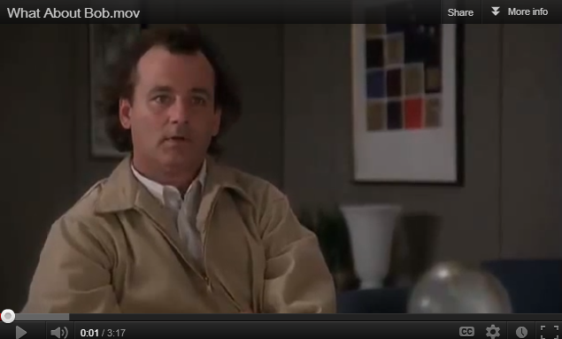
(http://youtu.be/ncFCdCjBqcE)
Could my system have been better? Sure. But don’t let perfect be the enemy of good. You can tweak and modify next year. Keep it simple, and just do it.
***

We must get rid of Algebra because Roger C. Schank can’t behave at parties, knows weird mathematicians.
Geoff 8/28
When Andrew Hacker wrote his “Is Algebra Necessary” article I was basically like
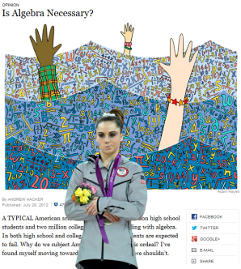
But at least it was well written and brought up some good points about math instruction, many of which math instructors actually agree with. Hacker had a fresh opinion and voiced it in the Grey Lady, which generated a nice back and forth between educational philosophers and math teachers.
Then yesterday, Valerie Strauss decided that Roger C. Shank should throw in a few hundred words in her column space that basically amounted to “ditto, Andrew!” in maybe the most mailed-in piece of writing I’ve seen since that NY Times piece where Tom Friedman rides with a cabbie and learns things. However, being so terrible and so mailed-in, it’s not really worthy of a proper rebuttal. It is definitely worthy of a Fire Joe Morgan style treatment, though.
===============================

No, algebra isn’t necessary — and yes, STEM is overrated
This was written by Roger C. Schank, a cognitive scientist, artificial intelligence theorist, and education reformer.
Thank God. For a moment I thought we’d have some math education expertise added to the conversation. And I’m not totally sure any of these things are actual disciplines. Do I have to include the “C” in Roger C. Schank? So many questions.
Schank wrote this in response to a recent post I published by University of Virginia cognitive scientist Daniel Willingham entitled, “Yes, algebra is necessary.” Willingham was himself writing in response to a New York Times op-ed, “Is Algebra Necessary?” by Andrew Hacker.
Does that make this a response to the response to the response? I’m getting confused. I bet cognitive science can save me from my confusion.
Whenever I meet anyone who wants to talk about education, I immediately ask them to tell me the quadratic equation.
You are a liar. Either that or the Worst Party Guest in History. I’m picturing that conversation.
Party-goer: Hello. My daughter just started fourth grade.
Roger: CAN YOU TELL ME THE QUADRATIC EQUATION?
Party-goer: /checks to see if there’s a clear path to the exit.
I wonder if Roger also quizzes people he just met on other, cherry-picked singular content topics at parties.
Roger: WHAT’S OHM’S LAW? WHEN WAS THE BATTLE OF HASTINGS? DIAGRAM THIS SENTENCE FOR ME!
Almost no one ever can.
So some can? Yay!
(Even the former chairman of the College Board doesn’t know it). Yet, we all seem to believe that everyone must learn algebra.
Roger’s party friends and a guy who used to be at the College Board can’t name the Quadratic Equation when quizzed, therefore we must rid Algebra from our society. That’s some rock solid logic there. I can see why Roger has so many more degrees than I do. I would also like to propose to make several other eliminations from our society, based on things I don’t remember:
- Traffic Lights, because I don’t know the difference between a red-with-a-green-arrow and a green-with-a-green-arrow.
- Cats, because I can only name, like, three breeds.
- Magnets, because, well, you know.
Why this religious zeal over algebra? It helps students learn how to think, people claim. Really? Are mathematicians the best thinkers you know? I know plenty of them who can’t handle their own lives very well.
Meanwhile, every liberal arts major Roger has met all live in houses with three-car garages and summer in the Hamptons. Also, at this point I’d like to remind you that according to Roger’s bio, he’s an expert on artificial intelligence. I’m going to go ahead and throw out that that might not be the most well-assimilated community.
Reasoning mathematically is a nice skill but one that is not relevant to most of life. We reason about many things: parenting, marriage, careers, finances, business, politics. Do we learn how to reason about these things by learning algebra? The idea is absurd.
LOL if you think finances don’t include math. Or than you can get a job in business without knowing math.
Yet, we hear argument after argument about the need for more STEM education (pretending we don’t have lots of unemployed science PhDs).
Ha ha. Who’s pretending that? Roger might be the first person ever to lose an argument with a straw man that he created. Oh, and here’s an interview on NPR’s Marketplace where they discuss how business and science PhDs are having a much easier time finding a job than history PhDs. But, as you were saying.
Everyone must study chemistry, memorize plant phylla and do lots of trigonometry.
Gross! That stuff sounds TERRIBLE. “Do lots of trigonometry”! Ugh. So much trigonometry-doing!
The argument for algebra rests on the transfer from math to other areas of life, something that has never been proven despite the claims of people such as University of Virginia cognitive scientist Daniel Willingham.
Wait, we’re back on algebra now? I thought we were riffing on trigonometry. And phylla.
The defenders of the existing system love mathematics because it is easy to test and there can be test prep courses and state-wide tests and national tests and tests comparing us to other countries, all signifying nothing.
My God, I’m starting to think this entire article is a piece of performance art on how to build consistently more ridiculously straw man arguments one after another. Roger is building a Burning Man of straw man arguments, except instead of burning it to the ground at the end, he’ll quiz you on the periodic table to prove that Science is dumb. Who the hell loves mathematics because it yields more tests and test prep and makes the U.S. look like imbeciles? Who loves mathematics for that? (Answer: Roger’s straw man, that’s who).
It isn’t just mathematics that is the problem, of course. Why do we all learn to balance chemical equations or memorize homilies about U.S. history? Because back in 1892, the president of Harvard University designed curriculum and said that those subjects should be the basis for high school classes.
Any cognitive scientist worth his salt knows that it isn’t subjects like algebra or chemistry that matter. It is cognitive abilities that are important.
It is thinking that is important! Finally, we have the answer! We’re not teaching enough Thinking in school. I can’t wait to take Roger’s “Intro to Thinking” course. So much better than my previous course of “Algebra-where-you-don’t-think 101″.
You can live a productive and happy life without knowing anything about macroeconomics
If you read the last sentence of Roger’s blog post, he basically refutes this. Maybe. It’s hard to tell. At this point, I’m not sure if he’s writing it or it’s a computer algorithm spitting out attempts at truisms.
or trigonometry but you can’t function very well at all if you can’t make an accurate prediction or describe situations, or diagnose a problem, or evaluate a situation, person or object.
Oh my God. Please find me the math teacher that doesn’t want to foster those attributes in his or her students, then put me on the panel to help fire them. Because making predictions, describing situations, and problem solving are at the core of what math teachers do. I must admit, these fictional educators Roger creates in his mind DO sound awful.
The ability to reason from evidence really matters in life, the names of famous scientists and their accomplishments do not.
Dang, and I spent my entire teaching career having students memorize George Boole’s pets’ names.
We can teach people the skills they need if we allow them to choose what interests them and then teach them to predict, evaluate, diagnose, etc., within their area of interest. Teaching algebra and then hoping those skills will transfer to other areas of life is simply fantasy, a fantasy that makes our kids bored and miserable in school.


http://www.youtube.com/watch?feature=player_embedded&v=6V-gHfTAa4k

The average person never does abstract reasoning.
Um, Roger, have you met people? I’m starting to think you may not have ever met a person. It’s probably because you scared them off when you asked them to recite the state capitols right after you were introduced. Because I promise you, every person does abstract reasoning. Whether you’re explaining directions, making an argument, writing songs, drawing a schematic, describing a setting, or pretty much communicating with anyone, you’re abstracting. Talking is abstracting.
If abstract reasoning was so important,
It is!
we could teach courses in that.
We do! It’s called algebra! And geometry!
We need to begin teaching people to reason well enough to make sensible political and life choices. This is a very important idea in a democracy.
OK now I’m convinced Roger is just playing around with his artificial intelligence machine. Because this last line sounds like it was written by a computer algorithm. I figured it out! So it doesn’t pass the Turing test! Either that or it was written by a 6th grader trying to pass his end-of-course Geography essay by following the format that his teacher showed him.
[Thesis] [2-3 sentences] [Something about democracy]
It really was this last paragraph (read: two sentences) that was the impetus for this blog post. I mean, it’s one thing to be completely wrong about pretty much everything and to develop entire theses based on cherry-picked and irrelevant anecdotal data (people not being able to answer your Quadratic Equation question). But it’s another thing to just mail it in. I’m willing to bet I put more thought into the first paragraph of this blog post than Roger did for that whole column. I mean, “this [reason well enough to make sensible life choices] is an important idea in democracy”??? At least end it on something other than every middle school paper I ever wrote.
So, just to recap, Roger can’t find many people that remember the Quadratic Equation, and he knows some mathematicians who don’t totally have their lives together, something about abstract reasoning, something about democracy, therefore algebra as it exists in Roger’s head should be done away with. This is a terrible job of abstract reasoning. So congrats on proving that point?
Q.E.D
***

Homework is a Tool (Use it for Good, not Evil)
Marshall 12/4
I got into it pretty hardcore on Twitter a few days ago with John Spencer. Smart dude and certainly a much more accomplished blogger than I. But 140 characters was just not enough to express fully my counterpoint to his post, Ten Reasons to Get Rid of Homework (and Five Alternatives).
It started with this:
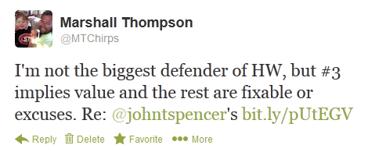
First of all, most of my argument revolves around a very simple idea. Homework is a tool. Used well, it's a tool that can be effective. It seems to be simplistic and irresponsible to arbitrarily throw a tool out.
But there are other parts of his argument that I strongly disagree with or am flat-out offended by. Foremost #3:
3. Inequitable Situation: I have some students who go home to parents that can provide additional support. I have others who go home and babysit younger siblings while their single parent works a second shift. I have some who don’t have adequate lighting, who constantly move and who lose electricity on a regular basis. Call those excuses if you want. I’ll call it systemic injustice instead.
Correct me if I'm wrong, but we as teachers should be trying to maximize learning for every student. To that end, we should exploit every advantage and learning opportunity we can find. Sure it sucks that some of our students have better parents than others. It sucks that some do not have support at home. It sucks it sucks it sucks. Royally pisses me off, actually.
But the way to remedy this isn't by neutralizing the advantages some have. It's by working hard to compensate for the privations of those lacking. Provide extra support for students and families. That's the way to maximize learning for all.
Now John would suggest that there are better ways: optional homework for parents that request it; voluntary project-based homework; optional extensions; provide workshops to parents who'd like to engage their children at home. Well I'm sorry these are great ideas but if you are eliminating homework in the name of equity, these undercut that argument.
I will thoroughly agree with John that homework is often poorly articulated and poorly targeted, and this can lead to a demotivating situation that erodes a natural desire to learn. But this is completely fixable through careful thought by practitioners. Fix it, don't throw it out.
Finally, John asserts that kids are busy and they need to play. True story. But kid or adult, we need to manage our time and priorities appropriately. Those students who prioritize poorly should be provided with support.
That's not to say kids should have mass quantities of homework every night. Play is important and valuable. All I'm saying is that the blanket elimination of homework is a simplistic solution to a complex problem.
***

What if we gave them the answers?
David 10/18
My experiment of teaching a course where preservice and inservice teachers share two hours of class time has been going well. (I introduced the concept here.) In fact, one of the preservice teachers said recently, "I wish all of my education classes had classroom teachers in them." I believe the following example explains why he feels that way.
That same preservice teacher was part of a small group (along with an inservice middle school math teacher and a community college instructor) who were analyzing middle school students' work on an algebra assessment. They were talking about how difficult it is to get students to share their thinking especially once they assume they have arrived at an answer. I concurred and explained that this was one of the reasons I focused on using metacognitive memoirs, saying, "I know the answer but I don't know what you're thinking." This gave the inservice middle school teacher an idea.
He wondered what would happen on the next test if he gave the answers and asked the students to focus on their thinking. A few days later, I (along with the preservice teacher and the community college instructor) received the following email:
Hi, I gave a test yesterday in my 8th grade math class and I gave them all of the correct answers at the beginning of the test to see if it would improve the work that they showed and how well they explained their thinking. They were shocked, but they actually caught onto the idea quickly, I didn't even have to tell them why I was giving them the answers, they came up with it themselves. While the test responses weren't perfect, students did a MUCH better job sharing their thinking than they ever have before. I am excited about how this turned out and I anticipate doing this more often in the future.
I asked the teacher if he would mind me sharing this experience and the test on my blog and he agreed. Not only that - he also provided how he implemented this new approach, a sample of students' work, and students feedback.
After handing out the test, the teacher began:
- Teacher: "Listen closely. This is a test. You know the rules as far as talking, etc."
- Teacher begins reading off answers.
- Students are following directions, no questioning until after the page flip.
- Student 1: “Why are you telling us all the answers?”
- Student 2: “I like this!”
- Student 3: “Don’t stop him.”
- Teacher keeps reading answers. There is no contesting of getting the answer and the kids keep filling in right answers for remainder of test.
- Student 4: “I don’t understand this...”
- Student 5: “Why did you just give us the answers?”
- Student 6: “Do we have to explain what we did for the answers you just gave us?”
- Teacher: “You’re not going to get any credit for having the right answers. You’re only going to get credit if you can explain how you get the right answers. So all of you are starting right now with all the answers and a 0%.”
- Student 4: “I like the other way better.”
- Teacher: “Let me just say one more time...You all have the right answers, so the explanations are where you can earn the points. With that in mind, go ahead.”
Here is what the test looked like after the teacher had read the answers.

And here are some examples of what students wrote:
After the test, the teacher asked for students' feedback on this approach to assessment. These represent some of their responses:
- "My head hurts because I actually had to think."
- "I realize now that I've never done a very good job explaining my answers."
- “This was like an English test!”
- “It took forever...like, I know what I want to say but I can’t explain it.”
- “Didn’t like volume of writing and repetition.” (Felt like there was too much writing and they were answering the same questions over and over.)
- “Didn’t see the point of giving out the answers because you have to do all that thinking to get the answer anyways.”
- “Liked it. I always spend time figuring out the problem so I don’t explain. This helped cut out the calculation step.”
- “Didn’t like because I don’t like explaining myself.”
- “Would have prefered to find answers instead of trying to explain because sometimes I can just get it (in my head).”
- “Liked having answers, otherwise I spend a lot of time trying to get the answer. This way I know the answer is right.”
I hope that I was able to adequately articulate this approach to assessing students' mathematical thinking. If you have questions or ideas, please leave them in the comments and I'll be sure to pass them along. We have 8 more weeks together in this course. I'm looking forward to whatever else they come up with in that time.
***

Stolen Pedagogy
Megan 11/15
Today marks my 6th Blogiversary. I started this thing documenting my daughter’s elementary years. These days, she’s concerned with AP Calc more than book reports. And I’m concerned with #globalmath more than her book reports. Ah, how times change.
One thing that hasn’t changed is that I’m still stealing your ideas. My classroom is a combination of all YOUR classrooms. I’ve taken your best ideas for several years now and shared mine (apparently Waterfall Trivia is still popular in some circles — you’re welcome!). That’s what we do in the best blogotwittosphere on Earth, right?
In the name of sharing my classroom with you guys, here are my top ideas taken from your blogs and your tweets.

Mailing Label Problems
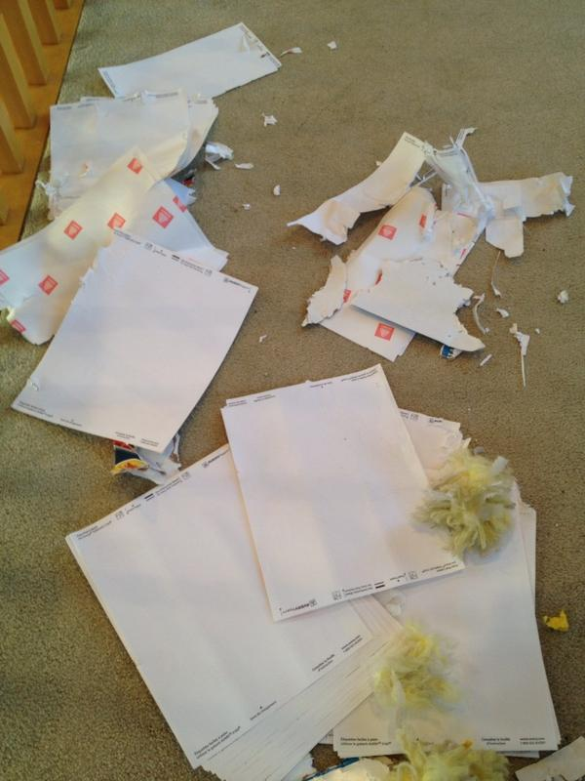
Fawn Nguyen (@fawnpnguyen) shared this photo of her puppy’s craftsmanship and I thought I was going to cry. Why was her loss of a box of Avery Mailing Labels so painful? The idea I stole from her was to put problems (or problem sets) on mailing labels. Fawn’s been using the labels to support her Standards Based Grading implementation:
this year I found the best use for the mailing labels with SBG. School is in full swing now and there are a lot of kids coming in at lunch time for retakes. Currently, and because this is our first year with SBG, we can only manage to assign selected questions from the textbook for reassessments. I either have to tell them what the problems are when they come in or give them a piece of paper that has the problems on it, then they have to copy all this information on notebook paper: section title, page number(s), and which exercises. Without this information, I can’t correct their papers.
I’m using her “old” idea to put problems on the labels. I give my kids a batch of 6 label problems, convenient because there are 30 on a sheet, for them to solve in their interactive notebooks.

Self-Feedbacked Quizzes
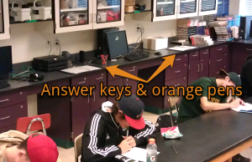
Frank Noschese posted a simple photo titled Quiz Day with some arrows drawn on it. Holy cow did that picture ever change my assessing life. Here are Frank’s words:
I set up stations with the answer key and orange pens on the counter around the room. When students were finished with the quiz, they brought their quiz to a station to check their work against the key and use the orange pens to leave themselves feedback directly on the quiz. Then they handed the quiz in to me. What I like about this: students give themselves the feedback they need and I get to see what that feedback looks like.
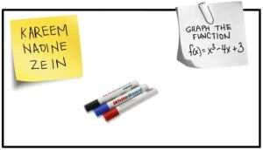
I still review everything on these quizzes, so it’s not proven a time-saver. Maybe I save a little time because I’m not hunting down the mistake a kid made in a long solution (and yeah, I’m a little in love with a circled term and the words “forgot to square distance”, cause dang! those can be hard to spot).

Whiteboard Groupings
Bowman’s idea to use stickies on whiteboards for class groupings makes the warmup time that much more efficient. I love the way the kids just know what to do when they walk in the room.

The Mistake Game
Before I ever talked with Bowman about whiteboards, Kelly taught me this whiteboarding game over at Physics! Blog!. Give kids a set of problems and time to work them. Then assign a problem to each group to post on the whiteboard. The catch: they have to hide a mistake that’s crucial to solving the problem. Their classmates later listen to the presentation and question their way to the mistake.
In my classes, we’re still improving our mistake-hiding and finding techniques.

Row Games
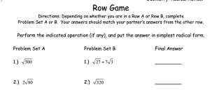
This is a great activity for the math teachers in the crowd and I used it a lot in my previous life as a math teacher.
Kate taught me about Row Games, where two people work two different problems (on a row) that have the same answer. I love me some self-checking work where kids cooperate rather than compete and boy howdy! is this ever one of them.

Now, Show Me Yours
Throw ‘em in the comments or (better!) share them at the next #globalmath My Favorite session. Shoot, the idea you share doesn’t even have to be yours so long as you attribute it.
Thanks, peeps, for listening, for stealing, for sharing. About our community, I like to say “We want to be better teachers. We share freely. We are always supportive.”
***

My 3 Favorite Math Whiteboarding Modes
Bowman 8/10

GOAL: develop frameworks and modes appropriate for MATH specific Whiteboarding.
I did a ton of experiments this year with whiteboarding and a lot of brainstorming, but here are my three favorite modes of math whiteboarding that I tried (some writing copied from previous posts). A good whiteboarding mode for me can be applied to many different topics and takes advantage of everything whiteboarding has to offer: collaborative, interactive, promotes risk taking and visually stimulating.
_____________________________________________________________
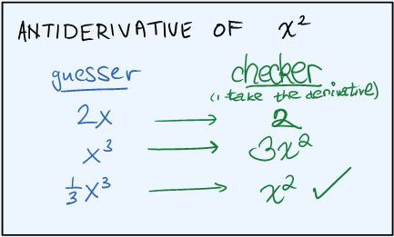
Guess and Check with a Partner

Students try to solve problems that take a certain amount of intuition or guesswork (like antiderivatives or factoring) by having one person write down a guess, and the other person check if it is correct.They would then keep doing this until they get a correct answer. After a certain number of problems solved, the two students switch roles. For example, above the students are looking for the antiderivative of – the guesser writes down and the checker takes its derivative to see if that is correct. Since does not equal , the guesser tries again. They continue this process until they finally get that back again. This mode is great for showing students that a great way to do math (at first) is to just try things and adjust their answer; it’s great for getting students to converse together about how to get a solution; and it’s great to get them in the habit of always checking their answers. I had a really hard time getting some students to follow the procedure for this one, but the ones that stuck to their roles got a lot out of it.
_____________________________________________________________

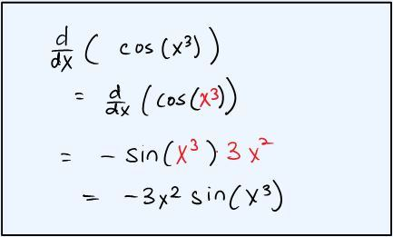
Color Coding Problems

Before solving a problem, students rewrite it using different colors to help them understand its important parts. For example, above is a whiteboarding exercise I did with the Chain Rule. Students were in groups of threes – for each problem, one person had to rewrite the problem in different colors to indicate which was the outside and which was the inside function, the next person had to differentiate it still using the colors to point out where each part of the new expression came from, and then the last person had to rewrite the expression in a simplified form. This was perfect because the hardest parts of the chain rule are recognizing when you need, seeing inside vs. outside and then seeing where the parts of the new expression come from.
_____________________________________________________________

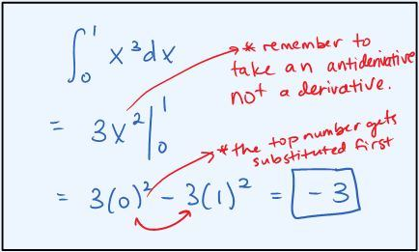
The Mistake Game

Groups present solutions to semi-complicated/involved problems on whiteboards, but while presenting their solution, they purposely make a mistake (and not an silly arithmetic mistake like - a real hardcore-misconception-style mistake). Then, they present their work to the other students in the class, trying to sell their mistake as having been made for real. Other students ask thoughtful questions about the presenting group’s solution to try to help everyone find the mistake. This is always great with a quick class followup at the end collecting the most common mistakes. Check out the Guide to the Mistake Game from Kelly O’Shea, who introduced me to this game.

P.S. I’m realizing now that the example above actually isn’t a great example of a time to use this game… Some topics that it worked well for this year were graph sketching, solving for limits algebraically, using the quotient rule, implicit differentiation, related rates and using infinite limits in graphing exponential functions.
***

Math as artistry: an interview with Steve Strogatz, mathematician
Wiggins 12/7
I have a treat for readers today, an interview I did recently with Steven Strogatz, mathematician and writer on math extraordinaire. Strogatz is the Schurman Professor of applied mathematics at Cornell University. He is the author, most recently, of The Joy of x, a lovely book on math that grew out of his series of postings in the New York Times called the Elements of Math. He recently concluded his second series in the Times.
How do I know Steve? I was his teacher in high school! We have remained in touch over the years, and he graciously consented to spend an hour on the phone with me recently to discuss math and math education.
GRANT: So, Steve, talk to me about the interesting part of math, the creative side. So many kids think math is just drudgery plug-and-chug work. What does it mean to be creative as a mathematician?
STEVE: Well, there’s a question part and an answer part to what we do. The 1st part is to find good questions. The 2nd part is to turn well-formed questions into answers. Both demand some creativity, but it’s the questioning part that needs more emphasis in schools.
How do I know what to investigate or think about? Most people would be puzzled – “Isn’t math already done? Don’t we know all the numbers? Are you trying to think of bigger and bigger numbers or new kinds of shapes?” Well, no. There are all sorts of interesting theoretical and applied problems out there.
Math is not just what we heard about in high school, the known and straightforward part of the subject. For example, calculus has all kinds of logical difficulties in it about handling infinity. Infinity, which is central to the calculus, is very problematic! And, thus a new entire branch of math grew up in 1800s, analysis, to handle these kinds of problems.
For me, I try to think about mathematizing parts of sciences that haven’t been understood mathematically, e.g. of social networks. A really interesting question that I have been working on, for example, involves people who sit on boards of directors, and the math of connections of those people. There is a practical issue of how to get the greatest connectivity between members of Boards who serve on many different Boards. But it generalizes beyond corporate governance issues to disease propagation, and Google algorithms. It’s the application of linear algebra. (I wrote a Chapter in the Joy of X on this).
GRANT: What then separates good from so-so mathematicians?
STEVE: The quality of their creativity and the quality of their technique. Most mathematicians are good at one or the other. Great ones are good at both. So, it becomes a self-knowledge issue, too. Just like any artist, you have to think – what problems will you work on? Are you comfortable on incremental or revolutionary issues? In terms of technical expertise: how strong are you at solving problems that are now more sharply posed? Etc.
I am more of a creative type than a technical type. And here again we find laypeople puzzled – what could possibly be creative about finding problems? Well, there is a huge amount of creativity in posing mathematically tractable Qs. Mathematical modeling – a key phrase in the new Common Core math standards in k-12 education – is, at its heart, the ability to spot interesting potential issues and pose them as problems that mathematicians can address.
GRANT: I think people would find that funny – that you are better at framing than actually solving as a mathematician, and can get paid for that.
STEVE: Here’s what makes me say that. The research I’m probably best known for is my work with my former student Duncan Watts on “small-world networks.” We were curious about the math behind “six degrees of separation”. How could it be that in a world of billions of people, we’re all just a few handshakes apart? We weren’t experts in network theory, and neither of us was a technical powerhouse… but we did manage to convince our colleagues that there was a whole new field here, just waiting to be investigated. We also gave evidence that the small world property might be universal for networks, by demonstrating that it occurred in three disparate systems: the power grid of the western United States; the nervous system of a simple worm; and the network of Hollywood actors. In the years since our paper came out in Nature magazine in 1998, it’s been cited by other researchers more than 17,000 times. Our contribution was mainly to phrase the question in a way that others could address it mathematically. It was an act of synthesis. Of course, there are other kinds of researchers who contribute by drilling deep, by focusing on solving small specialty problems. That approach – analysis as opposed to synthesis — is another way to make a mark. Fortunately, there are a lot of ways to express yourself.

GRANT: In terms of working with Cornell students: how do you get them to think more creatively (especially since their training is not ideal for it)?
STEVE: I spend a lot of my time with students about how to ask good Qs, and to get more in touch with their own curiosity and questioning. What are your sources of inspiration? What paradoxes might you consider? Paradoxes are very fruitful! Something puzzling – how can everyone on the planet be 6 handshakes apart, (as we just mentioned)? – has rich potential as a problem. Recognizing itas a paradox is a key 1st step, then thinking about it endlessly is the next part.
GRANT: Say more about the adequacy of preparation for real math in college.
STEVE: Well, almost all students have no conception of their strengths and weaknesses in math in terms of creativity and technique. Since almost every school emphasizes only the procedural side, how could they? The idea that you would find and formulate your own problems is unknown to most students. So, this is vital in school math: students have to practice and improve at finding and framing problems. It’s a habit, a skill; you can’t just teach ‘math modeling’ and expect them to be able to do this.
My old HS teacher [and Grant’s former colleague, Don Joffray, about whom Steve wrote a touching book on their correspondence] would take us out to the football field and set up a problem. Should you kick the field goal when you are close but way off to the side? Or take a 5-yard penalty which, while making it longer for the kicker, seems to give a much better angle. As soon as you start talking, you are modeling, you are practicing problem framing. I just don’t see students coming in with this ability. If this were more regularly done it would be very helpful to me and my colleagues.
GRANT: Say more, specifically, about the deficits of incoming students.
STEVE: There is an almost universal thoughtlessness, the feeling that this is all mechanical, very robotic thinking, that you can only handle already-well-formed problems. If you ask Qs that depart from that, well, the students are brittle, they have no suppleness to think about it. (Getting good at this is like getting good at word problems in school, and those are the ones that students often dislike the most). Happens a lot students confront a novel problem and protest: “we didn’t cover that.” [Grant: this is of course central to Understanding by Design and our emphasis on transfer.]
Another big stumbling block is all the misconceptions students bring to the work, misconceptions that have to be rooted out in discussion. This is why it is important to get at what they think they know and what they think they don’t know. They often think they know something that is not true, in fact. I have found that’s very important, it’s not ignorance and just learning a right way to do a problem. Until you root out the misconceptions and misunderstandings (which they are often reluctant to share because they start to feel dumb), they can’t move forward. So there has to be empathy and a questioning spirit in the class. They have to trust you enough to be able to admit an idea – a shaky feeling – that they think might be wrong. Until it gets laid out on the table they cannot advance. Good math teaching is a bit like surgery, it’s a little like removing a tumor. That may not be the right metaphor, but it captures how I think about my need to have their misconceptions brought to the light to be removed thru back and forth with me and with peers.
Students need to constantly confront problems that have 4-5 plausible ways of looking at and framing them; and they need to see that sometimes a technique works and sometimes it doesn’t. For me the rush to more AP and more content is just not helpful. We don’t need more sophisticated content in school courses that students don’t really get, we need better problem solvers.
Of course, this generation of teachers hasn’t been taught how to think about and find such problems readily. Nor do most of them have first-hand experience in thinking about real problems day after day, not much personal experience really doing math.
GRANT: Then, aside from such classics as Polya’s How to Solve It, what are some great resources for math teachers in how to get kids to become better problem solvers?
STEVE: Two great books are Guesstimation 2.0 and Streetfighting Mathematics. And of course, as we discussed [in another part of the conversation not provided here], all the Car Talk puzzlers and Martin Gardner books!
Going back to the idea of paradoxes, there are some in high school math that can be addressed by teachers:
- Why can’t you divide by zero? (Many teachers think this is an arbitrary edict!)
- Why is a negative times a negative a positive?
- Is .99999999… the same as 1? Is infinity a number?
- What is zero to the zero power?

GRANT: These are great, Steve. And so are your other reflections. Thanks so much for sharing your thoughts with readers on mathematics and math education.
PS: Other resources and related thoughts can be found in an earlier blog post of mine here and in a paper I wrote on Quantitative Literacy, for an anthology, available on the MAA site here.
***

Tasks

Whiteboarding Mistake Game: A Guide
Kelly 7/5
The Mistake Game (which I’ll describe in more detail in just a moment) has become the default mode of whiteboarding (problems, not experiments) in my physics classes. I’ve written about it before (old links at the bottom of this post), but felt like I needed to write again, now that I’ve been using it almost exclusively (as opposed to “regular” whiteboarding) for the past year.
I also want to point out some potential pitfalls of using this type of whiteboarding, give some tips on how it has worked best for me, and talk about some of the benefits. I’d better start, though, with a description of what I mean by the “Mistake Game”.

What is the Mistake Game?
In a moment, I’m going to describe the first day of whiteboarding in my classes using the same sort of style that I use in my model-building posts. I think that will give a better picture of how it looks in my classroom than my trying to describe it.
Before that, I should talk a little bit about what happens before we start whiteboarding.
The students have been working “individually-together” in groups of two or three on a few problems (not necessarily an entire worksheet) from our packet. We don’t divide up time by the worksheet numbers; rather, we just keep working continuously through, with different students always at slightly different places, then pause when we’ve all done at least a certain chunk (usually about 5 problems/parts of problems) of work.
While they were working, I was moving around the room, doing some coaching, but also trying to look sort of unavailable and not like I’m looking directly at their work. That is especially important at the start of the year, before the students “get” the whole groove of the class. The answer-driven, nervous students will seize me if they think I’m available or even just looking at them. They are too eager to check every step of every solution, to scan my face for some tiny signal that they are doing everything correctly, and to ask me questions that I really want them to answer themselves.
Later in the year, I won’t worry so much. They know that they are going to be whiteboarding the problems, so they know they will soon have all of the answers available to them. They know that the best way to learn the concepts is the wrestle their way through the problems, so they actually don’t even want me to help. They are more likely to shoo me away, or tell me to stop looking at their work, than to play Clever Hans.

In September, though, they aren’t there, yet. They don’t come in that way. They haven’t been allowed to make mistakes before. Not in the way that they’re required to make them in physics class. Right now, it’s scary for them. If a group ensnares me, it will take a long time to get myself detached from that table without making them feel abandoned or frustrated (though they’ll probably feel both anyway, since I won’t answer the questions the way they want me to do). Trying to answer their questions without answering my questions involves a lot of side-stepping, responding with a different question, and explaining of why I’m not being as helpful as they’re used to teachers being. In the meantime, I’ve missed out on hearing the discussions, arguments, and resolutions at the other tables, so I’ve lost the pulse of the class for several minutes, and I need to get reoriented.
Eventually, I know that all of the tables have done the first 5 or 6 bits of work. It’s time for our first ever whiteboarding session. I’m psyched; I love whiteboarding!

The First Day
Hey everyone, can we pause for a couple of minutes? We’re about to do something for the first time that we’ll be doing really frequently this year. It’s called “whiteboarding.” Let me tell you a little bit about how to do it, then we’ll try it out right away. In a moment, not yet, each group will need a whiteboard and a marker. Each table will write a solution to one of the problems on their board. When you’re finished writing it, you’ll take your board and put it up backwards on the ledge of the big board up front.
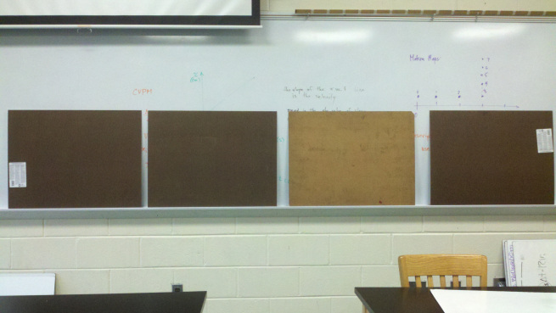
When all of the boards are up, we’ll know we’re ready to start. Each group will get the chance to come up and present their solution to everyone.
Oh wait, I forgot an important part! There’s a little wrinkle in the solution-writing part of whiteboarding. When we whiteboard in this class, we almost always play the Mistake Game. So the wrinkle is that you have to include at least one intentional mistake in your work. You can also include as many unintentional mistakes as you’d like.
For your intentional mistake, you should be trying to make a really good mistake. That means it should be something that you think your classmates might actually do. A lot of the time, a good way to come up with a quality mistake is to use something you actually did wrong when you were first solving the problem.
Let’s try to avoid Where’s Waldo? types of mistakes. So your intentional mistake should NOT be something like labeling the axes backwards, changing a number in an arbitrary manner, or spelling your names wrong. You might do some of those things unintentionally, but for the Mistake Game, you’re goal is to include a really quality, conceptual mistake that will lead the class to a good discussion when you present your board.

Okay, let’s get working on the boards. Would you two do #1? This table #2? #3? 4? And then you three take #5? Great. And don’t worry; you’re going to get better at making mistakes. [Now it takes a few minutes for them to grab boards and markers and to write up their problems. I basically walk around a bit and encourage them along. I don't comment on whether their answers are correct or not, since we're about to have that discussion. It doesn't take them long (in the year) to stop asking those sorts of questions because they know that they will have the correct answer by the end of the discussion.]
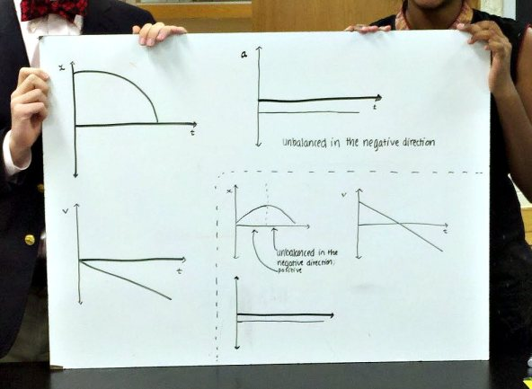
Are we all ready? Excellent. Now I need to tell you what your job is during the boards that you’re not presenting. For everyone not presenting, your job is to ask questions of the group up front. If you think there is something they need to change about their board, you need to ask them questions to get them to change it.

Asking questions is probably (definitely) the hardest part of this whole process. Okay. So examples of bad questions: “Isn’t that part wrong?” or “Don’t you think you should change it to be like such-and-such?” Okay, any statement that you’ve basically just put a question mark on the end of is not going to be a very good question. Good questions usually try to lead people to seeing an inconsistency or contradiction in their work. And you’ll get better at asking questions, too. It will take time.

Now, at the beginning of the year, a lot of times students have an impulse to look at me while they are presenting or while they are asking questions after the presentation. I’ll help facilitate the conversation a lot today, but one of our goals it to get to the point where you don’t really need me to talk during whiteboarding.
Okay, before you get worried that you’ll never know what the “right answer” is in this class, let me tell you a couple of other things. First, I’ve read about how these kinds of group discussions work—even if everyone in the room has the wrong answer at the beginning, as long as you don’t all have the same wrong answer, you’ll end up with the correct one through the discussion. So that’s one of the reasons why I tried to get you to keep from checking with all of the other tables while you were working—I wanted to make sure that we preserve diversity in any of the wrong answers. And second, I’ll obviously let you go up with a wrong answer on your board, but I won’t let you sit back down with one. If you ever finish your discussions with a wrong answer, I’ll chime in with a question or two at the end to redirect the conversation. What I’ve found, though, from my past classes, is that I actually very rarely have to do that. You guys tend to do a really good job with these discussions.

One two last comments before we get started. Remember to be nice to each other. So none of the… “That’s wrong and you’re stupid!” type comments, right? And also remember that you never know whether a mistake on the board was intentional or not, so be gentle. Finally, for the people presenting—you shouldn’t act and draw it out when you are asked a good question that addresses an error on your board. Even though you put the intentional mistake in your work, you don’t have to act like you’re totally and hopelessly confused about the mistake. You can acknowledge a good discussion and make the change pretty quickly when it happens. But also don’t jump to change the board after a question that just hints at how to fix the mistake. It’s sort of a balance. We’ll figure that out along the way, too.
Alright! First problem, here we go! Go ahead and do the dramatic reveal of your board guys, and then walk us through your work. Everyone else, please give your respectful attention to the front of the room. [All of that took a while to write, but doesn't take more than a few minutes to actually say before getting right into the real work of whiteboarding.]

Why it rocks
After trying it myself, I completely recommend starting the year with the Mistake Game as the primary way of whiteboarding problems. It was a good way to teach the students how to have effective whiteboarding discussions. Asking questions to uncover the intentional mistakes sets up an artificial, but comfortable, way of showing students how to have a productive conversation that leads to an increase in understanding. At the start of the year, when the problems are relatively easy for the students, it also helps isolate those difficult discussion skills from confusion about problem solving.
The following comparisons are based on my observations of students in my classes before and after I started using the Mistake Game.
Without mistakes: Student presentations often consisted of them standing silently next to their board, occasionally pointing. It was awkward, and they didn’t know what to say because they assumed that their work was self-explanatory and that everyone already had the same work.
With mistakes: There is an obvious need for explaining their work, since they assume it will be different from everyone else’s. Moreover, the way to explain their work now seems clear—they must walk their peers through their thinking so that their mistake will be highlighted.

Without mistakes: When a group presents a board with a wrong answer, the atmosphere in the classroom gets increasingly uncomfortable. Often, the error is pointed out very quietly, and an embarrassed group member quickly edits the board, hoping to cut off any discussion.
With mistakes: Errors are a normal, expected part of every presentation. In the case of an unintentional mistake, the presenting group always has the option to act as though it were intentional. Remarkably, most students feel no need to “cover up” their unintended errors. Since mistakes are expected, they feel okay about both making one (or two or three) and having a discussion about it.

Without mistakes: If there are no immediate comments or questions, the presenting group often tries to put their board away (below the big whiteboard) and go back to their seats as quickly as possible. The teacher often has to keep the group up front long enough for anyone who has a different answer on their paper to formulate a question.
With mistakes: After many presentations, there is a comfortable period of silence while everyone scrutinizes the board in front of them. Sometimes there are immediate questions, but sometimes it takes time to find and digest the mistake(s). Since everyone knows there is at least one thing wrong with the board, there is a need for that quiet reflection. The presenting group does not make haste for their seats because their mistake hasn’t yet been resolved (some groups do still try to run at the first opportunity, but that opportunity comes later).

Without mistakes: Students vied to be assigned a problem they knew they had done correctly. If they weren’t already sure about an answer, they try to check with as many people as possible, including the teacher, before putting their board on the ledge.
With mistakes: When groups are assigned a problem that they aren’t sure they’ve correctly solved, they don’t worry. They write as much as they can, knowing that by the end of their presentation, they’ll know how to solve the entire problem (with the help of their classmates). There is no right-answer anxiety from any of the groups while they are writing on their boards.

Without mistakes: Especially in the regular classes, little thought is put into conventions and format when writing on whiteboards. No students ever correct mistakes in symbol use, axis labels, etc. The teacher is left to ask these picky procedural questions at the end of every presentation, much the annoyance of everyone (teacher included).
With mistakes: Students are delightfully picky about each other’s work. They have permission to be respectfully picky without having to be a jerk (and also without leaving the teacher to be the jerk). Students think about symbol use, labels for graphs, formatting for algebra, etc when writing their whiteboards. Good habits are reinforced.
A secret of the mistake game—it’s actually the best test corrections ever. Over the course of the year, as the students get better at making worthwhile mistakes, something wonderful starts to happen. Students start to work out their mistakes from old tests by, I guess, role playing them in front of their peers. They present a problem using a mistake they’ve made before, but this time the joke is on the mistake. This time, the student knew it was a mistake all along. Even better—especially near the end of the year, students express pride in a particularly good mistake. When that happens, it is almost always about an old mistake that they are now showing mastery over. That’s not to say that students aren’t thinking of great conceptual mistakes that are original for them; rather, students are just exceptionally proud of exorcising an old demon.

That’s all great, but how do I win the game?
Okay, you’ve got me. It’s not really a game. At least, it’s not a competitive one. There’s no winning. No awards. No badges. No rankings.
I don’t build it up as a game, though, and I haven’t yet had any problems with students wanting to “win” it.
Building it up as a “game” is probably one of the potential stumbling blocks of using the activity in class. That leads me to the next portion of the post—

Possible pitfalls
Over the past year or so, it’s been really fun to hear from other teachers about how they’ve used this whiteboarding strategy in their own classes. Among the situations I’ve seen in my own classes, as well as stories from other teachers, I’ve recognized some ways that the activity can get stuck in a more inefficient/ineffective rut.
Here are the ones I’ve heard about or seen so far. I’ll add to the list as I hear about or experience others.

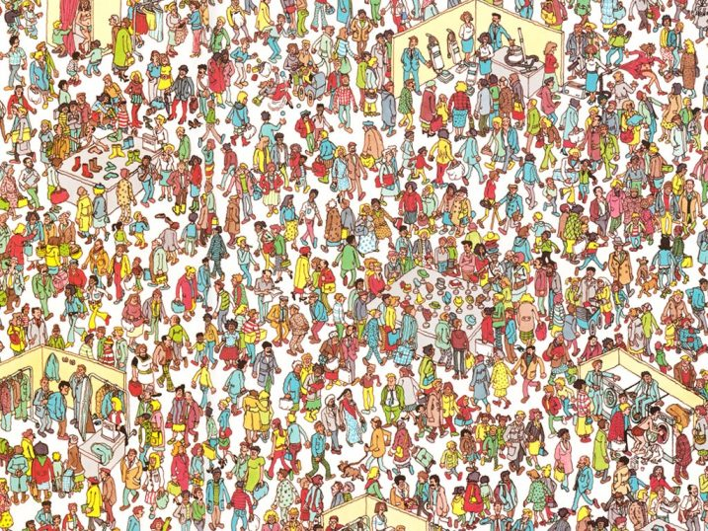
Where’s Waldo? mistakes
Misspelled names (no, seriously), arbitrarily changing a digit in the solution (often without that change even affecting the rest of the work, though it should have), switching the labels on the axes of a graph—I see these the most near the start of the year. I’ve also heard a lot about these. Sometimes they seem to be generated by a misunderstanding of the game. If students think that the goal is to hide a mistake in their board, Where’s Waldo? is clearly the way to go. It’s hard to argue with a classic!

Of course, the goal of the Mistake Game isn’t to hide a mistake. Everyone already knows that your board has a mistake. The goal is to generate good discussions by working through errors in reasoning and understanding that are likely to besiege a few students in the class at one point or another.
The other main source of Where’s Waldo? types of mistakes is probably weak metacognition skills (or a weak understanding of the problem—or a combination of those two). It takes a while to develop the ability to think about how you might go wrong while working a problem, and although students have been making mistakes for years, they haven’t often been asked to make them on purpose. So they probably need more guidance, to have good examples pointed out when they arise, and time to practice.

“Our mistake is… that we didn’t make a mistake!”
Some of the best, most productive, and funniest results of playing the Mistake Game come from situations where students either (a) think that they wrote a board with no mistakes (yes, everyone think’s they’re hilarious for thinking of that mistake at the beginning of the year) or (b) think their board still has an error when it is actually correct (that is, they thought the correct solution was actually a mistaken one). In the first case, the “no mistake” board almost always contains the most unintentional mistakes of that batch. In the second case, rather than running back to their seats, the presenting group tends to stand around for a while at the front, even though no one has any more questions.
Both of these possibilities could lead to uncomfortable situations, but again, with the mistake norming that is being done on a daily basis through the whiteboarding routine, the presenters are usually good-natured about it. I guess this one is actually more of an anti-pitfall, unless the “we didn’t make a mistake…!” becomes a routine. If there is a student or group who is really intent on not making (intentional) mistakes (I haven’t had this happen, but I could imagine such a student), one option might be playing Mark‘s Mistake Game spinoff: the Mystery Mistake Game. It is exactly the same, except that each group may choose (without telling the other groups) whether or not to include an intentional mistake.

Whiteboarding with mistakes takes forever
This is a complaint that I haven’t really seen myself. I haven’t timed it, but adding mistakes hasn’t seemed to make my whiteboarding process any longer than it was before. Of course, whiteboarding at all is going to take much longer than lecturing or “going over” answers to problems. If you make the jump from no whiteboarding to whiteboarding with mistakes, it will probably take a lot more class time than originally planned.
I suspect that much of the other taking “forever” aspects come from the other items on this list, so the solution is probably to attack those problems.
If the time problem seems to happen while students are writing the whiteboards (rather than during the discussions), having a timer somewhere visible might help students become more aware of the time they are spending. I also find the “put your boards up backwards” part of my process to be helpful here; a slow group will see that the other groups are visibly ready, even if they are chatting, because the boards have been accumulating at the front. That can help keep some groups on track when they were wandering, as they start to realize that the class is waiting for them.
In my regular classes, we tend to whiteboard every problem that we do (though we don’t always do every single problem in the packet). In my honors classes, the students tend to get pretty good at knowing which problems they think are worth whiteboarding. They usually want to skip the discussions for problems that they already feel confident about, and that can save some time, too. Of course, I just have to be careful to make sure that I always agree with their assessment of problems that are “skippable” during whiteboarding since they don’t always know when a problem has some extra subtlety that will make for a good argument in presentations.

Presenters who love playing “dumb”
I saw a lot of this one when I was first trying out this activity and hadn’t yet completely understood what would work best. It can be a little tricky at the start of the year to calibrate the “acting” required in presenting boards with mistakes. Basically, when they talk through their written work, they should include the mistake fluidly with everything else. Once the presentation shifts to answering questions, they should stop acting as though they totally believe their mistake and instead fix it when prompted by questions. They shouldn’t, though, fix the mistake in response to really poor or irrelevant questions. They can engage the asker a little. The problem comes when they take that engagement too far, or when they respond with mock-confusion to even decent or good questions.
So. Part of the fix here is just a little teacher intervention when it happens (one of the reasons why I talk more during whiteboarding in the first few weeks than I typically do during the rest of the year). The other fix is making sure that the students really understand that they aren’t supposed to be “hiding” their mistakes. The jig is up; we all know you have a mistake.

“I got 5 for the velocity.”
Ignoring the naked numbers in that statement, the real problem is two-fold: (a) it is not a question and (b) it is about the student’s work, not the presented work. I usually intervene immediately when “questions” like this arise, whenever they happen. “Ask about their work, not your work.” If the students have enough time to be quiet and thoughtful after a presentation (instead of rushing to ask questions or move forward to the next problem), then the problem is usually not that they don’t have time to compare the work on the board to their own. In that case, these questions are probably symptomatic of a larger problem: the students talk sequentially, not to each other. That is, they wait patiently to make their own statements (usually not listening to anyone else—except maybe the teacher) instead of responding to classmates. They often make the statement to the teacher. They are stuck in an individualized view of school and are used to learning next to, not with, other students.
I am still working to get my regular students up to the level of discussion that I’d like during whiteboarding. When I’ve had success at changing this mindset/behavior, it’s been due to short talks with the class about what great physics classes do (subject of a future post, hopefully). I basically start a class one day with a quick 2 or 3 minute chat about how I think they are a really decent class, and about how I want to share something I’ve noticed about what really great physics classes do. Then I tell them about talking to each other, making each statement a response to what has been said by someone else. I’ve seen really huge changes happen with just those kinds of short talks in an honors class this past year, and I’m hoping to try to apply it more in my regular classes this fall. I think the key is to remember that they don’t know how to have those kinds of discussions in physics class. So patience and some explicit, well-timed pointers seem to help them develop those skills.

Asking questions is tough!
This potential pitfall is such a big one, the headline deserved a bigger font.
Asking good questions of the presenters during whiteboarding is one of the most challenging things I ask students to do all year. And I start asking them to do it around the second or third day of school. Every student will have trouble coming with questions that highlight contradictions and that aren’t just statements with a raised voice at the end.
What I’ve found to be most helpful is pausing the class, acknowledging how difficult it is to formulate good questions, asking for a reworded question, and occasionally rewording a question myself to help show them how to do it (and especially to interpret the meaning if I know what they are trying to ask, but the presenters are at a loss about how to understand/answer the question as posed). Critically important to that whole process is allowing silence and thinking to happen without trying to rush to the quickest solution. If a question is badly phrased, I try to let the same student ask again instead of letting someone else just jump in. Without letting them reword it, that student won’t move forward in his skill, even though the class might resolve the problem by having another student ask a great question. I want all of the students to keep wanting to participate, and I want all of them to get good at asking questions.
Another question-asking difficulty—some students only ever want to ask questions of me, never of the presenters. The Mistake Game itself does help refocus those students, but some persistent ones will still exist. If they turn to me before or while asking, I just point back up to the front of the room (I always sit/stand at the side or back during presentations). If they say that they have a question for me, I direct them back to the presenters anyway. They will usually ask the presenters if I insist, thinking (I guess) that I will answer their question once I hear it and realize it is actually for me. The presenters almost always do a really nice job answering the generalization question in those cases, and I’m always glad that I gave the students up front that opportunity when I hear their responses.
Final note about asking questions: A lot of this blog post, and especially this section, was prompted by reading this post about confidence in reasoning (and having a discussion in the comments). More good thinking about setting up discussions among students is contained over there.
—
Links to the old posts along my mistake whiteboarding journey: The Mistake Game | Whiteboarding with Mistakes
More about challenges for whiteboarding: Understanding the Pressures Against Whiteboard Meetings
***

Algebra Bootcamp in Calculus
Sam 6/1
So it was the Old Math Dog who pointed out that I never wrote a post explaining how I deal with the issue of kids not knowing basic algebra in calculus. I started this practice two years ago (when I also started standards based grading) and I have seen a remarkable difference in how my classes go from my life pre-bootcamps to my life post-bootcamps…
An issue in any calculus course — and I don’t care if you’re talking about non-AP Calculus or AP Calculus — is the student’s algebra skills. They might see and have no idea how to solve that. Or they might not know how to find . Or they might cancel out the -1s in to get . It depends on where they are coming from, but I can pretty much guarantee you that every calculus teacher says the same thing to their classes on the first day:
Calculus is easy. Algebra is hard.
In my first three years of teaching calculus, I started with how all the books started, and all my calculus teacher friends started: a precalculus review. Then we went into limits.
The problem with that is that we might review some basic trigonometry, and then we wouldn’t see it again for months. And by then, they had forgotten it. And who could blame them. The precalculus review unit at the beginning of the course wasn’t working.
As I transitioned into Standards Based Grading, I looked at everything I taught really closely, and I honed in on the particular skills/concepts I was going to be testing. And since I’d taught calculus for a number of years prior, I knew exactly where the algebra sticking points were. Thus was born The Algebra Bootcamp.
Before our first unit on limits, I carefully analyzed what things I needed students to know to understand limits to the depth I required. I then looked at all the skills and thought of all the algebraic things, and all the old concepts, they would need in order to understand limits. And from that, I crafted an algebra bootcamp, and I made SBG skills out of just those limited skills.
For example, here was our first bootcamp (which, admittedly, was longer than most of the others, because we were settling in and I was gauging where the kids were at):
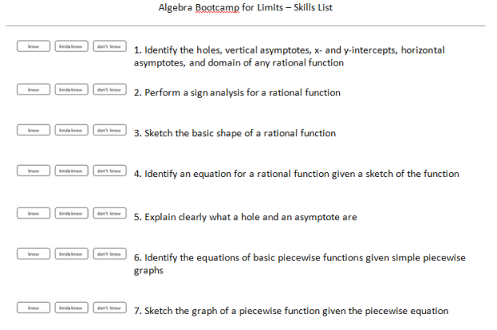
and I did the same for other units… just the targeted prior knowledge that they tended to not know or struggle with…
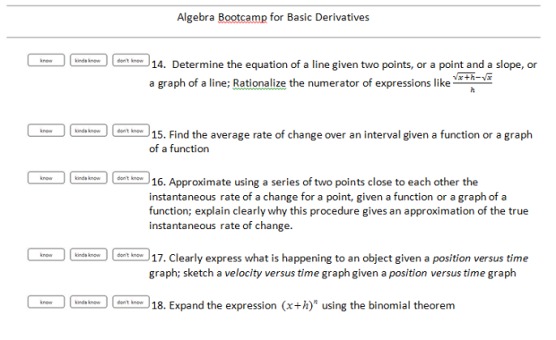
Notice how they tend to be very concrete and specific? Like “rationalize the numerator” (because I knew we were going to be doing that when using the formal definition of the derivative) or “expand using the binomial theorem. Very specific things that they should know that they are going to be using in the following unit. It’s kind of funny because it is a hodgepodge of little (and often unconnected) things, and they have no idea why we’re doing a lot of what we’re doing (why are we rationalizing the numerator? why are we doing the binomial theorem?) and I don’t tell them. I say “it’s our bootcamp… once training is over you’ll see why these tools are useful.”
It is called “bootcamp” because I am not reteaching it from scratch. I’m reviewing it, and I go through things quickly. I only do a few of them in the first quarter and maybe the start of the second quarter. By that point, we’ve done what we needed to do, and they die off.
The reason that this has been so effective for me is because students aren’t having to relearn old topics/algebraic skills while concurrently learning the ideas of calculus. We review these very specific things beforehand so that when we approach the calculus topics, the focus is not on the algebraic manipulation or remembering how to find the trig values of special angles or what a piecewise function is… but on the larger picture…. the calculus.
Remember: calculus is easy, it’s the algebra which is hard.
So we took care of the algebra beforehand, so we can see how easy calculus is.
My kids in the past two years have made so many fewer mistakes, and we’ve been able to really delve into the concepts more, because I’m no longer fielding questions like “could you review how to do X?” Doing this has also forced me to think about what the purpose of calculus class is. The more I teach it, the more I take the algebraic stuff out and the more I put the conceptual stuff in. For example, I don’t use , , and in my course anymore [1], because I wasn’t trying to test them on their knowledge of trigonometry. Doing these bootcamps coupled with standards based grading has forced me to keep my eye on what I really care about. Students deeply understanding the fundamental concepts of calculus. And I think you can do that without knowing how to integrate just fine. [2]
[1] With the exception of for the derivative of .
[2] I teach a non-AP calculus, so I have this luxury. But it’s nice. Each year I strip more and more stuff off the course and add in more and more depth. And I am glad that I understand depth to mean something other than “more complicated algebra in the same old calculus problems.”

***

This Logic Game Needs a Name
Kate 1/25
This is a game to give Geometry students practice evaluating the truth value of conjunction, disjunction and conditional statements.
This is what one game set looks like, for use by two students:
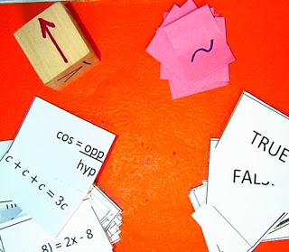
Each set has: 36 statement cards, 18 T/F cards, a cube with logic operations on it, and 4 negation chips. (All the cards are one-sided.)
The sides of the cube look like this:
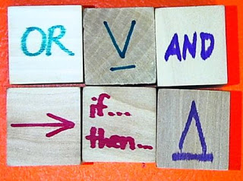
I bought unfinished wooden cubes at a craft store and wrote on them with a Sharpie (hence the bleeding.) I'm sure someone clever will comment with a better way to make these. You could also just use regular 6-sided dice and provide a decoder (rolling a 1 or 2 means "or", etc), but I was in overachiever mode yesterday.
The kids are very much beginners in the Logic unit, so we gradually dialed up on the cognitive load by playing two easier warm-up games before the real game. I also had them set their notes from yesterday out on their desk for reference.
Warmup Game 1: Easy Mode
1) Use only the True/False cards and the cube.
2) Distribute half the cards to each player.
3) The person whose birthday is next wins when the outcome is True. The other person wins when the outcome is False.
4) Game play is like “War.” On each turn, each player flips over one card, and the cube is rolled. The players work together to determine whether the resulting compound statement is True or False. The winner keeps both cards.
5) The game is over when time is up or one person gets all the cards.
So if this happened, "True" would win the round:
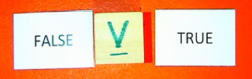

But if this happened, "False" would win the round:
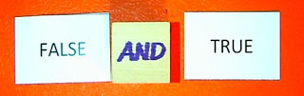
We only played Game 1 for a couple minutes, because it's pretty lame. Not very challenging, no strategy, also the "True" player has an advantage, because more of the possible statements come out True. On to...
Warmup Game 2: Like Game 1 but Harder
1) Use only the Statement cards and the cube.
2) Shuffle and randomly distribute 10 cards to each player. I gave them a few minutes to look through them to familiarize themselves with what the statements looked like, and think about whether they were true or false.
3) The person whose birthday is next wins when the outcome is True. The other person wins when the outcome is False.
4) Game play is like “War.” On each turn, each player flips over one card, and the cube is rolled. The players work together to determine whether the resulting compound statement is True or False. The winner keeps both cards.
5) The game is over when time is up, or when one person gets all the cards.
6) VARIATION: Each player also gets two negation chips. A negation chip can be played at ANY TIME, but can only be used once and must be discarded after use.
So if this happened, False would win the round:
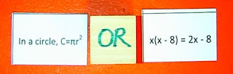

But if this happened, True would win the round:
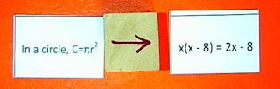

But if the False player still has a negation chip, she could opt to throw it down, and take the round:
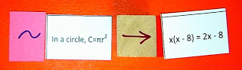
So that was all a warm up to familiarize ourselves with the materials, and remember the stuff we learned about yesterday. Still kind of lame because there's not really any strategy. Finally, we get to play the very fun...
The Real Game (which still needs a good name)
1) Each player gets: 10 Statement Cards, 5 True/False Cards and, 2 Negation Chips. You will be choosing cards to play on each turn, so it’s ok to look at all the cards in your hand. (You could deal out more or less cards if you want the game to take more or less time. This number was manageable for about a ten-minute game. Most groups were able to play two games.)
2) The goal is to get rid of all your cards by making statements that work.
3) Game play is turn-based. On your turn, you select three cards and place them in the field of play: two statement cards and a True/False card.
4) Then, roll the cube.
5) Both players should agree on whether the resulting compound statement works or not. If the statement works, you discard the three cards used in the turn, and go again. If the statement doesn’t work, you keep the cards in your hand, and lose your turn.
6) A negation chip can be played at any time. Even after the cube is rolled. However, once a negation chip is used, it must be discarded, whether the resulting statement worked or not.
7) The player that gets rid of all her cards first, wins.
So if a player selected these three cards, and rolled OR, the statement works:
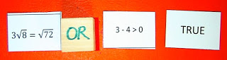

They discard those three cards from their hand and take another turn.
But if a player selected these three cards, and rolled IF THEN, the statement does not work:
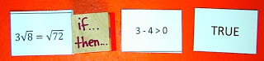

And they return the cards to their hand, and lose their turn.
HOWEVER, if they still have negation chips, they could play one now:
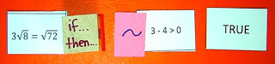
and now the statement works, so they can discard these cards and go again.
All the kids were engaged in playing for the whole period. Some of them asked "Can we play this again?" which blew my mind. I intended to do an exit assessment but didn't, so I'll give it to them at the beginning of class tomorrow and see what they retained. If I made new games, I would make the Statement Cards a different color from the T/F cards for easier sorting. It also needs an awesome, catchy name! But I haven't thought of anything worthy yet.
The final version owes a big debt to my colleague Dina Kushnir who talked through the game play with me, and came up with some of the basic mechanics. I'd also like to thank Maria Andersen for all her writing and insights about what makes a good math game - I don't think this would exist without her.
Here are some resources so you can make your own games. Enjoy!
***

Sprinkler Task
Nat 7/24
I am frustratingly mathematical. Ask my wife. I see the world as a combination of, in the words of David Berlinski, absolutely elementary mathematics.(AEM). The path of a yo-yo, the tiles in the mall, and the trail of wetness after a bike rides through a puddle are all dissected with simple, mathematical phenomenon. The nice part about AEM is that I can talk about it to almost anyone. People are (vaguely) familiar with graphs, geometric patterns, and circles even if they can't decipher what practical implications they have on their city block. Unfortunately, people (and students) don't often want to hear about them--they need to see them.
I can remember the look on my mother's face when I broke out the silverware to show her that the restaurant table corner was not square. Without a ruler, I showed her that trigonometry allows us to rely on ratio rather than set measurements. As I was in the midst of showing her that the 3-4-5 knife-length rule was breached, the waitress came. Mom was horrified; I was thrilled.
AEM has a visual nature; school mathematics often destroys that nature--reducing it to a simple diagram of a rope hanging from a drainpipe or train chugging its way through the prairie. I am guilty of the same thing in my class. I am a tactile learner so spend the majority of my time teaching with things. Students play with triangles to learn trigonometry and we build models to slope specifications. I often describe problems--good problems--to my students and have them struggle through them. Great learning occurs, but I have robbed them of the ability to find their own problems--the very problems of AEM that exist all around us.
Enter the twitterverse.
I have been watching the work of many educators for a while now. I love the way they use simple, visual elements to create extremely intriguing problems. This past week I was particularly inspired by Timon Piccini (@MrPicc112) and Andrew Stadel (@mr_stadel). They create video problems that not only test the AEM underpinning, but the curiosity and problem solving of the students. It is under this inspiration that I created my first video-based task. It contains a strong visual component and is based on a natural phenomenon that I observed during housework.
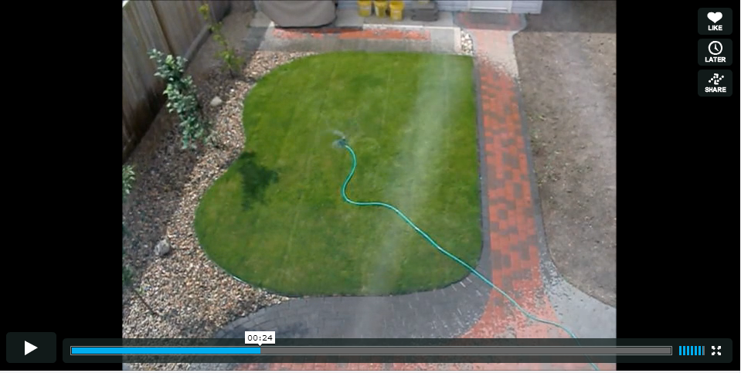
http://vimeo.com/46260169
Sprinkler Task (V.2) from Nat Banting on Vimeo.
The video shows two takes of me using my "circular" sprinkler on my oddly-shaped piece of lawn. The natural question that came to my mind was, "Where do I place my sprinkler to minimize the amount of water that is wasted?"
The question is broad. The situation is organic. A simple curiosity can be cultivated in a novel way. That is my favorite part of the problem. I will simply play the video for my students. I will pause after the first take and allow students to absorb the situation. Hopefully cynics will point out that the pattern is not circular; this will lead to a great conversation about perspective and spatial reasoning.
I want students to notice that the first pattern touches a corner of the yard. What if the edge of the circle didn't touch any edge of the yard? Could this possibly be the most efficient watering method?
I will clear up any variables that a good mathematician would. We assume the spray is uniform. We assume that the pressure can be turned up or down to any desired radius. Wasted water is considered water that lands outside of the grass. Wind is not a factor. After our initial conversation, I will re-play the video and see the second case.
Which one wastes more? Have students discuss. Ask the students what information they need to solve the problem. Measurements will undoubtedly come up. If students are done theorizing with the problem, I provide them with a picture of the yard complete with measurements.
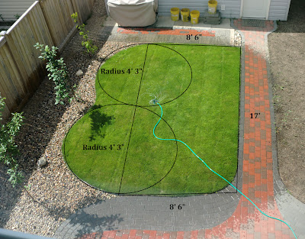
The lawn has been modeled as a rectangle and two semi-circles. What error has occurred? Can we refine the model? (Possibly by placing a quarter circle on the bottom right-hand corner). Do the measurements help you calculate how much water is wasted?
To aid in their work, I created a scale diagram of the yard. I then created three different worksheets--each has a different size scale drawing on it. This creates three unique scales within the classroom. As a group, we will try the first placement together. We'll draw the sprinkler and create triangles to calculate the distances to the furthest points. The longest of these must be the radius of the sprinkler circle.
I will then send the students out into groups to discover a more efficient placement. If they are going to communicate with one-another, they will have to convert using their scales. For example, "We placed ours 3 inches down and 2 from the left" won't work if a group has a different scale factor on their diagram.
At the end, I will construct a table of results to see which group indeed maximized the efficiency.
To follow up, I created two other "yards" complete with measurements. I will ask the same question. One involves the possibility of introducing trigonometry and the other has students explore the idea of circumcircles. Both of these diagrams along with the video, measurement picture, yard diagram and the three worksheets are posted for download on my wiki page.
This is hopefully the first video embodiment of my thinking. Tasks like these not only "real-world", they cater to multiple learning intelligences. The visual, spatial, kinesthetic, and auditory are all engaged. Some of the best lessons in the classroom mirror experiences that students may have outside the classroom.
***

New Math Game: Factor Dominoes!
Malke 11/7
Lately I've been looking for different ways for my seven year old and I to conceptualize multiplication. As has happened many times before on our math journey, this graphic showed up at just the right time (albeit somewhat circuitously through the excellent influence of the Math Munch blog).
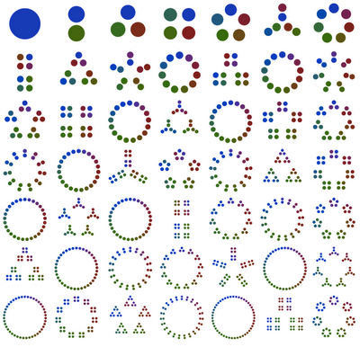
My favorite thing about it is that it's not about numerals; when I look at factoring trees I can make some surface sense of them, but my mind goes numb pretty quickly. In this visualization, however, there is an incredible connection to shapes and grouping. I find this visual especially well-suited for kids in general and at least this adult specifically.
Last night I printed out the graphic and left it advantageously on the kitchen counter. I thought maybe my kid might be interested but was truly surprised by her reaction when she found it this morning. It is probably the first piece of math my daughter has ever admitted she was excited to know more about, which is saying a lot.
She wondered what it was about so we looked it over together. At first it was basically 'count the dots' and notice that each configuration was one more dot than the one before. Then, in the same way we tackled the 100's chart last winter, we started looking around and noticing things: The ring of seven dots on the far right column has multiples of seven underneath it. The 6 shape shows up two more times on a descending diagonal. It's fun just to look and talk about what you see.
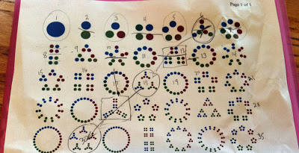
It's the geometry of the design that really shows the relationships between numbers. And, even though this was not meant to be a multiplication chart, it's probably the best one I've ever seen.
All our talking and looking got my mind spinning. What if...what if I made little playing cards out of each factorized number? What kind of game would it be?
I was about halfway through constructing the cards when my big AHA! moment hit. As I made and sorted them one by one it became completely clear to me that the integers 1 through 7 formed shapes that were echoed in the other factorizations. As an attempt to organize my growing pile of cards I laid out a top row of 1 through 7. But where to put the other cards? For example, 5 is a pentagon made out of single dots and 10 is a pentagon group of two dot groupings. Where does it belong? The 2's column or the 5's column? This kind of question is at the heart of the new game.
Here's how my daughter decided to sort them in a 'get acquainted' activity before we started playing:

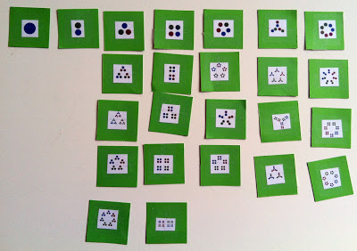
As we went along I refined the language she needed to help her make her choices. Was she going to place a particular card based on its large grouping (outer shape) or the smaller groups? As you can see above, there's a 5 shape of 3s in the 3 column, because the smaller group is a match to that number. But, every other 5 shape is in the 5's column. She's also got a 7 shape in the 3's column for the same reason -- the smaller grouping matched and, ultimately, the whole 3's column is consistent on that criterion.
For some comparison, here is how I sorted the cards, earlier in the day. I was trying to match to the category of 'outer shape':
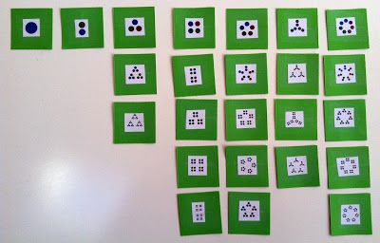
I'm not sure I got it the way I wanted it, but no worries. There is probably no one right way to sort these cards and the activity in itself makes for some really interesting thinking and conversation.
After she familiarized herself with the cards we started in on the new game which I'm calling Factor Dominoes (with a side of Scrabble). The title alone should give you clues as to the game's aesthetic and procedure, but here's how to play:
Split the deck equally between two players. Player 1 puts down the opening card. Player 2 tries to find a match. If Player 2 has no match the card is put aside face up for future use and play returns to Player 1. You can find a match either by outer grouping/shape (triangle, square, pentagon, weird six shape and seven ring) or by similarity between the small dot groupings. In our game we also matched 'echoes' -- small groupings that are the same shape as another number's outer shape.
For example, in the picture below the first card is a 5 shape with small groups of 2. The 6 shape next to it works because even though it's a different shape it also is comprised of 2s. And, the card directly below the first card also works because the smaller groupings of 3 match the 5 shape of the larger grouping. Make sense?
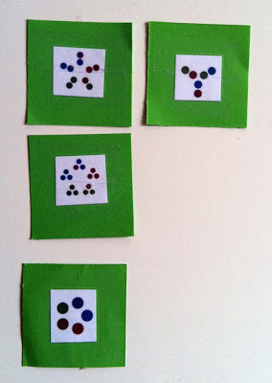
Here's another example: The top line of matches have the 3 shape in common. The bottom row connects to the top with small groupings of 4.
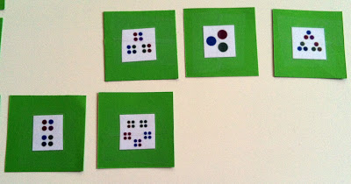
And, here's a picture of a couple more interesting matches. See if you can figure out our reasoning on this section of the game:
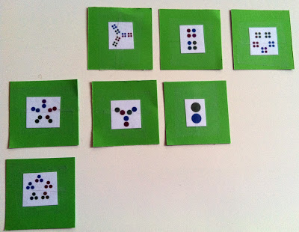
Play the game until there are no more cards. This is a cooperative/conversational game but feel free to give it a point structure if you like. You can also make the game bigger and more complex for older students -- just cut out more factors and make more cards! That's what I'm going to do for our next round of play.
Here is our completed first game:
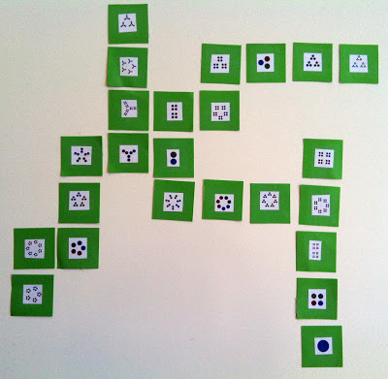
Based the exponential growth of my personal understanding of primes and factors, gained in just one short day, I am firmly convinced that a wide range of ages, experiences and abilities can get something of value out of this game.
My seven year old was perfectly challenged as we focused on groupings, but what if you added the prime numbers beyond 7 into the mix? How would that deepen or change things? What about adding exponents as a match category? What if you figured the value of each card and matched them in sequences (like {25, 26, 27, 28...} or {4, 8, 12, 16...} or even a sequence of primes, in order)?
If you do play this game PLEASE let me know how it went and what other ideas you have for it. And, please do consider joining us on the Math in Your FeetFacebook page. We're having a good time over there!
p.s. I cut up the chart of 49 integers and made my own version. What do you think?
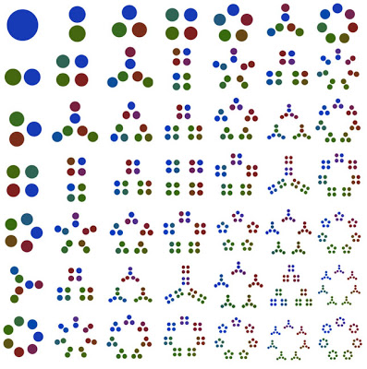
***

3 Acts - Broken Calculator
Timon 7/19
This is easily one of my favourite problems that I have come up with. Mainly because of the back story. I handed a student this calculator, and he told me that it didn't work. The numbers weren't working. I showed someone else and they decided to throw it out, but I couldn't help but think that something more than broken buttons was the problem.
Act 1 - The Brokenness
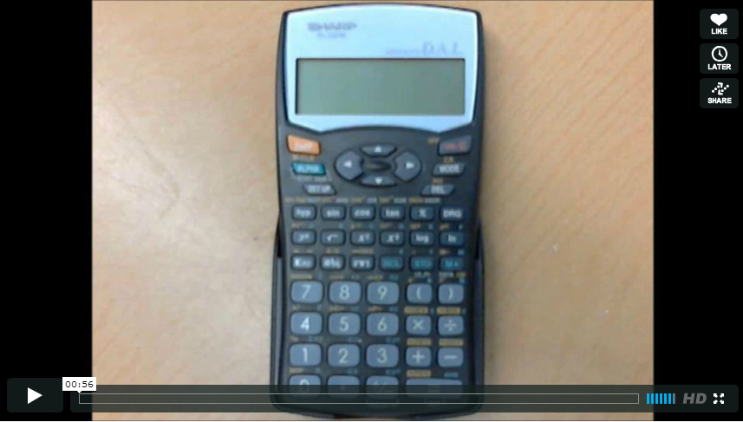
http://vimeo.com/44767477
So ask the students: "What is wrong with this calculator?" or "What is this broken calculator going to give us for '433+233'?"
Act 2 - Examples
Okay full disclosure here, this is not really what I want to give my students, but as a low tech version (and one that you can use as well), I have made these...
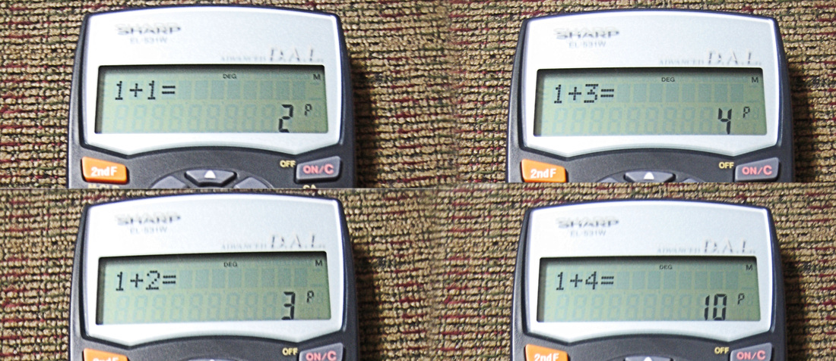

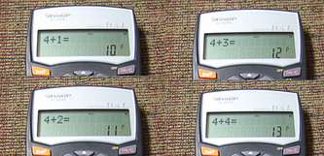
What I really want students to do is to explore their own numbers and find patterns on their own. In order to do this, I want to program a base 5 calculator that kids can use on the school netbooks, BUT I don't know how to program. If anyone has ideas about how I could put this calculator into my students hands without telling them that it is a different base please put them in the comments.
The other option is I just put my calculator under the document camera and have students ask and record class wide. That doesn't help you guys though, so this is what I have started with. If you think I need some more/better examples please tell me in the comments and I will make them (groups of four look nice).
Act 3 - The Reveal
Sequels
This is a pretty pure mathematics WCYDWT so I can only think of standard sequels. (Please give me more ideas in the comments, these are pretty lame).
How does multiplication work in this number system? Can you find some easy methods for solving basic multiplication statements?
Pick a random base (2,7,12,4.5(?), 16), and create some problems, and share them with a partner. What is different and similar among different bases?
From @trianglemancsd: How would you represent 1/2, 1/4, and 1/10 as a "decimal" number? What does 1.3, 1.021, and 0.033 become as a fraction? (All sorts of headaches happen here, clarify a fraction in base 10 or base 5; what does 1/10 mean?
***

Bike Trail Task
Nat 7/30
There is two hour parking all around University of Saskatchewan. I once went to move my car (to avoid a ticket) and found that the parking attendant had marked--in chalk--the top of my tire. I wanted to erase the mark so began driving through as many puddles as possible.
I then convinced myself to find a puddle longer than the circumference of my tire--to guarantee a clean slate and a fresh two hours.
As I walked back to campus, I got thinking about the pattern left behind by my tires. For simplicity, let's take the case of a smaller vehicle--a bike.
If you were to ride a bike through a puddle of a certain width, the trail would look like this:

Is this model correct? Evenly spaced iterations of puddle-width splotches.
Assume that:
width(puddle) < circumference(tire)

and consider the following bike-ish contraptions. Can you predict the pattern? Better yet, can you draw an accurate prediction on graph paper? Assume a six-inch puddle (why not?)
That is the task I present to the students. The emerging patterns are interesting.

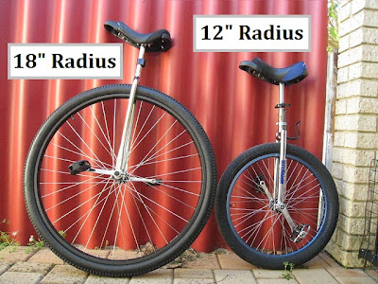
Unicycles--one wheel; one pattern.

But now combine them. (Of course, the bike goes in a perfectly straight line...)

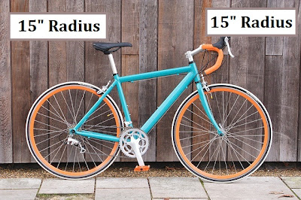
A standard bicycle-- two wheels; same size.
Alter it slightly. (You may want to encourage colour coding for overlapping paths...)

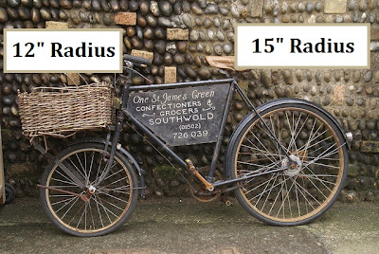
Old school--two wheels; different sizes.
Exaggerate the difference.

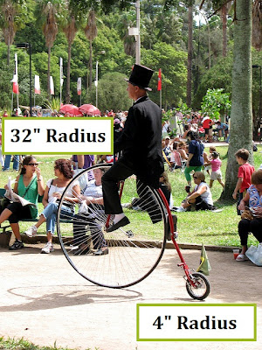
Crazy old school--two wheels; way different sizes.
How does the pattern change? Is it important to know how far apart the wheels are? (Experiment...)

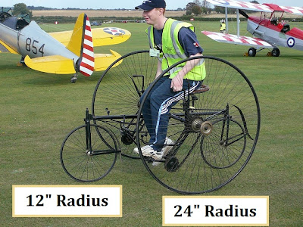
Just for fun--4 wheels; 3 tracks; 2 sizes.
What do you notice about certain radii? What causes certain patterns to "line-up"?
An interesting task to give a class working on circles, algebraic manipulation, factors, etc.
***

Building A Better Taco Cart
Dan 10/9
And by "taco cart" I mean "digital math curriculum."
I made Taco Cart out of videos and photos. I'm comfortable making math curricula out of videos and photos but I'd rather build them out of code.
Here's the Taco Cart I wish I had made. Implicitly, here, I'm admitting I'm in over my head. I need a new set of skills or a new set of collaborators.
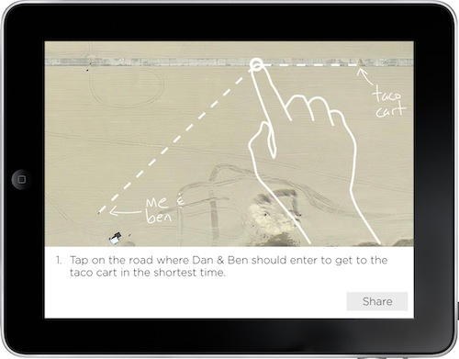
Currently, I'm asking students to guess where Ben and I should enter the roadway to get to the taco cart as fast as possible. But how do they register that guess? Do they point to it? Do they make a mark on a printout of the scene?
Let's give them tablet computers, instead, and let them slide their fingers down the road until they're happy with their guess.
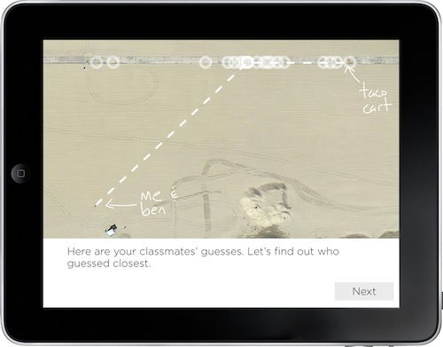
Then they see all their classmates' guesses. Ideally those guesses are all attached to faces or names somewhere so you can see how your best friend or the girl you have a crush on guessed. This ratchets up their perplexity. Who guessed closest?
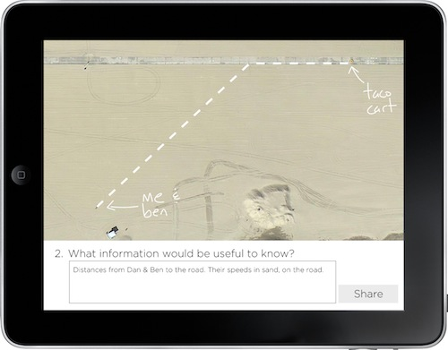
Then we ask them what information would be useful. This is abstraction. We're giving the students a chance to extract the essential features of the context.
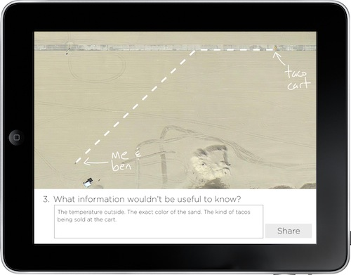
We ask them to discard the inessential features of the context.
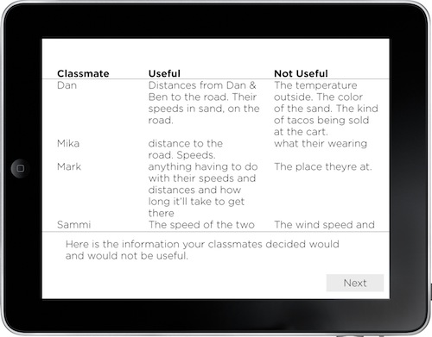
The tablet summarizes the class' responses. The teacher can use this information to seed a brief discussion.
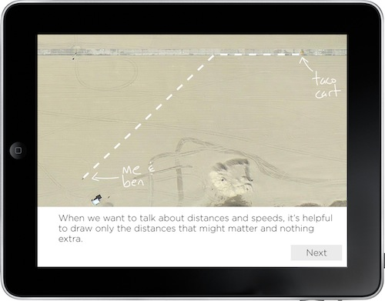
What happens next is violent. We're going to vaporize the world. We're going to strip away the sand. We're going to destroy the buildings. We're going to wipe Dan and Ben and the taco cart off the map and replace them with points and lines. If you've studied math at the university level, it's possible you've lost touch with the violence inherent in mathematical abstraction.
So we scaffold that process briefly. We prepare the student. We say, "We're going to get rid of a bunch of stuff you said was inessential and represent the rest as neatly as possible."
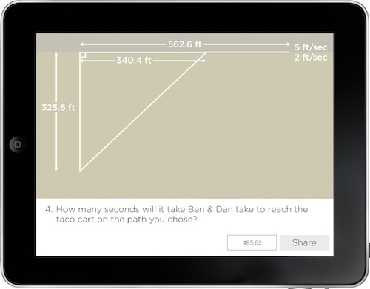
Now this is interesting. Each student is given her own task, a task that she, herself, picked. "You guessed that this would be the fastest path," we say. "Go ahead and figure out how long your path would take."

This is more fun than evaluating the duration of a generic path and it's easier than differentiating the generic path and solving for its minimum. It isn't all that much more difficult for the teacher to check either because everyone is performing the same calculation, just on a different value.
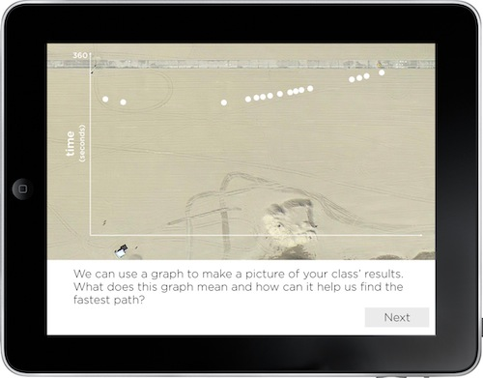
Everybody enters their results. The tablet checks them for correctness and then displays them.
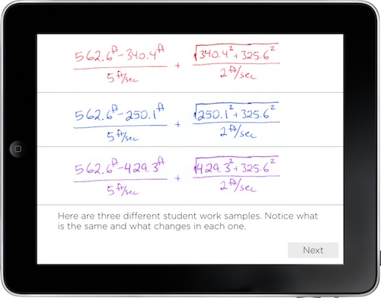
Remember that everybody is doing the same calculation on a different value? [BTW: Christopher Danielson is right that I overstepped myself here.] That means it's abstraction time again.
We pull out three student pages (never mind that these are all from the same person) and we ask the students to notice what changes and what doesn't.
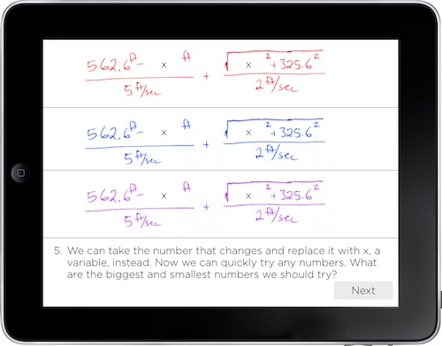
We turn the thing that changes into a variable. But why? Because math teachers need the work? Because math teachers amuse themselves with this notation? No. Because it lets us try any value we want really quickly. What are the highest and lowest values we should try?
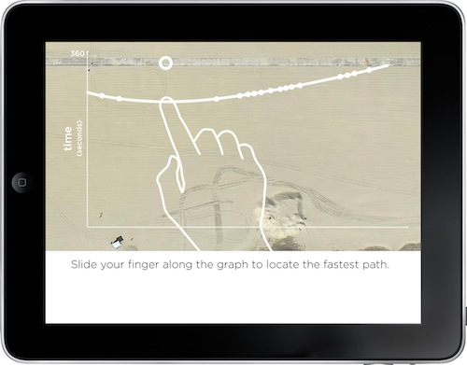
The student slides her finger along the graph and the path adjusts with it. The tablet snaps to points of interest like minima and maxima and displays the value of the graph at those points.
From here we'd play the video that shows that answer. The tablet would find out which student guessed the closest initially and throw some love on her.
A Few Closing Notes Before I Ask Your Opinion About This Kind Of Curriculum
- On the upside, this task attempts to clarify abstraction for students and make that process participatory. It involves the entire ladder. Students pick their own math problem. Students are guessing. They're deciding what information is useful and useless. ¶ Look at the original task and imagine how many more students are included in this re-imagining. ¶ The task is also social in a way that's difficult to achieve without 1:1 technology. The tablet collects and represents the entire class' guesses in real-time. A teacher can't do that.
- On the downside, I'm not sure what the teacher does in this sketch. At different times, I wobble between having the textbook function as the teacher and having the textbook simply maintain a steady course through the problem. If I taught this problem, I know I'd handle a lot of the exposition (ie. "Here's why we use variables.") myself, in conversation with students. But what should the textbook do? ¶ Also, we didn't differentiate the function and solve for the minimum. We formulated the model and solved it graphically. Does that still count as math?
Now you go.
2012 Oct 11. Dave Major went out on spec and put a lot of this into code. It's exciting.
***

1,400 Rectangles
Dan 10/25
Some math teachers were sharing dinner following last week's Northwest Math Conference when Marc Garneau said something truly implausible:
If you have a class of students draw a rectangle, they'll combine to create the golden rectangle.
Truly implausible, but Marc stood by it, along with at least one other member of our party. Dave Major set up a web page so we could collect data. You all obliged us with 1,400 rectangles, about a third of which I'll show you in this video:
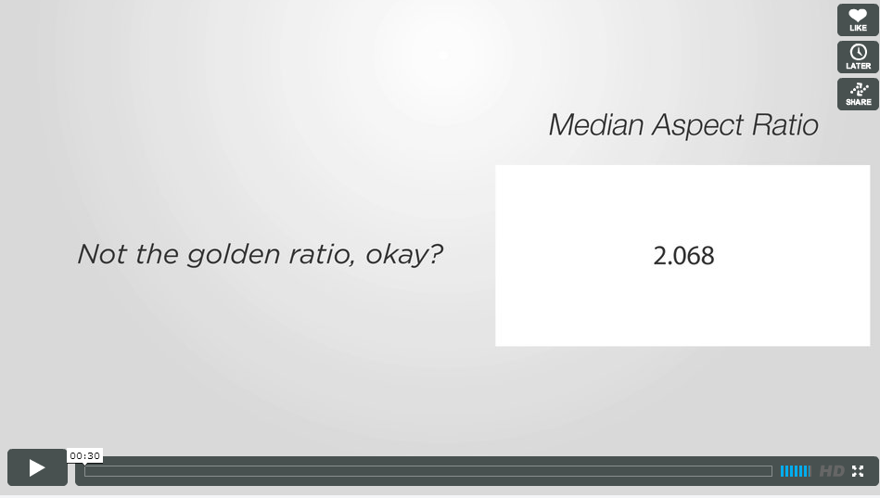
http://vimeo.com/52136711
Mean: 6.16; Median: 2.087; Standard Deviation: 18.296. So, no, not the golden rectangle. And now Marc owes me a new car.
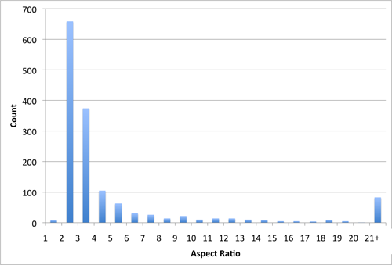
a different dave wrote:
I predict that the shape of the rectangles is going to be very heavily influenced by the shape of the canvas provided.
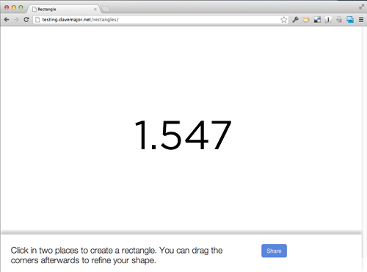
Not that either. Now a different dave owes me a new car too.
Here's all the data. Tell us something interesting about them we don't already know.
***

The hierarchy of hexagons
Christopher 10/12
True confessions: I find a great deal of the school geometry canon tedious.
Does a trapezoid have exactly one or at least one set of opposite parallel sides? Circumcenters and orthocenters. Dull, dull, dull. Boring, boring, boring.
School geometry seems to me one of the most lifeless topics in all of mathematics.
And the worst of all? The hierarchy of quadrilaterals.
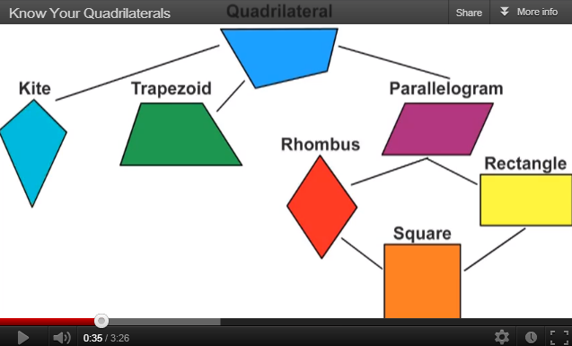
(http://youtu.be/rXZcYHVwkqI)
This representation of relationships among the special quadrilaterals bored me in fourth grade and I cannot muster energy for it as an adult. But I gotta teach it with my future elementary teachers.
So a year ago, I had an insight; an idea about breathing some life into this dead horse. What if we classified hexagons instead?
We began with these:
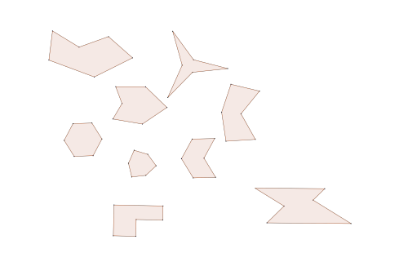
We cut these out. I had students choose one that seemed special to them for some reason, and to identify what property or properties make the hexagon special.
Students identified this one as being special because it has all right angles:
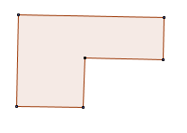
We clarified, defined interior angle and right angle, and agreed that this hexagon is special because it has exactly five right angles. The shape needed a name and we chose Bob. So a Bob is a hexagon with five interior right angles.
We also agreed that we would only specify interior in the future if there was likely to be confusion; we gave ourselves permission to refer to the interior angles of a polygon simply as angles in most cases.
Students identified the next figure as being special because it has three congruent acute angles.
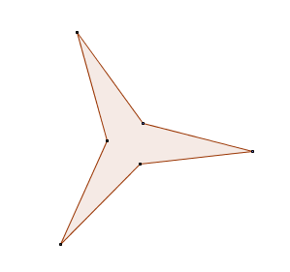
Again, we needed a name and it became a Stacy. So a Stacy is a hexagon with three congruent acute angles.
We identified several of our hexagons as being concave, so we defined a concave hexagon as one that has at least one interior angle greater than 180°. (Side note: It turns out that this is the standard definition; I had remembered something about diagonals staying in the interior. In any case, we had to do some work to get from the visual shape with a dent definition to this one.)

I threw a couple of useful terms into the mix: equilateral and equiangular, and pretty soon we had enough to work with.
We took these properties two at a time and made Venn diagrams. Is there such a thing as a concave hexagon that is not a Bob? (Yes) Is there such a thing as a Bob that is not concave? (No) Is there such a thing as a concave Bob? (Yes) Etc.
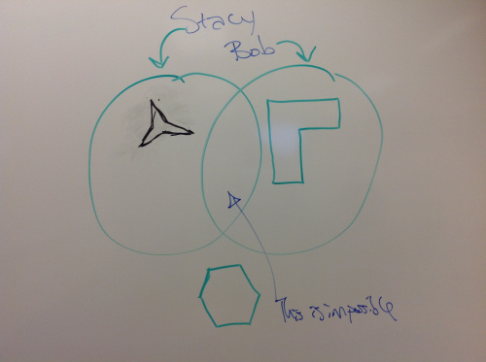
Having polished off all of the pairwise possibilities, we took to the whiteboard to categorize and to argue.
Concave hexagons, Stacys, equilateral hexagons and equiangular hexagons are all special hexagons that don’t necessarily have anything to do with each other. But you can have an equilateral hexagon that is also equiangular. We named that a “Norm”. And a Stacy can be equilateral. That’s a Mercedes. The Stacy above is a Mercedes. We weren’t sure whether a Mercedes must be concave.
My students proved that no Bob is equilateral.
I would like to repeat that.
My students proved that a Bob cannot be equilateral.
I have never before been able to say that my future elementary teachers proved something. I could say before that they followed a proof I presented. Or that they produced a proof that closely mirrored one they had seen. But never that they proved something. This group did.
Their argument was based on parallel sides in a Bob-how there are two sets of three sides, and that the lengths of two sides in a set add to the length of the third. If a Bob were equilateral, one of these sides would be of length zero, which means it’s not a hexagon and so not a Bob. QED. I have spared the reader some details.
Behold the hierarchy of hexagons:
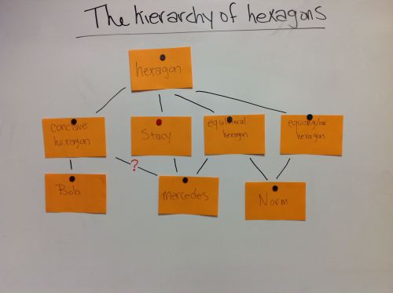
After this, the hierarchy of quadrilaterals was a mostly trivial exercise. We built it in like 20 minutes and used it as practice for the skills we developed with the hexagons.
We marveled at the bizarre relationship between the definitions of quadrilaterals and their relationships. Why is a rhombus defined in terms of its side lengths, while a parallelogram is not? This makes it hard to see why a rhombus is a special parallelogram.
The question of the concavity of Mercedes was an open one for a couple of weeks. Then yesterday we got out the polystrips. Boom!
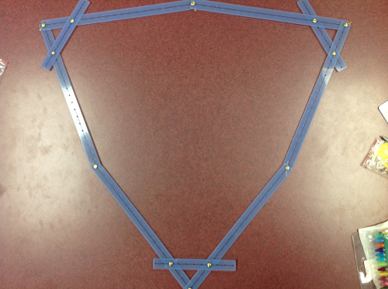
Not all Stacys are concave.
If we had more time, we would revise our hierarchy to incorporate this fact. But we have to move on to measurement.
Our work here is done.
Total time? Five weeks.
***

Teaching an Old Word Problem New Tricks
Nico 10/3
Today, I used the fairly well known 'Locker Problem' with my students. If you haven't heard of it, here's my version:
Imagine 50 closed lockers in a hallway.
One student goes by and opens every one.
Another students goes to every second locker and closes it.
A third student goes to every third locker and if it is open, closes it, and if it is closed, opens it.
A fourth student then does the same but for every fourth locker.
A fifth student does the same but for every fifth.
And so on.
At the end, which lockers will be open and which will be closed? Why these numbers?
I think there is merit in analyzing the best way to deliver the problem. Case in point, the students did question the words 'And so on.' "Do you mean forever?", "How far should we go?", "When do we stop?" were fairly common.
But here, I want to emphasize something that totally surprised me. About how the students solved the problem, and what they chose as their method. The options were wide open. I'm defining wide open here as 7 different ways of solving this.
1) Pen and paper (immediately popular when they were reading the problem)
2) Chart paper (the response was, muted)
3) A long roll of mural paper (the rolling, intriguing, but not much commitment from the crowd)
4) The white board (notable enthusiasm)
5) Cube Links (crickets)
6) 2-sided plastic counters (aha moments for most groups, interest was building)
7) Sticky Notes (game over...close the door...the kids are getting rowdy)
But I didn't close the door. Instead, I offered two groups of students (per class) to take the problem outside, into the hallways, with their sticky notes. Inside the classroom, 2-sided counters were popular, followed by some independent pen and paper enthusiasts.
Having given some time for the groups outside to get going while I watched students inside, I wandered out the door to check on the progress. And there was the surprise. I thought, Sticky Notes outside the class, was one option. My misconception was that I could imagine how students outside were using those Sticky Notes. It wasn't one option. And I had no idea the students were going to do all of this:
Lay numbered Stickys on the Floor
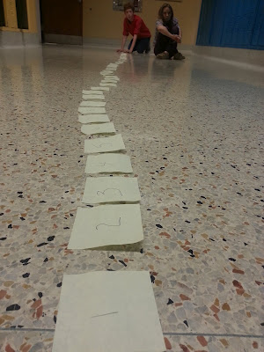

Using O's and C's
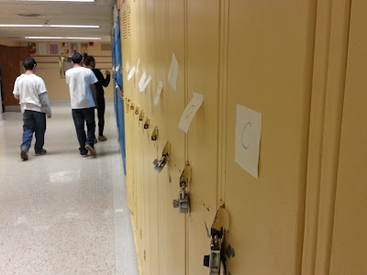

Only OPEN Stickys without using Close Stickys
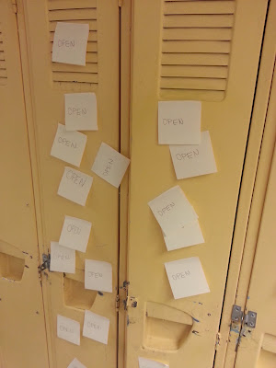

Choosing to skip lockers instead of all being labelled.
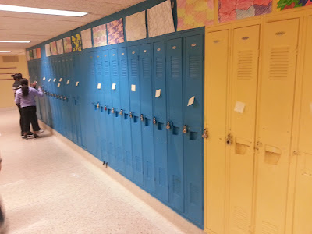

Tally Marks on each Sticky as needed.
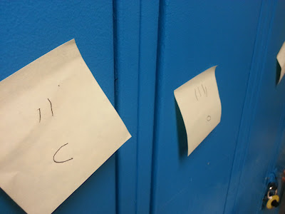

Moving Stickys up and down, for Open and Closed
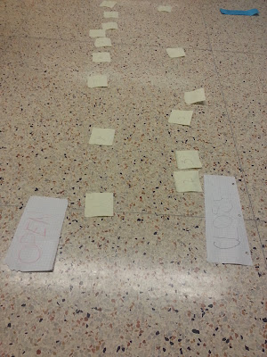

How long will 50 remain OPEN?
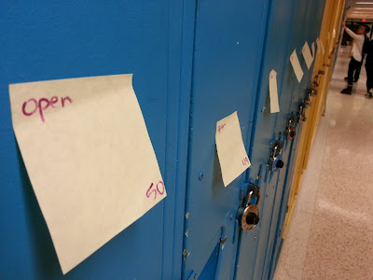

24 has been through some changes:
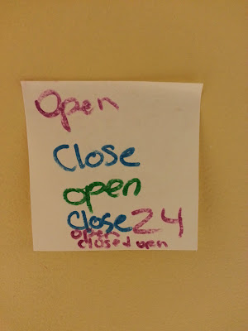
Some inside highlights can be seen here:
Here come the counters,
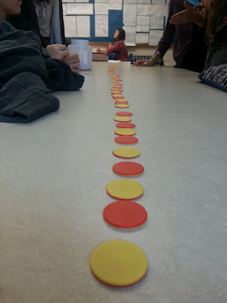

Some planning with Paper and Pencil.
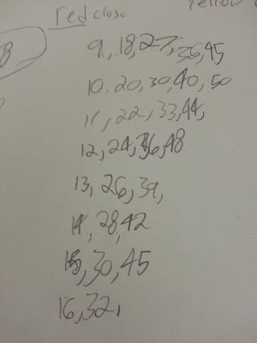
I thought I knew what I was going to see. Today was a pleasant surprise. This is good.
At the end of the day, I still have these questions:
How could I have widened their options (choices) before starting?
Logistics and timing were an issue. How can I manage this better?
What prompting questions, if any, are needed here?
How can I better word the question, "Which lockers will be open and which will be closed"?
An attempt at answering that last one: Can I just say, "What will happen?"
***

Made4MathMonday: The Best FORMATIVE ASSESSMENT EVER!
Terrance 10/14
Here is a rough video. My 1st one on my iPhone as, I forgot my flip camera.
But here it is, this is the easiest best way to use a formative assessment with your students, IMO.
Thanks to Lisa Henry, for making me do this even though she doesn't know it yet, and Kristen Fouss, for giving me the courage to, though I don't show my face :), she doesn't know that either.
All You Need is Sticky Notes! Without further ado....
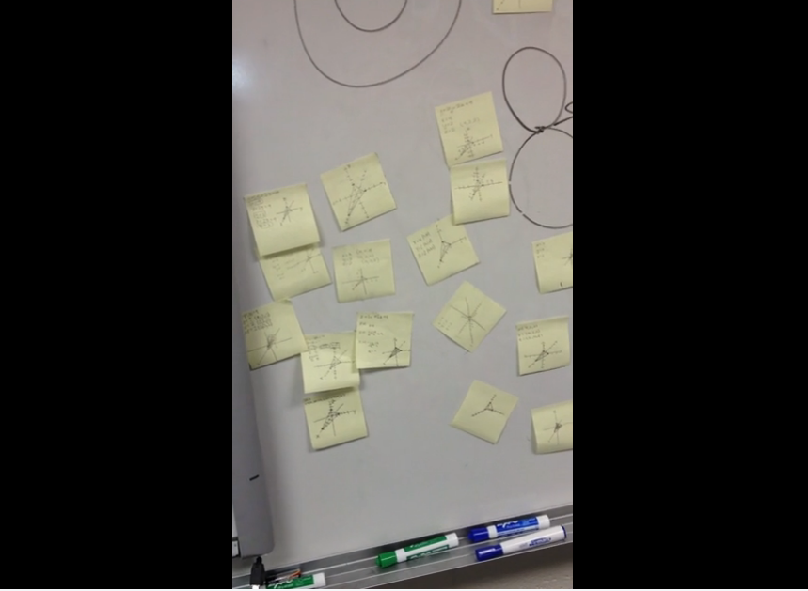
http://vimeo.com/51409172
Formative Assessments Sticky Notes from Terrance Banks on Vimeo.
***

Story Math: Introducing Square Numbers, Sets & Subsets
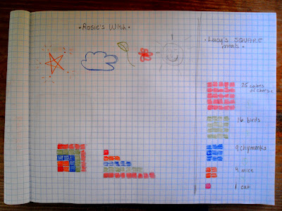
Malke 4/19

I feel comfortable doing a lot of things, but storytelling isn't one of them, especially when my kid insists I make one up on the spot. Today was no different, but luckily I got inspired. There have been a few math-y things I've been wanting to introduce, but she's been having none of it. Fortunately, a narrative (even a thin one) is often the way to get her hooked so I decided to go for it. Here, then, are three of today's stories. The first two illustrate different aspects of square numbers. The third was actually mostly for me to start figuring out how to explain sets -- I'm not quite sure I've got subsets yet.
As you read my modest stories, please imagine me simultaneously illustrating while I narrate. The illustrations build as the story develops...one red cat, three orange kitties, five blue raindrop cats, etc.
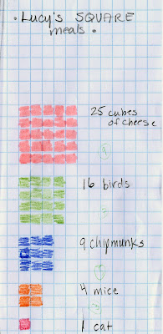
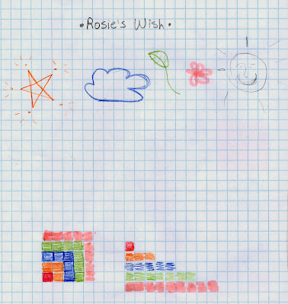

Story #1: Rosie's Wish
Once upon a time there was a little red cat named Rosie [one red box colored in] who was very lonely. She wished on a star for the company of a few new friends. [You tell good stories mama! Just as good as papa...!] The star said, "I think I can do that!" and sent down three orange cats to play with.
The little red kitty loved playing with her new friends, but soon wished for even more friends. She looked up into the sky and this time made a wish to the cloud she saw floating by. The cloud obliged and sent her five blue raindrop kitties. They played and frolicked, but soon wanted to share the fun with even more cats! The little kitty made this wish to the trees around her, and the trees sent her seven little green leaf cats and, later, nine pink cherry blossom kitties.
The whole group, all 25 of them, played and frolicked the night away. When the sun came out in the morning, they were all tired out. And what do kitties like to do in the sun? Why, they curl up and take a nap!
The pink kitties lay down first, and made a soft bed of flower petals. The green leaf cats added to the bed, then the raindrop kitties, and then the orange cats. Rosie lay on top of the whole pile of friends, purring happily.
You probably noticed that this story ended up illustrating the growth progression of square numbers, first in a square and then in a line. I didn't mention anything about squares or numbers in this story. My thought was that I wanted to present the image and show the growth, which I think is cool to look at; laying the same number of squares out in lines was an in-the-moment inspiration and shows the pattern of growth more clearly. The kid loved the story and, interestingly, didn't bat an eye at the fact that the characters were represented as little colored squares!
Story #2: Lucy's Square Meals
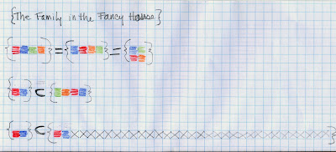
Lucy, our cat, likes to eat. She begs and begs us for food. Today she said, "Give me something to eat, I'm starving. You haven't fed me in weeks!" So, we gave her four orange mice.
Lucy said, "That was a great square meal but I'm still hungry -- give me more to eat! I'd love if it could be another square meal but even bigger this time, meow!" So we gave her nine blue chipmunks.
Of course, that was only a tiny snack for Lucy...[I want things to fall from the sky! the kid interjects]...and she wanted another square meal, bigger than the one before. So, we got some of the green birds that were flying around up in the sky. As before, the meal had to be bigger than the last one, so let's count out four birds in a column, but look! That's not a square, that's a rectangle! If we add four more, that's still a rectangle...oh look! Four columns of four green birds in each column make a square that is bigger than the square of blue chipmunks. How many birds did she eat all together?
I can't imagine Lucy is still hungry....she IS?!? What does she want to eat this time? Okay, a square meal out of cubes of pink cheese. How many cubes of cheese will she get....? I think that's enough food for Lucy, don't you?
There was actually quite a bit of buy-in from the kid on this story, especially when I was 'trying' to figure out how to make the green square bigger than the blue one. She actually leaped in to help her apparently inept mother, ha!
Story #3: {The Family in the Fancy House}
Once there was a family who lived in a fancy house [Meaning the brackets { } used to denote a set]. The family included Lucy (a living cat, red square), Isobel (a living cat, blue square), Mama (green square) and Papa (orange square). Sometimes they are in different rooms of the house, but no matter where they go in the fancy house they are all still part of the same family. Lucy and Isobel (red and blue squares) are included in the family who lives in the fancy house.
In addition to Lucy and Isobel, there are other kinds of cats in the fancy house as well. There are soft cats, and china cats, and plastic cats too. The two living cats in the house (Lucy and Isobel) were also included in a set of 33 soft (living and stuffed) cats...
...and I left it there for the day. To you, Lucy our cat and Isobel the daughter/cat might not be in the same set, but they are to Iz. In fact, things got a little rocky when I defined the other soft/stuffed cats as 'not living'. The set/subsets concept is new to me and, honestly, a little challenging. The kid and I have lots of conversations about same/similar/different, in a Venn Diagram style, but this seems different somehow. I actually think it will make more sense when we figure out sets using numbers. Or maybe it's time to ease in the Cuisenaire rods?
I'm not yet sure what she made of all this math-y storytelling today. But, the beading/pattern experiment from last week is really bearing fruit this week (lots of spontaneous observation of and creation of patterns) so I'm fairly sure square numbers and sets will show themselves in her play or drawings in one form or another some time soon!
***

Hours of Entertainment (Pew pew!)
Kate 10/12
Hey did you know underclassmen are almost as easy to entertain with laser pointers as kittens? It's true.
This challenge has had them going on and off for hours.
Hold this:
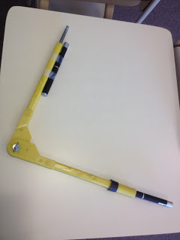

And move your body from one side of this board to the other:

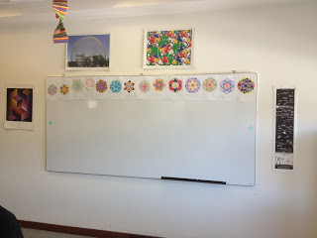

while keeping the lasers on the stars. (There is a green Expo-marker star drawn on each side of the board.)
Other rules:
- no changing the angle
- hold the vertex against your sternum
- always face the board, and no one stands between you and the board (safety, you know.)
A few of them are getting pretty good at it, so we appointed another kid to trace his path with chalk on the floor.
The children. They have some questions.

I know there are boring ways to get this point across with paper and pencil, but LASERS. THAT'S WHY.
Update: David Petersen made a Geogebra file to illustrate what is happening.
***

Mullets: The Only Lesson They’ll Remember

Matt 5/3
I admit, I would love for my 8th graders to remember a sweet lesson about Systems of Equations (when we used math to convince my wife to buy skis rather than rent them) or something more mathematical than what we did yesterday. But this will probably be the one they tell their parents about.
Mulletude: Just How Mullety Is It?
I was browsing Mr. Piccini’s blog a few weeks ago and came across a simple question: “Who has the more Mullety mullet?”
We’re done with state testing, so why not explore it? Here’s how it went down.
Prologue:
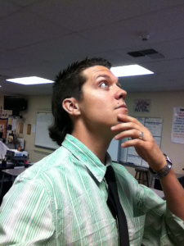
I gave myself a mullet. It was totally worth it; every student came into class with a smile, already curious. It also felt good to say, “Good morning! We’re studying Mullets today.”
A student, certain I was lying, exclaimed to her friend:
“Omigod! Look at the Agenda! It’s all about Mullets!”
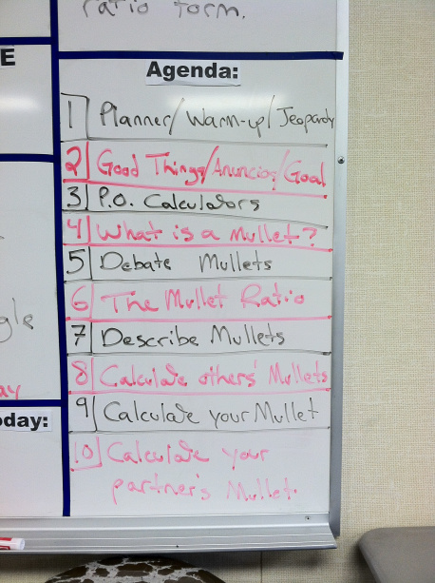
Part 1: Warm-up
To get them thinking, I started with this mullet question (#1). No numbers, no right answer, just taking a risk and interacting with a foreign subject.
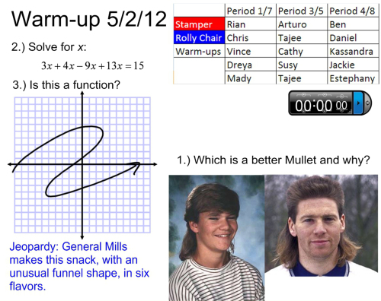
One student said, “No solution. They’re both terrible.” I loved it.
Part 2: What is a Mullet?
I previously discussed the lesson plan with my teammates, and discovered that some of them didn’t know what a mullet was. After the usual start-up business, I went to this slide.

I threw these two beauties on the board and asked, “Which is more Mullety?”
The best part is that students immediately began using the terms I introduced.
Kelsey: The hillbilly has a little too much Party in the back, even though his Business is the same as the cute guy.
Susy: I think the cute guy has the better mullet because it’s more even.
John: Yeah, his Business and Party are more proportional.
“Hold on to that word for later.” I said to John.
Part 3
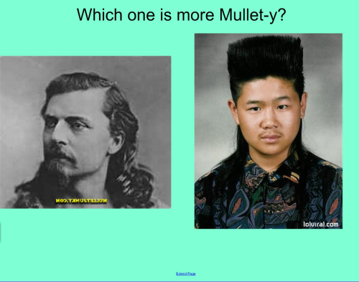

I then started introducing different mullets, asking which is more Mullety. I knew I’d baited the hook when a student said, “Can we rank their mulletude?”

Yes! Yes, student! Yes, you can! High five!

Part 4: The Mullet Ratio
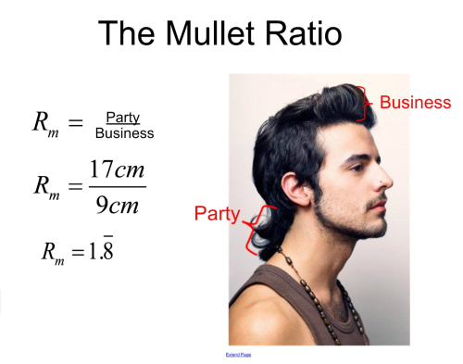
Students already recognized the vocab from before, so this transition was very smooth. And (here’s the best part) they all jumped on the math with no groaning. Students lunged for their calculators like bagels at a hunger strike.
As a sample, I guided the class as we calculated my mullet ratio on the board (See above; it’s 4.73).
“Show me a thumbs up if you got 4.73… okay, good. You’re ready to go.”
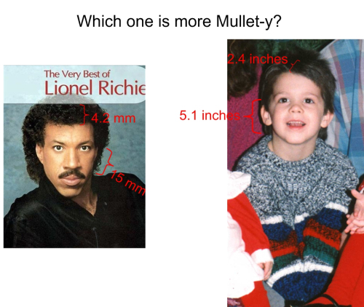
Then I took a seat, moved through the slides with a clicker, called on students (using my random cards), and let them discuss.
The above slide (Lionel Richie vs. me in 1989) led to a great discussion on the differences between mullet, afro, and Jerry Curl.
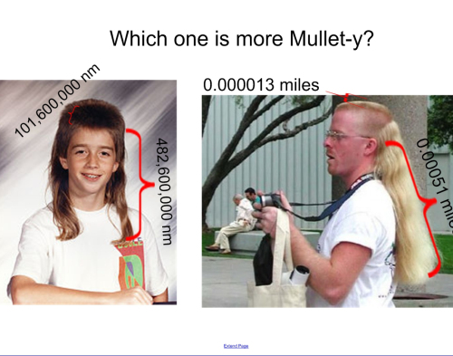
With calculators, they weren’t afraid of large numbers, and they realized that the ratios were still comparable, even when the units were nanometers and miles. After a few slides, we got into a groove, and I could start asking key questions:
“Mark, you calculate the hockey player, Dariana, you get Uncle Jesse”
“Does that answer make sense?”
“Why do you think his ratio is so much higher?”
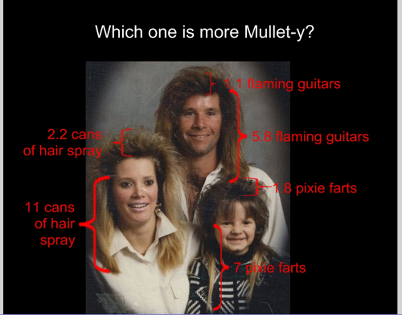
I also wanted to emphasize that the measurement doesn’t matter; it’s a ratio between two things. This slide and the one above it really drove that home. The Mullet Family caused a fit of giggles in every period, but who cares? It was fun for me.
Highlights:
“This is the best homework we’ve ever had.”
“Where did you find all of these?”
Part 5: On Your Own
Then I passed out pipe cleaners and rulers, along with copies of this worksheet.
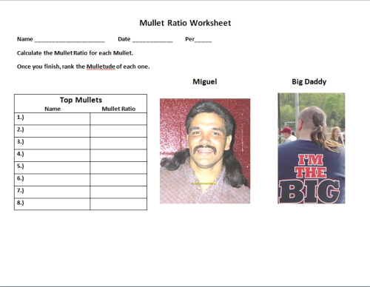
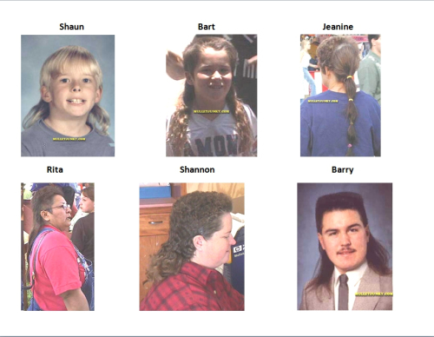
Students fit the pipe cleaner along the hair, then straightened it onto their rulers to find the measurement of the Party. The Business was usually pretty straight.
Ryan: Jeanine’s is more like a ponytail, is that okay?
Bree: How do I know where the Party ends and the Business begins?
Jose: My uncle has a haircut just like Miguel.
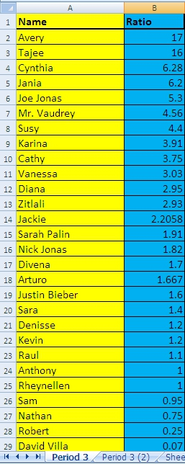
Highlight: For Big Daddy, one Honors student used 0.0001 cm for the Business, and got a mullet ratio of 2.5 million. This led to a great discussion of why that happened. What made the ratio so big?
(Also, I managed to make it the whole day without saying “the length of Big Daddy’s Business”, because I didn’t want any parents hearing that taken out of context. If I were still teaching seniors, I’m sure they’d have noticed the comedic appeal well before I did.)
Part 6: Your Own Mullet Ratio
Students who finished were directed to find their own ratio, which led to another great mathematical revelation for some of them:
Sara: I don’t even have a mullet!
Vaudrey: No, but you do have a Mullet Ratio. So find it. And find the Mullet Ratio of four other people, too.
Students worked for a few minutes, finished up their worksheets, and found each others’ ratios. Now here’s my favorite part of the day:
The Discussion
Oh, and some of them calculated the Mullet Ratio of photos on my Wall of Fame. Joe Jonas isn’t really in my 3rd period.
I quickly recorded all the student ratios into Excel and ranked them, then put it on the board and we had a discussion.
“What does it mean to have a Mullet Ratio of 1.0?”
“What does it mean to have a Mullet Ratio of less than 1.0?”
“Why can’t you have a negative Mullet Ratio?”
Student: “If my hair is longer, how come Karla has a higher ratio than me?”
“What’s the Mullet Ratio for Mr. Krasniak (the bald science teacher)?”
That was my favorite question; the initial yells of “One” and “Zero” turned into “No, wait… undefined!”
How I Know It Worked
Look at the Excel chart. Students in other periods got Mullet Ratios in the 20s and 30s, even 40s.
…meaning they falsified their data for a higher mullet ratio, and they knew what they were doing.
Teachers, download the materials here:
The Mullet Ratio - PowerPoint
Mullet Ratio Worksheet
Famous Mullets Worksheet
…and let me know if you try it. I’d love to see how this could be improved.
I’ll be writing about the Barbie Bungee lesson this week, once some paperwork is done. Until then, go read Fawn Nguyen’s lesson on the same thing.
UPDATE 14 MAY 2012:
Wow. Thank you all for the gushing, I’m humbled.
Thanks to dozens of Twittizens (that’s a real word, right?) who linked this page, to Dan Meyer for his review and kudos, and to Peter Price for his ‘Atta boy.
I got an excellent extension from Mr. Bombastic:
I would like to see some additional questions on this day or the next that do not involve measuring and calculating the ratio (just estimation and mental math). For example, sketch a person with a mullet ratio about half that of Barry; or sketch three different looking people with about the same ratio; or a person whose hair is half as long as Barry with a ratio three times as large; or sketch a person that has a mullet ratio of…
Also, from Dan Henrickson:
9. Tom has a Mullet Ratio of 6.2. His party in the back is 19 inches. Find the length of his business in the front.
10. Joe has a mullet ratio of 1.7. Find two possibilities for his hair lengths.
11. Write an equation that models all possibilities for Joe’s business and party. (define the variables used)
12. Graph all possibilities for Joe’s business and party:
Wicked. I’m definitely working those into a warm-up this week, though I’ll probably use the names of students in the class.
UPDATE 31 MAY 2012:
Thanks to a second-hand recommendation from @nsearcy17, I updated the Famous Mullets Worksheet with some doozies.
***

Thanks to all who teach math and are willing to put themselves and their practice out there for us all to enjoy and learn from. Let’s keep collaborating in 2013.
-- Geoff

