Math Blogging Retrospectus 2013

A sprinkling of what made the math blogosphere so great in 2013

About
This volume is simply a compilation of some of the math teaching blog posts that inspired someone else. I asked for a post or two that inspired them in 2013 and I received a tome. What’s better, compared to 2012, the authors are more diffuse, a flatter blogosphere.
2012 saw a boom in the number of math teaching blogs. 2013 marked the rise of the single service sites. Math Mistakes, Would You Rather Math, Visual Patterns and so forth. Some of these sites were started in 2012, but really received traction this past calendar year. If someone makes the “Always / Sometimes / Never” site, then we’ll pretty much be set.
I was struck at the movement in the categories. There were much more “Commentary” posts and fewer “Tasks” and “Stories” posts (as I categorized them in 2012 and this year) nominated than last year. It might just be a blip on the radar but it is an interesting anecdotal data point that might portend to where folks’ minds are going and where their needs are. It could also be due to the unscientific way I classified them. To that end, I left the Venn Diagram of Contents up to the reader to fill in.
I’m sorry, you were saying something?
So why did you do all this copying-and-pasting?
It does take a surprisingly long time to copy the blog posts, images and all, and get a consistent format going, so why bother? I mean, the posts are there and it’s called hyperlinking! What’s the deal? Well, for one, compilations are nice. I still burn mix CD’s of my favorite songs for friends. I’m old fashioned like that. Also, not everyone is plugged in to the blogosphere yet and they might not know where to turn. Lastly, it’s incredibly easy to miss a great blog post. With dozens of new math posts to read every day, it’s not feasible to keep up with them and retain the spirit of the posts in a meaningful way. This is an attempt at slowing down time.
But this thing is like, really long!
It sure is. Over 140 pages in printed form. Is that a problem? Flip through it. There’s a lot of pictures and diagrams. I’m sure you could find an interesting read within 90 seconds of flipping through this. Also, it gives you a chance to use up your schools copy machine paper and toner. Or, you know, you could just stash it on your e-reader.
So do whatever you like with it. Curl up by a nice log fire and your iPad and swipe the night away. Or head over to Kinko’s and shell out $35 and give it to your favorite math department head as a thank you for always making sure there are plenty of paper clips in the supply closet. Or hop on the computer and start contributing to the 2014 Retrospectus.
Geoff Krall


Table of Contents
Commentary
- The Unengageables, Dan … 6
- Deconstructing a Lesson Activity – Part 2, Fawn … 8
- Everything that’s wrong with traditional grading in one table, Scott ... 14
- Two-Column Proofs that Two-Column Proofs are Terrible, Ben … 15
- Gender and Mathematics, Kate … 20
- My Three Cents on the Common Core, Fawn … 23
- What Does it Mean to Understand Mathematics?, Robert … 25
- Kids Summarizing, Ben … 28
- The idea is the easy part, Jason … 31
- The Tests Matter, Kate … 32
- Dear Parents, Frank … 34
- It’s time for this meme to die, Michael … 35
- The association of tracking and self-concept, Daniel … 36
- Out of Class Interventions – Never Look Back, Michael … 38
- The Real Flip, David … 40
- Making a Gift More Valuable, Kate … 40
- Rules of (iPad) Engagement, Jonathan … 44
- Inverse Problems in Education, Jason … 47
- Blogging > Twitter, Michael … 50
- Direct Instruction V. Inquiry Learning, Round Eleventy Million, Dan … 51
- SBG: My Standards, Assessments, and Thoughts on Grading, Daniel … 55
- A Critical Ingredient Missing From My Math Blogging, Geoff … 58
Tasks
- When I Let Them Own the Problem, Fawn … 61
- 26 Questions You Can Ask Instead, Max … 70
- Partitive fraction division, Christopher … 72
- Imbalance Problems, Paul … 73
- Conics Hide and Seek, FracTad … 75
- Quadratic Frames – Totally Nguyening, Julie … 76
- Introducing Conic Sections, Sam … 78
- One way to introduce ratios so they make sense to students, Nicora … 81
- Made4Math – Function Operations, @druinok … 82
- Protocols for Mathematical Discussions, Jeff … 84
- Coupon Composition: Just In Time For The Holidays, Scott … 86
- Weekly POPs, Andrew … 89
- When Desmos Fails, Patrick … 92
- Open Letter to Sal Khan, Christopher … 95
- Projectile Projects, Audrey … 97
- [Makeover] Ferris Wheel, Dan … 104
- [Makeover] Low Arching Bridge: The Makeover, Andrew … 109
Stories
- An Encouraging Thought, Timon … 118
- The Pain and the Glory: Running Iowa’s BIG Competency Based School, Shawn … 119
- Routines, Langermath … 121
- Measurement, explored, Christopher … 123
- Day 62: Explorations and Lack of Effort, Justin … 129
- Learning is a Fluorescent Light, Ben … 131
- #DuckFace, John … 133
- Mistakes, Radicals, Rational Exponents and Partitioning?, Michael … 136
Venn Diagram for Reader’s Use or Facilitation
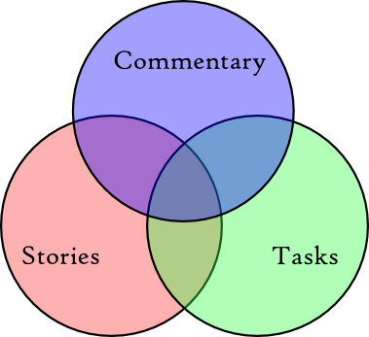

Commentary

The Unengageables
Dan 6/12
Halfway through my curriculum design workshops, I ask teachers to share their "secret skepticisms." These are the sort of objections to new ideas that often take the form, "That would never work in my class because …. " They share them anonymously in a Google Form before lunch.
The secret skepticisms came back in Phoenix two weeks ago and these four were easy to group together:
This process assumes every student wants to learn or has the motivation to learn.
How do I get students to buy-in when they struggle with any problem solving skills at all?
What if my kids don’t know enough math to be engaged?
This approach is very compelling but this lesson will have additional challenges with students who could care less about getting involved. It is difficult getting any engagement by students who have little interest.
These responses were troubling. They seemed to emerge simultaneously from a deficit model of student thinking (ie. students lack engagement in the things we think they should be engaged in) and a fixed model of student intelligence (ie. these students are unengageable and that's just the way it is).
Neither idea is true, of course.
What is true is that after years and years of being asked questions every day, students may find it odd to be asked to pose their own. After years and years of associating "math class" with a narrow range of skills like computation, memorization, solution, they may find it odd when you try to expand that range to include estimation, abstraction, argumentation, criticism, formulation, or modeling. After years and years of acclimating themselves to their math teacher's low expectations for their learning, they may find your high expectations odd.
They may even resist you. They signed their "didactic contract" years and years ago. They signed it. Their math teachers signed it. The agreement says that the teacher comes into class, tells them what they're going to learn, and shows them three examples of it. In return, the students take what their teacher showed them and reproduce it twenty times before leaving class. Then they go home with an assignment to reproduce it twenty more times.
Then here you come, Ms. I-Just-Got-Back-From-A-Workshop, and you want to change the agreement? Yeah, you'll hear from their attorney.
"But it's tough to start something this new in April," a participant said.
That's true. For similar reasons, it's tough to start something new in a student's ninth year of school. That doesn't mean we don't try. Thousands of teachers successfully change their practice mid-year and mid-career. Luckily, there are also steps we can take to acclimate our students gradually to new ways of learning math.
Here are three of them:
- Model curiosity. I asked some kind of miscellaneous question on every opener. The questions weren't mathematical. (eg. How much does an average American wedding cost? What's the highest recorded temperature in Alaska?) I pulled them from different published books ofmiscellaneous facts and figures. This cost me very little classroom time and bought me quite a lot. It benefited my classroom management but it also built general, all-purpose curiosity into our classroom routine. That helps enormously when it comes to mathematical modeling where we're telling students that we welcome their curiosity.
- Ask the question, "What questions do you have?" Show any image or video from the top ten of 101questions. At the longest, this will take you one minute. Then ask them to write down the first question that comes to their mind. Take another minute to poll the crowd for their responses. (I model one polling procedure in this video.) This will also help your students to become more inquisitive and it will demonstrate that you prize their inquisitiveness.
- Make estimation part of your daily routine. Modeling takes place on a cycle that runs from the very concrete to the very abstract and back again. Typically, we drop students halfway into the cycle with all kinds of abstract representations (formulas, line drawings, graphs) already given. Give your students more experience with concrete aspects of modeling like estimation by taking an image or video from Andrew Stadel's Estimation 180 project and showing it to your students at the end of class. Ask them to write down a guess. Poll their guesses. Find out who has the highest guess and the lowest guess. Then show the answer.
Your students will come to understand you prize curiosity in general and their curiosity in particular. They'll understand that mathematics comprises more than the intellectual hard tack and gruel they've been served for years. At that point, you can help walk them through activities involving estimation, abstraction, argumentation, criticism, formulation, modeling, and more, aware that each of your students can be engaged in challenging mathematics, that none of them is unengageable.
Related
- No blogger tore through a teacher's conviction that teaching would be great if only we had different students harder than Kilian Betlach, whose nom de blog was "Teaching My Ass Off." If you only came to the blogosphere in the last four or five years, after Betlach moved on from blogging to school administration, you should carve out some time this summer to dig into his entire catalog. Here is a sample I quoted on this blog, as well as his own highlight reel.
- If you work with teachers, you'll appreciate Grant Wiggins' recent postwhere he describes some useful interventions for situations like mine.
Featured Comment
Kate Nowak:
Corny as it sounds, don't give up. The first and second and tenth attempt at -whatever it is that's a very different approach in your class – a 3Act, a project, a whatever it is — is probably going to either fall flat or fail spectacularly. The kids might get mad and weirdly uncooperative. Things might happen that you didn't anticipate and don't have the skills to handle. You aren't going to get good at planning them until you get some experience planning them. You're going to suck at this for a while. [..] You need to keep stretching the rubber band over and over until it loosens up and doesn't snap back all the way.

Deconstructing a Lesson Activity - Part 2
Fawn 7/8
Deconstructing a Lesson Activity - Part 1
No matter what I write in this Part 2, I hope it's not a wrap-up of this topic. On the contrary, I hope it opens up and extends our conversations on improving the implementation of rich tasks in our classrooms.
Physical arrangements, whiteboards, groupings. The student desks are set up in rows and columns in my classroom. Not terribly exciting, but don't judge a teacher by his/her furniture arrangement. When I'm given 38 desks (I had 37 students in Math 6 last year) and x square units of floor space, my creativity is stifled.
- Work with whatever space you have. Push the desks together, pull them apart. Kids don't mind sitting on the floor. (If they do, ask them to stand and see if they like that better.) Can they work in the hallway — or outside if you're in warmer climate — where you can see them from inside the room? Just make sure you are constantly roaming among the groups.
- Big-ass whiteboards. Nathan just wrote a letter asking for these. Last summer I sent my principal the link to Frank Noschese's post — and the whiteboards were waiting for me when school started. I got ten 2' × 2.6' boards, each at $10.50 from here. Please get them. By far the single best school purchase, worth their weight in gold. Just how much do I love these? You touch my whiteboards, I'll kill you.
- Randomly assign kids to groups. We do group activities often enough that eventually pretty much every kid ends up with somebody new in the group. If you try to group them "heterogeneously" with high-medium-low kids, then you accomplished just that — you just told them who's high, who's medium, and who's low without saying a single word. Kids aren't stupid. I use Instant Classroom to randomly assign. You can always use your discretion to change a few kids around after the computer picks them — but still let the kids think that the computer did all the choosing. I never heard any whining. Kids don't whine at what the computer says.
- Group roles. What are these?? (No, I'm asking you!) Like "facilitator," "recorder," "reporter," "budget person," "dietitian," "hairdresser," etc... These roles wouldn't work with problem-solving tasks. I don't want a kid sitting there doing nothing because it's not time for his role to occur yet. Please, no assigned roles. Except the one about trying to solve the problem.
Grading this type of task. I don't see dead people, but I hear student voices all the time. While I enjoy grading as much as I enjoy poking needles in my eyes, I hold certain beliefs about grading problem-solving group tasks (and the student voices that guide mess with me). And my possible reasons/solutions for them?
- It is wrong to give a lower grade because they socialized too much instead of focusing on the problem. (We're teenagers and you expect us not to socialize? OMG! Did she just put me and Joey in the same group? He's sooooo cute. How's my hair? This problem is just too hard anyway! We really tried but we got stuck and you were too busy with another group to help us. Laura is such a show-off. I wish Andrew would grow up.) If the whole group is off task, then I'd seriously reconsider the relevance/engagement level of the task and the social dynamics of the group. It's back to that Step 0 of picking the right task that's engaging and has low entries so everyone can get on board. It's my fault that the kids are not on task.
- It is wrong to give a lower grade because they did not come up with the correct solution when the bell rang. (Sucks that we didn't win the game today, but we still had a good game, right? Didn't we work well together as a team, especially on defense? Nice block there, Mitch. I almost had a pick right there if my damn leg didn't cram up! Ha, now I know what Coach meant by the hook-and-lateral play!) Our goal of wanting kids to engage in problem solving is to honor the process that they go through — their thinking, their collaborating, their critiquing one another. We want to tap kids' two most abundant natural resources: their curiosity and their need to socialize. I simply cannot justify putting a grade on this.
- But bottom line, you grade it if you want to. Don't grade it if you don't want to. I graded fewer than 50% of the tasks that were done in class last year. When I did "grade" them, I gave full credit. To worry about how to grade group tasks is really to sweat the small stuff. That said, if you had a handout for each student that went with the task, then it's fair to give the individual grades.
Establishing a classroom culture of problem solving and finding time to do so. Stephanie Reilly's question in Part 1 helps me shape what I'm trying to convey in this section.
- I can't think of a better day to start doing problem solving with kids than Day 1 of school. Kids pick up on what we say we value and what we do to back that up. Set a goal to do one task every two weeks. Too ambitious? Then once a month. Just please don't give up. On Day 1, I might just start with Pyramid of Pennies (Ha! I nailed the spelling there) or the new Bracelet Craze problem. If I were a student and knew that all my teachers would go over "Rules & Procedures" on the first day of school, then I'd be tempted to feign high fever and induce vomit to stay home.
- However, you need to come up with guidelines for group work that you will share with kids before they begin. Culture takes time. It takes a lot of reminders too. I'll share what I say [for guidelines] to the kids under "group time" in the last section of this post about implementation.
- Post the strategies for problem solving in your classroom. I have these on just regular size paper, but laminated, and we refer to them all the time. You know, strategies like these ones.
- Teacher concern: I'm afraid I don't have time to do this because there's still so much to cover in the textbook. You can't do this and feel guilty. (Remember how crazy in love you are supposed to be with the tasks you choose for them?) You have to be okay with not being able to go cover the textbook front to back. The person who tells you that you have to do so is delusional and mean. Common Core does have fewer domains and standards at each grade level. Spend this summer mapping out key concepts and lessons. I believe in having some sort of pacing guide, but I don't believe in having it dictate how we move through the year — the kids and your formative assessments of their learning should govern the flow. I haven't done research or have hard data of my own to give you, but I believe your kids will do better on year-end assessments if they have been exposed to problem solving throughout the year. Trust me? :)
- Carve out time by re-examining and possibly eliminating things that you normally do.(For the last two years our students had two periods of math each day. I think this is going away next year, so I have to re-think this through too.) Besides just having better classroom management — meaning it's not taking you 10 minutes to get the kids to settle down and start class — how effective is your use of class time when you do these items?
- Warm-ups
- Games
- Review games before a test
- Pre- and post-surveys
- Benchmark tests (beginning, mid-year, end-of-year)
- Stuff that kids can do at home blindfolded (I think we know what these are.)
- Class parties (What the hell are these? I like parties too, but let's have them at lunch time.)
Lastly, please don't forget that these are perfectly good SCHOOL days for doing mathematics: First day of school, last day of school, last day of the quarter, first day of the quarter, whatever day. The day before Christmas or spring break. The first day back from an extended vacation. Sub days. Your sub is perfectly capable of passing out a meaningful handout (it's meaningful because you made/selected it), and it will go well because you have already pre-taught the kids what's on that handout — give them a sneak peek at it! — and shared with them your expectations the day before you leave. If there's one assignment worth grading, then it's the work that they do while your sub is there.
Finally, implementing the task. Thus far I've covered the behind-the-scenes stuff that was missing from my lesson posts. The task itself is actually a lot more straightforward — pretty much what you read on my lesson posts is my best storytelling of what went on in the classroom.
If you're doing an actual 3-Act lesson a la Dan Meyer, then you're good to go! These are some of my favorite 3-Acts that I'd written up:
- File Cabinet
- Taco Cart
- Equilateral Triangles
- Penny Pyramid
So, this is an outline of how I implement a non 3-Act problem-solving task.
Ask for a volunteer to read the problem aloud (5 minutes). Each kid gets a copy of the problem to follow along. After it's read aloud, everyone reads the problem again quietly to self. Then my questions begin for the whole class:
- What are we trying to solve for in this problem?
- What information do we know?
- Is there information that you wished you knew? Why is it not given then?
- What's the first strategy you have in mind that might help you attack this problem? And why did you say 'do a simpler problem'?
Depending on the task, I've also begun to ask — instead of the questions above — these two questions from Annie Fetter (YES! Please watch the 5-minute video if you haven't.) The kids write down their answers, and I randomly call on them to share.
- What do you notice?
- What do you wonder?
Quiet individual work time (10 minutes). You have to allow for some individual thinking time. I can't work on a problem when others around me are talking. So I set a timer for 10 minutes. Of course it doesn't have to be 10 minutes, it's up to you and depends on the problem, but this is NOT the amount of time in which I expect any kid to solve the problem. If a kid does solve it quickly, then hopefully you have an extension — you should always have an extension — ready for this kid. If a bunch of kids could solve it quickly, then you've chosen the wrong task, too easy. Back to Step 0.
I say something like, "I'm setting the timer for 10 minutes so you can think about and start the problem on your own. There's no talking and no sharing at this time. You'll get in groups to continue to work on the problem after the quiet time. You're welcome to get up without my permission to get any tools (protractor, compass, ruler, graph paper) that you need. Do you have any questions for me before you begin? Remember our rule of NEVER TELL AN ANSWER. Go!"
While they're working, I use Instant Classroom to form the groups and move some kids around if necessary.
Group time (30 minutes). Again, this is a very generic time allowance. You're the teacher, you'll know by how much to shorten or lengthen the time depending on the groups' progress or lack thereof.
I say something like, "You will now continue to work on this with your group mates. You will use the large whiteboards to show your work. Everyone has his or her own marker to use. But now I'll explain more by what I mean by 'never tell an answer.' If you think you have an answer already from working on it just now by yourself, then please don't share it with your group. Choose to be the last person in your group to speak because I actually need to speak with you first.^{[1]}
... Also, every time we do a task and I hope we get to do lots of them, I ask the computer to randomly assign you in groups, so if you have a complaint, take it up with the computer. If your group would like more individual work time, like 5 more minutes, then that's great and fine by me.
... I'm interested in your working together to solve this task. I'm not asking you to become best friends. One person speaks, everyone else listens. Argue about it, but be respectful. Ask questions of one another. Don't take so-and-so's word for it, ask him or her to explain it. Don't let others think for you. Help each other out. Maybe this whole structure is new to you, don't worry about it. I'll walk around and listen in and smack you in the back of the head when you don't quite have it right. Just kidding. Not. Yeah, I'm kidding. Go!"
I actually repeat much of this same spiel throughout the year.
[1] So I talk privately to the student who does have the correct solution and suggest a few things:
- Can you solve the problem a different way? (It's important that you do not force a student to find another strategy especially when you can see that she has found the most elegant one already — this just seems counterproductive to me.)
- I'd like you to try the extension to this problem. What if...?
- I need you to go back to your group and practice really good listening skills. I just want you to listen to your teammates talk. Then see if you can help them by asking questions only. Kinda like what I normally do with the whole class. You may give them one hint if they're really stuck. You want to give that a try?
Teacher role during this group time. This is where the book 5 Practices comes in for me. I've been presenting its contents at workshops over the last two years. There's no way I can do it justice here, and I've already written a brief post on it just as a quick review.
The gist of it is that I go around and listen in and check on the groups' progress. I ask questions of specific individuals in the group.
Hey, Julia, can you explain to me what I'm seeing here on the whiteboard? Maybe you didn't write it, but whoever wrote it, did he/she explain it to you?
Jonathan, I'm not sure where this equation/number comes from. Please explain.
I saw this same strategy at Erika's group. Allie, did you come up with this strategy? If not, what is yours? Where is your understanding of the problem so far?
Joey, what has Cindy contributed to the group thus far? (If Joey says, "Nothing," then I'll ask Joey again, "What have you contributed?" I don't remember ever having two people in one group who have not shared anything. Remember they had 10 minutes of quiet time to work on this already. They have something to share!)
Cole, your group is over here. I don't want to tell you that again. (And I never have to.)
Now, when there's one group that has made a lot more progress than the other groups, I ask for the whole class attention and say, "Julia's group has made an important connection, so I'm going to ask someone from her group to share with the class one hint, one strategy, or one something that would help all the groups along. Listen carefully."
If none of the groups has made progress, then the teacher needs to jump in with a hint. But be patient too!! You have to watch the clock. How much time is reasonable? Are the kids mostly working and asking questions of one another? If they're exhibiting productive struggle, then let them be. Nobody is going to die if you extend this lesson another day.
The SHORT version can end here after the groups have figured out the solution. Maybe not all the groups finished, but remember, most of them did. Depending on the task, depending on the students, depending on time, depending on whatever you deem as important, you can end the lesson here andnot feel guilty that there was no large-group sharing at the end, no connections made among the different strategies. Instead, focus on all the mathematics that you did allow the kids to be engaged in. I see enough teachers feel discouraged that they "didn't get to do everything that I wanted to do" — it's not about doing everything, it's about doing something to get started, to get better, to suck less each day, to remember why you went into teaching in the first place.
The FULL version includes the "connecting" piece that the 5 Practices refers to. It's about making connections between the different strategies, and you accomplish this by having the groups share their work on the whiteboards. (This step is moot if the task didn't have more than one strategy.)Kelly O'Shea is my whiteboarding goddess. And connecting is also about you the teacher making the connections of all their work back to the original intended learning goal of the task.
Who says you can't add the connecting piece to your short version 2 or 3 days from now (hell, even two weeks later) and make it a complete kick-ass full version? In real life we return to problems all the time. Snap a photo of each whiteboard if the kids need to refer back to their work at a later date but you have to use the whiteboards for another class in the next period. Problem solved.
You can do this. We can do this together.

Everything that’s wrong with traditional grading in one table
Scott 11/7
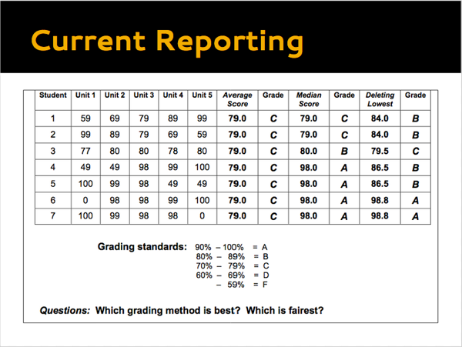

Two-Column Proofs that Two-Column Proofs are Terrible
Ben 10/16
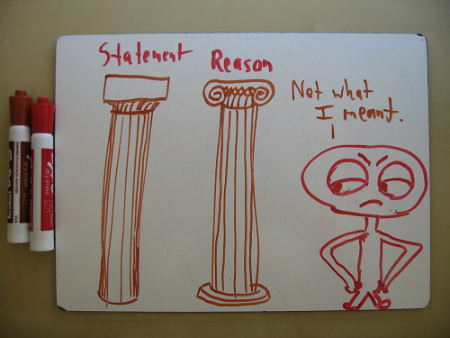Theorem #1: “Justifying steps” ought to be an opaque, frustrating process.
Statement | Reason
1. In an argument, all steps must be justified. | 1. Definition of Argument
2. In real, adult arguments, such justifications often take the form of cogent explanations, appeals to agreed-upon facts, and clear, explicit reasoning. | 2. Definition of Justification
3. High schoolers are too simpleminded for such techniques. | 3. Fundamental Axiom of Condescension Towards Young People
4. Besides, it would take too long for instructors to grade such arguments. | 4. Overworked Teacher Postulate
5. Instead, high schoolers ought to justify their arguments by reciting the names of theorems and axioms, invoked as if they were not logical statements but magical spells. | 5. Property of Nonsensical Schooling
6. Logic ought to be learned through two-column proofs. | 6. Theorem of Maximal Damage
Before sarcasm carries me too far down the rhetorical river, let me plant an oar and explain my stance.
I see the appeal of two-column proofs. They’re clean. They’re easy to grade. They offer a scaffold, a structure, a formal framework for students to lean on. Properly understood, they function almost like diagrams of arguments, and can serve as useful tools.
But in practice, they often obfuscate more than illuminate. A good proof contains not only bare statements of fact, but connective tissue of explanation. In a two-column proof, the organic matter that holds the argument together is flushed away, and replaced with a right-hand column full of terse bullet points that students may use without understanding at all.
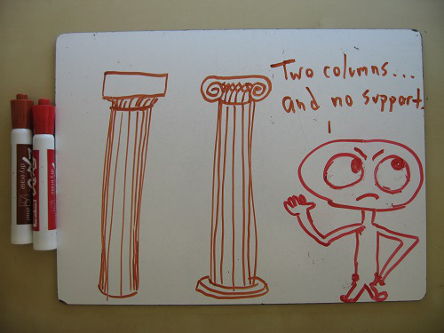
Theorem #2: A proof is just an incomprehensible demonstration of a fact you already knew.
Statement | Reason
1. In a good proof, each individual step is obvious, but the conclusion is surprising. | 1. Definition of a Good Proof
2. In many two-column proofs—especially those taught earliest in a geometry course—each individual step is mystifying, while the conclusion is obvious. | 2. Definition of a Stupid Proof
3. Experience with such proofs will help students see logic as an alien enterprise, foreign to common sense and deaf to the simplest realities. | 3. Definition of Students Not Being Idiots
4. Logic ought to be learned through two-column proofs. | 4. Definition of a Bad Idea
My beef here is that a geometry course often begins with totally mystifying two-column “proofs” of elementary facts. For example, take the “Right Angle Congruence Theorem,” which states that all right angles are congruent to one another:
Statement | Reason
- Angle 1 and Angle 2 are right angles. | 1. Given
- m(Angle 1) = 90o, and m(Angle 2) = 90o | 2. Definition of Right Angle
- m(Angle 1) = m(Angle 2) | 3. Transitive Property of Equality
- Angle 1 and Angle 2 are congruent. | 4. Definition of Angle Congruence
When I run such arguments by math PhD friends, they look at me dumbfounded. “Why would you prove that?” they ask. There are important lessons here, surely—for example, that even seemingly obvious truths demand justification. But the argument hinges on the fussy technical distinction between the angle (a geometric object) and the measure of the angle (a number describing the size of that object). If you’ve ever been a 9th-grader—or even met one—you know that such a distinction isn’t the most inviting welcome mat to geometry.
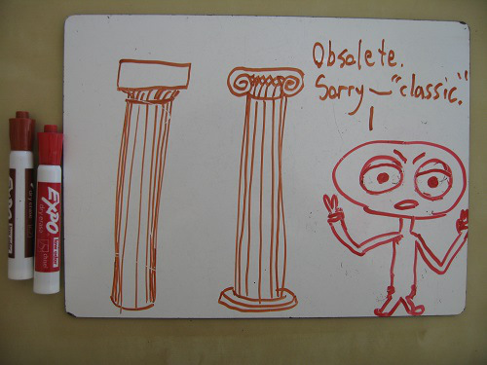
Theorem #3: Two-column proofs are great preparation for the future.
Statement | Reason
1. High school ought to prepare students for their remaining years as scholars, and their future decades as citizens. | 1. Definition of Education
2. Real mathematicians employ two-column proofs all the time! | 2. Theorem of Lies
3. Two-column proofs are also used in the workplace and the political sphere. They’re everywhere! | 3. Theorem of Even More Lies
4. I mean, we wouldn’t be using such an artificial, opaque system for teaching logic if it didn’t have some real-world utility, right? | 4. Definition of Wishful Thinking
5. Logic ought to be learned through two-column proofs. | 5. Axiom of Systemic Stubbornness in Education
Finally, there’s the fact that no mathematician—indeed, no adult human other than a geometry teacher—uses two-column proofs. Flip through a math journal, and you’ll find only what geometry textbooks call “paragraph proof”—that is, English prose laying out an argument. Sure, the proofs are dense, and often interrupted by equations spanning the width of the page, but they’re written to be understandable, not to adhere to an artificial boxed-in format.
How do we fix the system? Here are some imperfect suggestions:
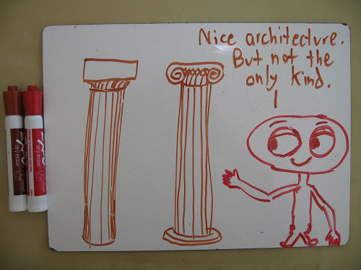
Begin with better proofs. Start a geometry class with a unit on proof structure, and don’t worry about what you’re proving. Prove that there are infinite primes. Prove the Pythagorean Theorem. Prove that there’s no school on Saturday. Prove that a bear would defeat a lion in combat. The axiomatic development of Euclidean geometry can come later. First, the students need practice playing the game.
Don’t let students give “Definition of A” or “Theorem B” as reasons. At least, not at first. They need to understand that a reason is a truth, not a phrase. The current format of two-column proofs obscures the logical content that underpins arguments. Instead, of letting students invoke “Congruent Supplements Theorem,” make them write out, “If two angles have congruent supplements, then they themselves are congruent.” (You can wean them off of such wordy explanations later.)
Use two-column proofs like spice or seasoning: Sparingly. They can be helpful clarifying agents. But two-column proofs ought to occupy a place in geometry similar to the “flow proofs” that some textbooks like to invoke. They should be a “sometimes” food, not a staple of the diet.
Consider adding a third column. My own geometry teacher started the year with three-column proofs: (1) Statement; (2) Reason; (3) Previous Steps on which This Step Relies. This way, a “reason” does not feel like a secret password, but what it is: a link between statements that have come before and the current statement.
I’d love to hear other geometry teachers’ take on the two-column proof, especially anyone who’s got a passionate (or dispassionate) defense for their pedagogic value.
For related ramblings, check out Black Boxes (or: Just Say No to Voodoo Formulas) andFor #9, I got “snake”.

Gender and Mathematics
Kate 2/5
This morning’s New York Times had a headline reading: “Girls Lead in Science Exam, but Not in the United States.” The article started with a rather fascinating graph showing country-by-country performance on the OECD test with a display of the percentage gap between male and female students. In the United States, the average scores were 509 for males and 495 for females; thus the males outperformed females by 14 points, or around 2.7%. Compare this with Japan’s data: Average scores of 534 for males and 545 for females gave the girls about a 2% lead.
Both the graph and accompany article interested me enough that a printed copy can now be found on my office door, along with my own editorial remark at the top. (See photographic proof.)
I found the Times article through my Twitter feed. Other interesting articles that hit my feed were a blog post by Hariett Hall (“Gender Differences and Why They Don’t Matter So Much“) and a 2005 article from Time magazine on “The Iceland Exception: A Land Where Girls Rule in Math.” [Michael Shermer linked to Hall's article, and I shared the link about to the Iceland article.]
After I posted the Iceland article, John Wilson (@jwilson1812) asked for my opinions “about what this report from Iceland might suggest, what’s generalizable, what isn’t, and so on.” In this post I’m hoping to capture a longer response than what 140-characters would allow.
1. The United States has a gender discrepancy problem in mathematics.
To me, this point seems somewhat obvious. But given the headline from Hall’s article, and other comments, conversations, and feedback I’ve received over the last decade or two, it also seems clear that it isn’t obvious to everyone. I mean “problem” in the above statement as in, “Something we ought to be concerned with pondering and understanding, and (if possible) fixing.”
2. A partial fix could be fixing the educational and employment climate.
As the Times article points out,
Researchers say cultural forces keeping girls away from scientific careers are strong in the United States, Britain and Canada.
Hall’s article points out that men and women are different, and that their skills, interests, and aptitudes are shaped both by biology and by culture. Talking about how biological differences may (or may not) influence mathematical aptitude gets murky very quickly, and I am certainly not qualified to say anything one way or the other. On the other hand, talking about how cultural differences influence mathematical aptitude is a conversation we ought to have frequently.
3. How can we fix the problem?
The real answer to this question is, “I don’t know.” But I have a lot of hunches.
Hunch #1: We need more collaborative classrooms.
Somewhere a long time ago I read about a study done on middle school aged children playing soccer during recess or physical education classes. The students were separated by gender. In each group, researchers looked at what happened if a soccer player were injured during the game. With the boys’ game, an injury momentarily paused play; a spectator was swapped for the missing team member; the game quickly resumed. With the girls’ game, an injury stopped play. The girls (on both teams) decided they’d rather not play without their injured friend on the field, and so they took up to doing another activity altogether.
I think this parable fits with how I picture what happens in math classrooms. While I’ve taken lots and lots of math classes, I was never able to take a class that would fit any description other than “traditional, chalk-talk, lecture-style, definition-theorem-proof.” The math classes I saw as a student were like the boys’ soccer game: If one student fell behind, or got confused, or failed at mastering a concept, the class would pause, remove the “injured” participant, and continue moving forward. The aim of the class was the soccer game itself and not who was playing and who wasn’t. In my experiences, math classrooms are places where students practice an individual sport (like tennis) concurrently. They are not places of collaboration or conversation or team work. The coach is interested in keeping the game moving forward (even if dropping players is necessary).
I think this is bad for a few reasons. But the top reason is that I think it gives everyone (both women and men) the false impression that mathematics is an individual sport where the performance of the athlete is a solo endeavor. But real mathematics is nothing like this. As mathematicians, collaboration is essential. We publish papers together. We give weekly colloquium addresses to teach each other new ideas and to solicit help on tough problems. We travel to conferences to have conversations with others and work through problems as a team. Why do our classrooms give the opposite impression of how mathematics is done?
Showing the world (and girls especially) that mathematics is not done in isolation is crucial. I believe that marketing mathematics as a collaborative, socially-based adventure would attract more girls to become mathematicians and scientists of all types.
Hunch #2: Attract, hire, and retain more female math professors.
I did my undergraduate work at U.C. San Diego where I was a “Pure Mathematics” major. At the time I was there (early 2000s), the department had about 55 full-time tenured math faculty members. Of those, 5 were female. [See their department directory today for comparison.] One of the women professors mentioned that, at the time, among the “Top 25″ math departments, U.C.S.D. had the highest percentage of tenured female math professors. What percent is 5/55? About 9%. This statistic was quoted with pride: “We are so great to have so many women! Among the math professors, only 90% of them are male here! Fantastic job!”
I think our cultural conception of what “Mathematics Professor” looks like needs to change. Yes, there are plenty of math professors I know who fit the stereotype exactly. But then there are those who look like me. The way we shift the stereotype is to disprove it. We need more minority math professors, we need more female math professors, we need more math professors who aren’t 60-year-old white males with chalk dust on their pants.
On keeping women in science: One thing obviously in need of repair in academics is promoting careers that allow for a work-life balance. Right now, I am expecting my second child. When I complained recently to colleagues about the “Leave Policy for New Faculty Parents,” one responded, “Well, when each of my five children were born, I was back at work the next week.”
I wish I could say this were not the norm. But it reminded me of a conversation I had 10+ years ago, when one of the women faculty at U.C.S.D. told me about giving birth on Thursday and being back teaching classes the following Monday.
I love my job, I love my co-workers, I love my students, I love being in the classroom. But my employer’s Leave Policy, combined with the remarkable and surprising lack of empathy from colleagues about said Leave Policy, has certainly made me consider jumping ship. Academia needs to wake up and offer a family-friendly, parent-friendly work environment where people are valued for being people first (and professors second).
Hunch #3: We need to teach teachers differently.
As an educator, it’s difficult to structure one’s classroom in a way dramatically different from the one you were in as a student. You think back, “How was I taught this idea?” and that’s the easiest answer to, “How will I teach this idea to my own students?” You can see this all over the math community as the traditional, blackboard-based, definition-theorem-proof machine chugs chugs chugs along. Thankfully, there’s been a giant movement in recent years toward changing the idea of what a classroom should look like. (See my earlier ideas about collaboration.)
Given that we are all inclined to teach the way we were taught, and given that for a very long time it was accepted dogma that boys always outperform girls in mathematics, it’s easy to see how this idea could still linger. Not that I think any particular person goes into their calculus classroom and says, “Sorry ladies, everyone knows you don’t have the skills to be really good at this.” But I do think (and I have seen ways) that this underlying stereotype has affected the way people teach.
My Conclusions
1. The gender imbalance in mathematics has some cultural factors.
2. We ought to be concerned with what those factors are, and how to change them.
3. Changing them is a process that will definitely take a lot of time and probably take a lot of money.
4. My best strategy at overcoming this problem is this: Become a female math prof who posts blog articles about the gender imbalance in mathematics. Unfortunately, this strategy is probably not widely implementable. It definitely takes a lot of time. An easier thing to do is to support and encourage those who are doing this or things similar to it.
5. My next best strategy for overcoming the problem is: Seek out like-minded people and work together to figure out how we can change the math culture.
As I said at the beginning of this, I know there is a problem and I don’t know it’s solution. But I’d be happy to hear what you think it might be.

My Three Cents on the Common Core
Fawn 6/8
(Inflation.)
I have a small side job as a co-presenter for the UCSB Mathematics Project. I imagine like many other math workshops around the country, our focus has been on the Common Core State Standards. For the last few years, we've run summer week-long workshops and follow-up days during the school year. Our work continues with a new group of participants this July. To fulfill my role and for my own good, I've done a fair share of reading up on the Standards — albeit mostly of middle school, algebra, geometry — and analyzing the Smarter Balanced assessments.
But I was naive enough to think that everyone — not literally everyone, but most — was on board with CCSS-M. (Forty-five states is most, no? And Texas doesn't count, Texas is a country.) Not until a few months ago that I noticed the hashtag #StopCommonCore on Twitter. So I've been sifting through a lot of news articles and posts about the anti-CCSS campaign. They are aplenty and multiplying.
It doesn't take long, however, to sense the political leanings when questions arise regarding the creation, funding, and implementation of Common Core.
I get dizzy after a while reading polar opposite statements regarding the same subject:
- it's fuzzy math —> no, it's robust
- it's one-size-fits-all —> no, it promotes individualism
- it shuts the door on innovation —> no, it promotes creativity
- the Tea Party is in on this —> and your point is?
- this is a federal mandate —> no it's not
- it's costly —> like what we have now isn't?
- it prepares kids for college —> no, kids will not be college-ready
- it's data mining —> not really
- Mom, he's looking at me —> No I'm not!
- It was nothing like that, penis breath! (from my all-time favorite movie)
I wonder if this is what marriage counselors sit through.
No matter what mandate comes down the pike, who funds it, or how the assessments will change, the teaching of mathematics — in a non-sucky way — to a roomful of students remains up to me. I may have limited say in the math content, but I get to design each and every lesson. That's a huge responsibility but one I'm grateful for. No one makes me teach a certain way, and I don't abuse this privilege as I see it as a privilege to be a public servant and yet granted this enormous trust to do my job as best I can.
It's easy to talk the talk. It's easy for me to cheer on CCSS or to knock it down through social media. It's easy and inspiring to watch a workshop presenter wholeheartedly do a lesson that he/she believes exemplifies Common Core. It's easy to follow a textbook that has been stamped with a seal of CCSS approval. It's easy to tell people I'm both a presenter and an attendee at Common Core workshops. It's easy to nod my head and say that I'll do something.
The walk requires hard work. It requires implementation in the classroom. Common Core or no Common Core, I don't see my bedtime changing. When I began teaching [science] in the Fall of 1988, my bedtime was between midnight and 1:00 AM. Now, my bedtime is usually after 1:00 AM. There are far better teachers than I am who get 8 hours of sleep a night. I'm just slow at this — slow at trying to hone my lessons so that Joey won't fall asleep, Erica won't watch the clock every 2 minutes, Anna won't scribble hate messages to me in her math journal, Matt won't spend the full period doodling all his lovely doodles.
I can do well by my students with or without a national curriculum. I did not go into teaching with this question: What set of math standards will I be teaching?
I don't really care what the standards are. And I don't mean this flippantly. I mean this:
- No set of standards will appease everyone nor will it fit the needs of every child.
- No set of standards will be fair.
- No assessment — the bubble kind, the computer-adaptive kind, or even the performance-based kind — will truly measure a child's learning.
- No set of standards will feed a child's hunger. Nor heal the myriads of abuse some kids go through.
- No set of standards will make me a better teacher; lesson designs do that.
Speaking of lesson design, what does a Common Core lesson look like? Is there such a thing? I mean prior to Common Core, we know what a good solid lesson looks like. Now through the lens of Common Core, is this same lesson any less good? Do we have to throw out parts of this lesson because those parts aren't Common Core aligned? What the hell are we talking about?
Let me be super generous and say that I've posted 30 solid lessons, each lesson say takes 2 days, that's a total of 60 days of stuff I'm pretty proud of. But there are 180 days of school, what am I doing the other 120 days? Probably a lot of crappy shitty stuff. My students deserve better than this 1 to 2 of good to bad ratio. I must continue to steal, adapt, learn from great lessons that are already out there and hopefully come up with some of my own to share. I've encouraged the 8 math practices in my students all along — some people just recently identified and gave them labels.
The experts in my teaching life are my students. I can do well by them.

What Does It Mean To Understand Mathematics?
Robert 6/6
Several years ago I had a profound moment that led me to completely rethink what it meant to understand mathematics. I was still in the classroom and had been working with 6th graders on adding and subtracting mixed numbers. My formative assessments and observations showed that most students were proficient, and I felt pleased.
To end the unit I gave students an application of subtracting fractions using the context of a freeway sign with fractional distances. Specifically I gave students the picture below (which is the first picture in this lesson) and asked them “How far apart are the exits for Junction 90 and Jefferson Blvd?”

I clearly expected students to do well with this problem, but as I walked around checking students’ progress I realized that something strange was going on. I saw answers like:
- 1/3
- 1 1/3
- 3 3/4
Relatively few students got 1/4. When I asked a student why she got 1 1/3, she said, “It is 1 1/3 because 1 1/3 is between 1 1/2 and 1 1/4.” I felt like it must have been April Fool’s day with the joke on me. I didn’t know what had happened. Was I wrong thinking that students were proficient… or worse… could this minor little context have thrown students off so significantly?
I needed to know for sure, so the next day I came to class and asked students what I considered to be the same problem with no context at all. I just wrote 1 1/2 – 1 1/4 on the board and asked them for the answer. Again, the results shocked me. The vast majority of my students got the correct answer of 1/4. I didn’t know how to reconcile the results of the two problems and this is when I started asking myself “What does it mean to understand mathematics?”
In the days that followed I reflected upon what happened and I decided that my students primarily had procedural skill and fluency but very limited conceptual understanding or the ability to apply mathematics. I realized that for my students to “understand mathematics” they would have to have a more balanced understanding that included all three. This experience provided the foundation for why I value using real-world applications whenever possible. They provide a context for building the conceptual understanding and procedural skill needed for rigorous mathematical understandings.
Now out of the classroom, I work alongside teachers and my goal is to help them realize why the Common Core State Standards state that “educators will need to pursue, with equal intensity, three aspects of rigor in the major work of each grade: conceptual understanding, procedural skill and fluency, and applications.“
To accomplish this I recently recorded myself working one-on-one with sixth graders completing the same problem that had been so meaningful to my professional growth. I wasn’t sure if I could duplicate the results I had experienced years earlier but my plan was to begin each interview by asking the student about the freeway sign and then, regardless of how he or she answered, ask him or her to do 1 1/2 – 1 1/4.
Watch the first video below and note that I sped up time when he was working to make the video shorter.
Is this student demonstrating a rigorous mathematical understanding? Does he have:
- Procedural skill and fluency
- Conceptual understanding
- The ability to apply mathematics
To me it appeared that he had none of these mathematical understandings. Now watch the follow up question with the same student. Again I sped up time when he was working to make the video shorter.
Like I experienced in my classroom, to my surprise he got it right and it appears that this student does have procedural skill but could not navigate around a minor context to actually apply what he knows. He has limited conceptual understanding to fall back on. Clearly this one student is not representative of all students; however it has been my experience that students with superficial mathematical understandings exist in most classes.
Here is another student’s experience with the two problems. Note that I did not speed up the video so you could see the time he spent thinking.
How do you reconcile what you just saw? On the one hand you have a student who found the freeway problem so challenging that he sat for over thirty seconds thinking about how to solve the problem before giving up and stating, “Dang. This is hard.” Then he proceeded to solve the same problem procedurally and explained his process in a reasonably thorough manner. If you had only seen him solve the fraction problem, would you think he could solve the freeway problem? Does he have the rigorous mathematical understanding required by the Common Core State Standards?
Something also worth considering is how subtracting mixed numbers has been and will be assessed. The problem below is from the California Standards Test released test questions. Would these two students get this problem correct? Will this question determine whether they have a rigorous mathematical understanding?
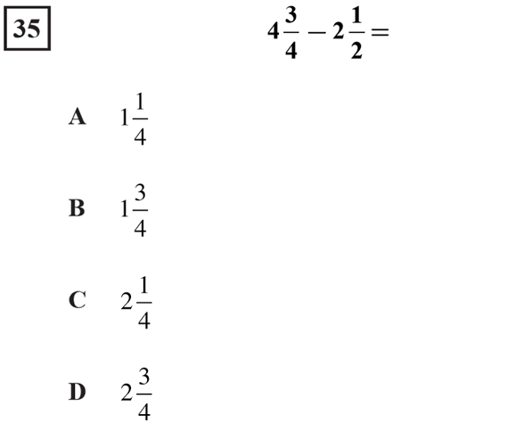
This problem is from the new Smarter Balanced Practice Test for Grade 5 (Question #2). Would these two students get this problem correct? Will this question determine whether they have a rigorous mathematical understanding?
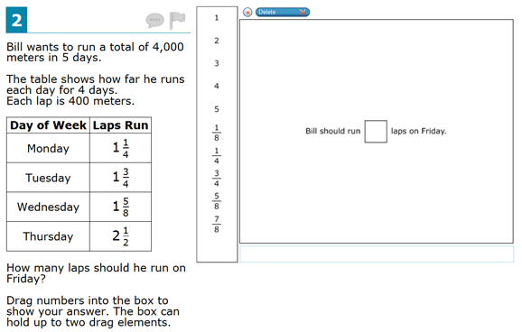
It is critical that we give students opportunities to develop rigorous mathematical understandings. Procedural skill is still an essential piece but it is just as important as developing their conceptual understanding and the ability to apply mathematics. Often times we teach students how to do mathematics with the belief that they will be able to apply it when the moment comes. Clearly that is not always the case.

Kids Summarizing
Ben 9/8
Back in the spring, I resolved to make a practice of having students summarize each others’ thoughts whenever I have classroom opportunities. This summer, I got the opportunity to give this technique a sustained go, when I taught at SPMPS (which was completely awesome btw). And:
It is an effing game-changer.
This summer, when I or a student put forth an idea, I regularly followed it with, “who can summarize what so-and-so said?” Or (even better), “so-and-so, can you summarize what so-and-so just said?” Following the models of Lucy West and Deborah Ball, I carefully distinguished summary from evaluation. “Not whether you buy it, just the idea itself.” When dipsticking the room on an idea, I would also make this distinction. “Raise your hand if you feel that you understand what was just said; not that you buy it, just that you understand what they’re trying to say.” Then, “leave your hand up if you also buy it.”
These moves completely transformed the way whole-class conversation felt to me:
* Students were perceptibly more engaged with each others’ ideas.
* The ideas felt more like community products.
* Students who were shy to venture an idea in the first place nonetheless played key roles as translators of others’ ideas.
Furthermore, for the first time I felt I had a reliable way past the impasse that happens when somebody is saying something rich and other people are not fully engaged. More generally, past the impasse that happens when somebody says something awesome and there are others for whom it doesn’t quite land. (Whether they were engaged or not.)
A snippet of remembered classroom dialogue to illustrate:
Me: The question before us is, do the primes end, or do they go on forever? At this point, does anybody think they know?
(Aside: This was after a day of work on the subject. Most kids didn’t see the whole picture at this point, but one did:)
[J raises his hand.]
J: They don’t end. If they ended, you’d have a list. You could multiply everything on the list and add 1 and you would get a big number N. Either N is prime or it’s composite. If it is prime, you can add it to the list. If it is composite, it has at least one prime factor. Its factor can’t be on the list because all the numbers on the list when divided [into] N have a remainder of 1. So you can add its factor to the list. You can keep doing this forever so they don’t end.
Me: Raise your hand to summarize J’s thought.
(Aside: although J has just basically given a complete version of Euclid’s proof of the infinitude of the primes, and although I am ecstatic about this, I can’t admit any of this because the burden of thought needs to stay with the kids. J is just about done with the question, but this is just the right thing, said once: the class as a whole is nowhere near done. This is one of the situations in which asking for summaries is so perfect.)
[Several kids raise their hands. I call on T.]
T: J is saying that the primes don’t end. He says this because if you have a list of all the primes, you can multiply them and add one, giving you a big number N. If N is prime, you can add it to the list. If N is not prime, and its prime factors are not on the list, you can add them.
Me: J, is that what you were trying to say?
J: Yes.
(Notice that a key point in J’s argument, that the factors of N cannot already be on the list, was not dealt with by T, and J did not catch this when asked if T had summarized his point. This is totally typical. Most kids in the room have not seen why this point is important. Some kids have probably not seen why J’s argument even relates to the question of whether the primes end. All this has to be given more engaged airtime.)
Me: raise your hand if you feel that you understand the idea that J put forth that T is summarizing.
[About 2/3 of the room raises hands. I raise mine too.]
Me: Leave your hand up if you also find the idea convincing and you now believe the primes don’t end.
[A few kids put their hands down. I put mine down too.]
N [to me]: Why did you put your hand down?
Me [to class]: Who else wants to know?
[At least half the class raises hands.]
Me [to T]: Here’s what’s bugging me. You said that if N is not prime and its prime factors are not on the list, I can add them. But what if N is not prime and its prime factors are already on the list?
T [thinks for a minute]: I don’t know, I’ll have to think more about that.
[J's hand shoots up]
Me [to T]: Do you want to see what J has to say about that or do you want to think more about it first?
[T calls on J to speak]
J: Can’t happen. All the numbers on the list were multiplied together and added 1 to get N. So when N is divided by 2, 3, 5, and so on, it has a remainder of 1. So N’s factor can’t be 2, 3, 5, and so on.
T: Oh, yeah, he’s right.
Me: Can you summarize his whole thought?
[T explains the whole thing start to finish.]
Me: Do you buy it?
T: Yes.
Me: Who else wants to summarize the idea that J put forth and T summarized?
Unexpectedly, this technique speaks to a question I was mulling over a year and a half ago, about how to encourage question-asking. How can the design of the classroom experience structurally (as opposed to culturally) encourage people to ask questions and seek clarification when they need it? The answer I half-proposed back then was to choose certain moments in the lesson and make student questions the desired product in those moments. (“Okay everyone, pair up and generate a question about the definition we just put up” or whatever.) At the time I didn’t feel like this really addressed the need I was articulating because it had to be planned. Kate rightly pressed me on this because actually it’s awesome to do that. But I was hungering for something more ongoingly part of the texture of class, not something to build into a lesson at specific points. And as it turns out, student summaries are just what I was looking for! The questions and requests for clarification are forced out by putting students on the spot to summarize.
A last thought. Learning this new trick has been for me a testament to teaching’s infinitude as a craft. Facilitating rich and thought-provoking classroom discussions was already something I’d given a lot of thought and conscious work to; perhaps more than to any other part of teaching, at least in recent years. I.e. this is an area where I already saw myself as pretty accomplished (and, hopefully with due modesty, I still stand by that). And yet I could still learn something so basic as “so-and-so, can you summarize what so-and-so said?” and have it make a huge difference. What an amazing enterprise to always be able to grow so much.

The idea is the easy part
Jason 3/4
.......and access is not a goal.
The idea is the easy part......
Audrey Watters and John Spencer both have articles up talking about the problems with TED. There is a lot there and worth a read. They hit on similar criticisms. Audrey says, "You are not supposed to interrogate a TED Talk." and John wrote, "TED Talks become a sort of Secular Scripture offering a script to fix humanity." Some of the TED ideas are bad. Some are good. That's expected.
I have a different issue. My problem isn't with TED. I happen to like quite a few talks. TED is simply mirroring our values.¹
My problem is that we place too much value on the idea and not enough on the work.
Sugata Mitra has an idea. He wants to open a School in the Cloud. Fine. Everyone has ideas. My question isn't about his idea it's about his willingness to put the work in to make it happen and keep it happening.
You've got an idea? So do a million other people. Let's stop celebrating ideas. Celebrate those standing waste deep in the muck with dirt in their nails and sweat on their face.
....and access is not a goal.
Bill Gates and Will.I.Am want everyone to have the opportunity to code.² Ok. California wanted every 8th grader to take Algebra. They said provide access and achievement will follow. Those of us in California can tell you how that went.
Providing access is the absolute minimum that we can possibly do and still feel like we've accomplished something.
(edit: I should link this for a scholarly view on access)
1: Or at least the type of values that someone who would watch a TED talk has.
1.5: I avoided ranting about Alfie Kohn. Be proud.
2: I'm not a fan of the idea itself, but I'm talking specifically about access and opportunity as goals. Also not a fan of the School in the Cloud. Mostly seems like 'access' but with the computer. It's like opening a school with an infinite number of textbooks available and some of them talk and have moving pictures and most are focused on cats.

The Tests Matter
Kate 4/6
Here is what is going on right now, in the time before the Common Core Standards have really hit high schools, and before a common assessment has been inflicted on any live children. The non-teachers in education are going: "Just start teaching the right way. Pay no attention to the tests. If you teach right, you don't have to worry about the tests. The tests will take care of themselves." The teachers are saying: "The way I teach is basically fine, anyway, so I'll make whatever adjustments I need to make once I see what they want kids to do on these new tests." I know there are probably some teachers changing their practice, and some non-teachers with half an eye on assessment. I'm painting with a broad brush. Go with it.
This is what I am afraid of: the thing that happened in New York State, starting in 1999. That's when NY changed from Course1/2/3: a decontextualized, integrated curriculum with very predictable though rigorous exams that were none of them a graduation requirement... to Math A/B, standards with more focus on applications and much less predictable tests -- also, kids had to pass the Math A exam to graduate. (This was a huge deal. Regents exams had traditionally been taken by your college-bound academically-oriented students, and suddenly everybody had to take one of them.) The new requirements were supposed to make things tougher, with all the rhetoric that comes with such changes. June 1998:
Yesterday, officials at New York City public schools welcomed the tougher tests, while some education advocates worried about the lack of resources to train teachers to teach for the higher standards.
If it sounds familiar, that's because it's straight from whatever school-reform-article-generating-machine the news has been using for thirty years. Moving on.
Some shit started hitting some fans. October 2000:
Mr. Mills said middle schools ''need to rethink what they are doing'' and quickly figure out how to teach students the skills they need to meet the new standards. He said he had no intention of backing down on the standards, which as of last June required every high school student to pass an English Regents exam to graduate, and by next June will require every high school student to pass a Regents math exam as well.
People started freaking out when they realized that requiring a passing score on an algebra test was going to be a graduation-rate debacle:
Students in the next class, which entered in fall 1997, will have to pass both the English and Math Regents to get their high school diplomas. If the results hold steady, about a quarter of this year's seniors will not be allowed to graduate.
There were protests (May 2001). There were districts trying to opt out (Nov 2001).
I don't know what happened to all the kids in the early 2000's who were denied a diploma because they couldn't pass the Math A Exam. A bunch of heartbreaking shit, I'm sure.
In June 2003, there was TESTMAGEDDON. The Math A Regents exam was the straw that broke New York's resolve.
Though many districts have not finished tabulating their scores, superintendents, principals and math department heads are reporting preliminary results that some described yesterday as ''abysmal,'' ''disastrous'' and ''outrageous.''
It was not a good test. Post-Course 1/2/3 exams were not good tests, generally: problems that didn't make sense, weird, contrived contexts, a fetishization of goofy vocabulary and notation. Too much content was a huge problem. A test that didn't know whether it was an algebra or geometry test was a huge problem. A test that didn't know what it was measuring -- readiness for higher mathematics courses? Basic skills that should be expected of every graduate? -- was a huge problem. In the end, the test measured nothing but whether or not a kid had passed that test. The accountability movement compelled schools with lower scores to make their math courses all about passing the test. Math A became a de facto curriculum, and a horrible one.
NY tried to raise the bar. Then, a whole mess of kids ran head-first into the bar and fell on their asses. Then, instead of re-evaluating any of their faulty premises, NY responded by lowering the bar.
On the June 2003 exam, they relented and lowered the cut score.
Then, they eased up on subsequent tests.
New York State's education commissioner, Richard P. Mills, said Wednesday that the state would loosen the demanding testing requirements it has imposed for high school graduation in recent years, including the standards used to judge math proficiency.
They made the tests easier. Lots easier. Also, the thing happened that took all the respectability out of the historically respected regents exams: for the tests required for graduation, the score you needed to pass got dramatically lower. They said it was a 65, but after June 2003, you only needed a raw score of around 42% to pass the Math A with a scaled score of 65. (The raw scores in the linked table are not percentages -- they are out of 84 points.)
I wasn't around when this all happened. I didn't start teaching until 2005. And I don't think we're getting exactly a repeat with the Common Core. For one, there does seem to be a coordinated,genuine effort to support teachers in changing their practice, independent of testing. For two, there's a coherence and focus in the CCSS that New York was sorely lacking. But also, there's the whole added wrinkle that tests are trying to fulfill still another purpose: teacher evaluation. The disaster story might not be "so many kids can't graduate", it might be "so many teachers are being rated poorly, even good ones that kids, parents, colleagues respect."
But I still think it serves as a cautionary tale, and I'm still curious about how this is going to play out once the new tests hit a computer lab near you. If they really measure the stated goals of the new standards, they're going to be very different. Because of that, they're going to be perceived as too hard. How the test-writing consortia, DoE, states, districts, etc react to that is going to be really interesting.

Dear Parents
Frank 3/29
Dear Physics Parents,
Recently in Dietrich, Idaho, a biology teacher is under investigation after several parents complained about a lesson on human reproduction. The parents said they simply wanted more notification about class content. I think such notification is a great idea, and thus my letter to you.
Right before spring vacation, I asked my physics classes what topic they wanted to learn about in the fourth quarter. The students overwhelming chose astronomy. They also made it clear they wanted to learn about how and why the universe works as it does, rather than simply memorizing the phases of the moon and names of the constellations.
As a result, we will be talking about some sensitive topics. You may wish to have your child opt-op of class on those days. These topics include:
Newton’s Theory of Universal Gravity. The driving force behind most astronomical phenomena is gravity. And, of course, it is “just a theory.” There are many problems with Newton’s Theory and it can’t explain everything we observe. I anticipate some of you may wish to pull your children out of class on those days so it doesn’t conflict with the Theory of Intelligent Falling they might be learning at home.
Moon Landings and Space Exploration. This is another controversial topic for some families. A decade-old Fox documentary questioned whether men have really landed on moon. It used physics in an attempt to beat NASA at its own game and show the moon landings were a hoax. I understand if you would like your child to stay home when we talk about the composition of themoon rocks the astronauts brought back and how NASA engineers applied Newton’s Theory of Gravity in order to make those journeys happen.
Giggle-inducing Scientific Terminology. Uranus, excited state, naked singularity, panspermia, ram pressure, Trojans, black hole, galactic bulge,hadron, space probe, parsecs, and 21-centimeter emission, to name a few. These are not “dirty words.” They are official scientific terms and we will need to use them in class.
Despite these sensitive and controversial topics, I do hope you’ll still keep your child in class. It’s always best to know both sides of an issue in detail.
If you have any questions, please don’t hesistate to contact me.
Sincerely,
Frank Noschese
Physics Teacher

It's time for this meme to die
Michael 7/17
Imagine if someone at a dinner party casually announced, “I’m illiterate.” It would never happen, of course; the shame would be too great. But it’s not unusual to hear a successful adult say, “I can’t do math.” - DB, NYTimes
Which clearly raises the question: Why is it socially acceptable to say that you're bad at math but not socially acceptable to say you're bad at reading? - JW, Psych Today
Why is it acceptable in this country to say, "I'm bad at math"? Do you know many people who would admit to being semi-literate? - Change the Equation
Look, if you can't read then you can't make it through school at any level, you can't read the warning label on your meds and you'll need someone to literally hold your hand and direct you through the supermarket. You can't drive, or really navigate yourself through the streets using anything but memory and intuition. You can't send a text; you can't read an email.
People don't brag about being unable to read because (1) being unable to read would be literally debilitating to a person's everyday life in a thousand obvious ways and (2) pretty much everyone who needs to be is literate, for exactly that reason.
You will hear folks saying "I don't read for fun" or "I haven't read a novel in, like, woah" and now you've got on your hands something that is far closer to what you hear people say about math.
But the very fact that doctors, lawyers, journalists, politicians, and many, many others make light of the fact that they don't know math is all the evidence you need that you actually don't need to know math to be a successful adult in America.
And, look, I hope that we have a fun time in the comments to this post, but I'm flagging one argument right now as suspicious: "WTF michael, you need to be able to count and do addition/subtraction to get by." Yeah, of course. Is that what people are talking about when they say "Oh jeeze, I'm bad at math. Always have been." Or are they talking about, say, fractions?
Anyway, that was fun to write. I should pick fights more often. See you in the comments.

The association of tracking and self-concept
Daniel 9/30
In Why Don't Students Like School? I pointed out that cognitive challenge is engaging if it's at the right level of difficulty, but boring if it's too easy or too hard. It sounds, then, like it would make sense to organize students into different classes based on their prior achievement.
It might make sense cognitively, but the literature shows that such a practice leads to bad outcomes for the kids in lower tracks. Those classes tend to have less demanding curricula and and lower expectations for achievement (e.g., Brunello & Checchi, 2007).
Further, assignment to tracks is often biased by race or social class (e.g.,Maaz et al., 2007).
What tracking does to students self-perceptions has been less clear. A new international study (Chmielewski et al., 2013) examined data from the 2003 PISA data set to examine the association of different types of tracking and student self-perceptions of mathematics self-concept.
The authors compared systems with
- Between school streaming: in which students with different levels of achievement are sent to different schools.
- Within school streaming: in which students with different levels of achievement are put in different sequences of courses for all subjects.
- Course-by-course tracking: in which students are assigned to more or less advanced courses within a school, depending on their achievement within a particular subject.
Controlling for individual achievement and the average achievement of the track or stream, the researchers found that course tracking is associated with worse self-perceptions among low-achieving students, but streaming is associated with better self-perceptions.
This figure shows the difference between the self perceptions of higher and lower achieving students in individual countries, sorted by the type of tracking system.
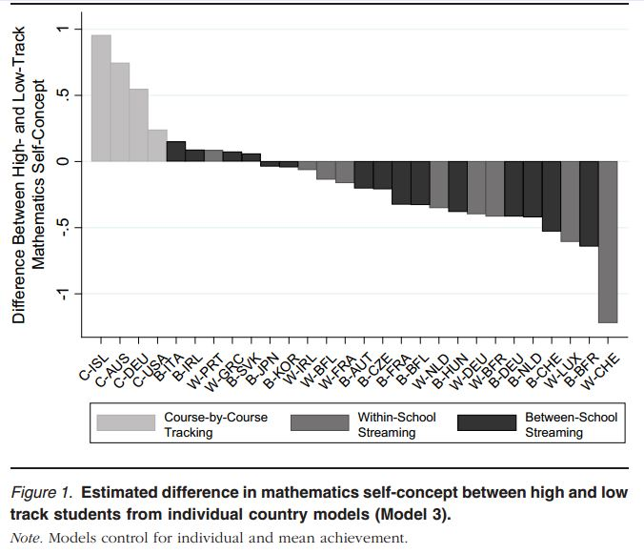
The data suggest that when students are tracked for some but not all of their courses, they compare their achievement to other, more advanced students, perhaps because they see these students more often. Students who are streamed within or between schools, in contrast, compare their abilities to their fellow stream-mates.
But why is there self-concept higher than higher-achieving students? This effect may be comparable to a more general phenomenon that people are poorer judges of their competence for tasks that they perform poorly. If you're not very good, you're not good enough to realize what you lack.
The authors do not suggest that between school steaming is the way to go (since it's associated with higher confidence). They note that the association is just the reverse of that seen in achievement: kids who stream between schools seem to take the biggest hit to achievement.
References
Brunello, G., & Checchi, D. (2007). Does school tracking affect equality of opportunity? New international evidence. Economic Policy, 22, 781–861.
Chmielewski, A. K., Dumont, H. Trautwein, U. (2013). Tracking effects depend on tracking type: An international comparison of students' mathematics self-concept. American Educatioal Research Journal, 50, 925-957.
Maaz, K., Trautwein, U., Ludtke, O., & Baumert, J. (2008). Educational transitions and differential learning environments: How explicit between-school tracking contributes to social inequality in educational outcomes.Child Developmental Perspectives, 2, 99–106.

Out of Class Interventions - Never Look Back
Michael 11/27
Andrew wants to spark a conversation about intervention strategies that work, and I've got something small to share.
In my teaching life so far, "intervention" has always meant "a time to meet with a kid outside of class." For me, that always seemed to be basically a waste of time. What can I do for a kid in forty minutes that I couldn't do in two months?
I'd use SBG. I'd say, look, you've got seven standards that you haven't mastered. Let's do two a week for the next month. Let's meet on Monday during lunch, and I'll tutor you in those skills. Let's reassess on Thursday. And every once in a while a kid would pull it together, but most of the time he would stop coming, or he wouldn't be able to study on his own, or he would still be getting lost on the new material as he's reviewing the old stuff...
Last year I basically begged people on twitter to show me a better way, and Frank Noschese sent me a document that made a small, but important difference in the way my interventions went. The most important part of that doc was the second line of this table:
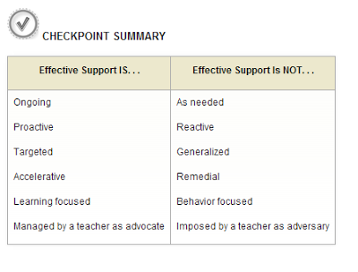

After reading this, I immediately stopped going over old material with kids, and instead spent our time prepping them for the upcoming week's lessons.
The theory is simple. In a weekly session, it's usually unrealistic to help a kid learn large swaths of material that they're struggling with. But it is totally realistic to help a kid understand tomorrow's class. That just requires a little bit of foresight and the careful selection of examples. And if the kid gets Tuesday's class, then they've got a decent shot at Wednesday. And we can build an area of strength for this kid, and that will be our start.
I don't want to paint too rosy a picture here. By the time you've got a regular intervention with a kid, it's often going to be rough going. Still, looking ahead worked much better for me than looking back.

The Real Flip
David 11/6
If we can get students to flip their thinking from this:
If I know the rules, then I can do the math.
to this:
If I do the math, I can know the rules.
Then we've won.

Making a Gift More Valuable
Kate 6/30
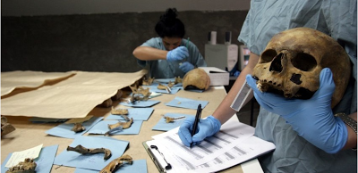
Spiegel Online: Forensic Anthropologists at Work
I'm starting to feel a little like an anthropologist, but I'm finding the implications of and discussions stemming from the last post framing the MTBoS as a gift culture, to be fascinating. Logical questions are: "What is a gift? What kinds of contributions earn a person status in our culture? If you're going to participate by gift-giving, anyway, are there steps you can take to make your gift more valuable?"
I think we'd all agree that status itself, here, is not the goal. That would be silly. But it can be a motivation, and that's okay. Importantly, the gifts make us, all who are participating in many different capacities, better teachers. That's worth paying attention to.
There are different kinds of gifts this community finds valuable: curation, commentary, cheerleading. But a discussion on Twitter today made me want to write down some guidelines for what features make a gift more valuable. Several people expressed incredulity, arguing that an artifact's value is too dependent on the needs of the receiver to make this exercise meaningful. But I disagree. While you might find one gift more valuable than I do, gifts can have general features that make them objectively more valuable to the community.
I am not posting this to make anyone feel like they should do something. Let's please keep the MTBoS easy fun free. You're free to do some, none, or all of these. You're free to quit this tab right now and order a pizza. But my feeling is, the more your gift displays these features, the more useful and valuable it will be. The ever-incisive Justin Lanier stated the query thusly:
Organization
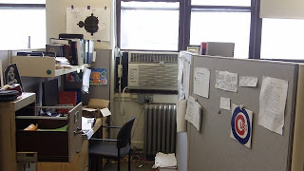
Pershan's Desk
- Contributions are compiled within some sort of structure, rather than scattered among blog posts. (see: Tina's use of tags and tabs to filter her posts by course.)
- Have taken others' work from disparate places, and made them more useful by compiling them into an organized structure. (see: Middle School Math wiki (multiple authors), Fouss's course-by Links, Sam's Virtual Filing Cabinet (including a link to other virtual filing cabinets. Filinception!)
Responsiveness/Connectivity
This one is about community. It's also about leveraging MTBoS so everyone becomes better teachers much more rapidly than they would without it.
- Allows comments; responds to direct questions, arguments, and suggestions.
- Citing/linking others’ work as inspiration. Beyond the blog roll, can I backtrack the evolution of your idea? (see Brian's adaptation of Fawn's post about a Taboo game)
- Is on Twitter
- Responds to @ questions on Twitter
(A good example that it's possible to be influential without Twitter is Shireen. Her Math Teacher Mambo blog is amazing, but Twitter doesn't seem to be her cup of tea, but that's okay.)
Generality
- The thing can be used for multiple topics, courses, grade levels, and/or subjects. (see: Kelly's Whiteboarding Mistake Game, Megan's Interactive Notebooks, Julie's Using a Tool for Preassessment.
- On the other hand, a very specific lesson can have enormous value. Just to fewer people. (see: Ashli's plan for polynomial long division)
Context
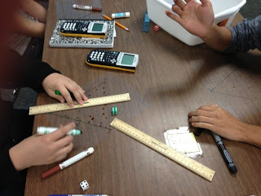
from Infinite Sums
- The math content is wrapped in well-matched pedagogical moves. Instead of just some cool math problem, we can see how the learning happened (see Matt's The Mullet Ratio. See Liisa and Jessica's use of dialog.)
- A lesson comes from some sort of curricular or philosophical organizing structure, instead of a one-off. (There are comprehensive examples like 3Acts, but see how Bowman shares a problem to motivate Riemann Sums, but frames it as a unit anchor problem.)
- Descriptions are illustrated with classroom photos, snapshots of whiteboards or IWBs, scans or snaps of student work. (see Fawn on any given day, Jonathan's blockheaded students, Frank doing his thing.)
Adaptability
- Providing docs is more valuable than not. People rarely print out and use docs wholesale, but they value not having to start from scratch.
- When docs are provided, editable is higher-valued than pdfs.
- When docs are provided, being able to download them immediately from Dropbox or another server is more valuable than having to request them by email like it's 1997.
On protecting your work: when we share something, we want and expect it to be used, adapted, and re-shared by teachers and maybe professors in teacher ed programs. We don't expect anyone to take our stuff, adapted or not, and sell it on Teachers Pay Teachers or its ilk. We certainly don't expect it to show up in a book or website of a large publisher. You can't do anything technologically to prevent this (even pdf's can be recreated by an enterprising soul). But, you can give yourself some recourse down the road, should someone seriously cash in on your work. Go here and get you one of these.
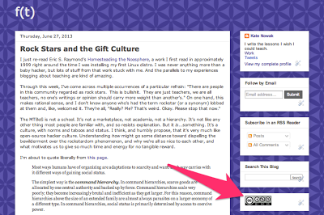
Humanity and Hilarity
- Just like your kids don't want you to be a teacherbot, no one wants to read a bloggerbot. People feel more connected to a personality. Let your voice come through. If you don't feel like you have a voice yet, the answer is to write more. (see: Mimi, Sophie)
- Earestness and seriousness beats work-a-day, but earnestness + a sense of humor is killer (too many examples, but I'm thinking the Platonic ones are Shawn and Fawn.)
So, let me know what you think! Did I miss anything? Do you have any better examples than the ones I cited? Am I way off base even trying to write these down?
Many thanks to Justin Lanier who basically deserves a byline on this post, and to @algebrainiac1@vtdeacon @JJJsally @jybuell and @samjshah whose help on Twitter planted some of these seeds.

Rules of (iPad) Engagement
Jonathan 3/15
About a year ago they started mentioning that classroom technology was expanding. We have our interactive whiteboards, now it was time for iPads and netbooks to enter the fray. I cringed. Mostly in a "one more thing to worry about" sort of way. Nowadays, it's not so bad. After spending a summer ruminating about how the heck you make 4 iPads work for 30 kids and then finding a way to make 4 into 14, things started to click in place.

You're Doing It Wrong
Getting students to the task should be frictionless, or as frictionless as possible. It should also enhance what you're doing and not be TFTS (technology for technology's sake). This is what I'd call the paper test. If you ask yourself "can I replicate this with paper?" and the answer is yes, rethink the lesson, or stop forcing the issue. There are natural avenues for iPad use. Typing up notes is not one of them.
- Ok kids, go to my edmodo page and...
- Ok kids, create a log in for this website and...
- Ok kids, sign in to your e-mail account and...
- Ok kids, take a picture of your work to e-mail me and...
- Ok kids, watch this instructional video and...
- Ok kids, I want you to take notes and...
- Ok kids, open this e-textbook and...
Why am I hating on edmodo/e-mail/logins? Well, they create friction. You know some kid will forget the password. You know edmodo will pick the wrong time to be unresponsive. You know some kid will have no idea how to attach a picture to e-mail. Then there's this ball of absolute ridiculousness. 23 steps to distribute and collect an assignment (a PDF of a worksheet no less)! Running to the copier and collecting the papers is the better choice. You want the time spent with the technology to be time spent learning/doing and not fiddling/troubleshooting. The first time I waited ten minutes for a netbook to login was the last time I booted the thing.
A lot of people get real excited with the concept of ShowMe. There are merits to having a student learn how to teach. But is dictating a lesson to an iPad enhancing the activity? Could they do that with chart paper? Could they do that in small groups? And isn't the idea that math is mastered through a headless narrator just reinforcing that thing we don't like to talk about? Also, have you tried sharing stuff with ShowMe? Logins! Hooray!
Oh, and Geogebra is a disaster on iPads (blame Java). Desmos is ok (logins!), but they need a native app desperately. The sooner you accept what iPads don't do well, the sooner you dive into what makes them shine.
Get to Work
Getting to the assignment has got to be the fastest part. A Dropbox or iCloud is key to quick starts. I have a Dropbox account (separate from my main one) tied to each iPad the students use. Once I have the images/PDFs together, it's as simple as putting them in a well-named folder on the Dropbox. I spend a few seconds showing the whole class where to find the file, and the task is underway. If I want them to assemble data in Numbers, I prep templates for them in advance. Each iPad is tied to the same iCloud account. Creating a spreadsheet on one propogates it to another. Because Numbers is quirky, I prep a template for every group that will need one, named appropriately (time taken = time to prep 1 template + time to hit copy x times). If you're more a Google Docs kind of person, Google Drive for iOS has been making progress. I need to re-examine my use of Numbers though, this year it set off the TFTS beeper.
For collection, iCloud auto-updates progress. A group says they're done with their spreadsheet, a tap later and all iPads (and my computer) have their data. I had students upload videos to Dropbox. It was easy. They spent longer picking out their best video.
Know what kind of device ratio you need. Creating videos or taking pictures is an easy 5:1 idea. Reading notes? Sketching? Researching? 2:1, TOPS. I mean it.
Chill Out
Some restrictions are going to be necessary. Once you sign into an iPad with an Apple ID, you can disable the ability to make account changes (preventing a kid from signing in their account). You can disable e-mail. You can disable messages. You can disable deleting apps. You can disable FaceTime. You can disable the camera. You can set a passcode for altering the restrictions.
No matter what you do, kids will find a way to fiddle. They are curious, they want to fiddle. Don't discourage this (provided the task at hand gets done). If they open Facebook, kindly tap the tab closed and have them move along. Do not lose your mind. If they take goofy pictures with their friend, delete it later when class is over. Do not lose your mind. A good way to reduce that sort of thing is to enable Photo Stream. Any iPad signed into a given Apple ID will auto-share any photo taken, making a public projection (from your iPad) of that goofy photo very easy. Seems to do the trick.
Do not think you have to use the iPads every day. If it takes two months before you find another way to compliment a lesson, so be it.
Sharing
Determine a way to share results. A student will assign value to an activity if they know others are going to see it. If the task involves one student typing some notes on an iPad that no one will ever look at, it doesn't inspire quality products. SketchBook Express is iCloud enabled, Photo Stream quickly displays photos taken by anyone, Dropbox gives you a central point to view video. Or invest in an iPad AV Cable or AirPlay solution. Show the students you are interested in what they are making and that the exercise is not TFTS, never to be discussed again. Do not have them submit electronic versions of worksheets.
Experiment
There are no magic apps. Do not repackage an old way of doing things in a shiny digital wrapper. Do not make them download your PowerPoint to read for homework. Think fast, how many times did you read those Chem 101 notes you downloaded in college? Or listen to those English lectures you recorded. Yeah.
As much as I liked the process of self-teaching, it could've been replicated with pencil and paper. But I had to learn that lesson by trying the idea. Do something unique. Taking pictures, making vidoes, learning sophisticated search techniques, running statistics through WolframAlpha are just some of the activities that are new and novel. Do not ban WolframAlpha because it gives them the answers, show them how to verify what happened. Teach them how to read the high-level vocabulary WolframAlpha uses in its results. Show them how to graph an equation with a Google search. Find a way to integrate your content into a new way of doing things, don't force students to digest a PDF of your perfect worksheet you made 5 years ago. Early in the year I kicked myself for giving students too much information. Learn to take facts out of the problem. Present the kids with just the question you want to answer. Teach them how to fill in the blanks and then give them the internet to do so.
On my mind currently is polar equations. Their graphs are pretty, the traditional TI-84 way of examining their graphs is not. Giant color displays give my students a new way to explore these. I have no idea if the iPad will enhance the experience, but it won't hurt to try.
Conclusion
Where I think a lot of iPad activities stumble is the idea that you should use them to consume a worksheet/website/video, things that paper can replicate. Where an iPad in your classroom shines is when you start talking about what kids can create. We spent the first part of the century getting teachers the internet in their classrooms. Now every student is getting a chance at that experience. Teach them how to use it. Don't assume they have any idea what's going on because they're young and you're not. Instead of putting a bland right triangle on the board, make them go find some. Instead of analyzing some bland quadratic equation, have them create one. Teach them how to sketch. Teach them how to go CSI Miami on a video. Teach them how to take a screenshot. Teach them how to teach someone else. Let them play with the camera. Show them all the crazy ways to interpret Maps. Shoot, have a discussion about how an iPad works in the first place.
Lastly, know when to keep the iPad in the cabinet.

Inverse Problems in Education
Jason 3/5
Forward problems are problems with a well-defined answer: throwing a fair die, what’s the probability of getting a 4? Inverse problems look at data and create what necessarily has uncertainty: looking at this data, was it generated with a fair die?
Most problems given in mathematics classes (outside of statistics) are forward problems, with well-defined answers. Yet, most real-life problems are inverse problems. We don’t know the actual equations of the world, and even if we did, our measurement of reality would have uncertainty.
Pure mathematics is important, but I maintain complete allergy to error is unhealthy and gives a distorted view of mathematics. Consider, for instance –
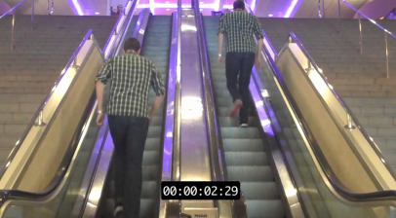
[Vimeo link]
This is my favorite of Dan Meyer’s videos.
If you go through the calculations correctly for working out how long it takes Dan to get up the stairs, the answer comes short by about a second and a half.
Yet, this is still a perfectly valid problem. Where did the extra time come from? This is a useful discussion and matches the sorts of discussions scientists and engineers have often.
(Note the long step, which would naturally extend the time slightly.)
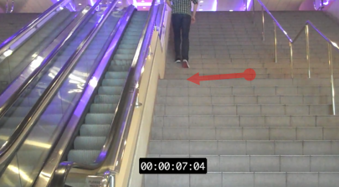
There’s also inverse problems where nobody could truly know the answer (but we can get a pretty good idea anyway with mathematics). I’ve mentioned previously my favorite problem from teaching statistics:
Based solely on the number of wrecks, is there anything mystical going on in the Bermuda Triangle?
By its very nature, “is anything mystical going on?” is a unfalsifiable claim, hence the problem is necessarily an inverse one. The students used a shipwreck database to decide if the number of wrecks in the area is abnormally high. (They found it was safer inside the Bermuda Triangle than outside it.)
The teacher can also manufacture an inverse problem where the teacher knows the answer but the students are not given enough to make a truly definitive answer.
For example, here are two excerpts from 19th century American humorists:
EXCERPT A
Under favorable circumstances the Roller-Towel House would no doubt be thoroughly refitted and refurnished throughout. The little writing-table in each room would have its legs reglued, new wicks would be inserted in the kerosene lamps, the stairs would be dazzled over with soft soap, and the teeth in the comb down in the wash-room would be reset and filled. Numerous changes would be made in the corps de ballet also. The large-handed chambermaid, with the cow-catcher teeth and the red Brazil-nut of hair on the back of her head, would be sent down in the dining-room to recite that little rhetorical burst so often rendered by the elocutionist of the dining-room—the smart Aleckutionist, in the language of the poet, beginning: “Bfsteakprkstk’ncoldts,” with a falling inflection that sticks its head into the bosom of the earth and gives its tail a tremolo movement in the air.
On receipt of $5 from each one of the traveling men of the union new hinges would be put into the slippery-elm towels; the pink soap would be revarnished; the different kinds of meat on the table will have tags on them, stating in plain words what kinds of meat they are so that guests will not be forced to take the word of servant or to rely on their own judgement; fresh vinegar with a sour taste to it, and without microbes, will be put in the cruets; the old and useless cockroaches will be discharged; and the latest and most approved adjuncts of hotel life will be adopted.
EXCERPT B
On the fourth night temptation came, and I was not strong enough to resist. When I had gazed at the disk awhile I pretended to be sleepy, and began to nod. Straightway came the professor and made passes over my head and down my body and legs and arms, finishing each pass with a snap of his fingers in the air, to discharge the surplus electricity; then he began to “draw” me with the disk, holding it in his fingers and telling me I could not take my eyes off it, try as I might; so I rose slowly, bent and gazing, and followed that disk all over the place, just as I had seen the others do. Then I was put through the other paces. Upon suggestion I fled from snakes; passed buckets at a fire; became excited over hot steamboat-races; made love to imaginary girls and kissed them; fished from the platform and landed mud-cats that outweighed me—and so on, all the customary marvels. But not in the customary way. I was cautious at first, and watchful, being afraid the professor would discover that I was an impostor and drive me from the platform in disgrace; but as soon as I realized that I was not in danger, I set myself the task of terminating Hicks’s usefulness as a subject, and of usurping his place.
It was a sufficiently easy task. Hicks was born honest; I, without that incumbrance—so some people said. Hicks saw what he saw, and reported accordingly; I saw more than was visible, and added to it such details as could help. Hicks had no imagination, I had a double supply. He was born calm, I was born excited. No vision could start a rapture in him, and he was constipated as to language, anyway; but if I saw a vision I emptied the dictionary onto it and lost the remnant of my mind into the bargain.
Which one is Mark Twain? I gave another known Mark Twain excerpt to the students and had them do statistical analysis to justify their answer as A or B.
It’s a messy and “impure” problem and even can be partly reckoned with via English class skills. Statistics deals with such worries all the time, yet many American students never see such a problem until possibly their senior year and often not until college.
Even ignoring statistics and just considering modeling problems like the first one, mathematics teachers seem deeply uncomfortable with the possibility of error. Mathematics is only infallible when contained within its own world.
(Incidentally, there’s a letter by a “Donald Ross” that some people think is by Mark Twain:Things a Scotsman Wants to Know. It qualifies for the category of “inverse problems nobody will know the answer to unless someone builds a time machine”.)

Blogging > Twitter
Michael 12/1
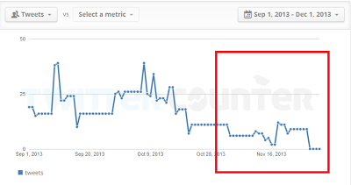
This is just to say that I spent November tweeting less and blogging more, and it made being on the internet more productive for me than it had been in a long time.
We read poems, short stories and novels differently, and one of the the many reasons why is because of length. What we expect from a piece of writing depends crucially on how long it is, and for good reason. Writing is hard, and we expect people to write something that's roughly as long as it absolutely needs to be. A novel, presumably, couldn't have been a short story. I'd suggest that much of the power of short poems comes from their brevity. Their length announces a sort of immediacy and clarity that ought to come as revelations. (A haiku isn't the sort of thing that's supposed to need argument or evidence.)
All of this to say is that, much to my past frustration, it's very hard to be subtle on Twitter, because the brevity of any tweet makes anything you say come off as a proclamation. That's good for a gal or guy with a lot of confidence, but I found myself just making people angry on Twitter with (what I thought were) speculative comments. These days I find Twitter most helpful when (a) I want to proclaim! or (b) I have a question.
Some more reasons why I prefer blogging to twitter for working out ideas:
- Tweets disappear, blog posts stick around.
- Every comment on a post is worth ten replies to a tweet.
- Blogging is consistent with me not constantly being near the internet. Twitter supports some of my worst internet habits.
Of course, Twitter is good for many things, and its brevity is a great deal of what makes it great. And, of course, you should do whatever you want to do. But November has been a very happy month for me.

[Mailbag] Direct Instruction V. Inquiry Learning, Round Eleventy Million
Dan et al 8/14
Let me highlight another conversation from the comments, this time between Kevin Hall, Don Byrd, and myself, on the merits of direct instruction, worked examples, inquiry learning, and some blend of the three.
Some biography: Kevin Hall is a teacher as well as a student of cognitive psychology research. His questions and criticisms around here tend to tug me in a useful direction, away from the motivational factors that usually obsess me and closer towards cognitive concerns. The fact that both he and Don Byrd have some experience in the classroom keep them from the worst excesses of cognitive science, which is to see cognition as completely divorced from motivation and the classroom as different only by degrees from a research laboratory.
Kevin Hall:
While people tend to debate which is better, inquiry learning or direct instruction, the research says sometimes it’s one and sometimes the other. A recent meta study found that inquiry is on average better, but only when “enhanced” to provide students with assistance [1]. Worked examples actually can be one such form if assistance (e.g., showing examples and prompting students for explanations of why each step was taken).
One difficulty with just discussing this topics that people tend to disagree about what constitutes inquiry-based learning. I heard David Klahr, a main researcher in this field, speak at a conference once, and he said lots of people considered his “direct instruction” conditions to be inquiry. He wished he had just labelled his conditions as Condition 1, 2, and 3 because it would have avoided lots of controversy.
Here’s where Cognitive Load Theory comes in: effectiveness with inquiry (minimal guidance) depends in the net impact of at least 3 competing factors: (a) motivation, (b) the generation effect, and (c) working memory limitations. Regarding (a), Dan often makes the good point that if teachers use worked examples in a boring way, learning will be poor even if students cognitive needs are being met very well.
The generation effect says that you remember better the facts, names, rules, etc that you are asked to come up with on your own. It can be very difficult to control for this effect in a study, mainly because its always possible that if you let students come up with their own explanations in one group while providing explanations to a control group, the groups will be exposed to different explanations, and then you’re testing the quality of the explanations and not the generation effect itself. However, a pretty brilliant (in my opinion) study controlled for this and verified the effect [2]. We need more studies to confirm. Here is a really portent paragraph from the second page of the paper: “Because examples are often addressed in Cognitive Load Theory (Paas, Renkl, & Sweller, 2003), it is worth a moment to discuss the theory’s predictions. The theory defines three types of cognitive load: intrinsic cognitive load is due to the content itself; extraneous cognitive load is due to the instruction and harms learning; germane cognitive load is due to the instruction and helps learning. Renkl and Atkinson (2003) note that self-explaining increases measurable cognitive load and also increases learning, so it must be a source of germane cognitive load. This is consistent with both of our hypotheses. The Coverage hypothesis suggests that the students are attending to more content, and this extra content increases both load and learning. The Generation hypothesis suggests that load and learning are higher when generating content than when comprehending it. In short, Cognitive Load Theory is consistent with both hypotheses and does not help us discriminate between them.”
Factor (c) is working memory load. The main idea is found in this quote from the Sweller paper Dan linked to above, Why Minimal Instruction During Instruction Does Not Work [3]: “Inquiry-based instruction requires the learner to search a problem space for problem-relevant information. All problem-based searching makes heavy demands on working memory. Furthermore, that working memory load does not contribute to the accumulation of knowledge in long-term memory because while working memory is being used to search for problem solutions, it is not available and cannot be used to learn.” The key here is that when your working memory is being used to figure something out, it’s not actually being used to to learn it. Even after figuring it out, the student may not be quite sure what they figured out and may not be able to repeat it.
Does this mean asking students to figure stuff out for themselves is a bad idea? No. But it does mean you have to pay attention to working memory limitations by giving students lots of drill practice applying a concept right after they discover it. If you don’t give the drill practice after inquiry, students do worse than if you just provided direct instruction. If you do provide the drill practice, they do better than with direct instruction. This is not a firmly-established result in the literature, but it’s what the data seems to show right now. I’ve linked below to a classroom study [4] and a really rigorously-controlled lab study study [5] showing this. They’re both pretty fascinating reads… though the “methods” section of [5] can be a little tedious, the first and last parts are pretty cool. The title of [5] sums it up: “Practice Enables Successful Learning Under Minimal Guidance.” The draft version of that paper was actually subtitled “Drill and kill makes discovery learning a success”!
As I mentioned in the other thread Dan linked to, worked examples have been shown in year-long classroom studies to speed up student learning dramatically. See the section called “Recent Research on Worked Examples in Tutored Problem Solving” in [6]. This result is not provisional, but is one of the best-established results in the learning sciences.
So, in summary, the answer to whether to use inquiry learning is not “yes” or “no”, and people shouldn’t divide into camps based on ideology. Still unanswered question is the question when to be “less helpful” as Dan’s motto says and when to be more helpful.
One of the best researchers in the area is Ken Koedinger, who calls this the Assistance Dilemma and discusses it in this article [7]. His synthesis of his and others’ work on the question seems to say that more complex concepts benefit from inquiry-type methods, but simple rules and skills are better learned from direct instruction [8]. See especially the chart on p. 780 of [8]. There may also be an expertise reversal effect in which support that benefits novice learners of a skill actually ends up being detrimental for students with greater proficiency in that skill.
Okay, before I go, one caveat: I’m just a math teacher in Northern Virginia, so while I follow this literature avidly, I’m not as expert as an actual scientist in this field. Perhaps we could invite some real experts to chime in?
Dan Meyer:
Thanks a mil, Kevin. While we’re digesting this, if you get a free second, I’d appreciate hearing how your understanding of this CLT research informs your teaching.
Kevin Hall:
The short version is that CLT research has made me faster in teaching skills, because cognitive principles like worked examples, spacing, and the testing effect do work. For a summary of the principles, see this link.
But it’s also made me persistent in trying 3-Acts and other creative methods, because it gives me more levers to adjust if students seem engaged but the learning doesn’t seem to “stick”.
Here’s a depressing example from my own classroom:
Two years ago I was videotaping my lessons for my masters thesis on Accountable Talk, a discourse technique. I needed to kick off the topic of inverse functions, and I thought I had a good plan. I wrote down the formula A = s^2 for the area of a square and asked students what the “inverse” of that might mean (just intuitively, before we had actually defined what an inverse function is). Student opinions converged on the S = SqRt(A). I had a few students summarize and paraphrase, making sure they specifically hit on the concept of switching input and output, and everyone seemed to be on board. We even did an analogous problem on whiteboards, which most students got correct. Then I switched the representations and drew the point (2, 4) point on a coordinate plane. I said, “This is a function. What would its inverse be?” I expected it to be easy, but it was surprisingly difficult. Most students thought it would be (-2, -4) or (2, -4), because inverse meant ‘opposite’. Eventually a student, James (not his real name), explained that it would be (4, 2) because that represents switching inputs and outputs. Eventually everyone agreed. Multiple students paraphrased and summarized, and I thought things were good.
Class ended, but I felt good. The next class, I put up an similar problem to restart the conversation. If a function is given by the point (3, 7), what’s the inverse of that function? Dead silence for a while. Then one student (the top student in the class) piped up: “I don’t remember the answer, but I remember that this is where James ‘schooled’ us last class.” Watching the video of that as I wrote up my thesis was pretty tough.
But at least I had something to fall back on. I decided it was a case of too much cognitive load–they were processing the first discussion as we were having it, but they didn’t have the additional working memory needed to consolidate it. If I had attended to cognitive needs better, the question about (2, 4) would have been easier, and I should NOT have switched representations from equations to points until it seemed like the switch would be a piece of cake.
I also think knowing the CLT research has made me realize how much more work I need to do to spiral in my classroom.
Then in another thread on adaptive math programs:
Kevin Hall:
My intention was to respond to your critique that a computer can’t figure out what mistake you’re making, because it only checks your final answer. Programs with inner-loop adaptivity do, in fact, check each step of your work. Before too long, I they might even be better than a teacher at helping individual students identify their mistakes and correct them, because as as teacher I can’t even sit with each student for 5 min per day.
Don Byrd:
I have only a modest amount of experience as a math teacher; I lasted less than two years — less than one year, if you exclude student teaching — before scurrying back to academic informatics/software research. But I scurried back with a deep interest in math education, and my academic work has always been close to the boundary between engineering and cognitive science. Anyway, I think Kevin H. is way too optimistic about the promise of computer-based individualized instruction. He says “It seems to me that if IBM can make Watson win Jeopardy, then effective personalization is also possible.” Possible, yes, but as Dan says, the computer “struggles to capture conceptual nuance.” Success at Jeopardy simply requires coming up with a series of facts; that’s highly data based and procedural. The distance from winning Jeopardy to “capturing conceptual nuance” is much, much greater than the distance from adding 2 and 2 to winning Jeopardy.
Kevin also says that “before too long, [programs with inner-loop adaptivity] might even be better than a teacher at helping individual students identify their mistakes and correct them, because as as teacher I can’t even sit with each student for 5 min per day.” I’d say it’s likely programs might be better than teachers at that “before too long” only if you think of “identifying a mistake” as telling Joanie that in _this_ step, she didn’t convert a decimal to a fraction correctly. It’ll be a very long time before a computer will be able to say why she made that mistake, and thereby help her correct her thinking.
2013 Aug 14. Christian Bokhove passes along an interesting link summarizing criticisms of CLT.

SBG: My Standards, Assessments, and Thoughts on Grading
Daniel 7/18
Hi Everyone,
I present, for your planning pleasure, portions of my Geometry Standards and around 30 Geometry Assessments that I used last year:
My Standards
My Assessments
There are comments at the end of each document detailing bits and pieces about how I made them and adjustments I would make if I had it to do all over again.
I’m not posting these because I’m especially proud or to brag or for feedback. In fact, I think most of it is pretty subpar. But, I’m posting them because someone emailed me asking what I did last year so they could have a place to jump-off from, so that’s what these are. I think they could be better. Maybe with these as a starting point, you won’t make the mistakes I made and your own standards and assessments become better. I hope they do, and that you post them, so someone else can jump off of those and we keep getting better and better.
I think there are better Standards documents out there on the web and a good place to find them is here: http://sbgbeginners.wikispaces.com/Skills+Lists
I think there is an ongoing effort to make assessments better and I know mine certainly could be. But, that effort is happening here: http://betterassessments.wordpress.com/
Update: This post was inspired by a teacher who emailed me asking about my assessments and standards and such. She also asked me about grading, which was a whole ‘nother long and complex email. I’ve copied it below in case you’d like to see even more into how I think about assessing and grading:

First, there’s the philosophy behind ‘grades’ and my desire for it to be more like feedback than like a grade. Most of that is well-documented on my blog (although if any of that is unclear, let me know and I’ll fill in the gaps). Then there’s my actual grading rubric – the 0-5.
Each page of an assessment is graded separately and entered into the gradebook separately. Each page receives a score of 1-5. The scores translate into the gradebook without any altering – a 1 on a test translates to 20%. A 4 translates to 80%. A 3 translates to 60%. This means, for a student to pass my class, they need mostly 3′s and 4′s on assessments, and a 2 represents a failing grade that necessitates remediation. I keep this in mind when I assign grades, and I’ll come back to this point later.
If a student left most of the assessment blank, I leave their score blank (not a 0, just blank) and tell them to come in and retake this. I think there’s something psychological about having a blank score vs a 0 score, and I find the blank score easier to motivate remediation with rather than the 0 score. Students are used to grades being final, so once any grade is given (even a 0), students tend to accept it. Blank scores, on the other hand, beg the question “Can I make that up?”. So, if I want a student to re-do something, I tend to leave it blank rather than give it a 0, even if the student already completed it but did a really poor job.
If a student gets 100% on a page, they get a 5. It has to be 100%. This is mostly for me so I don’t get too subjective with my grading and so I can be consistent. This is also why my 5′s are a big deal and why I started the Wall of Champions to help motivate students to get 5′s on my assessments.
Beyond that, a 4 is meant to represent “Understanding with 1 or 2 Small Mistakes”, a 3 is meant to represent “Strong Understanding, but inconsistent performance / one big glaring mistake that is straightforward to fix”, and a 2 is meant to represent “Little understanding – major mistakes, work does not convince me that you understand the material, we need to talk’. In my mind, 2 is failing, 3 is barely passing, and 4 is passing but not perfect. Here’s the handout I give to my students and I have posted in my classroom: https://app.box.com/s/36zaj5t1w6zmtjnsx6zo. Whenever I’m in doubt, I look at this to remind me. A few major influences for this rubric was Sam Shah’s rubric/explanation of his SBG system (there’s a link to this post somewhere on my blog), but also this grading rubric from a few teachers I know here in Tucson: http://edweb.tusd.k12.az.us/dmcdonald/documents/Rubric%20Math%20General.pdf
How I assign 2′s, 3′s, and 4′s depends on what type of skill I’m grading and how specific their knowledge needs to be. For example, things like integer operations / linear equations / geometric definitions / coordinate geometry formulas (slope, distance, midpoint) / other foundational skills: I design the assessments to be very straightforward so that there is very little gray area in terms of the grade. This usually means those foundational skills are graded very harshly, but are also reassessed throughout the semester. This is me setting the bar high: everyone should be able to add and subtract signed numbers, and if you miss more than 2 questions on that assessment, you haven’t proven to me that you know it and you won’t earn higher than a 2. When I design these assessments, I want students to get a 5 on them, which is why some of my assessments look extremely straightfoward and simple – there’s no tricky or complex questions which means I can grade clearly and directly. It also makes it apparent when a student has a superficial understanding of a concept or skill, which makes it easier for me to remediate and fix.
For more conceptual skills – ones that are better measured with ‘explain’/'justify’/'sketch’ question – I usually think about the handout I give the students (linked above) and what that looks like for the specific skill I’m assessing. This is where separating the questions into “Level 2″, “Level 3″, and “Level 5″ questions helps make it easier for me to grade. If a student can answer the Level 2 questions correctly, they’ve earned at least a 2. If they can answer 2 and 3 correctly, they have at least a 3. If they make a mistake during the level 5, they earn a 4. This post was really influential in the way I think about these conceptual skills: http://itsallmath.wordpress.com/2012/08/23/tiered-assessment-for-geometry/. The rest is all subjective and based on the context of the assessment. In these situations, I think of their assessment as an argument to me – they’re saying “I know how to do this and here’s my proof!”. Which means if there are nonsensical statements, or a lack of work shown, or inconsistent mistakes (they get one question right but another question of the same type wrong), then I tend to mark down. If I’m debating between two grades and it takes me longer than 10 seconds to decide, I go with the lower one, since my internal debate must mean that they haven’t convinced me that they deserve the higher grade (if they did, my decision would be faster). The nice thing about SBG and offering reassessments is that if a student disagrees and talks to you about it, they can come in the next day and take another version of the test to prove they were right.
At the end of the day, the score on an assessment is both feedback and a grade. In the past, my final gradebook has looked like a reverse bellcurve – several scores below 40, several scores above 80, and a range of scores in between. When I was thinking about how I wanted my scores to translate into grades, I knew I wanted my grades to be more granular – I don’t really need the entire 0-100 range for student grades. I need extremely failing (20%), almost passing but still failing (45-55%), doing fine (65-75%), and exceeding (85-100%). This is why the scores translate exactly – a 1 is 20%, a 2 is 40%, a 3 is 60%, a 4 is 80% and a 5 is 100%. As a result, I found my gradebook looked like a true bell curve – a few scores in the low 20′s, most of them between 65-75, and a few A’s in each class. I found that it wasn’t until near the end of the semester that everyone’s grades leveled off where they should be. I found that giving assessments at the right time became extremely important – if my students aren’t ready, I don’t give the assessment. Having positive reinforcement for earning high scores is really important. Reassessing often is essential. Emphasizing a growth mindset is essential. Making it clear that I want students to ace my tests is important.
So…. there’s a lot of thoughts on grading. If something is unclear, definitely ask me about it and I’ll try to illuminate it.
Cheers,
Daniel Schneider
aka: Mathy McMatherson

A Critical Ingredient Missing From My Math Blogging
Geoff 10/3
Recently I came to a convicting realization recently with the help of a friend. If I’m painting with a broad brush, I’d suggest that effective math classrooms have three things in place:
- Quality mathematical tasks
- Effective facilitation
- Social and emotional safety
I’m not sure if there’s a rank-order of the importance of these ingredients to a successful math classroom, but let’s just say that they have equal weight: a third, a third, a third.
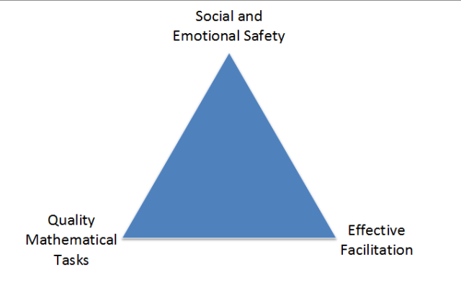
As I look at my own posts, others’ posts that I’ve bookmarked and favorited, and where I spend most of my time, it looks roughly like this.
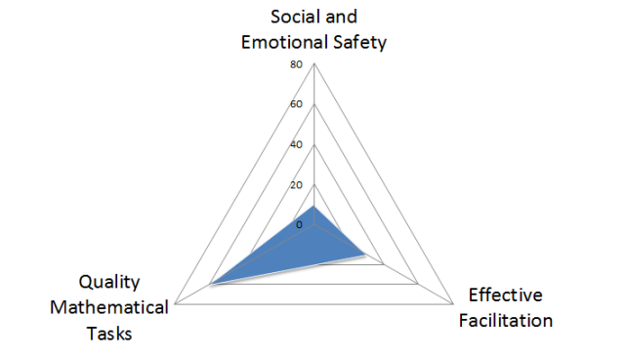
I’d give it a 60%-30%-10% split, and that 10% might even be generous.
In other words, social and emotional safety is something I rarely think about, and even more rarely blog about. In Jo Boaler’s “How To Learn Math” course, she shares interviews with former math students who exhibit signs of trauma. That’s the word she and they use: trauma. While I think most math teachers that I read and follow probably understand the need for developing a safe place emotionally and socially for the classroom, it’s something I don’t come across that often. Much of that is my own fault. I spend most of my time blogging and talking about cool, engaging tasks and nifty facilitation moves. I don’t spend much time at all trying to flatten the spoken and unspoken social structures that crop up in nearly all classrooms. Part of this is that it’s actually much harder work to do that than designing a cool task based around an article or something. It’s also something that really can’t be modeled in a few-hour single PD session.
It’s also probably in part because I’m a dude. This post on the prevalence of males and math tasks has been lodged in my brain like a tumor. I can forget about it for a few days at a time, but every now and then it’ll pop up and I’m reduced to a stammering mess. I hope I’m not gender-norming when I suggest males tend to be more in to designing tasks and “troubleshooting” student engagement and less adherent to the social and emotional component accompanied with mathematics classrooms, which is just as if not more important than the other ingredients. I certainly have spent 10-to-1 time or more on designing, finding, and thinking about mathematical tasks versus flattening the social status of mathematics learners. Again, the ratio of what makes for a successful math learning experience is off, either in what I’m reading or what’s actually out there. Probably both.
Consider this post part confession, part imploration. My lack of writing on the social and emotional structures is something that has shaken and convicted me. It’s also something that’s damned hard to find posts on throughout the Math ed blogosphere. Maybe I’m looking in the wrong places, but I am looking and not finding much. Consider this not only an imploration for math bloggers to blog about developing social safety in math classes, but also to share these more often (starting in the comments here, pretty please?).
I can’t promise that I’ll start blogging about how to develop a flatter math classroom as I can’t be sure I’ll acquire any unique insight other than copying and pasting what others have said. But I do plan on making this a huge point of learning for myself this year. I want to read more about developing an emotionally and socially safe math classroom that flattens structures and gives students an in to mathematics. I want to write more about it too.
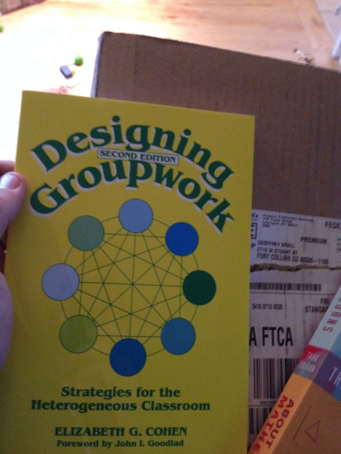

Tasks

When I Let Them Own the Problem
Fawn 5/7
From our textbook:
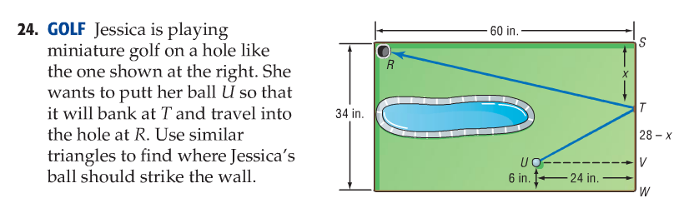
Stuff like this makes my heart sink. (I actually wrote that it makes me fart — but that's very unladylike. And I'm trying to write better.)
There is essentially nothing left in this problem for students to explore and figure out on their own. If anything, all those labels with numbers and variables conspire to turn kids off to math. Ironically even when the problem tells kids what to do (use similar triangles), the first thing kids say when they see a problem like this is, "I don't get it."
They say they don't get it because they never got to own the problem.
I wiped out the entire question and gave each student this mostly blank piece of paper and the following verbal instructions:

- Make sure you have a sharpened pencil. Write your name and date.
- Inside this large rectangular border, draw a blob — yes, blob — with an area that's approximately 1/5 of the rectangle's area. No one will die if it's not quite 1/5.
- Next, draw a dot anywhere inside the rectangle but outside the blob. Label this dot H.
- Now, draw another dot — but listen carefully! — so that there's no direct path from this dot to the first dot H. Label this second dot B.
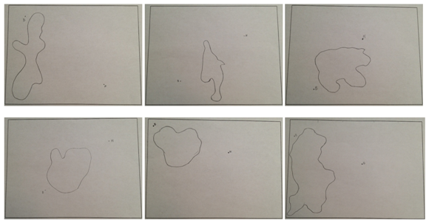
I asked the class if they knew what they just drew. After a few silly guesses, I told them it was a miniature golf course: blob = water, point B = golf ball, point H = hole location.
The challenge then was to get the ball into the hole. Since you can't putt the ball directly into the hole due to the water hazard, you need to make a bank shot.
(Some students may have drawn the blob and points in such a way that this was not really possible, at least not in one-bank shot. I let them just randomly pull from the stack of copies to pick a different one. I made a copy of their sketches first before they started their work.)
The discussions began as they started drawing in the paths. One student drew hers in quickly and asked, "Is this right?" I replied, "I'm not sure, but that's my challenge to you. You need to convince me and your classmates that the ball hitting the edge right there will bounce out and travel straight into the hole. Does it? What can you draw? What calculations are involved?"
What I heard:
- The angle that the ball hits the border and bounces back out must be the same.
- Because we're talking about angles, something about triangles.
- This is like shooting pool.
- Right triangles.
- Similar right triangles.
- Do we need to consider the velocity of the ball?
- This is hard.
- I can't figure out how to use the right triangles.
- Similar right triangles because that'll make things easier.
- Even though it's more than one bounce off the edges, I'm still just hitting the ball one time.
- I think I got this.
- I have an idea.
- Wish my golfer is Happy Gilmore.
BIG struggles, so I was happy and tried not to be too helpful. (I struggled big time too on some of their papers! And I think this made them happy.)
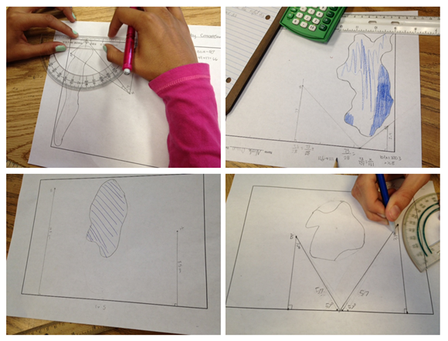
Lauren explained in this 55-second video how she found the paths for the ball to travel. I also had her explain to the whole class later at the document camera.
Jack took a different approach. Instead of measuring the sides and finding proportions to find more sides to create similar triangles like Lauren did, he started with an angle that he thought might work [via eyeballing] and kept having the ball bounce off the borders at paired angle until it went into the hole. (His calculation was off — or his protractor use was inaccurate — as he had angles of 90, 33, and 63. Or maybe if he had a better teacher, he'd know the sum of the interior angles of a triangle was 180.)
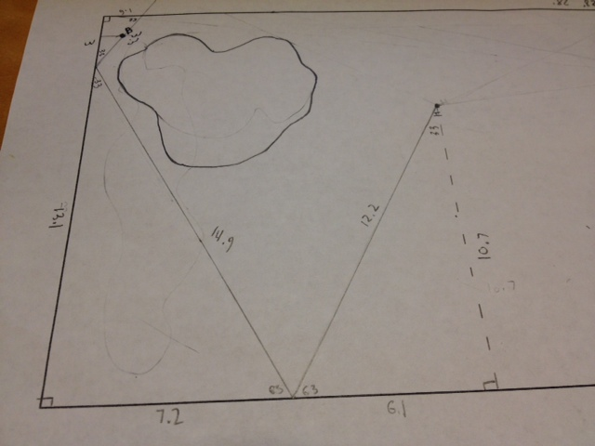
Gabe was quieter than usual today. When he finally shared, his classmates realized he was the only one to solve the entire problem using just constructions with a straightedge and compass. He walked us through his series of constructions until he found point C on the bottom border where the ball needed to bank off and end up in hole H.
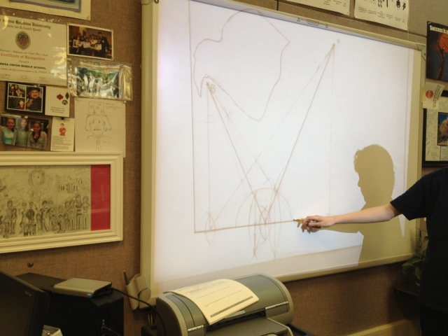
Imagine none of this thinking and sharing would have occurred if I had given them problem #24 in the book.
Half of my kids were still struggling and working to find the correct bank shot(s), but they were giventhe chance to struggle. And none of them said, "I don't get it."
**********
The cutest thing also happened while we were doing all this math. Yesterday (Monday) I bragged to the kids — and I'm doing it again right now — about the Rolling Stones concert that we went to on Friday. I am still over the moon ecstatic that we got escorted into the Pit from our way-in-back-floor-seats!!!!
Anyway, a kid today started humming to the tune of (I Can't Get No) Satisfaction and quickly others joined in with THESE LYRICS:
I can't get no similar triangles
I can't get no similar triangles
'Cause I try and I try and I try and I try
I can't get no, I can't get no
When I'm drawing in my lines
...
This lesson leaves me so full and proud. Their singing to the Stones while struggling in math makes me crazy in love with them.
Just so you know, I swooned shamelessly in front of my students over a 70-year-old rock star's butt.


[Added 05/08/13]
Today I had the kids work on someone else's paper (remember I made copies of their papers before they worked on them) and find similar triangles to make the bank shots. Because I purposely told the kids to draw in the blobs and the 2 points without any mention of where exactly to place them, it was then by chance that these papers below allowed for one-bank shots to get the ball into the hole.
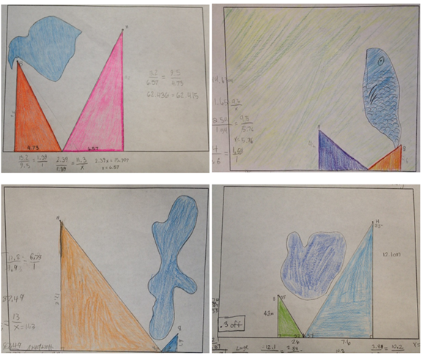
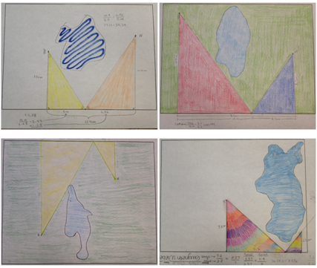

The ones below, however, are some of the ones that would not work with just one-bank shots, but I had the kids create similar triangles on them anyway because that was the learning goal of the lesson.
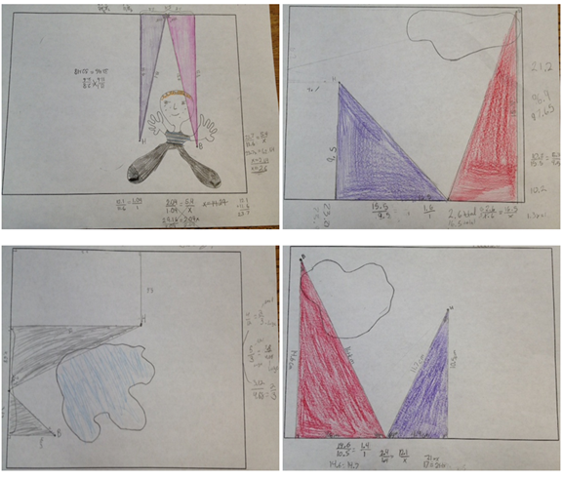
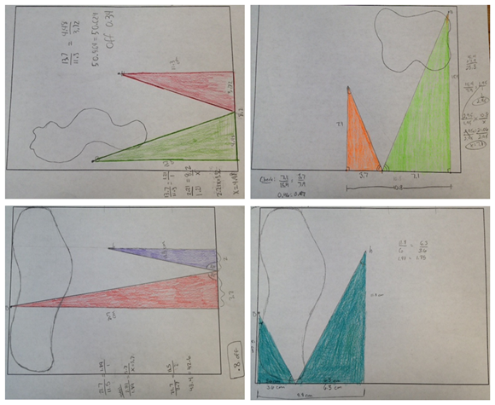

[Added 05/11/13]
Look what the crazy and wonderful Desmos did (click on tweet below to see):



26 Questions You Can Ask Instead
Max 9/11
Lots of times when we ask questions in math class, they fall into 2 categories:
- Procedural/Right Answer questions, e.g. “What do you call the longest side of a right triangle?” or “What did you get for number three?” or “What is the mode of this data set?”
- “Higher-Order Questions” aka hard questions, e.g. “Why do you think someone might have come up with that [wrong] answer?” Or “Which of these is correct? Defend your choice.”
In my experience, even though we want all kids to be able to answer both types of questions, they’re both tricky. For the first type, kids either know what I’m looking for or they don’t, and so I either get a few loud kids participating or awkward silence, and often devolving into off-task behavior.
For the second type, look out! Talk about awkward silence and devolving into off-task behavior. Kids look at me like I’m crazy when I ask them to synthesize, justify, explain, etc. And they wait. They can’t out-wait me (I am the king of outlasting the awkward silence) but they sure do try.
So I’ve been trying to come up with questions that are good, math-y questions that don’t fit in either of those categories. I want questions that every kid can answer, by virtue of being a human (and therefore reasonably observant, semi-rational, interested in other humans, and decently resourceful). I want questions that kids see some need to answer, or are interested by. And I want questions that get kids doing some intellectual work that will help them do more work. And that doesn’t shut them down. Oh, and that helps me figure out what’s going on with them. And that aren’t questions I already know the answer to. Here are some:
- What do you notice about ______?
- What are you wondering?
- What’s going on in this ______?
- What’s making this hard?
- On a scale of 1-10, how easy is this for you? How come?
- What’s one thing you remember about ______?
- Here are three different ______. Which do you like best? What’s one thing you liked about it?
- Tell me one thing you thought about problem three.
- What’s the first thing that pops into your mind when you see this?
- What’s the fourth thing that pops into your mind when you see this?
- What do you think a mathematician might notice about this?
- If you saw this image/story/statement on a math quiz, what question(s) might go with it?
- If your math fairy godmother appeared right now and offered to give you one helpful hint, what would you ask her for?
- How confident are you in the work you’ve done so far?
- The answer to the problem you’re about to work on is ______. How could someone have figured that out?
- Have you ever had an experience like the one in the story?
- What do you think the person in the story might be feeling?
- Why do you think I showed you this?
- What’s one thing you like about what she just said?
- What’s one thing you’re wondering about what he just said?
- What’s your best guess for the answer to this problem?
- What is an answer that is definitely wrong for this problem?
- Make a prediction. What do you think will happen…
- Without writing anything down or calculating or thinking too hard, could ______ be the answer?
- What’s your gut feeling?
- Do you have a reason or a gut feeling (or both)?
And from the comments/Twitterers:
Dan Meyer:
- “What do you think an incorrect answer would look like?”
- “What more information do you need here?”
This Google Doc from Justin Aion of questions he uses to help his students become better readers in math class.
Max Hoegh:
- “How would you explain this to a ___________?”
- “How would you explain this with a drawing?”
Ed note: In part because some of us teach 10-year olds, but also because I think that explaining math is a constant process of revising and adjusting based on audience feedback, I left the audience of “How would you explain this to…” blank. I like the idea of playing around with different audiences for different explanations. Like, “How would you explain this in a Tweet?” or “Send a friend who missed class today a text message about what they missed.” or “How would you explain this to a friend? How would it be different to explain it to an enemy?” I even know of a teacher who pasted her class picture from 3rd grade on a chair and will drag that chair to the front of the room when she wants kids to explain something clearly and step-by-step.
In general, I’m trying to push myself to ask more questions in which I’m not trying to get the kids to say the thing I need them to say. Instead, I’m trying to find questions that get kids to put into words the things they need to say — to let me know what’s on their mind, what their current working model is, where they’re stuck and what they’re ready for. I can make predictions but I never know exactly where a kid will turn out to be, and so I try to maximize what I can learn about them, while using questions that let them know I value them and really want to hear their ideas (not them stating my ideas for me!).

Partitive fraction division
Christopher 5/25
As promised, more notebook pages on fraction division. This is based on the work I did a while back on trying to write authentic partitive division problems with fractional divisors. (As I wrote that last sentence, I reminded myself what a bizarre niche market I am trying to occupy on this here blog.)
I settled on situations involving fractional values of unit rates, such as the following.
If of a lawn takes of an hour, how much can I mow in one hour?
Before we begin, remember that if the problem were about 2 lawns in 3 hours, we would easily and naturally divide by 3. Only the numbers have changed, so the mathematical structure remains the same and we need to find .
Click each image to see it full size. If you’re into this sort of thing.
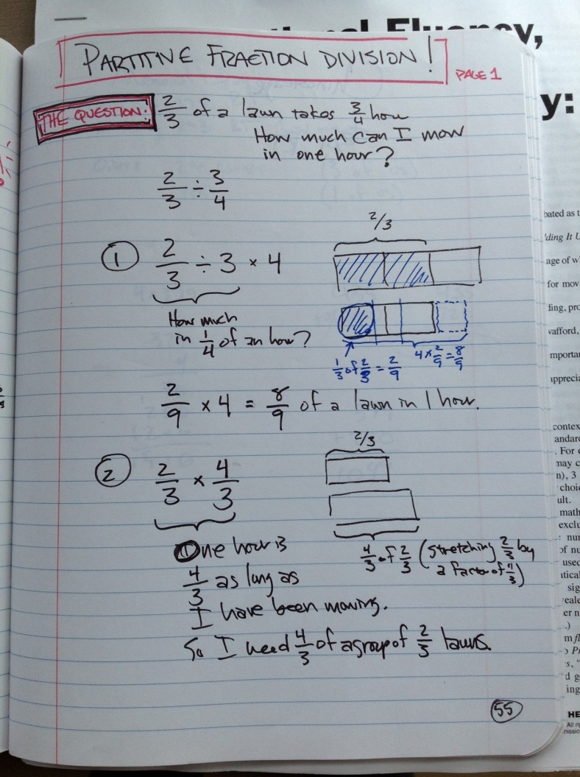
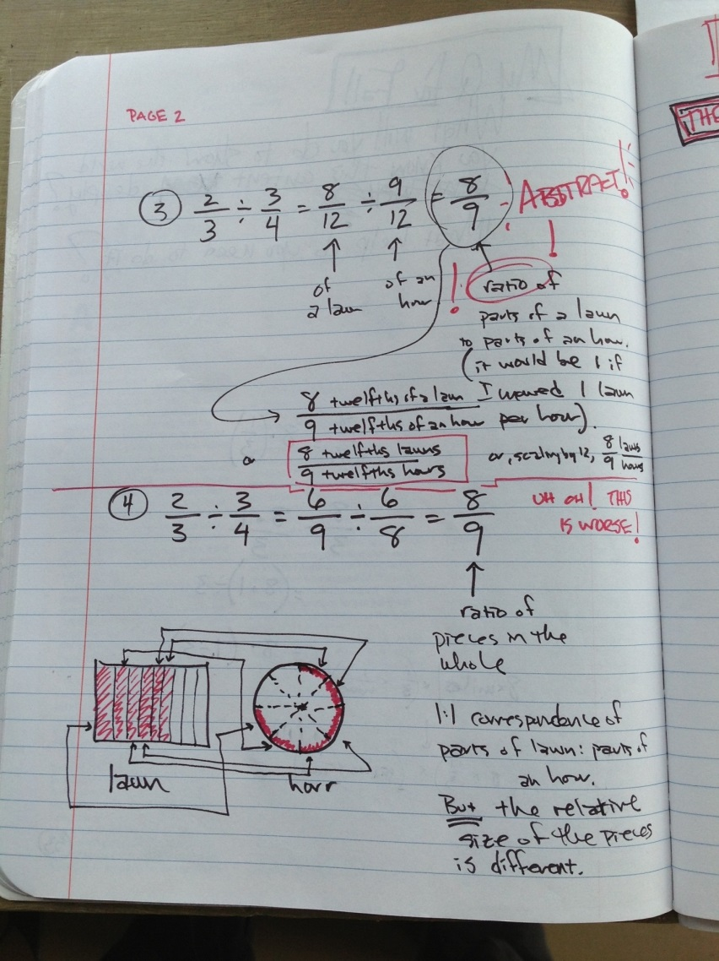

Imbalance Problems
Paul 3/21
My fifth graders have been writing problems this week. Mostly things liks “5 branches have 40 leaves, and 10 trees have 200 branches. How many leaves will 320 trees have?” Some of them have been writing problems with symbols that amount to systems of linear equations, and earlier this year we worked on balance problems to get at that sort of thing.
While all this was going on, inspiration struck.* What if the scales don’t balance? What if one side weighs more? Behold, my “imbalance problems.”
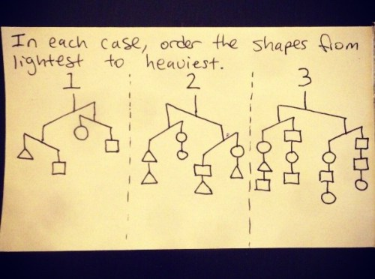
Unfortunately, problem 2 cannot be uniquely deduced. It has two possible solutions.
These are just three I came up with for example, but I can see a whole world of possibilities. I love how designing them is maybe a better problem than solving them. How many pieces of information do I need to give (albeit, implicitly)? [turns out it depends on what the information is! (maybe that's not surprising.)]
IMBALANCE PROBLEM CONTEST
Inspired by this post by the incomparable Shawn Cornally, I’ve decided to offer a little puzzle-writing competition. Spend some time writing great imbalance problems (the kind that push the state of the art), then share a link to them in the comments. My two favorite puzzle-writers (based on indescribably subjective criteria) will win a print of their choosing from my Stars of the Mind’s Sky series, up to 12″x12″. All of the rest of us will get a collection of excellent imbalance problems to solve and share with others! Exciting right? Who’s in?
+ + +
*not a ground-breaking, revolutionary, or truly novel inspiration, I admit. For me, this is a clear cut Cohen-Ventorism.** It’s such a slight tweak on an extremely common problem type. Someone else (countless others) must surely have also come up with this. And yet, a google search for “imbalance problems” yielded surprisingly little.
** Cohen and Ventor are two imaginary mathematicians who completely independently, perhaps simultaneously, discover (or coinvent) all sorts of mathematics. (See Newton and Leibniz)

Conics Hide and Seek
FracTad 4/21
We just wrapped up our study of conic sections, which can be a pretty dry topic. So to liven things up, I had my precalculus students go on a scavenger hunt. These days, everyone has either a digital camera or phone with a camera, so everybody could participate. Here is the handout I gave them outlining the rules:
Conics Hide and Seek
Names____________________________________
Math is all around us, and in this activity, you are going to find some places where it is hiding. We have finished our study of conic sections (parabolas, circles, ellipses, and hyperbolas), so it’s time to have a scavenger hunt! Using your phone or digital camera, you and a partner will explore the campus and take a picture of at least one example of each type of conic. The team with the most points will get a prize. You are on your honor not to share your finds with other teams.
Here’s how many points each type of conic is worth:
Circle: 1 pt (maximum of 5 examples)
Ellipse: 2 pts
Parabola: 3 pts (remember, a parabola is not the same as a “U”!)
Hyperbola: 5 pts
You can submit your photos via email. Happy hunting!
They spent more than half of an 80-minute block combing the campus for examples of conics. Did this activity involve rigorous mathematics? No, but it was a lot of fun for the girls, and it opened their eyes to some of the ways math can describe the world around them. When we reviewed the teams’ submissions, there was a lot of discussion about whether certain shapes actually were parabolic, or ellipsoid, etc. All in all, a very useful activity.
Here is a sampler of the best submissions. The winning team took over 100 photos!

Quadratic Frames – Totally Nguyening
Julie 5/2
If you teach middle school math or Algebra 1 and you are not reading Fawn’s blog, then you should. I get all of my ideas and inspiration from her!
She posted a great activity about Quadratics and framing. Please go read her post for instructions. I wanted to post how I modified her activity for Pre-Algebra (using simple factoring instead of the quadratic formula). I followed her instructions exactly, and modified four things.
- I teach Pre-Algebra so I made the problem easier for my students so that the numbers would be easily factorable and not need the quadratic formula. As a result, my students were more easily able to discover the frame dimensions (sadly, they did not beg). It did take most of them quite a while however and they appreciated when I finally showed them the math.
- I had my students draw their own picture on a 3×5 index card. They could also take a picture and bring it in. This way I didn’t have to find a picture for them, or print it and make copies, or cut it out. (Yes, I’m lazy and they love being creative so it was win-win.)
- I used index cards so I wouldn’t have to cut up a bunch of paper to the perfect size. Really Fawn, you are a saint. I had my students draw the picture on 3×5 index cards, then I used 4×6 index cards for the frame. I cut them down to 4×5 to make the border an even 1″ (see #1).
- I had them post the finish product on a half sheet of paper. This way they could glue down the picture and the frame instead of using tape. I am always short on tape. Also, on the back of the picture is where we all “did the math”.
I am posting mainly to say THANK YOU for Fawn, and to share my students creations! I am really into notebooks so I also included an idea for adding the work to the students notebook.
The Process:
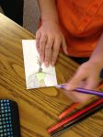
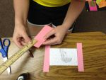
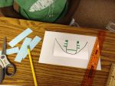


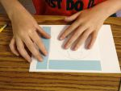
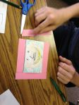



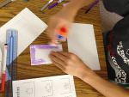

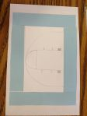
The finished product:
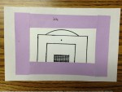
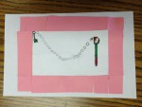



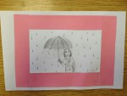

On the back of their picture, we did the math.

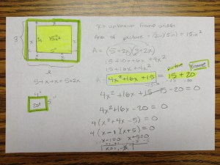
T

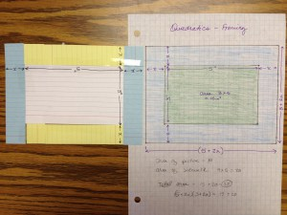
he Notebook Entry:
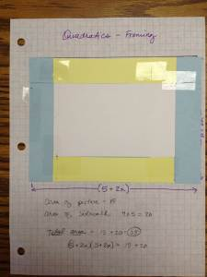

It’s like a foldable!

Introducing Conic Sections
Sam 4/5
One Equation to Rule Them All
On Monday, in Precalculus, I am starting conic sections.
I’ve made the decision to introduce conics through polar equations. This is totally backwards to the way that most people do it. Our textbook even sticks the polar version of conics at the end of the chapter of conics. However, I think it will be more powerful to do it this way.
You see, we just finished a unit on polar a hot minute ago, and I want to capitalize on that so students can draw connections between polar and conics. Additionally, we did a project on families of curves.
And in case you didn’t know this, the polar equation [1] give rise to all the conic sections by varying the parameter . In other words, you can see all conics as a family of curves with a varying parameter.
Noticing and Wondering
For you, I decided to take a few seconds to plot them on geogebra:
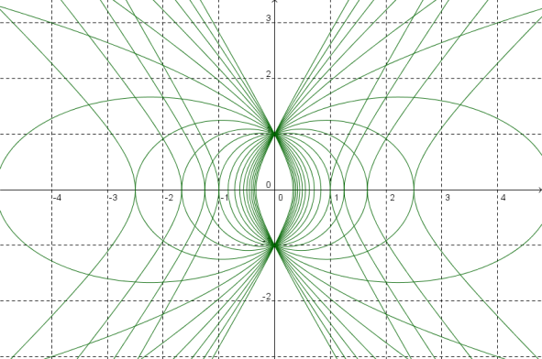
Instead of teaching them anything, on the first day I’m going to have them work in pairs. The plan:
- Have students get in pairs
- Have students use desmos.com to explore the family of curves using a slider to change
- Have each pair notice things and wonder things about what they see as they change the parameter — and record their observations on a google doc (this sample doc is set so you can view it)
- After each pair is done noticing and wondering about , I’m going to have kids spend a few minutes noticing and wondering about
I’m handing out this worksheet [.docx] to get us to do these things.
I don’t know how long this will take. Maybe 20 minutes, maybe 50 minutes? It really depends on how into the noticing and wondering. I’m a little uncertain where to go next with this — how to share the noticing and wondering… Each pair is going to have a group letter (A, B, C, … H, I, J). So I might have them spend a few minutes looking at the documents of those that preceed and follow their group (e.g. C will look at group B and D’s group’s observation).
Then I’m not sure how to wrap this all up. I think what I may do is leave it there, and not do a whole-class share. But after that, I’ll collate their noticings and wonderings, and as we introduce new things, I’ll tie them back to statements from these documents. For example, if a group notices “when is a huge number, the graph looks like two intersecting lines,” when we get to hyperbolas, I’ll start the day reading that statement, and after delving into them, we’ll return back to that statement to see how it relates to the algebraic work we did. Or if a group wonders, “When , I wonder if there’s a relationship between the value of and the angle between the two intersecting lines,” I could build that into the questions in the worksheets I’m writing for this unit.
Or maybe I’ll do nothing with them. Just the mere act of exploring, and coming with the conclusion that one family of polar curves can general four distinct general shapes (circle, ellipse, parabola, hyperbola) is good enough for me. Just paying attention to what’s happening to the graph, and learning to ask questions about what’s happening, that’s a skill in itself I should be content with cultivating.
(I should point out that I have rarely used the notice/wonder thing… so this isn’t fluent for my kids.)
Where I go from Here
From this activity, though, we are definitely going to talk about how we see four qualitatively distinct shapes, and we’ll name them:
circle, ellipse, parabola, hyperbola
And since we aren’t relying too much on the textbook, I am going to want them to make a schematic chart to organize what they’ve uncovered through observation.
And then we go on to the icky algebra, identifying various polar equations as different types of conics, and then eventually converting polar to rectangular form. (But in our polar unit, they already were asked to convert equations like to rectangular coordinates, so this will be a bit of review.)
View this document on Scribd
[.docx]
This is all subject to change, obviously.
And then… then… when students have qualitatively understood conics as all emerging through one equation… when students see that the conics all gently slide into and out of each other as a single parameter changes… when students see two things they already know (parabolas and circles) and see two things they don’t know (ovals, weird pairs of curves that look almost like crossing lines)… then we’ve motivated this luscious mathematical journey we’re going to embark on. [2]
Then we can get to the rectangular form for conics and see how they come to look so similar, and why the differences arises… Why certain things open up and certain things open sideways… all the traditional stuff… But motivated by this untraditional beginning.
UPDATE: It’s Sunday, before I try this on Monday. I decided I want kids to understand why hyperbolas have asymptotic behavior from the polar form (and why ellipses don’t!). So I made this sheet [scribd online, .docx] which I think will get them to discover some algebraic connections behind some of the visual things they will have uncovered from their noticing and wondering.
UPDATE 2: My kids did their noticing and wondering. Because they were comfortable with Desmos from our polar unit, it went really smoothly. It took them about 25 or 30 minutes before they had exhausted all their observations. I walked around and pressed a few on some of the things they were doing/saying without giving anything away… Like if they said when that the graph is a parabola, I had them graph to confirm that it wasn’t… and then they had to zoom out to see it truly was an ellipse. Or if they said that very high values of give rise to intersecting lines, I would ask them to record in their noticings the point of intersection was (so they’d zoom in and see there was no point of intersection!). All my kids’s observations are recorded here in their google docs: Group A, B, C, D, E, F, G, H
[1] And, technically,
[2] I’m in the middle of Paul Lockhart’s Measurement and what’s amazing is I was reading it on the subway to school, and today of all days, I started his introduction to conics. He introduces it in a stunning way, through projections, and showed me one of the most elegant proofs I’ve seen dealing with ellipses and why the sum of the distances from the foci to the ellipse is a constant. I wish I could move away from our traditional curriculum to work as qualitatively and beautifully as he has done.

One way to introduce ratios so they make sense to students
Nicora 10/25
We know that students struggle with understanding ratios and reasoning proportionally. The cross-multiply algorithm doesn’t make sense to them.
What can we do to help ratios make sense to students?
Whenever I’m thinking of how to introduce a new concept, I like to start by thinking about what students already know that can be built on so that a new concept makes sense to them.
That’s when I usually go to the research. Researchers have conducted lots of studies that focus on what students can intuitively do or what contexts have been successful in fostering particular concepts.
In the case of ratio, the research shows that recipes are an effective context for introducing ratio. Students understand how to adjust a recipe to make more or less of it without changing the taste.
What are some potential ways to build on this when introducing ratios?
- Give them a recipe that involves two quantities, such as lemons and cups of sugar and ask them how to make more lemonade that tastes the same and less lemonade that tastes the same. Have them record different values in a labeled table.
- Ask them how to make lemonade that tastes the same if you only have 1 lemon or ½ of a lemon.
- Ask them how to make lemonade that tastes the same if you only have 1 cup of sugar or ½ a cup of sugar.
- Give different recipes, varying the difficulty of the numbers used.
- Have them graph different recipes.
- Later, give two recipes and have students determine which is “more lemony”
Of course, this is just one potential route to introduce ratios. I am sure you can think of others you might use.
The development of proportional reasoning is a complex process and requires a number of conceptual steps. I only addressed the beginning steps in the suggestions above. If you want to know more, check out the work below.
Kent, L. B., Arnosky, J., & McMonagle, J. . (2002). Using representational contexts to support multiplicative reasoning. In B. Litwiller, & G. Bright (Ed.), Making sense of fractions, ratios, and proportions (pp. 145-152). Reston, VA: NCTM.
Noelting, G. (1980). The development of proportional reasoning and the ratio concept.Educational Studies in Mathematics, 11, 217 – 253.
Streefland, L. (1984). Search for the roots of ratio: Some thoughts on the long term learning process. Educational Studies in Mathematics, 15(4), 327 – 348.

Made4Math - Function Operations
@druinok 2/4
It feels like it's been forever since I blogged! One of my New Year Resolutions was to find more balance in my life and while I'm happy to report that it is going well, it has meant a decrease in things like blogs and twitter. I've not had an extremely creative semester, so far, but here's some goodies from this past week :)
Function Operations
Last week, one of our lessons was on function operations... you know, (f+g), (f-g), f(g(x)), etc and honestly I thought it would go very smoothly since we had already done polynomials. Oh my goodness... it was a diaster! I did a self-guided worksheet (you can see it HERE), and thought the kids would zoom through it, but no... it took us TWO DAYS! I was at my wit's end and so frustrated because it was issues that I did not even anticipate!
Anyway, to make a long story short, we needed practice... and LOTS of it! So I grabbed my handy flash cards, a marker, and one of my big dice and here we went...
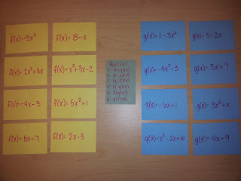
We picked an f(x) and a g(x), then rolled the dice to tell us what to do. It was definitely good practice! Crisis averted!
Inverses Foldable
So the next day, our lesson was on function inverses. It had been a while since we had done a foldable, so we did a foldable for our notes.
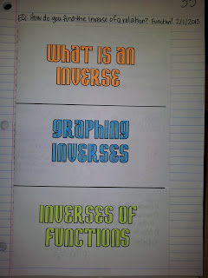
Let's just say that after a stressful week, I enjoyed coloring the foldable! :)
Get the entire foldable HERE

Protocols for Mathematical Discussions
Jeff 5/9
I’ve tried to make mathematical discussions a much larger part of my class. Here’s what I’ve done.
The Protocols
To begin, my school is very protocol-driven. We use many of the protocols from the National School Reform Faculty, among others, along with protocols we create, tune, and share amongst ourselves. I use all kinds of protocols in class, including to run discussions. So these are what I’ve used this year.
Text-Based Seminar
For discussions based on texts, nothing beats the good old NSRF Text-Based Seminar. We use it often in Advisory (and for staff meetings). I used it toward the beginning of the year to discuss an excerpt from What’s Math Got to Do With It? (around page 40-41 if you’re interested…I don’t want to break any copyright laws). The trick as facilitator – as with any protocol – is to stick to the protocol, which in this case means holding learners accountable to referring to the text when speaking.
Pros: Keeps participants focused on the topic at hand without becoming a random opinion-spouting session.
Cons: This is a great protocol, but the opportunity to use it doesn’t come up all that much in my class.
Progress Fishbowl
This is a protocol I created based on a standard fishbowl when most of the class was struggling with a problem. I mean really struggling. A couple of groups in each class were finding some good solution paths and I wanted a way for them to share it productively. This one’s a bit lengthy – it could probably be pared in half.
View this document on Scribd
Pros: Allows those with good ideas for solutions paths to help others without resorting to a “tutoring” situation. Those outside the fishbowl can come to their understanding through participation in the discussion rather than being told what to do.
Cons: It can get messy, particularly if some are totally lost. One time the protocol broke down entirely because the discussion was good enough on its own merits that a protocol was no longer needed. In that case, the class renamed it “the broken fishbowl”…we even drew a logo for it.
Linking Fishbowl
This protocol was my attempt to be sure all voices were heard. I’ve used it for conjectures on problems that were complex, yet had a low entry point. Most of the thinking is done beforehand, so it kind of amounts to a glorified share-out…until a learner pushes the previous speaker’s reasoning. Then it becomes glorious.
View this document on Scribd
Pros: All voices are definitely heard, the discussion moves quickly, and it can go fantastically well when learners push each others’ thinking.
Cons: Since it is more of a share-out, learners can become disengaged once they’ve shared.
Yes, And… Protocol
My most recent creation, I used this for a similar reason as the Progress Fishbowl – to gather all the good ideas in one place and help those that needed it come to a better understanding. However, I wanted to avoid the breakdowns that can happen when disagreements occur, so learners had to build on what the previous speaker had said by prefacing with “Yes, and…” – which made for some great conversation. This went so well that it sparked me to write this post. I hardly had to say a word – my favorite kind of discussion!
View this document on Scribd
Pros: All voices were heard, and great ideas were shared and improved upon.
Cons: It was actually fairly time-consuming. If you’ve got short class periods, it may not work for you (I have 90 minute periods, so I can pretty much do whatever I want).
What makes these kinds of discussions work? As a class and as a school, we focus on building a culture of trust, respect, and responsibility. We spend the first week-and-a-half of the school year exclusively on building culture – we don’t even touch content. Trust me, this pays off. Among other things, it creates the environment where these kinds of discussions are possible.
Also, it isn’t as if we do nothing but protocols. We have discussions everyday that are more typical of a classroom. But these are a great way to come to a wider understanding as a group for an important topic.
I’m leaving so much out; these protocols in a vacuum are worthless. But I thought they might spark some ideas for anyone looking for new ways to discuss mathematics in their classrooms.
Side note: I recently purchased Smith & Stein’s Five Practices for Orchestrating Productive Mathematics Discussions, but I also bought three other books at the same time (including the long version of A Mathematician’s Lament) so I haven’t even cracked it. That is to say that this post is a baseline of sorts; I want to get my thoughts and current strategies for discussions in writing before it all (probably) changes after reading Five Practices.

Coupon Composition: Just In Time For The Holidays
Scott 12/03

In the spirit of Black Friday, let's see if we can save some green.
Whether you are guilty of joining the Black Friday "festivities" or not, this lesson contains something for you to be aware of in your shopping with coupons.
If you have multiple coupons, of different discount types (amount discount vs. percent discount, that is), then there is a particular way to apply these savings that will earn more savings than the other.
Long story short:
Apply the percent discount before applying the amount discount for more savings.
The concept relies on the concept of composition of functions, commonly written in the form f(g(x)). These are functions that evaluate in one functions and then another, in a particular order. The topic puts emphasis on evaluating with the order of operations as well as other properties like the commutative property and associative property, both of which are staples in algebraic concepts.
Always good to start out with a real-world example, right? Despite not using my wife's likeness, I do mention her lovingly.


Remember, always use the percent discount FIRST when given the opportunity.
Teaching this lesson in class works well, mainly due to the fact students get so wrapped up in seeing whether they know how to reap the biggest reduction on their purchases in the future.
To help solidify their learning, or ward off skeptics on the topic, we try a couple examples: a $50 purchase and a $100 purchase, for ease of computation. Follow along:
For a $50 purchase:
- $10 discount applied first: $50 - $10 discount = $40, then $40 - (0.2)*$40 = $32 final price
- 20% discount applied first: $50 - (0.2)*$50 = $40, then $40 - $10 = $30 final price
For a $100 purchase:
- $10 discount applied first: $100 - $10 discount = $90, then $90 - (0.2)*$90 = $72 final price
- 20% discount applied first: $100 - (0.2)*$100 = $80, then $80 - $70 = $70 final price
It is no strong coincidence that there is a two-dollar difference between these scenarios. This is the critical piece of what I'm trying to convey with this post (oh, and it's a fun math lesson to teach).
In using the dollar-discount first, the consumer or retailer is causing the percent-discount to be applied to a smaller value, therefore not letting it stretch as far as it could otherwise. It is, in essence, as if you are also taking the percent OFF of the dollar discount you wish to use (note the examples above, where there is a $2 difference and $2 is 20% of $10).
In applying the percent discount first, your percent covers the larger original purchase price and stretches further. This is the gist of why the percent coupon should be applied first, when you have the opportunity. NOTE: Some retailers have a point-of-sale system which is programmed to use the dollar discount first, no matter when you had a coupon to the cashier, so you might be forced to play their game and sacrifice part of your savings. I will not name names, but have had a couple of disappointed students bring in receipts and show me how much MORE they could have saved if the register didn't force the order of discounts applied.
I'm making a bunch of links in this sentence if you would like either the TI-Nspire file I have shown up above in the slideshow, or the original presentation and handout I did for this topic to earn T^3 Instructor status a few summers ago. (Don't have a TI-Nspire? Try running the TI-Nspire file through the TI-Nspire Document Player without a need for download of software.)


A 101qs.com entry I posted in May, 2012. This was a head-scratcher but good example.
I managed to take a trip to an outlet mall, where I saw a curious sale display, pictured at left. To use the word "PLUS" in this instance seemedadditionally confusing (yes, pun intended there), and caught the ire of Dan Meyer on his blog shortly after I'd posted the photo to 101qs.com.
This, and other sale opportunities like it have been a common cause of commotion in class among my students who have heard me teach this lesson. They are able to bring up new shopping adventures they have had, where they might have corrected the way a cashier had rang something up, or a discount was applied more favorably than they expected, or the discount merely balanced out the sales tax they would have paid anyway. Regardless, the lesson sticks.
Applying similar, consecutive discounts have proven to be a decent introduction to exponential growth, since students are aware that "50% off, then another 50% off does not make the item FREE." For those students who are very shopping-savvy, these applications hit home for them much more quickly than any compound interest problem ever could.
Speaking of interest, I hope this sparked some of yours. Have a good day and enjoy the holiday season, saving all the while!

Weekly POPS
Andrew 11/20
Have you ever tossed a puzzle at one of your students? Y'know, the puzzles kids can play around with using their hands and minds? It's crazy, right?! It's fascinating to watch a student display a wide range of behaviors: curiosity, engagement, perseverance, frustration, and an earnest desire to know the solution if they get fatigued and stumped. I have a couple bins full of puzzles in my classrooms that do this to kids. Students rarely have a chance to play with them, but when they do, they go bonkers in a good way. Occasionally, you'll hear a triumphant yell when someone solves a puzzle. Other students look in disbelief. It's hilarious. My collection of puzzles ranges from the Bedlam Cube (now known as Crazee Cube), to Cannonball Pyramids, to the Rubik's Cube, to Tangrams, to ThinkFun puzzles, to other miscellaneous puzzles I've picked up over the years. A few weeks ago, I was driving home and wanted to know if there was something I could do in math that had a similar magical effect on kids.

Have you ever tossed a puzzle at one of your students? The ones on paper that require logic and critical thinking? Those are crazy too! Kids can really get into them. Around the same time I was thinking about the power of physical puzzles, my school wanted to revamp our weekly intervention/study-hall period. I thought students could benefit from working on logic puzzles, patterns, or Get to Ten. I went to a resource called The Colossal Book of Short Puzzles and Problems by Martin Gardner in which Fawn recommended. I came across this Billiard Balls gem in which I remade for my students:
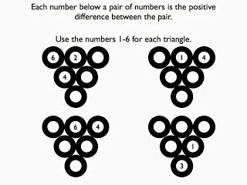
So I got to thinking and thought of some inspirational people/things from my PLN. I've always wanted to incorporate Fawn's Visual Patterns into my classroom more, especially with it's beautiful new makeover. Fawn is also known for her weekly problem-solving tasks. I've also wanted to incorporate more PoWs from the Math Forum. The Math Forum has an abundance of problem-solving tasks that range in difficulty across grade levels. Sign up, yo! Last but not least, Dan Meyer had impeccable timing and recently wrote a very invigorating post on [Fake World] Conjectures that has created quite the buzz in the comments. Personally, he struck a chord with me as he ended it saying:
Find those puzzles in the real world, the fake world, the job world, or any other world - it doesn't matter.
His post and quote made my day (with a smile).
The result of all these crazy things: Weekly POPS.
POPS stands for:
- Patterns (or puzzles like the Billiard Balls above)
- Order of Operations (Get to 10 or Get to 24)
- Problem-Solving
Patterns (or puzzles):
I will include a pattern either from Visual Patterns or one I create. As you can see from the handout below, it's similar to Fawn's form. I am adding a section for students to describe the pattern in their own words. If I decide not to do a pattern that week, I'll do some type of puzzle like the Billiard Ball puzzle above.
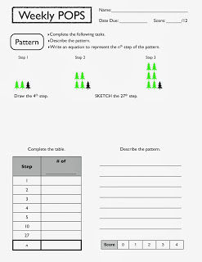
Order of Operations:
Students are to use the four given numbers and mathematical operations, symbols, and/or notations to get to the values of ten (or twenty-four). As you can see from the handout, students need to write the expression and evaluate it correctly using Order of Operations (or PEMDAS).
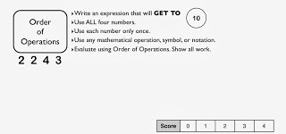
Problem-Solving:
Definitely one of the most important parts of the Weekly POPS, problem-solving. Right now, I'm finding old PoWs from the Math Forum's library to share with my students. As you can see from the handout, be sure to include the Math Forum's copyright information when photocopying. I'm looking for students to organize their work, demonstrate their solution strategy, and think critically.
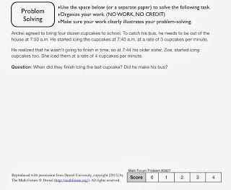
My goal with Weekly POPS is to get students to really think critically and problem-solve. Why? because they so desperately need it. It's challenging, demanding, and necessary. There's a slight puzzle feel to POPS. Students have really been into it this week.
Students receive the POPS every Friday and have a week to complete it. They'll turn it in the following Friday and receive a new POPS. I've invested a lot of time in class this week going over my expectations, but will use Monday and Tuesday next week to show my classes student POPS that are exemplars, average, and sucky. I told them, "You earn a zero on your POPS, it's the same as POOPS."
I look forward to this adventure with my kids. Here's a folder with the POPS I've created so far. Feel free to join in the action. If this link is broken, please notify me and I'll fix it, unless your name is Fawn.
POPS,
951

When Desmos Fails
Patrick 11/21
I am huge fan of Desmos, the free online graphing calculator. I use it almost every day in my classroom: to sketch simple graphs, demonstrate mathematical relationships, and dynamically explore mathematical situations. And like most worthy instructional technologies, it’s really alearning technology: it’s easily accessible to students as well as teachers..
As far as technology goes, Desmos works very well. But some of my favorite mathematical questions arise when technology does something we don’t expect.
For example, here’s the graph of . This graph has a hole (a removable discontinuity) at the point (-2,-1), which I have colored blue.
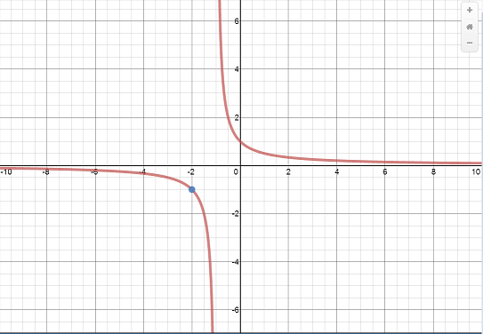
But look what happens when you zoom in around the hole:
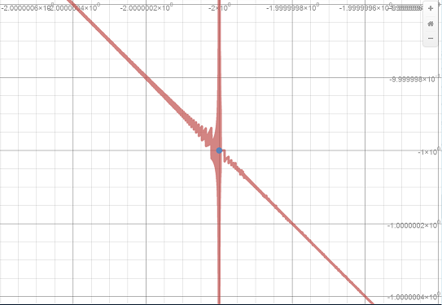
At a very small scale, some very curious behavior emerges!
Now, it’s not the function here that’s behaving strangely: its behavior is well-understood. It’s the mathematical technology that is behaving strangely, as it tries to represent the function.
Lots of interesting questions emerge from such anomalies, and these are great questions for students to explore. In doing so, they’ll not only learn some mathematics and some computer science, but they’ll also develop a healthier relationship with technology, by learning to understand how it does what it does, and perhaps more importantly, what it doesn’t do.
You can find more of my work with Desmos here.

Open letter to Sal Khan
Christopher 8/1
Dear Mr. Khan,
A year ago, I expressed my concerns on the Washington Post’s blog that your decimal place value videos and exercises failed to incorporate very basic knowledge about how people learn place value.
I wrote that your decimal comparison videos were problematic because they only addressed decimal numbers with the same number of decimal places, and that a very basic, robust finding in rational number learning research is that students do not struggle with these comparisons—because students can treat them like whole numbers and get correct answers. Instead, students struggle with comparisons where the decimals have different numbers of decimal places because here, the whole number place value rules do not apply.
Together with my co-author, I wrote,
A student who thinks that 0.435 > 0.76 is offered nothing in the way of correction on Khan Academy. In fact, one of the top questions on the page for this video (as of July 18, 2012) is “So is .02009 greater than .0207?” This is exactly the sort of question that a competent teacher of arithmetic needs to anticipate and to answer. Khan fails to pose it.
In short, these decimal videos and their accompanying exercises are useless.
You must have read our piece, as it came out at the same time as Karim Kai Ani’s critique of your treatment of slope, which you responded to directly in writingand video.
But you do not seem to have taken the critique seriously. Consider the following video, which you posted yesterday.
Notice how 1000 is the same size as in that exercise?
Mr. Khan, that matters. It matters very much.
The hard thing about learning decimal place value isn’t learning the names of the places. It is learning the relationships among these places. That is of , for instance, and that 10 make . And that these two relationships are themselves related.
When we fail to emphasize these ideas in instruction, we get the following results. (The following is a short excerpt from a longer video that is part ofIMAP at San Diego State University, on a CD-ROM published by Pearson.)
These two girls (earlier in the video) correctly identified that 1.8=1.80 because you can add a zero to 1.8. But then, if it’s “You Cannot Add a Zero Day” they decide that 1.80 is larger because it’s “1 and 80 hundredths” while 1.8 is only “1 and 8 tenths”.
These two students have learned all the rules that you seek to teach them, and they do not understand decimals at all. What we see in these two girls’ thinking is precisely the problem you set out to solve with Khan Academy. But you aren’t solving the problem, Mr. Khan. You are perpetuating it.
The problem is that students learn names for places and rules for operating without thinking about the values and the relationships among these values that our place value system represents.
In the imagery of the exercise in your new video these students would be imagining 80 hundredths boxes for 1.80 and 8 tenths boxes for 1.8. The exercise builds a mental model for students that feeds their misconceptions.
Mr. Khan, you have a team of teacher advisors. If none of them can identify these gaps for you, you need to ask for help from the larger community (and then to reexamine your hiring practices).
You might consider starting with Twitter. Like this:
Dear Twitter: What is one common mistake or misconception made with decimals? #mathchat#MTBoS
— Christopher (@Trianglemancsd) August 1, 2013
You have many more followers than I do, so you should be able to generate in a few minutes several dozen times what I got back in a couple of hours. You might get responses such as the following…
@davidwees @Trianglemancsd “0.05 is not equivalent to 0.050.”
— ATLT Games (@ATLTGames) August 1, 2013
@Trianglemancsd 0.5,0.36,0.004, etc are decimals. They forget about 3.8, 6.2 etc. Or 2 is not a decimal b/c no decimal point.
— Jamie Rykse (@jrykse) August 1, 2013
@Trianglemancsd 0.05 is larger than 0.5 “because it has more zeros in it.”
— David Wees (@davidwees) August 1, 2013
@Trianglemancsd @mathtans When making comparisons, Ss think the more digits in the decimal number, the larger the number.
— Math Minds (@MathMinds) August 1, 2013
@emwdx @Trianglemancsd blindly use algorithms wo thought/estimation. So 2.1*5.25 can end up 110.25 or other such variation.
— Julie (@jreulbach) August 1, 2013
@Trianglemancsd Mistake: 0.3*0.3=0.9
— Evan Weinberg (@emwdx) August 1, 2013
@Trianglemancsd Appending zeros at the end creates a larger quantity.
— Chris Robinson (@absvalteaching) August 1, 2013
@Trianglemancsd Assuming universality of decimal system units? 4.25 hours isn’t 4 hrs, 25 minutes.
— Gregory Taylor (@mathtans) August 1, 2013
Do you see that none of these has to do with the instructional purpose of your video or exercise? None of these has to do with naming the decimal places. They all have to do with understanding the relationships that decimals are intended to notate.
What your work presents as being the whole mathematical story (naming decimal places) is just the tip of the iceberg.
You could hire experts, Mr. Khan—on an ad hoc or long-term basis—to advise you in these matters, if you don’t trust Twitter to provide good guidance.
Or you could educate yourself (as we require of all licensed teachers) on what is known about how people learn mathematics. I’m not talking about reading everybody’s blogs, or years of professional teaching journals. You don’t have time for that.
I’m talking about reading a few reports of robust research. You should start with Children’s Mathematics and Extending Children’s Mathematics. These are highly readable accounts of how children develop early ideas about whole numbers and operations (in the case of the former title), and about fractions and operations (in the case of the latter).
Then you could move to some of the work of the Rational Number Project. Now, they have many, many years of research that is challenging to wrap one’s mind around. Their work is overwhelming. Because we are talking about decimals, I’ll recommend one article in particular: “Models for Initial Decimal Ideas“. (Behind paywall, but someone at Khan Academy is an NCTM member, right? Right? If not, shoot me a note. We’ll get a copy to you.)
If you read that article, you’ll see that you are on to something at about the 10-second mark of your new video.
We could say this is one-hundred and twenty-three thousandths, or we could say it is one tenth, two hundredths and three thousandths.
That right there? Gold.
That’s the important bit. That is where you need to expand your instructional videos and your exercises. Good, long-running research projects will show you how.
I am not for hire, Mr. Khan. I am not lobbying for a job here. I am advocating for you to do what’s right, which is to use your visibility, your reputation and your capital investments to produce and promote informed instruction. As is often noted, you get millions of hits every day on Khan Academy. I want those students to get something better than they’re getting right now.
But I will make the same offer to you that I do to everyone I communicate with on Twitter and on this blog, which is this: Let me know how I can be helpful. You can do that through the About/Contact page on this blog or through Twitter.
Sincerely,
Christopher Danielson
NOTE (1): This letter has been edited a couple of times for clarity since originally being posted.
NOTE (2): We seem to have gotten ourselves stuck in an endless feedback loop. Comments are now closed (as of August 7, 2013). There are a few threads below that are interesting enough to follow up on, and I’ll do so. In the meantime, if you want to continue your conversations elsewhere, you can link back here; pingbacks remain open.

Projectile Projects!
Audrey 12/2
Here are the projects! I and my fellow LearnQuebec teachers, Kerry Cule and Andy Ross, have just received these joint physics-math projects.
I am beside myself. Speechless, which doesn't happen a lot. Such variety - sports, nursery rhymes, video games, abstract art, pirate ships. And such creativity!
Each caption is a link that takes you to the html5 version at geogebratube.org. They all work, so have fun!
Enjoy!

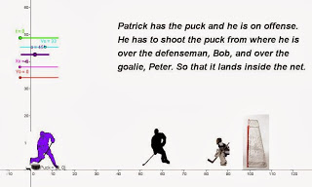
AB - hockey

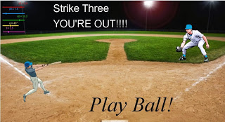
AG - baseball

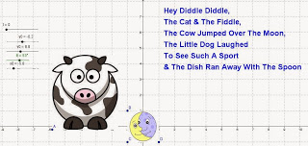
AGR - Nursery rhymes

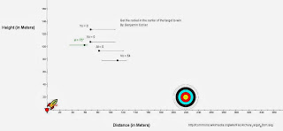
BC - rocket

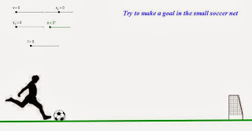
CP - soccer

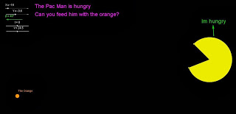
CC - pacman

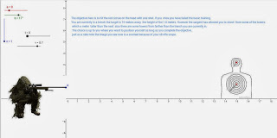
JM - CoD

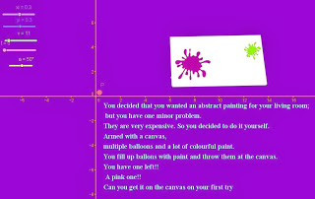
KR - abstract art

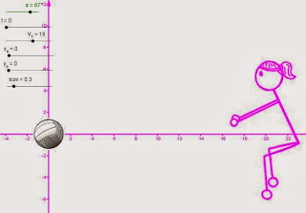
KLD - catch the ball

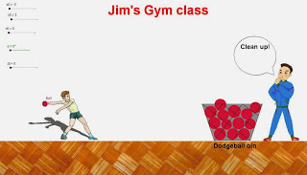
LF - Jim's gym class

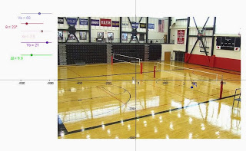
RM - volleyball

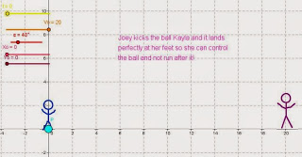
SC - soccer


TC - archery

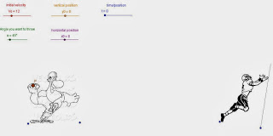
VM - football

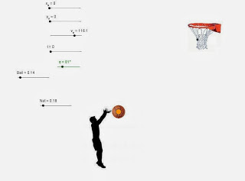
XG - basketball

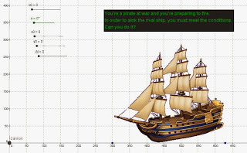
ZB - pirate ship

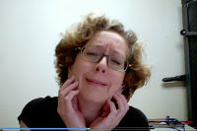
This is me now:
Projectile tears of joy!
An embarrassment of riches:
Many questions and conversations arose in the course of this project. Some I plan to bring up to the whole class. And all came from the kids' own individual problems that they encountered along the way to trying to get their projectiles to fly. Some of these are ideas that I'm sure all physics teachers try to get across every time they do the unit, but I also think that some of these probably never would have even come up without this project as a backdrop. Riches beyond imagination!
"My formulas are right, but my projectile won't fly!" Launch velocity has a threshold: You need a certain velocity to overcome gravity - if the greatest velocity your slider allowed was 12, your projectile won't go up practically at all, because gravity overcomes it almost immediately: eg at 2 secs y = 12 (2) sin 50 - 4.9 (2)² = -1.2 m
Size of projectile: One student had a projectile whose diameter could be varied. Will that affect the path?
Value of g: One student had a slider for g. When would we need to vary the value of g? And should it be 9.8 m/sec² over the moon?
Dimensional analysis: What are the units of all the variables in the sliders? What must be the units along the axes?
Realistic values for variables - Why allow negative velocity, initial position, or time? Do they make any sense for your situation? Under what circumstances would those make sense?
Frame of reference - Not every student used the first quadrant as the location of their situation. Is that ok?
Angle - some allowed their angle to go up to 360°. Does that make any sense for this context? Under what circumstances would it make sense?
Other stuff: One student's projectile was an arrow, and one was a rocket. Super bonus: How to get them to move realistically along their flight pats? eg it begins with the tip pointing up and other end down, then they slowly reverse. Two different points joined by a segment? And what would be the difference between the coordinates of those two points? One has an angle that's the other one delayed, by a phase shift perhaps?
Math stuff: A couple of students defined the position of their projectile as the intersection between two lines - the vertical line x = horizontal position of the projectile at time t, and the horizontal line y = vertical position of the projectile at time t. Mathematically sound. Works. Never thought of that. Mind blown.

Next post will have student reflections about these projects - more riches. Any feedback would be hysterically appreciated, especially by these hard-working rocket scientists, literally!

[Makeover] Ferris Wheel
Dan 8/5
The Task
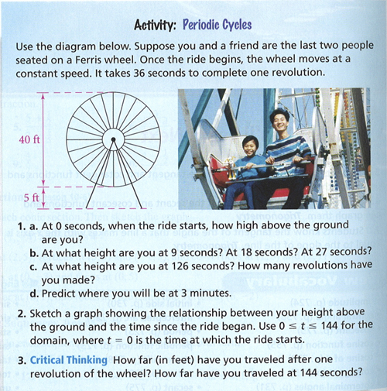
What I Did
TLDR: Here's the 101questions page.
- Start concretely. Saying "it takes 40 seconds to complete one revolution" isn't the same as seeing a ferris wheel travel at that speed. ¶ The task also asks students to trace the path of a car on a ferris wheel, precisely, point by point, for a given domain. We'll get to that kind of precise abstraction in a minute but for now I'd like an actual sketch. I want to know how my students see the ferris wheel's motion.
- Give a reason to give a damn. Here, as with our last Makeover Monday, you're asked to create a graph simply because we said so that's why. There isn't any sense that a graph could be useful for anything more interesting than receiving a grade.
- Raise the ceiling on the task. We're attempting to lower the ceiling by starting more concretely, with a sketch, but we'll also help students develop the periodic concept further than the current task does. (The "critical thinking" extension task here doesn't develop periodics so much as call back to circumference.)
- Prove math works. The task asks students to "Predict where you will be at 3 minutes" but we don't get the payoff. Do periodic functions actually predict where you'll be?
Play this video.
Pass out these empty graphs [pdf]. Ask students to graph the height of the red cart above the ground as best as they can for two complete spins. We aren't asking for exactness yet. We're looking to see:
Do they create smooth maxima and minima or pointy, non-differentiable cusps? If they're making cusps, they're suggesting the cart bounces at the top of the ferris wheel.
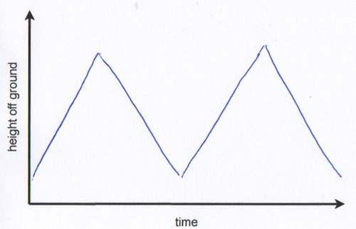
Are all their maxima at the same height? Are all their minima at the same depth? If they're different, they're suggesting this metallic ferris wheel shrinks or expands over time.
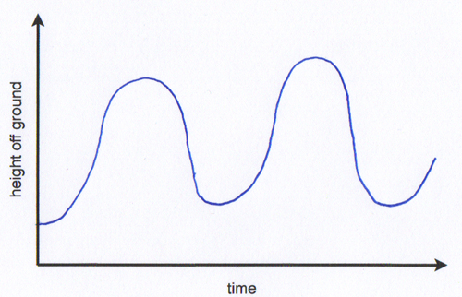
Is the horizontal distance between maxima the same? If they're different, your students are suggesting the cart isn't moving at a constant rate, that it speeds up or slows down during the ride.
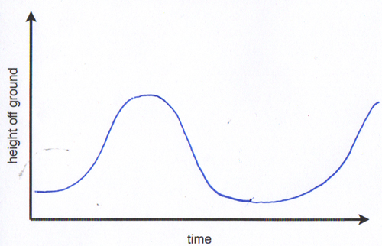
Are their minima a few feet above ground level? Or are they suggesting the red cart hits the ground at the bottom of each turn?
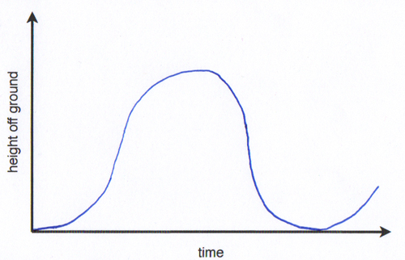
In every case, push your students to attend to precision. (Common Core achievement unlocked!) Give them more of these graphs or have them hit erase on the tablet and start again. Get it right. Be precise.
Now that we're pretty clear on the structure of this new kind of function called "periodic," let's step our game up. Ask them to guess how many full turns the red car will take before its ride is over. Tell them their other goal is to figure out exactly how high off the ground the cart will be at the end of three minutes. (Real-world relevance achievement … still pretty much locked.)
Now we're ready to start the task as written. Use this screenshot with information. Head to Desmos, kids. Punch in points that are more obvious to you. The minima. The maxima. The position at far left and far right. Keep that going.
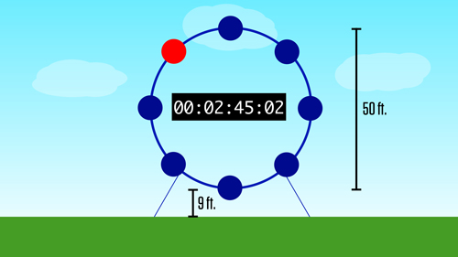
Students need to see that their old models are useless to describe these points. So give them a new one. Out with y=mx+b. In with y=asinb(x+c)+d.
Have them mess with the parameters until they get a perfect fit. Then use it to find the position at 3:00.
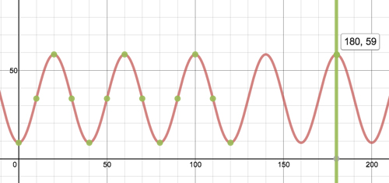
Now show them whether or not the model actually works.
For an extension, perhaps ask:
- How long should a ride last so the person ends at the bottom for an easy exit? A: Lots of different correct answers here. That's the fun of a periodic function. Hey write out all the correct answers in order and subtract one from the next. What's happening here?
- If the ferris wheel spun backwards, how would that change your periodic function and your calculation?
- Where else would periodic functions make sense as a model?
What You Did
Over on the blogs:
- Michael Pershan beats me to the punch and asks his students to justsketch the ferris wheel first.
- Beth Ferguson draws from a collection of periodic applets.
Previously. The preview post where you'll find some other interesting ideas.

[Makeover] Low Arching Bridge: The Makeover
Andrew 8/5
Once again, the task:
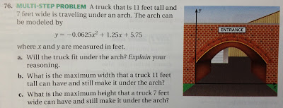
What I like:
I like the placement of the x-axis along the ground to represent zero height.
I like how this task reminded me of the low arching bridges along George Washington Memorial Parkway in Alexandria, Virginia.
What I dislike:
I dislike that the x-axis and the y-axis were already placed for us. The students have no say in this.
I dislike how the arch is already "modeled" by the given function. There isn't any chance for students to explore this on their own, especially if they had no say in the placement of the y-axis.
I dislike the answer to this question. It's hilarious. Get this:
The truck has to be dead center so that it will allow 0.23 feet of clearance on each side of the truck. Regarding number sense, what is twenty-three hundredths of a foot? No one talks like that, do they? After converting this answer, I could see myself telling the driver, “You have less than 3 inches to spare on each side. And that’s ONLY if you center the truck with the middle of the bridge." Let's look for an alternate route or someone might have to get out of the truck [not it] to guide the driver.
Things I'm intrigued by:
What was the reasoning behind the placement of the y-axis? Why isn't it dead center or along the right wall?
Why isn't there any sign on this bridge that says the maximum height and/or width of trucks allowed?
Is this a "one way" road?
Here's what I did:
*Disclaimer: I'm not pretending to nail this Makeover: I think it can be better. That's your job: so let's get it on and help me in the comments. I'll admit, the Makeover was more work than I anticipated and I'm tapped, but I'm happy to do it now during the summer. Thanks Dan for the Makeover challenge!
I found an accident report for a coach bus that crashed into this exact bridge (below) in 2004. There are many of these low arched bridges located along George Washington Memorial Parkway in Alexandria, Virginia. I've seen a few of them when we've taken our 8th graders to visit Mt. Vernon. I remember our bus driver telling us about this specific collision.
1) Show your students this picture, but don't tell them about the collision:

Allow students to make observations and ask questions (maybe Notice and Wonder). Tell them where this bridge is located if they ask. Don't tell them what the signs say. Have a discussion.
2) Now show your students this picture and ask:
Which of these (six) vehicles would safely pass under the arched bridge?

3) Have students make guesses and write it down. You're taking a chance, but at least one student should notice that some vehicles might pass safely using the left lane, but not when the same vehicle is traveling in the right lane.
4) Ask your students what information or tools they might need to help determine which vehicles can safely pass through this arched bridge.
- Bridge height(s)
- Vehicle height(s)
- Width of road
- Width of lanes
5) Find the vehicle heights we'll be working with. Depending on the time you have, students can use the internet for finding the average height of each vehicle. I did the grunt work for you with this slide:
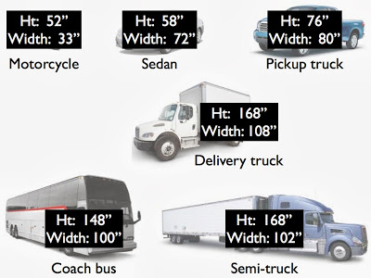
6) Show students three heights of the bridge and street dimensions. They probably want to know what those yellow signs on the bridge say. Too bad! The picture is low quality and very pixelated. I'll admit, this might feel like we're now stringing the kids along, but let's offer them measurable dimensions, not some arbitrary equation that "models" the arch. Share the following:
Height of the bridge on the left side
Height of the bridge in the center
Height of the bridge on the right side
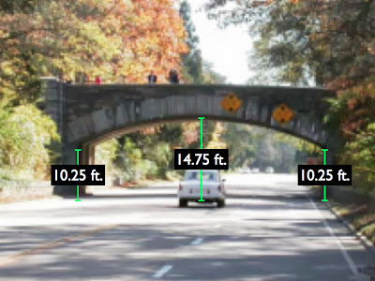
Width of the entire road (including space for lane lines and shoulder) and width of two lanes.
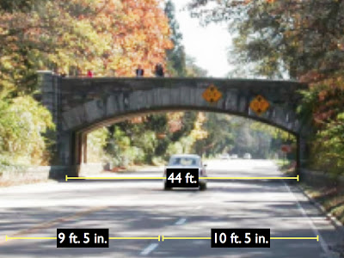
7) Offer your students Desmos or Geogebra. Plot the three heights. Use sliders to find an equation that models this low arching bridge. Here are three four scenarios I came up with in Desmos. I'm still not sure which I like best. You decide. I've linked the Desmos files for you to mess around with.
Where do you fancy the y-axis?
y-axis justified RIGHT:
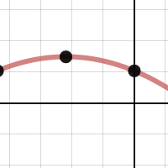

y-axis justified CENTER of bridge:
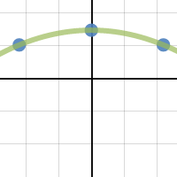

y-axis justified LEFT:
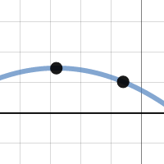

Just for fun (the actual bridge):
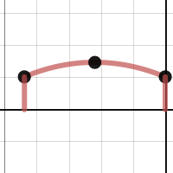

Okay, I like both the center and the justified right. Placing the y-axis in the center of the bridge made it a lot easier to find an equation that modeled the bridge. Placing the y-axis on the right side of the bridge might produce negative x-values, but since distance is never negative, the absolute value of the domain will tell me how many feet away from the right side of the road the vehicle must be.
8) Give students time to explore the functions, quadratics, sliders, domain, range, and so on. There's more. This task requires students to apply the heights of the vehicles in a specific manner. Sure, students can click and drag on the graphs in Desmos to find the heights of vehicles and determine if it safely passes, but what part of the car "safely passes"? The top left? Top center? Top right? Therefore, students have to now take into account the width of the vehicle. Let's go back to the original question:
Which of these (six) vehicles would safely pass under the arched bridge? And in what lane?
- Which vehicle(s) will pass safely in both lanes?
- Which vehicle(s) will only pass safely in the left lane?
- Which vehicles(s) would have to go into the oncoming traffic lanes?
- Which vehicle(s) need to stop and turn around?
- Ask how far the vehicles will be from the right side curb when "passing safely"?
9) Tell students to look for a little more clearance than 0.23 feet (2.76 inches). You can read the accident report for all the details about the street and bridge. You'll find the clearance heights posted on the bridge and about 1,500 feet before the bridge.
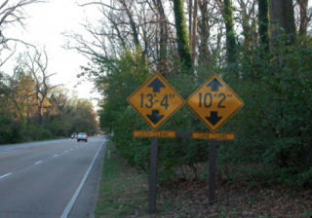


Unfortunately, the accident report will also show the bus that collided with the bridge while the driver was talking on his cell phone. The bus ran into the bridge without even applying the brakes.

What you did or suggested:
Amy Zimmer emailed:
"Is it the new Daniel Craig James Bond that has the train scene where he has to duck just before he is about to run into the bridge when the good guy and the bad guy are fighting on a speeding train?" followed by "I would give lots of trucks and see which ones fit."
Everyone else's input can be found here:
If you've made it this far. I appreciate your determination and perseverance. Thanks for tuning in. I know this task can be better, so let's get it on in the comments.
Up next, Global Math Department presentation on August 13, 2013: Back to School Night: Ignite. Join the fun.
Under the bridge,
1230

Stories

An Encouraging Thought
Timon 2/21
It has been far too long since I have posted here, and for that I am sorry. To tell you the truth I have been busy, but more than I busy I can admit that I have been a bit down on myself. I still have so much to do to become the nguyeningest teacher that I want to be, and I have been a bit under a rock by recognizing that I am not there.
We can talk a big game on these blogs and share all these awesome lessons that work (when they work), but even those great ideas can fall or be used improperly, or rushed to the point that no meaning is taken from them. I am a the point right now where I find myself trying to catch up to all the curriculum that needs to be done, and I don't like that, but I have a professional responsibility to make sure that kids are prepared, so I have to work better and harder than I do at this point. Have I led students through inquiry? Are they engaging with their world? Why can't I be more like (insert awesome blogger/teacher/awesome person name here)? I feel as though I am not measuring up, and that's a hard place to be.
So I am introducing volume and I asked them to notice and wonder, and this is what I got...
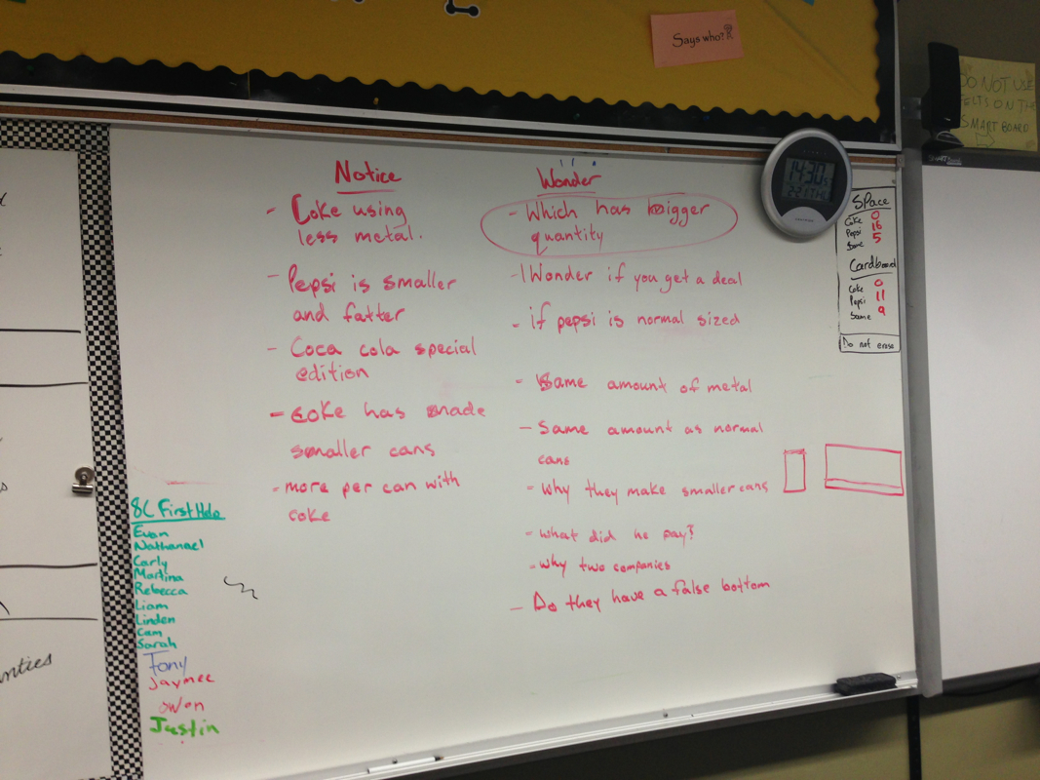
This board of notice and wonder seemed a little too good to be true, so I asked the class (a class who I trust to be honest) this:*
Raise your hand to vote. Here are your two options: Did you notice or wonder because you actually want to know, or did you notice and wonder this because you think it is what I want you to notice and wonder?
The majority of the students put their hand up for option A. They looked at pop-cans and wanted to know legitimately awesome things. They were curious, and they were taking it seriously. They had cool discussions on why the companies would make these decisions. Now granted, we have talked about pop companies before when we did surface area, and I walked them through that, BUT I can see that they have caught a bit of this math bug. They have caught a bit of the curiosity that I had when driving home and watching road lines whiz by.
I am not a perfect teacher by any means. I lose control of my class. I take forever to assess. I give them notes, and I even *dun dun dun* lecture. Not every class is inquiry based. I am not always fully prepared. I am very disorganized. I have more faults than I care to name, but somewhere, hidden under the heap of my self-deprecation is something that has attracted kids toward curiosity. We often say to ourselves "If I but do this ONE thing, it will have all been worth it." Today this board represented my one thing. Today I saw that I am not in the wrong profession; I am not the worst person in the world; I am not a terrible teacher. Today I cast off my self-deprecation and embrace encouragement.
*Keep in mind this is ONE of my classes. My morning class was not as indepth.

The Pain and the Glory: Running Iowa’s BIG Competency Based School
Shawn 9/26
So, my professional life has been completely consumed with running BIG. No tweeting, no blogging here or at Edutopia (sadly), little for-fun programming, but it’s worth it.
The model is so simple: do a project that is big, do it for an audience that extends well beyond the school’s walls, do it because you have to know, and do it until you get it right.

No grades, no points, no bells, no finals until it’s final.
This is as fantastic and horrible as it sounds. Students are often caught in a chaotic oscillation between worlds. This has been amplified by the concession BIG has had to make — which made the political existence of the program easier — but is causing us this code-switching friction: We don’t enroll students full time. They come to us for as much or as little “resume building” as they want to do during their academic day.
That means a student may be attempting to mental shuffle the concept of non-linear competency based education in with the psychological contrast of for-points worksheets. Not to mention the logistical challenges of interfacing a schedule-less system with the institutional bells of a regular high school.
That said, the work is awesome, and I can’t express the magnitude of my appreciation and awe for the moxie the Cedar Rapids Community School District has shown on this project.
There’s not much better than sitting with a student as they realize they’re in the driver seat of a real project. There’s a freedom in this that doesn’t exist when the teacher forces the standards on a project. It feels a little Wild West, though.
I’m currently working on a CBE version of BlueHarvest that will allow for competency-standard mapping and project management. We’re calling it BlueHarvestBBQ, and it creates public-facing profiles for every project happening at BIG. So, until that’s done. Here’s a list of the awesome stuff my students are working on (and the curriculum to which said stuff is connected to):
- Phytoremediation of waste water with engineered Poplar root cells. (standards met from: environmental science, physics, biology, economics, and industrial engineering)
- Build Me A Starship Please: A blog considering the finer technologies aboard the Enterprise-D and the cost to achieve them sooner rather than later. (Physics, English)
- TEDxBIG: We have a budding event organizer who is throwing a TEDx event in May concerning the genetic, sexist, and neurological pressures women feel along their journey to success in the working world. (Marketing, Biology, Communications)
- A Record of Tanzanian Popular Gospel: A student is recording from scratch the great works from the folk and popular library of Tanzanian gospel. (Audio engineering, physics, digital electronics, anthropology, piano performance, sound programming)

- Number 5 has morphed into a a project regarding Engineered T-Cells and Immuno-Oncology. More soon.
- Robot Angler Fish: A team of students is producing a robotic angler fish run by Arduino, cuz winning. They’re hoping to enter into a competition to produce a robot that will eventually travel to Jupiter’s Europa. (Robotics, programming, physics, environmental science, Marketing)
There are more, but they’re too nascent to mention here.
I hope you can see that the BIG model is rotated by from the traditional model. We don’t ask ourselves “What project teaches this content?” We ask, “What content does this project hit with contextual fidelity?” We avoid using projects as assessment tasks, and shine to the idea that BIG projects are deep contextualizers.
It’s not about pigeon-holing the project, it’s about being open to what the students want to do, because that’s the only psychological leverage I have at BIG. If you don’t like your project, I can’t make you do it; we don’t have points or grades. This is the pain and the glory.
That’s so different from how I would teach 30 kids calculus. So different. And to such different effect.
Oh, here’s the candidate for our mascot done by graphic artist Joshua Koza. Can I get tweets in support for how awesome this is?

Routines
Langermath 5/18
It is 6:30am on a Saturday. I’ve been up for at least an hour, worrying about how in the world I’m going to teach my students to do so many routines next year, many of which are new to me, many independently, all while trying to honor autonomy/purpose/mastery (love, Daniel Pink).
First, I want to share my current idea of how the week could look (note: this hasn’t dealt with the fact the first period rotates and has students trickle in).
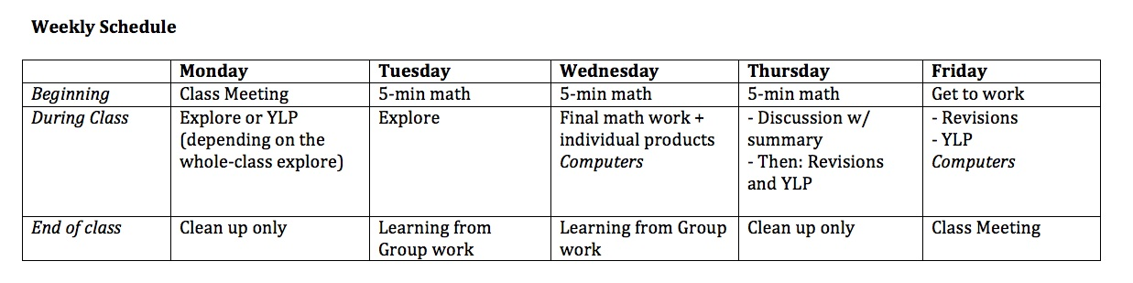
(Bloggers, how do I make this image bigger in the post?? It’s big if you click on it…
Also, YLP = Year Long Project)
From this, I have started a list of what routines I need students to be really good at. It’s rather intimidating.
- Class meetings
- Class jobs
- Using the math “rough draft” journal (or whatever I end up calling it)
- End of class
- 5 minute math
- Group work
- Individual work
- Whole-class learning from each others’ work (discussion, gallery walk, etc.)
- Revision days
- Year-long-project days
- Making a final product in writing, video, voice, or artistically (or other)
- Submitting work on a blog
This scares me. I have only taught some of these as routines before. And not that successfully, all the time. But I want to do it. And I don’t think only doing some of it will work for me.
Hopefully, if I’m incredibly intentional, it will be fine/great? Like, maybe September will only include …
- Class meetings
- Class jobs
- Using the math “rough draft” journal (or whatever I end up calling it)
- End of class
- Group work
- Individual work
- Revision days
- Making a final product in writing, video, voice, or artistically (or other)
- Submitting work on a blog
Umm. Did I say only? Oy.

Measurement, explored
Christopher 4/5
This idea started with someone else, but I do not remember his name. I believe he’s a shop teacher in a Twin Cities suburb. Inver Grove Heights, maybe? In any case, he was in a professional development session I was helping to run this year on the topic of fractions. We had a conversation over lunch in which he recounted a lesson he did that became the basis of the activity I am about to describe. If I can dig up the originator, I’ll revise to give credit.
In any case, while the kernel of this idea originated with someone else, I have given it the usual OMT treatment—expanding and complexifying in many ways.
Regular readers will know that I am always in search of ways to get my future elementary teachers to explore old ideas in new ways. Consider the cases of place value and the hierarchy of quadrilaterals. In that spirit, I give you the measurement exploration extravaganza. Do with it what you will.
THE PREMISE
Groups of three are each given a dowel (or, in this year’s case, a paper strip). The dowels vary in length. The lengths are chosen to provide a useful combination of compatability and incompatability. One may be 9 inches long, while another is 15 inches long. Choose numbers according to the skill level and age of your students (and yourself!)
But-and this is important-THESE LENGTHS ARE NEVER SPOKEN OF! You will never refer to these dowels using standardized lengths.
Each group names its unit. In recent semesters, we have had:
- Stick
- Woody
- Shroydelshnop
- Oompa Loomp
- BOG
- Ablue
- Pen
- Et cetera

The members of the group measure some stuff with their units. They make a tape measure to use for this purpose, and they decide how long a tape measure they would like to have.
For example How tall are you in Sticks? requires (in all likelihood) a tape measure that is several Sticks long. Well, it does not require such a thing, but such a thing facilitates this measurement.
At this point, students are measuring only with their own units. It usually occurs to them to subdivide the unit in some way, and they will frequently report out fractions of (say) a Stick.
Next, each group is responsible for creating a partitioned unit from their original. They choose how many of these smaller units make up the original, and they name the smaller unit.
And then they create a composed unit from their original. Again, the choice is theirs to determine the number of original units that make up a composed unit. And again they are tasked with naming the composed unit.
INTERLUDE FOR IMPORTANT OBSERVATIONS
The fun has only just begun and already we stumble upon some beautiful insights. Among them are these:
- Students nearly always partition in 4ths, 8ths and 16ths.
- Students almost never partition into 10ths.
- Students may group in threes or sixes, but they never ever partition this way.
- Students rarely think to group the same way they partition. That is, if they made 8ths, they might very well group in sixes. The convenience that would be afforded by consistency does not tend to occur to them in advance.
BACK TO THE INSTRUCTIONAL SEQUENCE
Now that we have the units, we need to measure some stuff. I typically choose things in our classroom environment. It is important that we all measure the same things and that these things range from smaller than the original unit to larger than the composed unit.
We need to express our measurements in (1) partitioned units only, (2) original units only, and (3) composed units only.
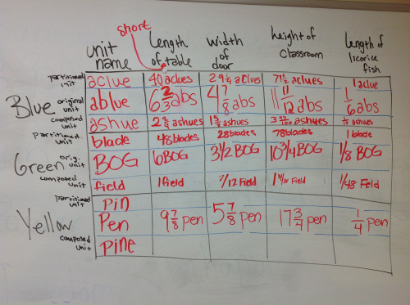
This semester I had students look at this table and I asked What do you notice?and What do you wonder? (These questions are, of course, not original to me. But this was a productive place to ask them.)
WORKING ACROSS SYSTEMS
Next, it’s time to switch things up. We put the table away. Each group passes their original unit, together with instructions for creating a partitioned unit and a composed unit (and the names of these) to another group.
Now each group is charged with these tasks:
- Get to know the three units that have been handed to you.
- Express relationships between your units and these new ones.
- For each thing you measured (table, licorice fish, etc.), make this prediction: If you were to measure that thing with these new units, would you end up with a greater or lesser value than when you measured in your own units? (In this step, do not compute; make a qualitative comparison instead.)
- Compute your height in these new units, and compute at least 6 of the measurements in the grid.
You have never seen such fraction computation work as proceeds from this sequence of tasks.
Now we list these computed measurements on the board, compare to the table we generated earlier and discuss reasons for discrepancies.
We write about these reflection questions:
- How do your three units compare to a standard measurement system?
- How is using someone else’s units like (or unlike) converting between standard and metric systems?
- How did your choices for partitioning, composing and naming support or impede your work?
- What do you need in order to be able to do these computations on your own?
ON TO AREA
Next, students build each of their units into square units.
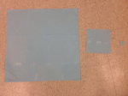
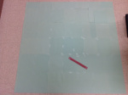
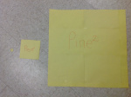
We consider the essential questions:
- How many square partitioned units in a square original unit?
- How many square original units in a square composed unit?
- How many square partitioned units in a square composed unit?
- Most importantly: How do you know each of these?
Sample student observations at this point:
- Wow. The square partitioned unit looks a lot smaller relative to the square original unit than I expected.
- Oh no! Why did we decide to put so many original units together to make the composed unit?
Now we measure something.
This time around, I had them measure the area of a whiteboard in our classroom. Not the most exciting measurement to make, but straightforward and accessible. Working with these new square units is challenging enough; no need to get too fancy. It is important that the measurement be concrete and tangible, not abstract.
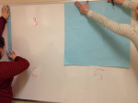
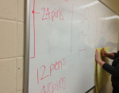
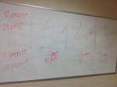

Students are encouraged to use known relationships in order to avoid tedious measurements, and to measure in order to avoid tedious computations.
Importantly (I think), most students want to use these square units to measure, rather than to measure with their tape measures and compute.
SUMMARY
We use these experiences to discuss differences—both practical and conceptual—among measuring by (1) iterating and counting units, (2) using tools, and (3) computation.
We reflect on what these experiences can tell us about working within and across measurement systems.
We build on our fraction work and on the meanings of multiplication and division that were the focus of the preceding course.
I have not had students move to cubic units.

Day 62: Explorations and Lack of Effort
Justin 11/26
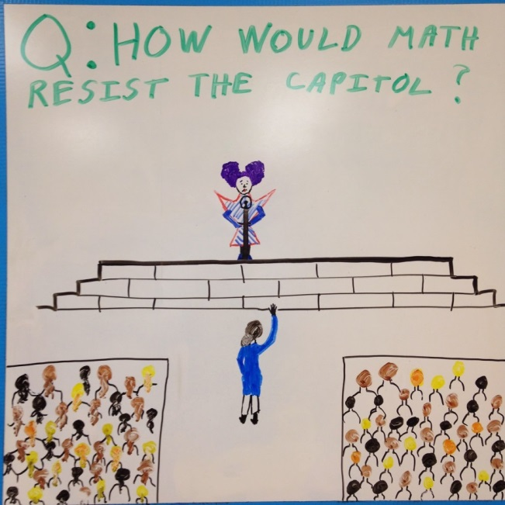
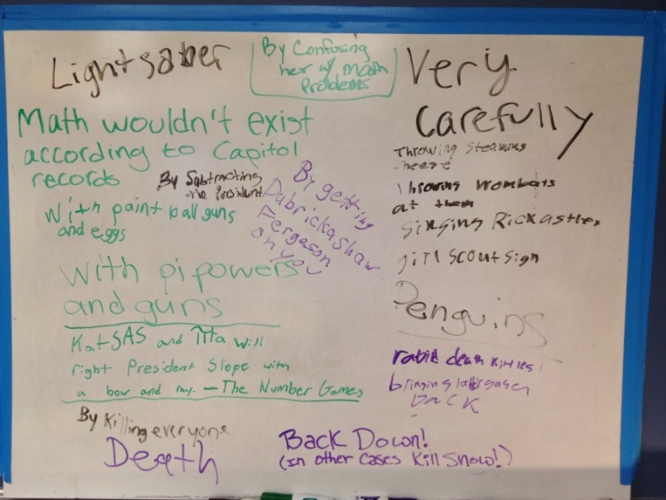
Finally got some clever responses!
Since I noticed that I hadn't entered any grades yet, my plan for geometry class today was a two-part test. The first would be individual and multiple choice while the second would be with a group and open-ended.
I found an e-mail this morning, however, that said that half of my geometry class was being pulled out for all of period 1, so plans changed slightly. Instead, we spent the period exploring shapes! Yesterday, we talked about the interior angles of a polygon. We explored the idea of creating triangles inside polygons to find the sum of those interior angles. Today, I gave them the same warm-up, but changed the word "interior" to "exterior."
This turned out to be a MUCH richer discussion with students making all sort of conjectures, only to have them disproved by other students. Several of them wanted to treat the polygons as though they were regular (the polygons, not the students) but a few others claimed that we couldn't. We assumed that they were so we could talk about a specific case, then changed the angles to talk about a general case. The students came up with a general rule for the sum of the exterior angles of convex polygons and we showed it worked in a few different cases.
Then a student asked about concave polygons. So we explored those! Protip: THIS exploration is wildly more interesting than convex. A great collaborative effort brought us to the end of the period and a general rule for the sums of the exterior angles of concave polygons. I was VERY impressed by them.
When the rest of the students returned, I handed out the open-ended portion of the quiz for them to work on in groups. They did not even come close to finishing. Even worse, I was stunned by the confusion on the faces and in the questions of these kids who are normally sharp as tacks. The first question read as follows:
In making a paper airplane, a student folded the top edge of her paper into 8 equal angles. What is the measure of each angle?
Classify each angle.
I don't even know how to begin explaining this problem without giving it away. I think it might be a matter of concentration, reading directions and persistence. After 40 minutes, in which none of the groups finished the 4 problems I gave them, I told them to finish it up for homework and come in tomorrow ready for the multiple choice section.
I'm hoping that if they work on it at home (which most of them will) they will see that it's a pretty simple set of problems. It's possible that just being in word problem format threw them off, which means I need to do more word problems.
In pre-algebra, we also took a quiz. It was a much more procedural quiz than I would have liked and I could come up with a host of legit reasons why that was, but the truth is that I'm tired and I need to make sure they CAN do the procedural stuff. This group of students has a tendency to give up SO quickly on complex tasks that it's hard for me to even know if they understand the procedural work.
The results of the quiz are, however, quite encouraging! With a few exceptions, the majority of the students DO understand the procedures and shouldn't get bogged down by them on more complex tasks.
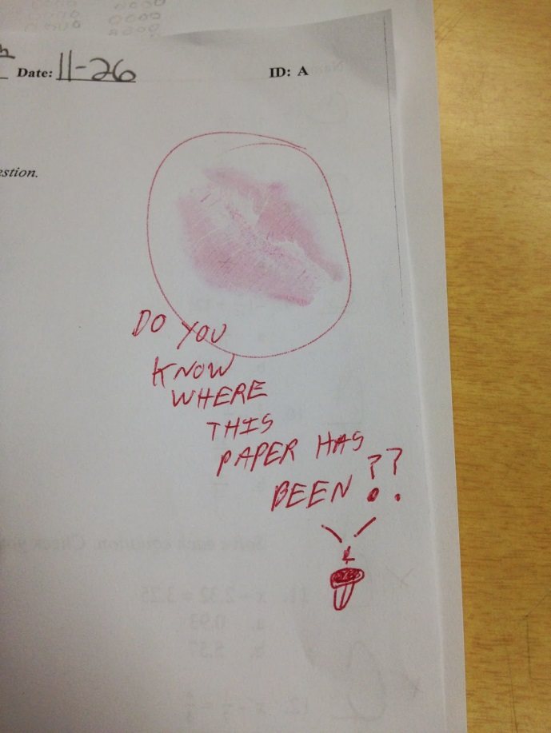
On the other hand, all of the students in pre-algebra have projects due tomorrow and, from the questions I'm being asked, it appears as though not a single one will be turned in on time. I'm hoping this is not the case. I am praying to be surprised.

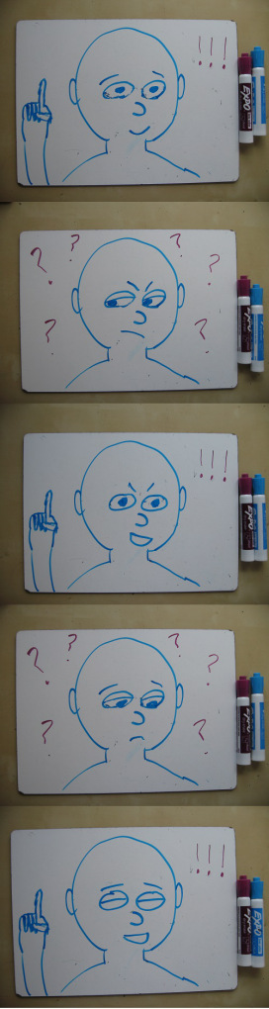
Learning is a Fluorescent Light
Ben 7/11
Me: I know this new concept feels hard. But you know what it’s like turning on a fluorescent light? It flickers on, then goes dark, then goes bright for an instant, then goes dark again…
Student #1: Then bright?
Me: Yes, because…
Student #2: And then dark again?
Me: Right. And what I…
Student #1: And then bright!
Me: Yes, yes. And eventually the light comes on, but it’s slow, and there are these alternating moments of illumination and darkness. And that’s how it is understanding tough math. You feel like you get it, then you don’t. There’s a moment where it’s perfectly clear, then a moment where it all seems hopeless. Your understanding flickers at first, but eventually it becomes steady and bright.
Student #3: Oh! I get the analogy!
Me: See? It’ll come to…
Student #3: Wait! I lost the analogy.
Me: Oh… well, I can…
Student #4: Ohhh! Now I get it!
Me: Hmm. Are you just mocking my…?
Student #4: No! It’s gone!
One student starts flicking the light switch off and on, as others cry and shout:
All students: It’s all so clear! No – I’ll never get it! Wait – I see! No – I’ve lost it! Hold on – yes!
Me: I love you guys. Also hate.

#DuckFace
John 10/17
“Why the hell do I teach middle school?” We’ve all thought this, after a day where nothing seemed to go right and it felt like you’ve been hit by a dump truck full of adolescent pre-teens.
Today was NOT one of those days. Today was one of those days when I asked myself, “How lucky am I that I get to teach these hilarious and always entertaining kids everyday?” I think a little back story is required to set the stage…
Fraction Monsters. That’s right, Fraction Monsters. Always one of the top 3 favorite activities students mention on their end of the year surveys in June. What is a Fraction Monster you ask? Well, simply put, it’s a “monster” or some other creature made out of fraction circles. Here’s a couple examples of some in progress from this week:
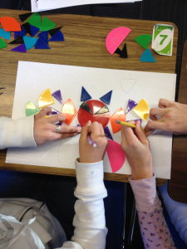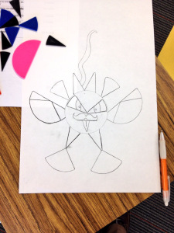
The activity works like this, students work in partners and create their monster (it can look however they’d like as long as they use 7 different sized pieces), color their monster, find their monster’s Monster Mass by adding up all of the different pieces they used, write a story about their monster, and then present to the class. I let them add extras like eyeballs or mustaches or a little picture of Dora the Explorer (which the monster ended up eating in the story) because hey, they’re middle schoolers and they love that stuff. Now, I openly acknowledge that this is no where near the richest or most rigorous task for students to work on, but who cares? IT’S FUN! A LOT OF FUN! And anytime I can get students excited about an activity that involves fractions, I’m going to take it.
I’m sure if you’re still reading this (thank you if you are, I promise it will be worth), it’s probably only because you’re trying to figure out why the title of this post is #DuckFace. While I had been planning to blog about this project all along, the theme of my post changed dramatically today as I sat in a student desk, listening to two 7th grade girls present their monster while the entire class and I laughed. To be honest, I’m not sure what the class was laughing at more, the story or watching me try to keep it together as I struggled to hold back tears from laughing so hard.
The title of this post was inspired by the name written on the top of the girls’ poster. They had made a giant duck out of their fraction circles and named him #Duck Face (you know, hashtags being all the rage with middle schoolers, and everyone else for that matter). They named it after that look that some girls like to do when they take pictures. You know the one: lips pressed together, pouting out, head usually turned a bit to the side to really accentuate the pout. Forming what in essence resembles a duck’s bill. I figured the story would be interesting when I saw the Starbucks on their poster, but had no idea how hilarious until they started reading.
So without (much) further ado, I present to you the poster and story of #Duck Face. I also included a zoomed in shot of the girls in the Starbucks line at the bottom of the picture, as well as the girl working the counter inside Starbucks.
“How lucky are we get to teach these hilarious and always entertaining kids everyday?”
We are indeed the lucky ones.
It’s days like this, as tears stream down your face in the middle of your class, a room full of 30 7th graders wondering what’s wrong with you, your guard completely lowered, acting as if you’re all old friends, sharing a truly authentic moment of pure happiness and youthfulness, that I cling tight to. It’s these days that stick with me the most and keep me coming back for more everyday. Because on those other days, those “dump truck” days when I ask myself, “Why the hell do I teach middle school?,” I don’t need anyone else to answer that question for me, I know exactly why I teach middle school. And I love every second of it.
Now I promise I’m finally done talking. I hope you enjoy #Duck Face as much as I did today.
PS – the story is completely unedited from what I received today. A little tough with the grammar at times, but you’ll get the point.

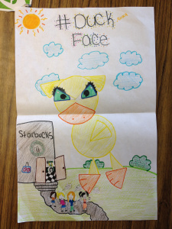
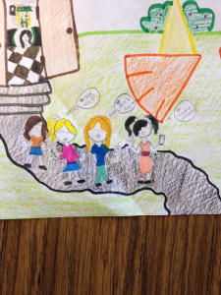
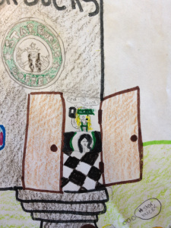
Duck Face
Once upon a time there once was a duck named duck face. He was on instagram one day when he saw these girls. They were making the “duck face”. This made the duck face duck flaming mad!
He said, “this is an insult to me and my fellow ducks”.
He told his family about the insulting mockery that the girls were doing. All the ducks threw up their wings and protested yelling, “this is an insult” and “outrageous!” Duck face duck made a plan he said, “ we will go find them and make them pay for the assaulting things they make us look like.”
“Sounds good and all, but we don’t know where they are.” said one of the ducks.
“dont worry about that. I have been following them on instagram and they post tons of pictures of them at starbucks making a “duck face”.”
“OF COURSE.” shouted one of the ducks. “Starbucks is there favorite.”
“yes” said duck face duck “so we will set up a fake starbucks tricking them and telling them that we are giving out free coffee, “next we will make them our prisoners and make them erase all of those embarrassing pictures on instagram!”
All of the ducks laughed evilly and got to work on their plan.
the next day thousands of girls got the memo about the free coffee.
“OMG” tweeted thousands of girls “whos going to get free coffee?”
The duck face ducks plan was working! All of the girls were falling for his trap.
Then on friday the 13th thousands of girls went to starbucks to get there drinks. The ducks gave out the drinks and watched as the girls made fun of them. They started to take pictures of peace signs, selfies and of course DUCK FACES! The ducks have never been so mad.
The duck face duck went to the Kitchen and created the magic potion. He drank it and slowly he got bigger and bigger. As the girls left the building they went outside to take a group picture. “Ok” said one girl ” 1….2….3…” *snap went the camera all the girls made there duck face.
“Ahhhhh” yelled a girl she saw duck face duck he came *Stomp stomp stomp*. Duck face duck was huge!!!! He chased the girls around maybe next taint u won’t make fun of us and threw them all in a bag.
Duck face duck took him back to his layer.
“Now he said let’s do this the easy way.” Duck face duck said. ” delete all of your duck face pictures or be my slave for life”
“No” yelled all the angry teens
“Ok then don’t say I warned you” suck face duck kept half the girl to keep and the other half to go watch Starbucks and there phones be destroyed.
“Where are u taking them” questioned the girls.
“No where u need to know now if u want to keep your phones delete the photos!”
Quickly all the girls deleted there duck face photos crying saying things like “this is my favorite selfi” and ” not this one”
Duck face duck saw that the girls were learning their lesson and let them go after he checked all there phones and instagrams.
AND THAT WAS THE END OF THE DUCK FACE ERA.
(totally worth reading to the end of this post, right?)

Mistakes, Radicals, Rational Exponents, and Partitioning?
Michael 10/2
A strange thing happened a few days ago. One of my Algebra 1 students stopped by Thursday afternoon to receive extra help on a topic. (That in itself is not the strange part.) He pulled up a chair, we discussed what he had been struggling with, and from that I typed out a review handout for him to work on while I helped another student from another class.
I asked him to complete as many of the problems as he could during the next 10 minutes or so. Then we’d chat about what he got right, what he got wrong, and what he skipped. A little while later he had this:
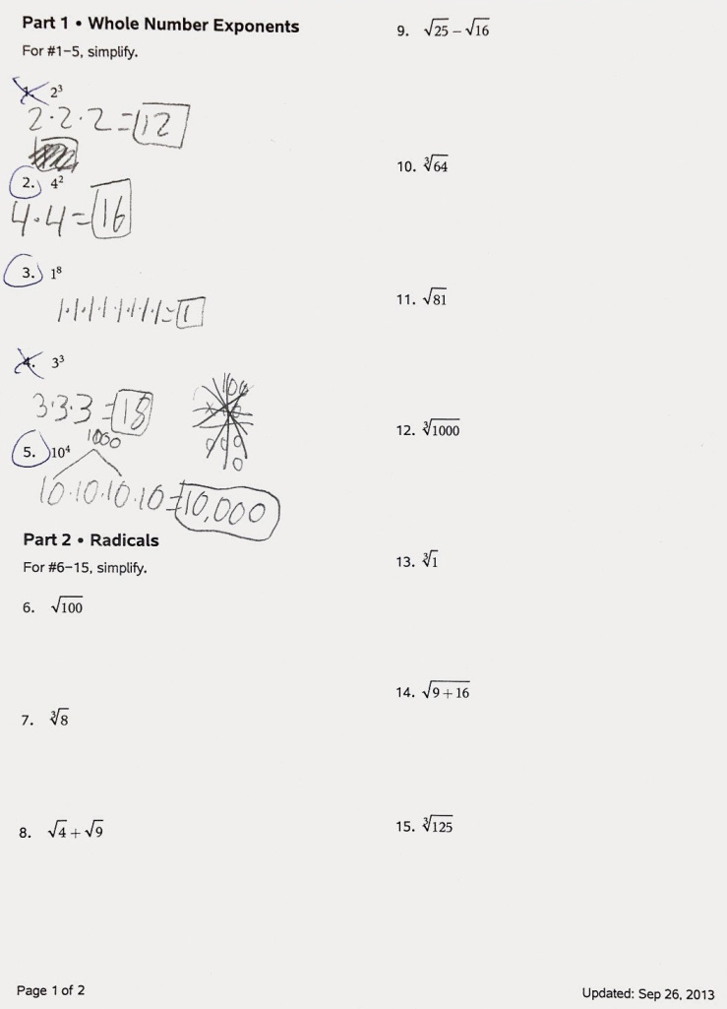
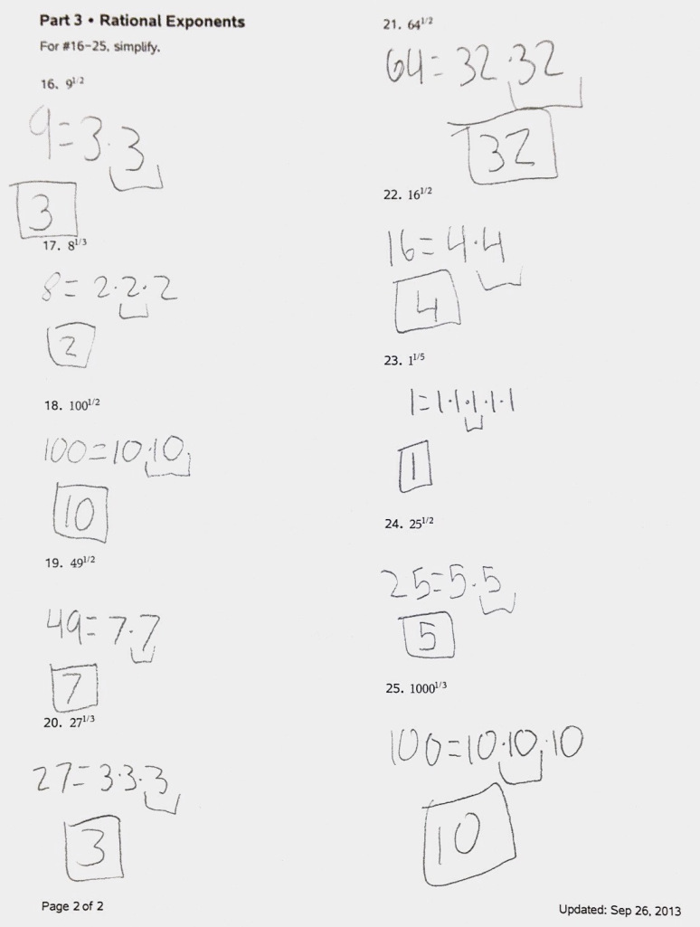
Trouble with Radicals, But Not with Rational Exponents?
When we first sat down, I figured he would have trouble with rational exponents. Nearly all of my students (this year and in the past) who struggle with this topic have almost no trouble with square roots in radical form, some trouble with cube roots in radical form, and (if they have any issues at all) massive problems with rational exponents.
This student’s struggle was more or less the exact opposite of what I typically see. He had trouble with radicals (square roots, cube roots, anything in radical form), and almost no trouble with rational exponents. (My conjecture on #21 is that the times table in his brain has a blank spot at 8 times 8.)
Concept vs Notation
The evidence clearly shows that this student doesn’t have a conceptual deficiency. Instead, his struggle is with…
Remediation for notation is usually fairly simple. We talked for a minute or two about how radicals (unknown and unfamiliar to him) relate back to rational exponents (known and familiar). Several minutes later, he came back with this:
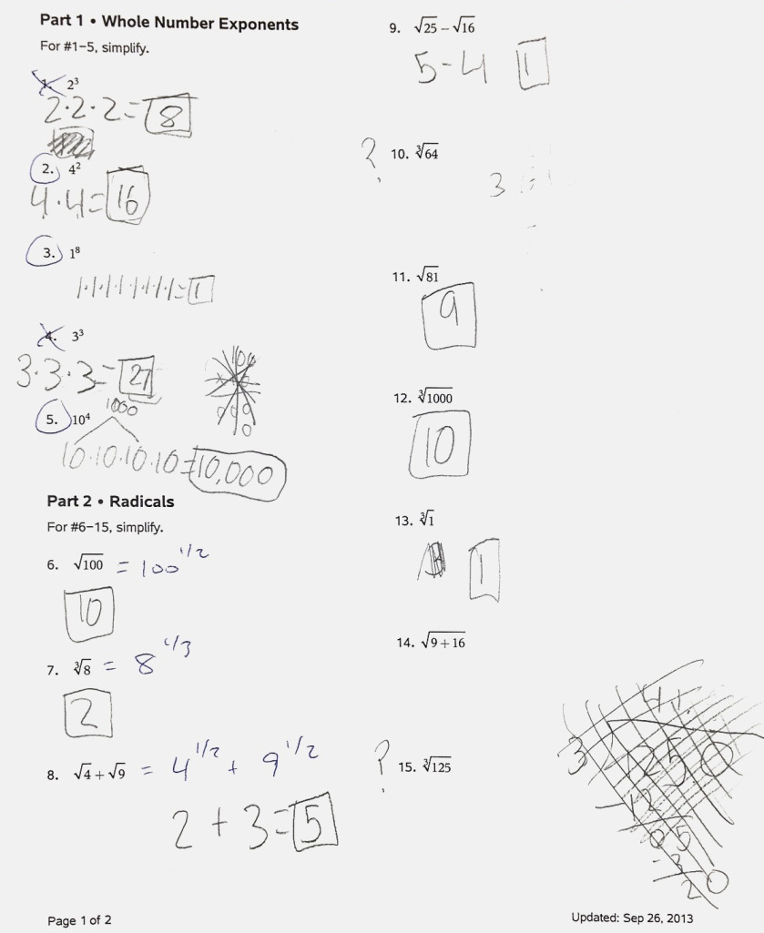
Things are looking up, even if they’re still not perfect.
Shifting My Approach
This exchange has me rethinking the direction of the conceptual/notational connection I’ve been trying to draw out for years. In working with an expression raised to the 1/2, I’ve always angled our conversations toward (and silently rejoiced inside when a student shouts):
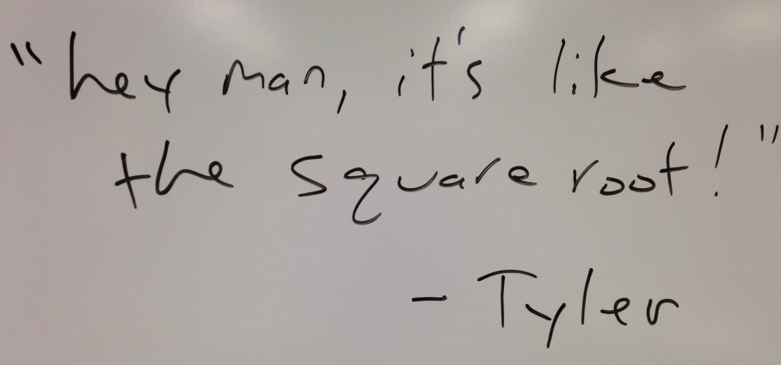
I treated square roots like the native language, the most helpful representation, and rational exponents as this foreign thing that needs to be converted back to familiar territory.
It’s true that students are more familiar with radicals (at least in my experience with middle schoolers), but I’m quickly starting to believe that rational exponents are dramatically more informative when it comes to thinking conceptually (and when it comes to working procedurally).
August, Every Year
When students enter my classroom, our first discussion about exponents (which invariable happens within the first couple weeks of school) goes more or less like this:
Me: What does mean?
Students: Eight!
Me: No, not “What is its value?” What does it mean, what does it represent?
Students: Oh (why didn’t you say so). 2 times itself three times.
Me: What?! You mean…
(two)
(times itself once)
(times itself a second time)
(times itself a third time)
Me: There. 2 times itself three times. Wait… That’s…
Students: No, you got it wrong. That’s 2 to the fourth!
Me: But you said…
Students: Yeah, but we didn’t mean…
Me: Grrr…
TWO MINUTE TIME WARP…
Me: And that’s why it’s more useful to say it like that. So, how would you state the meaning of this:
Students (in unison, with a three-part harmony): Four factors of 10!
Me: Perfect!
I want them to express powers this way for a number of reasons. At the very least, saying it the other way is flat out wrong. But describing as “b factors of a” has proven immensely useful in developing properties of exponents (which, for what it’s worth, I don’t hate as much as many in the MTBoS, probably because I’m easily entertained, and maybe also because my simple brain enjoys finding and justifying simple patterns).
Okay, So… What Exactly Are We Talking About?
By now, of the 12 people who started reading this post, and the three who are still reading, at least two of you are wondering: What does this have to do with rational exponents and your struggling student?
Well, several weeks ago in Algebra 1 (the above student’s class) we had our first discussion of rational exponents. As usual, I was trying to elicit from them the idea that “to the 1/2″ can be thought of as “square root,” and so on.
But a few students—bless their little hearts—wondered: Why?
And another student—bless his heart—applied our beloved “bfactors of a” phrasing to come up with this:
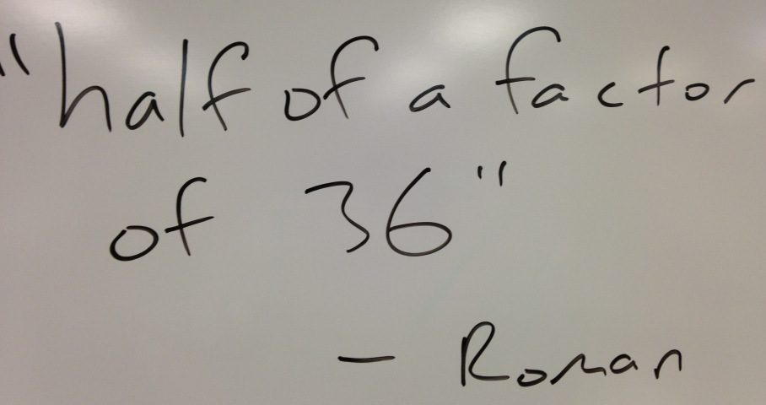
What would that even mean? I knew, and you know, too, because we’ve seen this movie before (or at least accidentally read a spoiler in some blog comment or Facebook news feed overpopulated by comments you were never interested in reading in the first place; I digress).
But my students didn’t have half a clue what “half a factor of…” would mean, and I was on the edge of my seat to see where they would take this. (Correction: I was standing. But I fully expect I was standing on the edge of wherever it was that I was standing.)
What They Saw
After a few more minutes of discussion, here’s what they saw and (more or less) how they described it.
- If you need to find “some number” to the 1/2, write the number as two identical factors. Then “take” one of them. That’s your answer.
- If you need to find the value of “some number” to the 1/3, write the number as three factors of the same number. Then “take” one of them. That’s your answer.
What I Wondered
I’d never have a conversation on rational exponents take that turn, so now I was curious… What would my students do with other rational exponents? The next day, on their Topic 2 assessment, I invited students to attempt two challenge problems on the back:
- Find the value of
- Find the value of
The results were mixed, but a majority of those who attempted the problems were spot on. Here’s a sample:
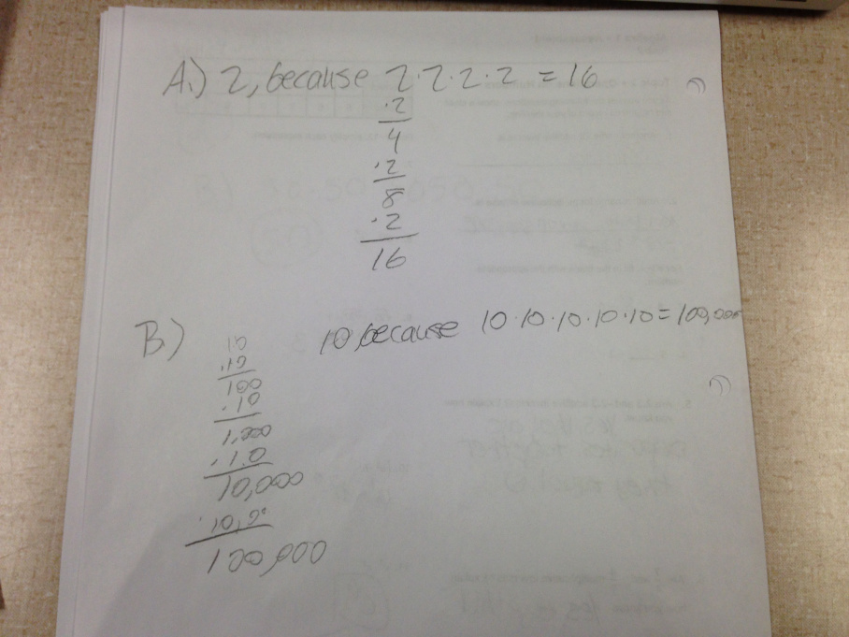
I guess in some ways this doesn’t differ much from the classic treatment:
because
But it somehow strikes me as different, as offering more potential for extension, at least in the form my student wrote it on the review sheet that inspired this post. And now I’m wondering another thing. Would these same students—without any additional instruction from me—be able to evaluate ?
My guess is some of them could, and I expect they’d treat it like this:
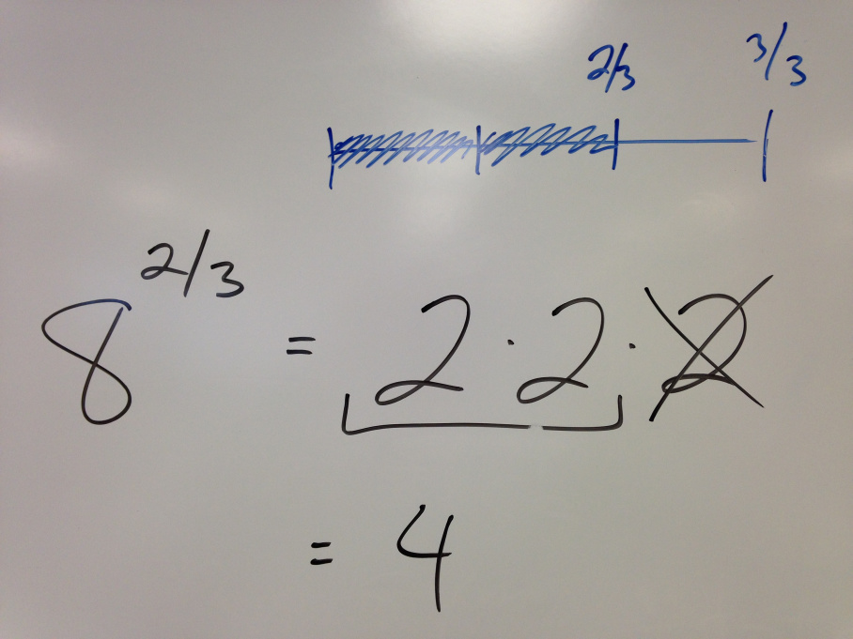
Write 8 as three identical factors, take 2
In fact, I’d wager that with a brief class discussion, most of them would be equipped to handle any of these:
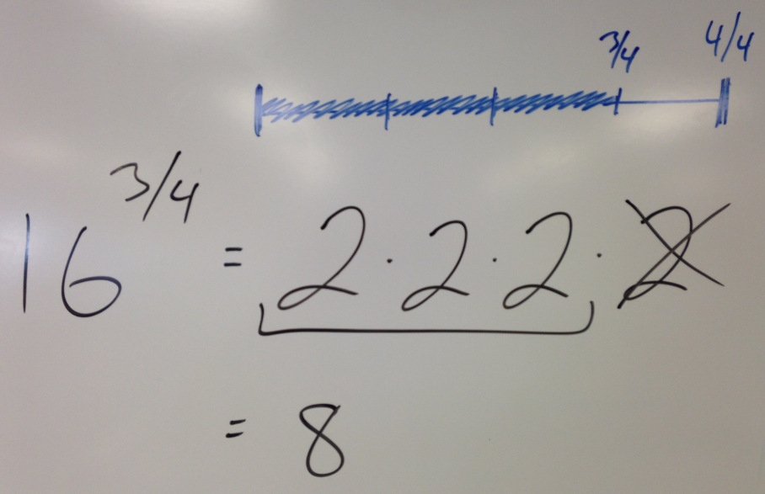
Write 16 as four identical factors, take 3
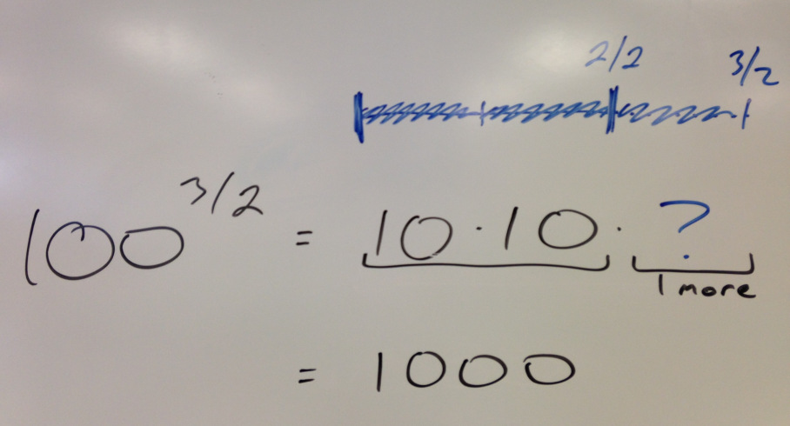
Write 100 as two identical factors, take 3
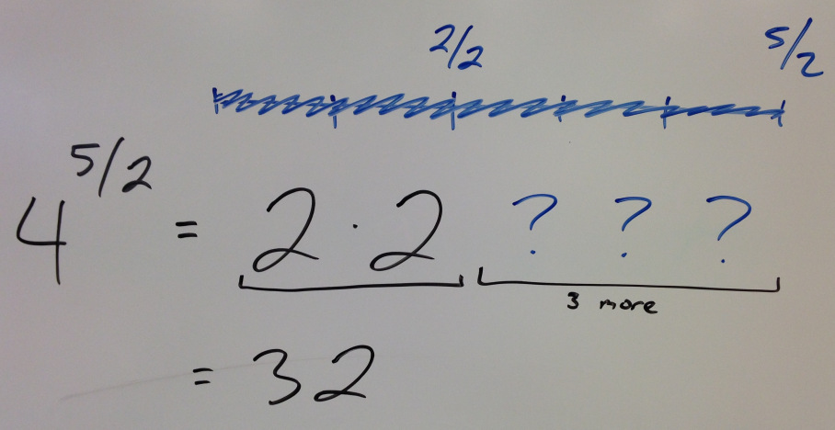
Write 4 as two identical factors, take 5
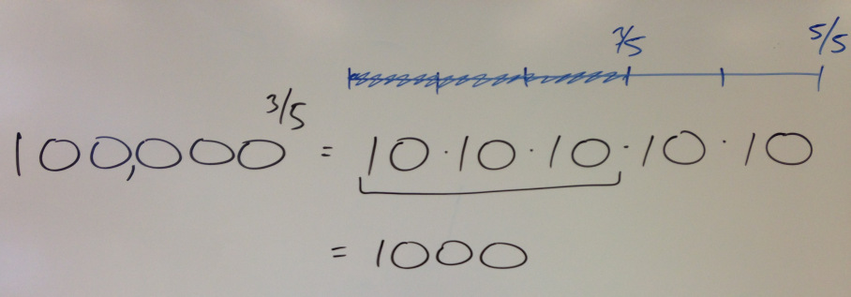
Write 100,000 as five identical factors, take 3
For My Next Trick, I’ll Be Misusing the Word Partition
This idea of partitioning a number into identical factors and selecting a portion of those factors feels an awful lot like multiplying whole numbers by rational numbers:
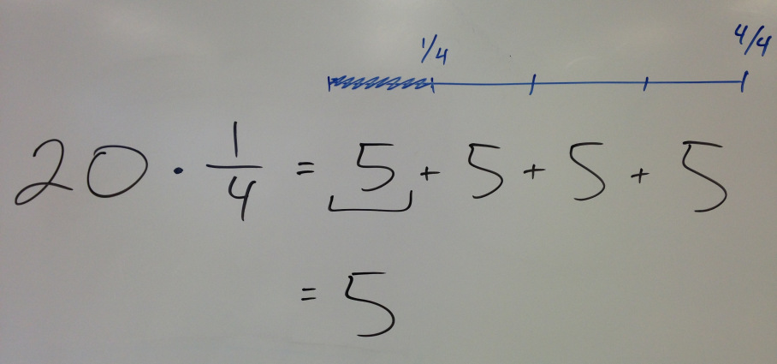
Write 20 as four identical terms, take one
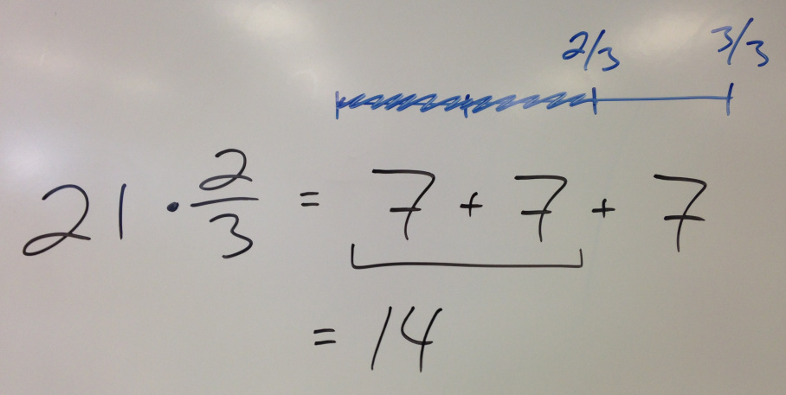
Write 21 as three identical terms, take two
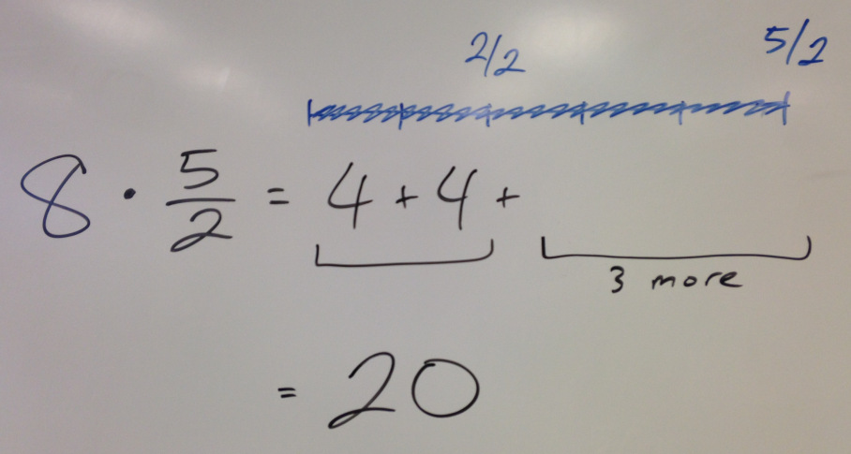
Write 8 as two identical terms, take five
I don’t know if you can use partition in that sense (thefactors sense), but I couldn’t shake the notion that these two problem types have a lot more in common than I ever thought before. (Maybe now that I’ve rambled all over the page I’ll be able to get some sleep at night. Or was it the kids waking up in the middle of the night that was disturbing my sleep… Too tired to remember.)
Your Thoughts?
I’m a little bit nervous about hitting “publish” on this one. I feel like there are four likely responses to the post—for anyone persistent enough to ramble (as in walk) through to the end of these ramblings (as in babble):
- Thanks for blathering, but I have no idea what you just said.
- Thanks for nothing, everyone already knew everything you said.
- Thanks for trying, but I think you need a mathematical intervention to work out some of your own misconceptions.
- Thanks for sharing, that’s a nifty connection. I might use it one day with my own students.
If you made it this far, let me know which of those reactions best describes your own. Or go off script and drop a more thoughtful comment.
Either way, thanks for playing!

Bonus Material!
These standalone resources were both nominated by the blogosphere folks as well.

Nix the Tricks! by Tina Cardone
Description:
Do you cringe when a student's reaction to every problem involving fractions is "cross multiply!"?
It doesn't matter whether you teach elementary or high school, whether you're a parent or a tutor, having a student yell out a trick without stopping to think is painful.
This book is filled with alternatives to the shortcuts so prevalent in mathematics education and explains exactly why the tricks are so bad for understanding math.
My PrBL Curriculum Maps by Geoff
Description:
The following Problem Based Learning (PrBL) curriculum maps are based on theMath Common Core State Standards and the associated scope and sequences. The problems and tasks have been scoured from thoughtful math bloggers who have advanced our practice by posting their materials online.
PrBL-CCSS Curriculum Maps

Fawn’s Comment on Andrew’s Post

Thanks to all who contributed to our learning this year. Your vulnerability helps us become better teachers, better people.
-- Geoff

