 Problem Planning Form
Subject / Course  Algebra 1 | Content Standards  CCSS: F-BF.1a,b,c; F-LE.2, F-IF.6,7a
Unit  Linear Functions | Key Ideas / Concepts  Modeling with Mathematics (CCSS-MP.3)  Building Functions from scenarios
Problem Scenario
Entry video explaining the scenario:
- Which size U-Haul truck should I rent based on the number of trips I have to take?

Anticipated Knows / Prior Knowledge  - Some practice with Pythagorean Theorem  - Some equation building skills | Anticipated Need to Knows (or information students should identify that they need)  - What are the dimensions on the map?  - What is the capacity of the U-Haul trucks?  - How many trips for each truck do we need?  - What is the per-mile cost of each truck?
Potential Next Steps / Entry Points

Possible Solution Methods
Method 1:
See below.

Method 2:

Method 3:

Facilitation Notes
Scaffolding Need to Knows
Need To Knows | Associated Scaffolding Activity

Formative Assessment  (How will you assess student progress throughout the problem?) | Benchmarks will be employed after the first sets of equations developed.
Problem Debrief / Sharing Out  (What are some of the key mathematical concepts you want to highlight during the problem debrief and students sharing out their work?) | Spend debrief time reflecting on the modeling process. How did groups identify relevant and non-relevant information? Recap the process the teams went through.  As far as content goes, how did groups organize and display their information?
Differentiation  (How will you support struggling students that require remediation?) | Create a Learning module for Pythagorean theorem refresher.
Extensions  (How might you be able to extend this problem into a more in-depth mathematical task?) | Can we develop a rule of thumb for differentiating between getting a 14’ vs. a 20’ truck (i.e. “If the # of trips using the 14’ truck is two or greater than the 20’ truck then it’s more cost efficient to get the 20’ truck.)?  Can we calculate the actual square footage of the 14’ and 17’ trucks? This incorporates volume standards.
Follow-Up and Assessment
(How will you assess your students? How will you determine if they’ve learned the intended mathematical concepts?)

Notes

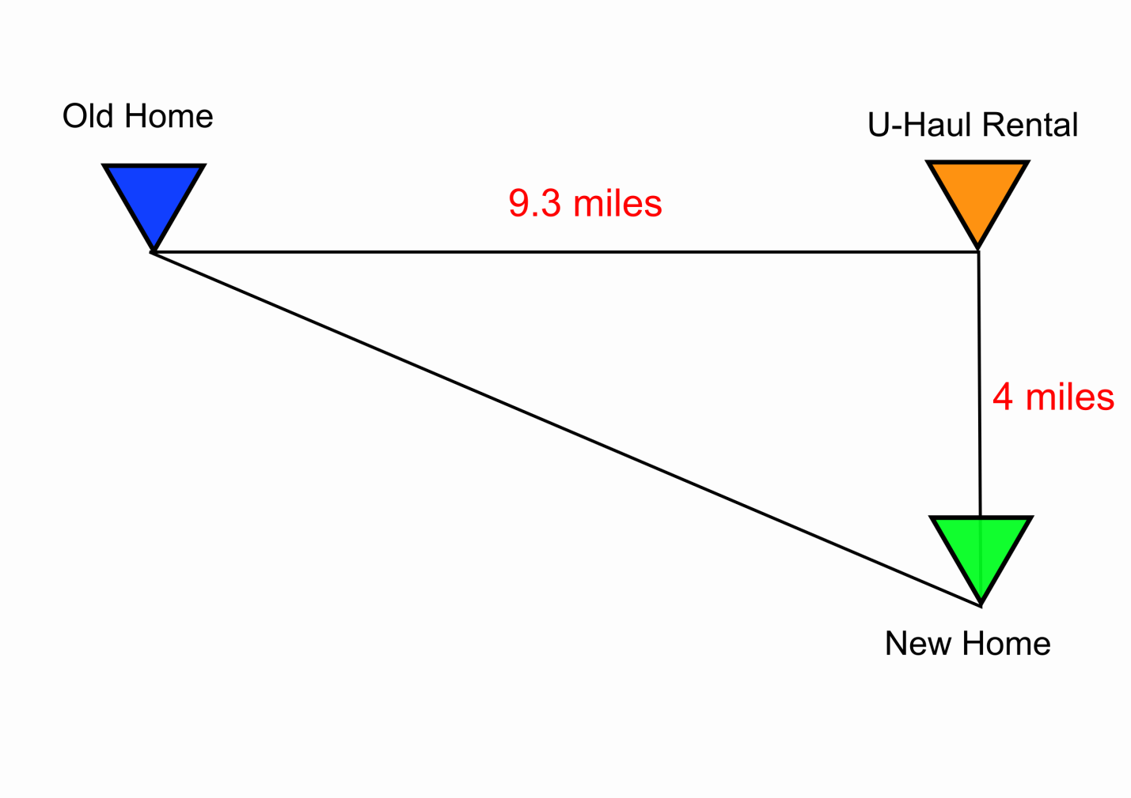
Truck length | U-Haul listed capacity | Up front cost (1 day rental) | Additional cost per mile
14’ | 733 cu. Ft. | $19.95 | $0.79
20’ | 1015 cu. Ft. | $39.95 | $0.79

Potential Solution route:
Building our model
Students should first come up with a basic functional representation of the cost vs. mileage before applying it to the number of trips.
Cost = (up front cost of truck)+$0.79*mileage
$${Cost}_{{14}^{'}}=\$19.95+\$0.79m$$
$${Cost}_{{20}^{'}}=\$39.95+\$0.79m$$
, where m=mileage driven. This can be graphed as well.
POTENTIAL BENCHMARK
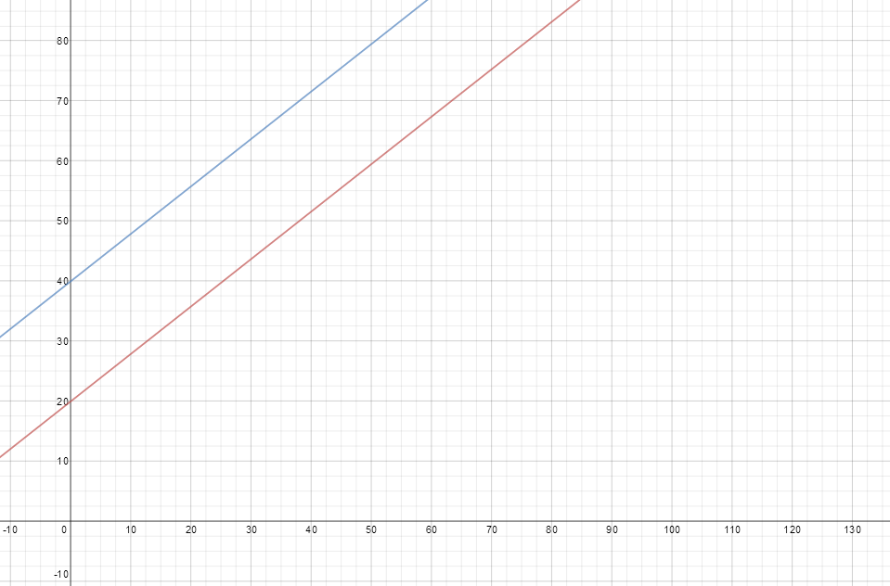
Distances between locations (in miles):
- Old House U-Haul: 9.3
- U-Haul New House: 4
- Old House New House: ~10.12 (using Pythagorean Theorem – Learning Module for students who need a refresher)
Students then will need to set up a model in the form of a linear function, depending on the number of trips between the Old Home and New Home. Each extra trip after the first one will tack on 10.12+10.12=20.24 miles to the total mileage.
Cost = (Up front cost of truck)+$0.79*(mileage from U-Haul to Old Home + mileage between Old Home and New Home + mileage from New Home to U-Haul) + $0.79*2*(mileage from Old Home to New Home)*(number of trips - 1)
Cost = (Up front cost of truck)+$0.79*(9.3 + 10.12 + 4) + $0.79*2*(10.12)*(number of trips - 1)
Cost = (Up front cost of truck) +18.5+16*(number of trips - 1)
We can break that down for the three given truck sizes. For the smallest truck (the 14’ truck):
$${Cost}_{{14}^{'}}=\$19.95+\$18.5+\$16(x-1)$$
$${Cost}_{{14}^{'}}=\$38.45+\$16(x-1)$$
where x = # of trips to and from the New/Old Home
For the other truck,
$${Cost}_{{20}^{'}}=\$58.45+\$16(x-1)$$
POTENTIAL BENCHMARK
Cargo Estimates
Facilitator: “I’m still working on figuring out the number of trips I’ll have to take. I had several moving companies come over – before I decided to rent a U-Haul – and they each gave me a wildly different estimate of the amount of cubic footage of stuff I have.
Estimate 1: 2225 cu. ft
Estimate 2: 3000 cu. Ft.

Which size truck should I rent, based on each estimate?”
Potential solution.
Each estimate would entail a different number of trips based on the size of the truck rented. Recall,
Truck length | U-Haul listed capacity
14’ | 733 cu. Ft.
20’ | 1015 cu. Ft.

Truck capacity | 14’ truck (733 cu ft) | 20’ truck (1015 cu ft)
Estimate 1: 2025 | 3 trips | 2 trips
Estimate 2: 3000 | 5 trips | 3 trips

We can translate this into cost also using a table. (most cost effective)
Truck capacity | 14’ truck (733 cu ft) | 20’ truck (1015 cu ft)
Estimate 1: 2025 | 70.45 | 74.45
Estimate 2: 3000 | 102.45 | 90.45

