Paleontological Dig

Congratulations! You’ve been assigned to a paleontological dig to dig up three ancient skeletons. Thanks to our fancy paleontology dig equipment, we’ve been able to map out where the skeletons are.

Your Task: For each skeleton, sketch and write four linear functions that would surround the skeleton, so we may then excavate it.

Check with your peers: Once you have it, compare your functions to your neighbors. Their answers will probably be different. What do you like about their answers?

Optional: For the technologically inclined, you may wish to use Desmos. (https://www.desmos.com/calculator/y1qkrfnsw2)

Challenge: What’s the smallest area you can make with the four functions that still surround each skeleton.

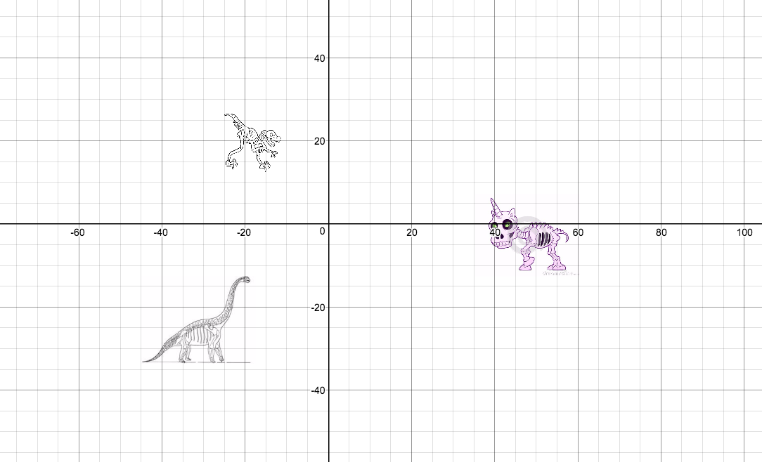

Work for Skeleton 1: Unicorn | Equations | Vertices
Work for Skeleton 2: Velociraptor | Equations | Vertices
Work for Skeleton 3: Brontosaurus | Equations | Vertices

Tell the diggers! You need to communicate to the diggers. Tell them where and how to start digging! Be sure to be as specific as possible and discuss your reasoning.

Reflection: What do you notice about the four functions for each skeleton?

Reflection: Describe the strategy you used to come up with the four functions.

