Running From the Law

🚨🚨🚨ALERT!🚨🚨🚨

Calling all units! Calling all units! We’ve just received notice that the notorious jewel thief Jimmy Slimfingers has struck again! A little while ago he stole thousands of dollars’ worth of jewelry and fled from the scene! We are currently looking for him. We believe he could be in one of the following buildings.

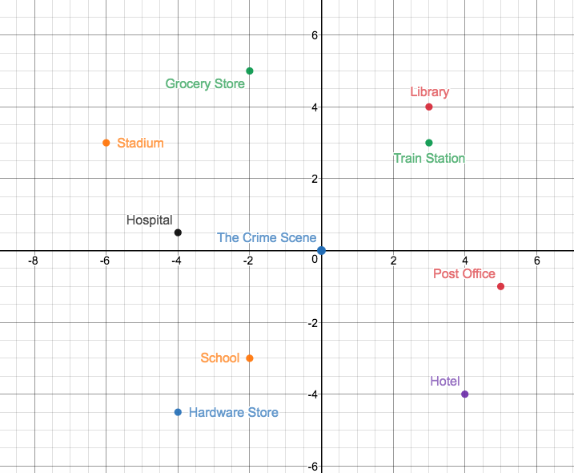
Figure 1: Each grid represents 1 km.

Given the time that’s passed and typical footspeed, he could be anywhere up to 5 kilometers from the crime scene.

Help us narrow down Jimmy’s hideout! Which of the buildings above could he be in? And can you help us establish a perimeter so we know the entire area that he might be in?

