Self Pre- / Post- Assess:
 | Emerging | E / D | Developing | D / P | Proficient | P / A | Advanced
Math Content | I identify a few important quantities and variable in a problem |  | I can sometimes identify and use important quantities and variables in a problem |  | I usually identify and use important quantities and variables in a problem |  | I can create a model to simplify a complicated situation
Collaboration: Group Roles | I know my role and fulfill it only some of the time |  | I accept my role and show understanding by fulfilling it |  | I know the roles of myself and others, and use the roles to maximize group effectiveness |  | In addition, I use group roles as opportunities to use strengths or address areas of weakness.  I encourage my group members when they are fulfilling their role.
Goal:
Problem Solving Framework
Define the Problem
What is the problem about? What is it asking you to do?

Analyze the Problem
What do you know from the problem scenario or lessons that can help solve the problem? | What concepts or information do you need to know in order to solve the problem?
Strategies and Solutions
Your work & decision

Check in with Mr. Krall: __________

Problem Entry Event: “A Day Out”
Good morning class,

I’m so excited about our upcoming field trip! You’ll recall we have three options for our field trip: Growlets Zoo, the Prison Museum, and the Space Science Show. Yesterday I had you list your first and second choice. The results are here:

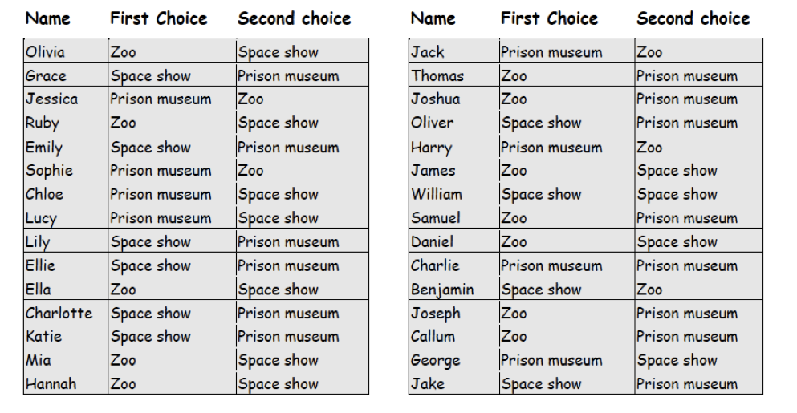
I would like you to analyze the results from the survey and come to a consensus as a group on which field trip to take. Be sure to employ as fair reasoning as possible, while acknowledging the benefits and drawbacks of your method. Please use our Problem Solving Framework on the back of this paper to help organize your information and work.

After you come to a decision, you will be asked to communicate your decision and the reasoning behind it to the class. Lastly, you will need to tabulate the total cost of the trip and the cost per student based on entry fees and travel mileage. Please check in with me once your group has come to a decision for those instructions.

I look forward to your presentations (and your mathematical reasoning)!

Mr. Krall
7th Grade Math Teacher
gmkrall@gmail.com

